
OUT FOR YOUR
Business and Information Technology Education
SAFETY

TABLE OF CONTENTS

FIRE PROCEDURES 6

TORNADO & STORM PROCEDURES 7

EARTHQUAKE PROCEDURES 8

ENVIRONMENTAL PROCEDURES 9
HAZARDOUS MATERIALS CLASSIFICATION SYSTEM 10

BOMB THREAT PROCEDURES 11
BOMB THREAT CHECKLIST 12

PREPARING FOR EMERGENCIES 13

PERSONAL SAFETY/SECURITY 14
GENERAL WORK HABITS 15
WORK AREA HOUSING 15
EQUIPMENT 15
FIRE SAFETY 16
ELECTRICAL SAFETY 17
LIFTING SAFETY 17
COMPANY VEHICLE SAFETY 18
SECURITY/SAFETY AWARENESS 18

EMERGENCY & IMPORTANT NUMBERS 19

RESOURCES FOR SAFETY MATERIAL 19

CREDIT 20

STATEMENT OF UNDERSTANDING 21

i

EMERGENCY PROCEDURES

Accidents involving injury or property damage must be reported to your supervisor as soon as possible. If an injury is minor, first aid equipment is available in the store room.

FIRST AID OR AMBULANCE

In any accident where the person injured is unconscious, do not move the person unless it is absolutely necessary. Remain calm in any emergency.

The following procedures are the most basic first aid steps that are vital to know. Humans need oxygen and blood to survive. Breathing stoppage or excessive bleeding can result in death or permanent brain damage within four minutes. Study, understand, and remember these life-saving steps.

Emergency Procedures (continued)

BLEEDING

LATEX GLOVES ARE REQUIRED BEFORE PROCEEDING WITH THE PROPER STEPS

Proper steps are required to control excessive bleeding:

1. Direct Pressure: Cover wound with clean cloth available or your bare hand and apply direct pressure on the wound. Add bandages (more cloth) if blood soaks through, but do not take off any of the blood-soaked bandages. Keep a firm pressure on the bandage(s) until the person is transferred to someone more qualified.

2. Pressure Bandages: If other emergency care is necessary, apply a pressure bandage to hold bandages in place. Things to remember are: Keep the pressure bandage tight enough to hold bandages directly over the wound; put the knot directly over the wound; try to elevate wounded limbs above the heart if you are sure there is no bone fracture.

3. Pressure Points (pressing the artery against bone stops blood flow): If direct pressure and elevation do not stop bleeding, continue both and apply pressure to the pressure point between the heart and wound. Release pressure point when bleeding stops. Pressure points are: For the arm - inside of arm halfway between shoulder and elbow; for the leg-midpoint between crease of thigh and body.

4. A tourniquet should be used only as a last resort for critical emergencies such as an amputation.
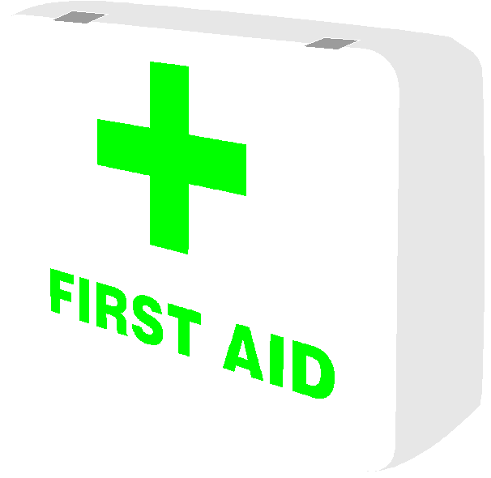
Emergency Procedures (continued)

CHOKING

Few people realize that suffocation is the sixth largest cause of accidental death in the nation.

The “Heimlich Maneuver” can save lives. Here’s how it’s done:

1. Stand behind the victim and wrap your arms around the waist, allowing the choking person’s torso to hang forward.

2. Make a fist with one hand and grasp it with the other. Place the first against the victim’s abdomen slightly above the navel and below the rib cage and make a quick upward thrust. This could expel the wind from the lungs and force the object from the windpipe.

3. Repeat as necessary.

4. If the victim is sitting, stand behind the chair and perform the maneuver.

5. If the victim is prone or unconscious, turn onto the back, kneel astride the torso, place both hands again on the victim’s abdomen above the navel and below the rib cage--then press with a quick upward thrust.

SELF-HELP FIRST-AID FOR CHOKING

What to do if food is stuck in your throat and nobody is nearby to give you the vital “hug of life” or Heimlich Maneuver:

1. Make a fist.

2. Place thumb of fist slightly above your navel.

3. With other hand, sharply press fist in and up several times. Repeat Step 3 until this forces air up your throat, shaking the stuck food loose.
Emergency Procedures (continued)

MOUTH-TO-MOUTH RESUSCITATION

Check to see if the individual is breathing--if not, restore breathing

Remove obvious foreign matter--such as broken teeth--from the victim’s mouth
Tilt the victim’s head back by pressing back on the forehead and lifting up on the chin.
Close the victim’s nostrils with your fingers.
While watching the victim’s chest with your eyes, place your mouth tightly over
the victim’s and exhale in the victim’s mouth until the chest expands.
If the victim’s lungs don’t inflate easily, check for an obstruction in the airway.

Start at once, then repeat every five seconds. Every second counts when breathing has stopped. Keep trying until the victim has begun breathing unaided, or medical personnel arrive on the scene.
Emergency Procedures (continued)

IF AN INJURY REQUIRES EMERGENCY MEDICAL AID:

 CALL FOR AN AMBULANCE, 911

 NOTIFY YOUR SUPERVISOR AND/OR ADMINISTRATOR

SPECIAL INFORMATION

After summoning emergency medical aid, try to obtain from the patient the nature of the illness, what, if any, medication has been taken and the patient’s choice of doctor and hospital.
Response
The fastest possible response to a call for mergency medical aid comes from ambulance service. They respond with trained personnel.


RESPONSE

FIRE PROCEDURES

Visible fire or smoke inside building - Pull nearest fire alarm pull box

When Fire Alarm Sounds:

Evacuate the building immediately via nearest exit and proceed to your designated assemble area for accountability.

Close all doors as you leave - do not lock doors.

If fire is small, attempt to extinguish it - but don’t take chances.

Fire Outside the building - Dial 911

Give the following information:

a. Your name, and that you wish to report a fire.

b. The exact location of the fire.

c. What is burning.

d. Do not hang up until released by the operator.

Fire Extinguishers

Fire extinguishers are labeled as to the kind of fire they will be effective against. You must read the label to be sure you have the appropriate equipment to extinguish the fire. Labels will indicate:

Class A - wood, paper, grass, cloth Class B - grease, oil, flammable liquids Class C - energized electrical equipment
YOUR SUPERVISOR WILL SCHEDULE A HANDS ON TRAINING SESSION ON HOW TO USE A FIRE EXTINGUISHER.
Extinguisher Use Instructions:

1. Check label and carry extinguisher
to vicinity of fire

2. Remove the ring pin by pulling

3. Squeeze discharge lever
4. Direct discharge nozzle at base of fire

5. Be sure all fire is out before stopping discharge

6. Back away from extinguished fire

7. Report to the Administration office as soon as possible about the fire and the need for fire extinguisher recharge.

TORNADO & STORM PROCEDURES

When the storm warning sirens are sounded (3-5 minutes steady blast), you should immediately:

 Remain calm!

 Get away from windows.

 Never use the elevator.

 Stay clear of storage racks and filing cabinets.

 Proceed to your designated assemble area for accountability.

 Close all doors to outside rooms.

 Monitor weather broadcasts, if a radio or TV is available.

 If tornado warning is issued, direct employees to take shelter under sturdy desks/benches; Or sit on the floor with their head between their knees and their hands over the back of their neck.

 If you are not in a shelter when tornados or severe storm dangers are present, you should quickly move to the inside of a nearby building or lay with your hands over your head and neck in a ground depression. (Example - ditch or culvert)

 Never stay inside a vehicle.

FOLLOW-UP

 Account for all employees. Administer first aid or call 911 for medical assistance if required. Do not move seriously injured persons unless they are in immediate danger or further injury.

 Check utilities and appliances for damage. If you smell gas, open windows and doors, turn off main valve. Do not turn on lights or appliances until gas has dissipated. Use a flashlight, not a candle or a match, to search for gas leaks. If electric wires are shorting out, turn off power at breaker panel. Shut water off if possible. Call utility companies for assistance. Keep building cleared until utility officials say it is safe.

EARTHQUAKE PROCEDURES

WHEN AN EARTHQUAKE OCCURS IN THE AREA:

Call Fire Department or Medical Personnel if required, 911. If there is any damage, notify the supervisor.

RESPONSE

 Stay indoors if already there.

 Stay clear of storage racks and filing cabinets.

 Take cover under sturdy furniture such as work tables, desks; benches; brace yourself in a doorway; move into a corner; protect head and neck with arms.

 Stay near center of the building away from glass windows, doors, and skylights.

 Do not run between buildings where there is a danger of falling debris.

 If employees are outside, they should stay in the open, away from buildings and utility wires.

FOLLOW-UP


 Exit the building and proceed to your designated assemble area for accountability.

 Administer first aid, call 911 for medical assistance if required.

 Do not move seriously injured persons unless they are in immediate danger of further injury.

 Check for damaged appliances and utilities. If gas leakage is detected, shut off the main valve; open windows and doors. Do not turn on lights or appliances until gas has dissipates. Use a flashlight, not a match or candle. Call utility companies for assistance.

 Keep building cleared until utility officials say it is safe.

 Be prepared for after shocks. Stay clear of any potential falling debris.

ENVIRONMENTAL PROCEDURES

IF AN ENVIRONMENTAL SPILL OR LEAK OCCURS AT YOUR PROPERTY:

 Notify proper federal, state, or local authorities.

 Notify emergency response personnel if required.

 Notify Supervisor and/or Administrator.

RESPONSIBILITY

It is the responsibility of each handler of hazardous materials to know all regulations affecting the handling, storage or transportation of those materials. If you have any questions on what materials may be covered, contact the Federal Environmental Protection Agency or local authorities. Notify the supervisor of any materials stored or handled on your premises. Maintain Material Safety Data Sheets and have them available for any emergency.

RESPONSE

 For emergency medical aid, call 911.

 For information or accidental poisoning,
call Poison Control, (800)522-4611

 For cleanup assistance call:
Local Fire Department: 911
U.S. Environmental Protection Agency (800)424-8802

 Notify the supervisor with full details of incident.
REMEMBER, KNOW THE HAZARD OF CHEMICALS IN YOUR SPACE AND TREAT THEM ACCORDINGLY.
HAZARDOUS MATERIALS CLASSIFICATION SYSTEM

HAZARDOUS MATERIALS DIAMOND - Warning symbols have been developed that immediately alert chemical users and emergency workers, such as fire fighters, of possible dangers. These symbols identify health, flammability, reactivity and other specific hazards. A numerical scale ranks the potential hazard with a 0 meaning “No Hazard” and a 4 meaning “A Severe Hazard.” All hazard warning systems are not the same.

Red, top diamond-Fire Hazard
Flash Points
4 - Below 73 F
3 - Below 100 F
2 - Below 200 F
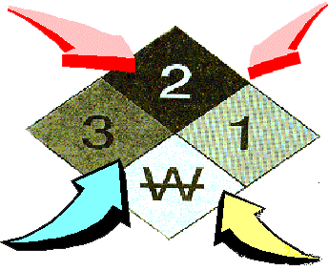
Blue, Left-hand diamond 1 - Above 200 F
Health Hazard 0 - will not burn
4 - deadly
3 - Extreme Danger
2 - Hazardous
1 - slightly hazardous
0 - normal material

Yellow, right -hand diamond
Reactivity
4 - May detonate
Black on White, bottom diamond 3 - Shock and heat may Specific Hazard detonate
Oxidizer OXY 2 - Violet Chemical change
Acid ACID 1 - Unstable if heated
Alkali ALK 0 - Stable
corrosive COR
Use NO WATER W
Radiation hazard
BOMB THREAT PROCEDURES

IF YOU RECEIVE A TELEPHONE BOMB THREAT:

 Be courteous. Pretend difficulty in hearing.  After the caller hangs up notify your supervisor
 Take notes using the Bomb Threat Checklist.  Notify your supervisor and administration
 Notify the Bomb Squad, 911

REPORTING

All bomb threats must be reported to your supervisor and/or administrator, and the bomb squad. Most reports of bombs are false alarms intended to create a disturbance at a specific location. For this reason, the decision of how to react must be carefully considered by your supervisors and administration.

SEARCH

Examine your office space for strange or suspicious items. As no one else knows your area as well as you do, do NOT touch any suspicious items. Immediately report any strange or suspicious item to your supervisor.

EVACUATION
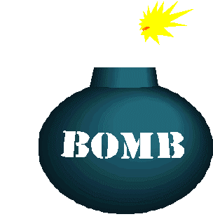

The final decision to evacuate your area rests with you. Proceed to your designated assemble area for accountability.

TAKE THE CHECKLIST WITH YOU WHEN BEING EVACUATED.

BOMB THREAT CHECKLIST

PLACE THIS UNDER TELEPHONE |  |  |  | CALLER’S VOICE
BE CALM, BE COURTEOUS, LISTEN, DO NOT INTERRUPT. |  |  |  | CALM LOUD NASAL CLEARING THROAT  ANGRY LAUGHTER STUTTER DISGUISED  SLOW NORMAL RASPY DEEP BREATHING  RAPID DISTINCT DEEP FAMILIAR  EXCITED ACCENT SOFT CRACKING VOICE  CRYING SLURRED LISP RAGGED
TIME CALL RECEIVED | TIME CALL ENDED
QUESTIONS TO ASK
1. WHEN IS BOMB GOING TO EXPLODE?
2. WHERE IS IT RIGHT NOW? |  |  |  | IF VOICE IS FAMILIAR, WHO DID IT SOUND LIKE?
3. WHAT DOES IT LOOK LIKE?
5. WHAT WILL CAUSE IT TO EXPLODE? |  |  |  | BACKGROUND SOUNDS  STREET NOISES CROCKERY VOICES P.A. SYSTEM  HOUSE NOISE MOTOR MUSIC CLEAR  OFFICE MACH. STATIC LOCAL BOOTH  FACTORY MACH. LONG DIST.
6. DID YOU PLACE THE BOMB?
7. WHY? |  |  |  | THREAT LANGUAGE   WELL SPOKEN (EDUCATED)  FOUL  IRRATIONAL   TAPED MESSAGE READ BY THREAT MAKER  REMARKS:
8. WHAT IS YOUR NAME?

9. WHAT IS YOUR ADDRESS? |  |  |  | DATE
10. ARE YOU CALLING FROM A PAY PHONE? YES NO |  |  |  | NAME OF PERSON RECEIVING CALL
11. LOCATION AND/OR NUMBER |  |  |  | TITLE | PHONE
SEX OF CALLER  M F |  | AGE | RACE | NUMBER CALL RECEIVED AT
EXACT WORDING OF THREAT:

PREPARING FOR EMERGENCIES

You should develop, and have in place, a plan to address any emergencies that might develop in your space or on the property.

You should distribute this plan to your employees and review it so that in case of an emergency everyone knows what to do. You should insure that everyone knows how to exit the property in case of an emergency. It is recommended that a walk through of the evacuation plan be conducted by everyone on a regular basis.

Purchase and keep on hand emergency supplies. They should be maintained and checked regularly. As a suggestion, they could include:

First Aid Supplies Flashlights Portable Radio Spare Batteries
Blankets Plastic Bags Weather Radio Portable Telephone & important numbers

Know how to turn off electricity in your space. Review the locations of circuit breakers and fuse boxes. Know how to shut off gas to your space. DO NOT turn off gas except in an emergency. If gas is shut off, only the gas company should turn it back on. Know where water shut off valves are.

Designate an assemble area away from buildings. Ensure that all employees know its location, and report there accountability after an emergency.





PERSONAL SAFETY/SECURITY

An accident is any unforeseen or unexpected event that may or may not result in injury or damage to property or equipment.

The ultimate goal in accident prevention is “zero” disabling injuries and no lost work-time. However, there are many barriers to achieving this goal, the most important of which is human attitude. Most people feel that “it won’t happen to me” or “it couldn’t happen here.” You can do more to protect yourself and your fellow worker by constantly thinking and practicing accident prevention than you can be memorizing all of the rules, regulations, and safeguards ever written or invented.

You must THINK before you act.
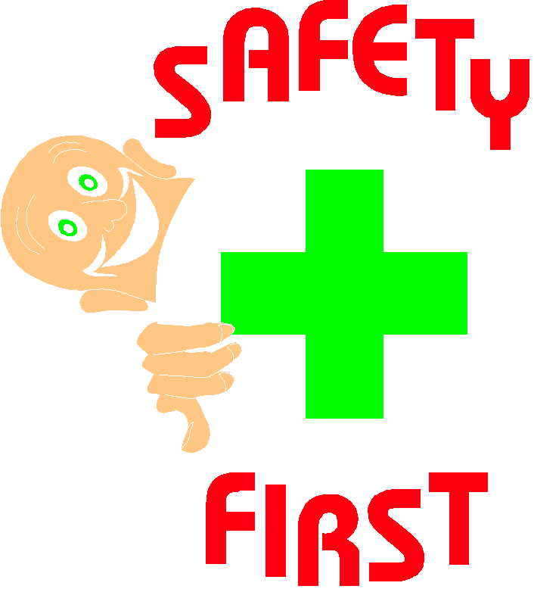
GENERAL WORK HABITS

Reducing accidents means reporting to work physically and mentally rested, prepared to perform your job safely and properly. Always report any unsafe condition or unsafe act to your supervisor. Whenever you’re performing your job, keep your mind on your work. Always keep your temper and thoughts under control.

Report any injury to your supervisor as soon as possible. If you are taking a prescribed drug that may have a side effect, inform your supervisor before beginning the day’s work. Use of illegal drugs or intoxicating beverages while at work (or reporting to work under the influence of these substances) may be cause for your dismissal.

WORK AREA HOUSING

Good house keeping is an essential part of every job. Work areas, aisles and equipment shall be kept clear of loose cords and personal belongings. A safe access shall be maintained to work areas. Never block aisles, traffic lanes, or fire exits with equipment or material.

EQUIPMENT

Your supervisor will give proper instructions on each piece of equipment located in your area. All electrical equipment will be properly grounded. You should never adjust repair or clean equipment while it is on.

If you feel a piece of equipment is damaged or creating a possible hazard, report this to your supervisor immediately.
All employees must protect company computer equipment by scanning for computer viruses.
VIRUS DEFINITION
Computer viruses are unlawful computer programs or harmful code that attach themselves to and “infect” other programs and systems. They are a threat to data processing. Viruses are often transmitted from computer bulletin boards, infected diskettes, loaned machines, and free diskettes received in the mail or from vendors. Once a program has been infected, it may be instructed to perform unauthorized functions before spreading to other systems. The interaction between users, either physical or over a network, may spread the malicious code.
Work Area Housing (continued)

PROTECTION PROCEDURES FOR COMPUTER VIRUSES

For protection these procedures must be practiced

1. Virus-detecting software will be installed on every PC.

2. All diskettes must be scanned by virus-detecting software before loading onto any hardware, including newly purchased blank and application software diskettes, demonstration diskettes, backups of file servers, and diskettes from other sources. If previously scanned diskettes are subsequently run on the equipment, they must be rescanned before being loaded onto the equipment.

3. Supply scanning equipment or services to employees who use company owned hardware, software, and peripherals is the responsibility of the supervisor.

4. Servers must be scanned periodically to detect viruses.

5. Employees shall exercise reasonable care to prevent introducing viruses when dialing into company owned equipment.

VIOLATIONS AND DISCIPLINARY ACTION

All violations of this policy and incidents of computer viruses will be logged by the supervisor and reported to administration. Any employee should contact the supervisor if they suspect a virus problem. In turn, those supervisors should report the suspected problem.

RESERVATION OF RIGHTS

The Company reserves the right to interpret, modify or revise this Policy in whole or in part without notice. The employee remains free to resign his/her employment at any time for any or no reason without notice. The Company reserves the right to terminate any employee’s employment for any or no reason without.

FIRE SAFETY

Learning the location of fire extinguishing equipment and fire alarms in your work area is important. Do not cover or hide fire protection equipment and fire alarms from view. Sources of ignition, such as cigarettes, matches, portable heating equipment, unguarded light bulbs, etc., are prohibited in areas where explosives, flammable liquids or gases, or other combustible exist, (i.e., near chemical exhaust outlets, flammable liquid storage areas, sump pump areas, and refueling areas). Always obey “No Smoking” signs.

ELECTRICAL SAFETY

It takes very little electric current to kill -- less than one-tenth of an ampere. With good contact, 115 volts is sufficient voltage to cause death. There have been fatal electrical shocks where voltage as low as 60 to 70 volts was involved. All electrical equipment should be periodically inspected. All electrical tools and equipment should be properly grounded or be of double insulted type. You should never use electrical equipment when standing in or near water. All exposed electrical wires should be considered “hot” or “live” until checked by the appropriate maintenance or utility staff.

LIFTING SAFETY

Over 250,000 industrial workers, housewives, and office workers injure themselves each year through poor lifting techniques. The practice of stooping over from the waist to lift, accompanied with the added factors of uneven footing, poor balance, or awkward positioning is a direct invitation to eventual injury, because undue strain is thrown on the back and abdominal muscles. The following rules should be observed
for safe lifting.

1. Determine if you need help--consider the distance and the object’s weight.

2. Look over the pick-up and delivery area for (1) tripping hazards, (2) slippery spots, (3) small doors, (4) sharp corners, (5) blind spots, etc.

3. Inspect the object for sharp corners, wet surfaces, slivers, etc.

4. Place feet correctly--one foot close to the side of the object to provide stability--anyone directly behind the object to provide lift or thrust.

5. Keep the object close your body.

6. Get a correct grip or hold on the object by using a full grip-not just your fingers.

7. Keep your back straight--this does not mean vertical--just aligned from head to pelvis.

8. You should tuck in your chin when lifting to insure alignment from head to pelvis.

9. Do the actual lifting with your legs only.

10 Just as importantly as lifting correctly is the act of lowering correctly. You should lower objects in the same manner as you lifted them. This is essential! The body should never be turned or twisted while under the stress of heavy weight. Instead, you should turn your whole body if you desire to change your position after you have made the lift. When team-lifting large, awkward, or heavy loads, one person should inform others-prior to lifting-of the safe, correct methods of lifting to be used. One person will give commands.

COMPANY VEHICLE SAFETY

Vehicle accidents can be costly from the standpoint of time lost, vehicle repair, and insurance premium cost increases--not to mention human injury. It is your responsibility to closely follow the laws set forth in the Oklahoma Driving Manual as your rules of the road. It is also your responsibility to provide preventive maintenance to the vehicle for which you are responsible. This means notifying your supervisor of braking or steering problems, lights or horns that have quit working, etc., as soon as the problem is discovered.

ALWAYS WEAR YOUR SEAT BELT

SECURITY/ SAFETY AWARENESS

When entering different or unfamiliar work areas, be aware of work being done around you and familiarize yourself with any required safety precautions.

If you should need Security in your area to assist, call the main office during working hours (7:30 a.m. to 9:00 p.m.). If you are an employee leaving or coming to work after dark and need for some one to meet you when you arrive or walk you to your vehicle notify the main office.

If you have a flat tire or need a jump to get your vehicle started Security on duty will air up your tire or give you a jump. Security will not change tires or perform mechanic work on your vehicle.

If you should lock your keys in your vehicle Security will assist in getting your car open.
EMERGENCY AND IMPORTANT NUMBERS

FIRE, POLICE, MEDICAL EMERGENCY 911

POLICE DEPT.

FIRE DEPT.

AMBULANCE

FAMILY DOCTOR

CHILDREN’S DOCTOR

OTHER DOCTOR

OTHER DOCTOR

PHARMACIST

HOSPITAL

NEIGHBOR

NEIGHBOR

GAS COMPANY

ELECTRIC COMPANY

POISON CONTROL CENTER 1-800-522-4611

U.S. ENV. PROT. AGENCY 1-800-424-8802

OTHER IMPORTANT NUMBERS

RESOURCES FOR SAFETY MATERIAL

OKLAHOMA DEPARTMENT OF LABOR
4001 NORTH LINCOLN BOULEVARD
OKLAHOMA CITY, OK 73105-5212
405-528-1500

OSHA PUBLICATION INFORMATION
OSHA PUBLICATION OFFICE
200 CONSTITUTION AVE. NW ROOM N3101
WASHINGTON, DC 20210
202-523-9667

FOR MORE SOURCES CONTACT YOUR LOCAL COLLEGES, HOSPITALS, AND UTILITY COMPANIES.

CREDIT

A BIG “THANK YOU” GOES TO THE FOLLOWING INSTITUTIONS FOR THEIR HELP AND COOPERATION IN COMPILING THIS INFORMATION.

OSU-OKMULGEE

OKMULGEE MEMORIAL HOSPITAL

CITY OF OKMULGEE

THE WILLIAMS COMPANIES, INC.-TULSA

GREEN COUNTRY AREA VOCATIONAL TECHNICAL SCHOOL



THIS INFORMATION WAS COMPILED BY TERESA PINKSTON, INSTRUCTOR AND PAULA LAYTON, SECOND-YEAR STUDENT FROM GREEN COUNTRY AVTS.
GREEN COUNTRY AREA VOCATIONAL TECHNICAL SCHOOL

BUSINESS & COMPUTER TECHNOLOGY

STATEMENT OF UNDERSTANDING

“I have received a copy of the Green Country Area Vocational Technical School, Business & Computer Technology Safety Manual and have read and understand its contents. If I encounter safety problems in the course of my work which were not covered by the manual or my supervisor, I will discuss them with my supervisor.
I am aware that this signed page will be placed in my personnel file.”

_______________________________________ _____________________________________
Employee Date

_______________________________________ _____________________________________
Supervisor Date

PLEASE SIGN, DATE, AND RETURN TO YOUR SUPERVISOR AS SOON AS POSSIBLE.

