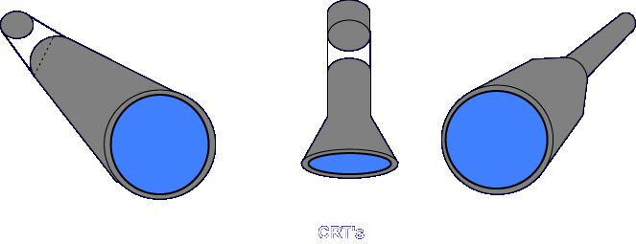
You are probably more familiar with the cathode-ray tube (CRT) than you may realize. The picture tube of a television is a CRT. But CRTs are used more than just in televisions. They are used in oscilloscopes, radar screens, video games, and computer monitors, to name just a few examples.
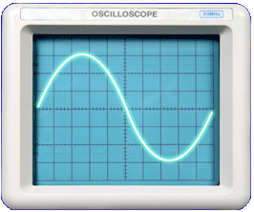
A CRT is a special type of electron tube that converts electrical signals into a visible image. These screens range from 2 inches to 40 inches in size and come in a multitude of shapes. CRTs fall into one of two basic types, electrostatic or electromagnetic. The method of beam deflection determines the type.
• | Electrostatic
• | Electromagnetic

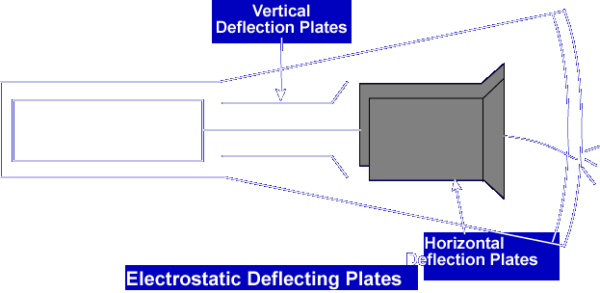
In the electrostatic type, deflection of the beam is accomplished electrostatically by means of deflecting electrodes within the envelope.
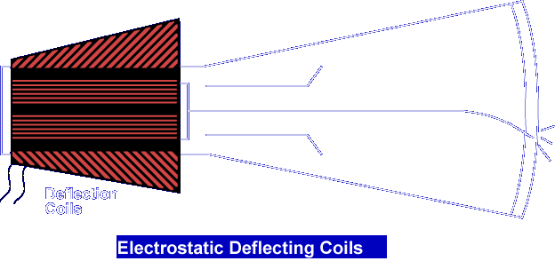

Electromagnetic CRTs use deflecting coils placed on the neck of the CRT. Let's talk about the different parts of the CRT and how they work together.

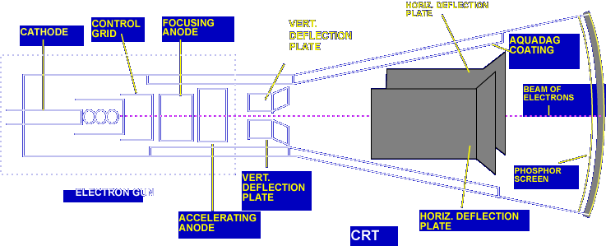

Electron Gun
The electron gun introduces, accelerates, and focuses free electrons into a narrow beam. The essential parts of the electron gun are the cathode, control grid, focusing anode, and accelerating anode. The cathode is the element that supplies the electrons for CRT operation. The electrons are attracted toward the focusing and accelerating anodes because the anodes are connected to very high positive voltage. The control grid forms the emitted electrons into a beam and provides a means of controlling the number of electrons in the beam. The closed end of the grid has a hole through which electrons must pass.

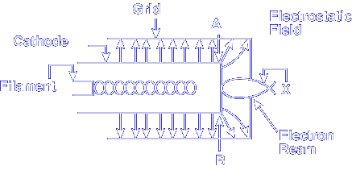

When the grid is made negative with respect to the cathode, an electrostatic field develops around the grid which forces electrons toward the opening in the end of the cylindrical grid. The electrons follow a curved path when they leave the control grid. Notice, the beams cross at point X. By changing the size of the electrostatic field, you can control where the beam will cross. By controlling this point, you can change the intensity of the display.

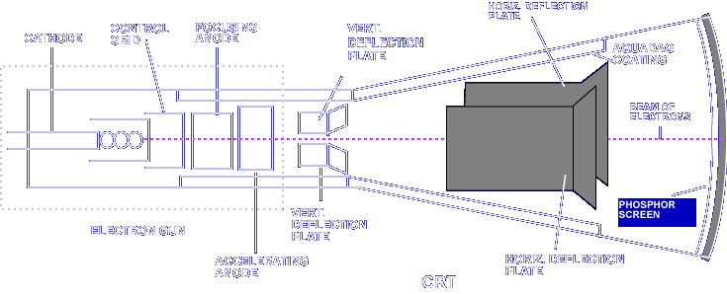

After converging at point X, the electrons in the beam begin to repel each other and start to spread out in different directions as they travel towards the screen.

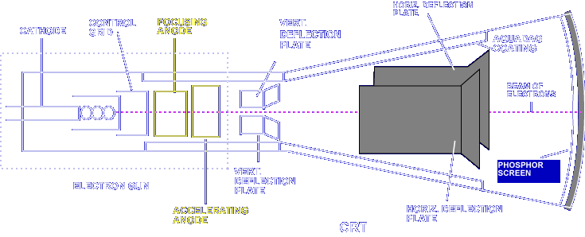

To re-converge and accelerate the beam of electrons, focusing and accelerating anodes are placed in the path of the beam. These two anodes are made positive with respect to the grid, with the accelerating anode being the most positive. The two anodes work together to make the beam electrons converge at a point on the screen known as the focal point. The voltage on the focusing anode controls this point of convergence. When the electrons converge at just the right point, the image on the screen appears sharp or "in focus".

Which component supplies the electrons for the electron beam?

Cathode

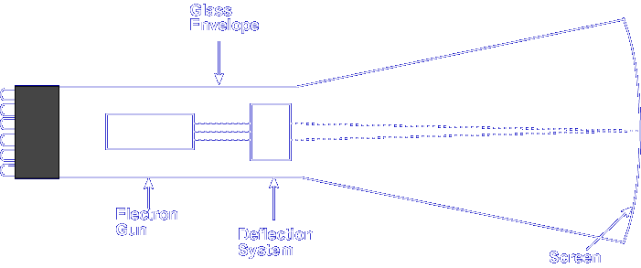

Screen
This is the section of the CRT that displays the image. The inside of the tube face (the screen) is coated with a material that emits light when struck by a stream of high velocity electrons. This emission of light is known as fluorescence. The amount of light emitted by a particular screen depends on the velocity and the number of beam electrons.

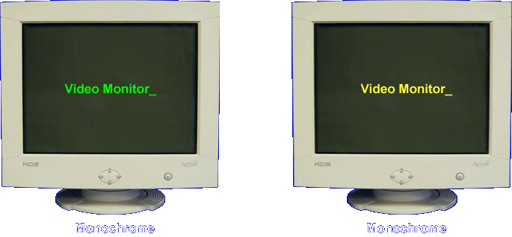

CRTs used in test equipment, some computer displays, and radar typically have screens that illuminate white, green, or amber. These types of screens are called monochrome because the image can appear in only one color.

Some CRTs contain specially coated screens to provide images in full color such as those used in color TV sets and video games.

What term is used to describe screens that produce only one color?

Monochrome

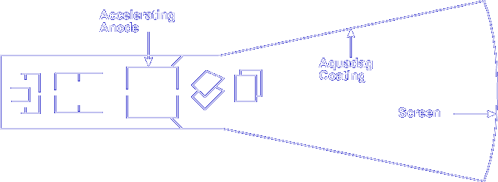

Aquadag Coating
Just like the tetrode, the CRT has to worry about the problem of secondary emission. The Aquadag coating is a thin conductive (graphite) coating on the inside wall of the tube. Connecting the Aquadag coating to a high positive potential will collect secondary electrons that are "splashed" out from the screen from the electron beam and return them to the power supply. If the secondary electrons were not collected, the screen would become highly negative and interfere with proper tube operation. In some tubes, the Aquadag is connected to the accelerating anode.

The Aquadag coating returns the secondary electrons to the _______

Power supply

Beam Deflection
The purpose of the deflection system of a CRT is to accurately move the electron beam to any part of the screen. This is done by controlling the horizontal and vertical movement of the beam. Let's look at the electrostatic and electromagnetic beam deflection techniques.

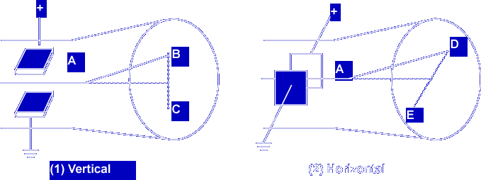

Electrostatic CRT
The electrostatic deflection system uses two pairs of metallic plates arranged so that the beam passes between each pair. One pair deflects the beam vertically while the other pair deflects the beam horizontally. Varying the voltage on the vertical and horizontal deflection plates moves the beam to different points on the screen.

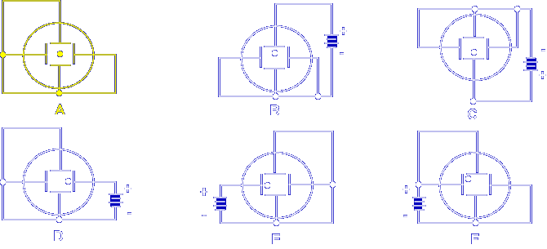

With all plates at the same potential, there is no field to act on the beam, so the beam arrives at the center of the screen.

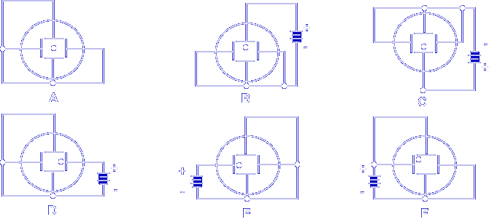

When a positive potential is applied to one or more of the plates the electron beam moves towards the plate, or plates, that have the positive voltage applied to it. The greater the voltage applied, the farther away from the center the beam moves. This method of beam positioning can very accurately position the electron beam on the screen.

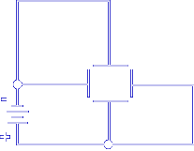

Which screen represents the screen of a CRT with the following potentials on the deflection plates?

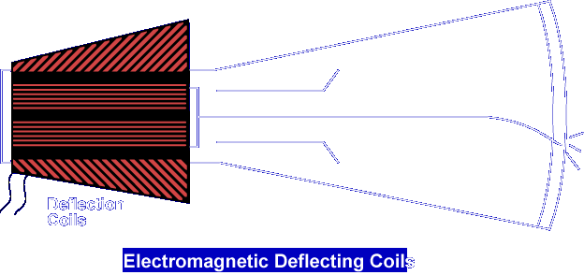

Electromagnetic CRT
Instead of using a set of internally mounted deflection plates, this type of CRT uses a set of deflection coils which are positioned on the outside neck of the tube. There are two sets of deflection coils. One set controls the vertical deflection and the second set controls the horizontal deflection.

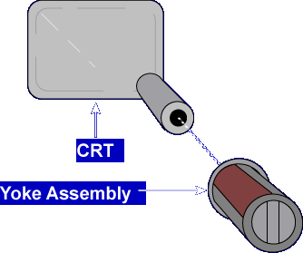

The coils comprise an assembly which is called a yoke. The yoke is placed on the neck of the tube.

The magnetic fields of the coils, caused by current flowing through the coils, deflect the beam.

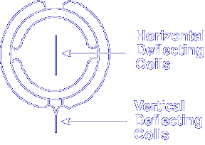

Two of the coils are wired in series and produce a magnetic field with lines of force that run vertically through the neck of the tube. This vertical magnetic field causes horizontal deflection of the beam. The other pair of coils are wired in series and mounted to produce a magnetic field with lines of force that run horizontally through the neck of the tube. This horizontal magnetic field causes vertical deflection of the beam.

The set of coils which produces a vertical magnetic field is used to deflect the beam ________

Horizontally

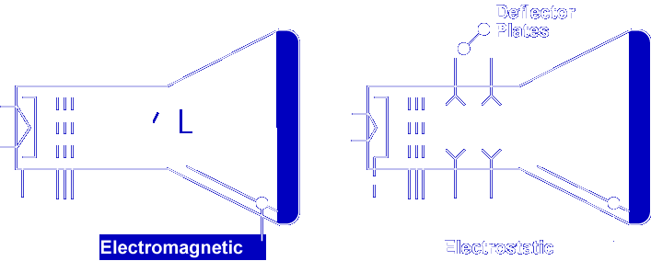

CRT Schematic Symbols
The last thing that we will cover is the schematic symbol for both types of CRT deflection configurations. Notice the difference between the two schematics. The electrostatic CRT schematic symbol has the deflector plates on the symbol whereas the electromagnetic doesn't.

This completes the information on ELECTRON TUBE APPLICATIONS.

