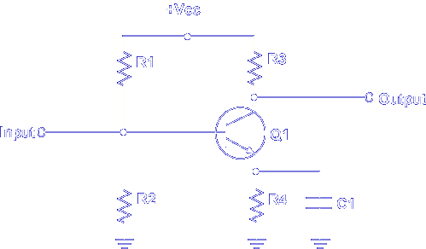

This is a typical common emitter amplifier circuit. For this discussion, an NPN transistor is used. Note that Vcc is positive.

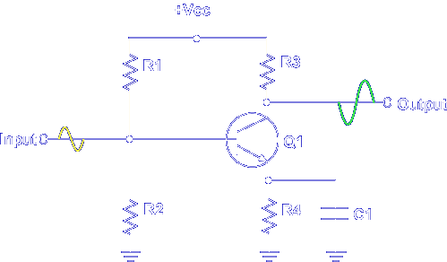

The amplifier's output is controlled by a small input signal. The output signal is an amplified and inverted replica of the input signal.

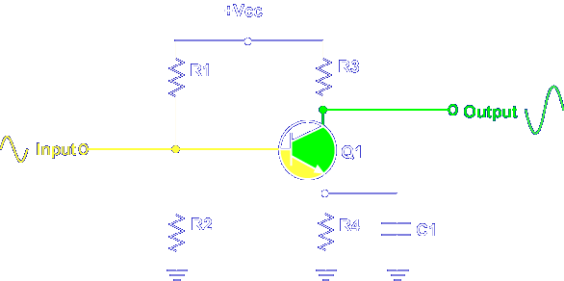

The amplifier has two basic circuits:
1. Input - Base to Emitter
2. Output - Emitter to Collector

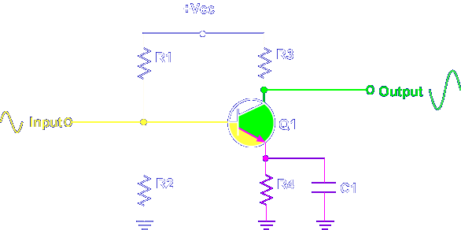

Note the emitter is common to both circuits. This means that a change in one circuit affects the other circuit.

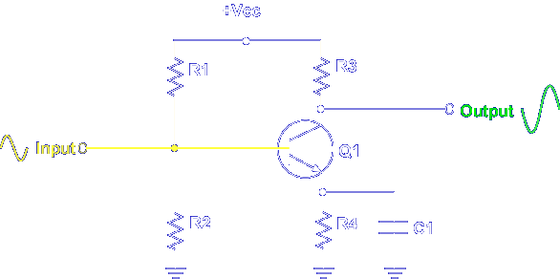

A changing input signal changes the bias voltage on the base of the transistor. When the input signal increases, the bias voltage increases.

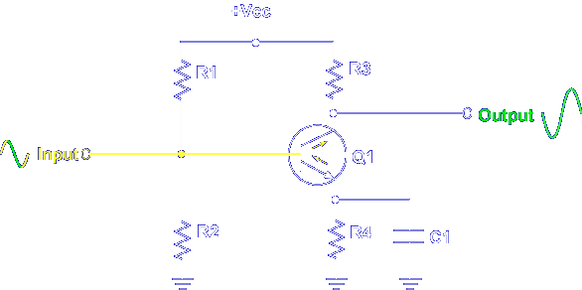

An increase in bias voltage affects current flow in the emitter collector circuit. Current then increases. When the input signal decreases, the bias voltage decreases.

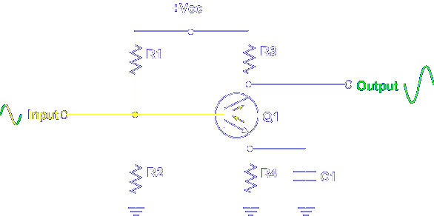

A decrease in bias voltage affects current flow in the emitter collector circuit. Current then decreases.

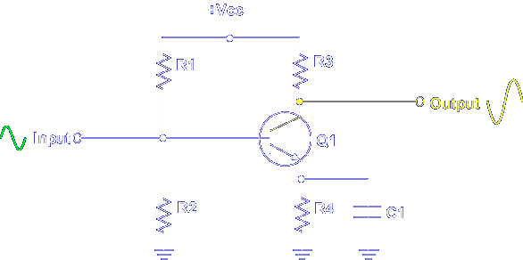

The effects of a changing input signal are seen in a changing output signal.

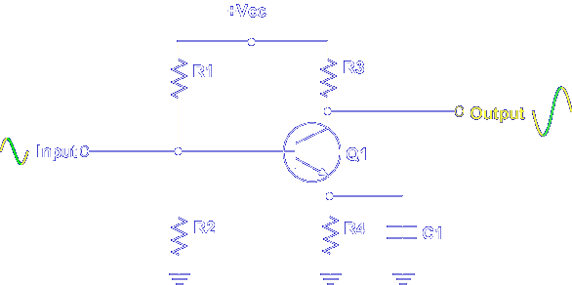

Note an increasing input signal produces a decreasing output signal.

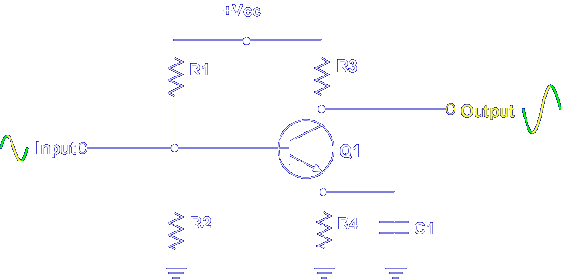

A decreasing input signal produces an increasing output signal.

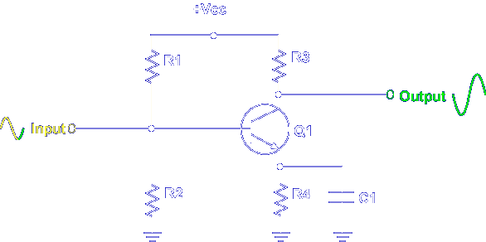

A small input signal controls a large output signal.

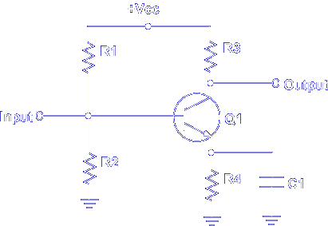

In a common emitter amplifier, when the base voltage increases, the emitter current _______

Increases

In a common emitter amplifier, when emitter current increases, the collector current _______

Increases

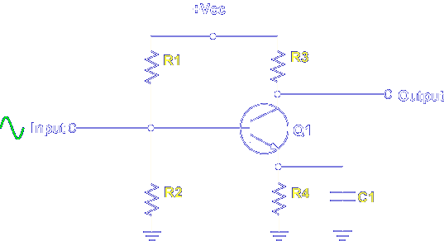

Transistor bias is determined by R1, R2, R3, R4, and C1.

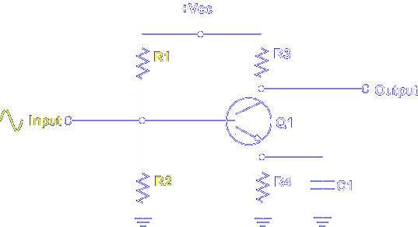

When an input signal is applied to the base of Q1, it's combined with the fixed bias voltage established by R1 and R2.

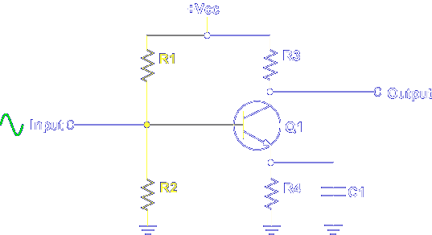

R1 and R2 form a voltage divider that is operated by +Vcc. A fixed bias is always present on the base of Q1. Any change in the fixed bias of Q1 produces a predicted change at the output.

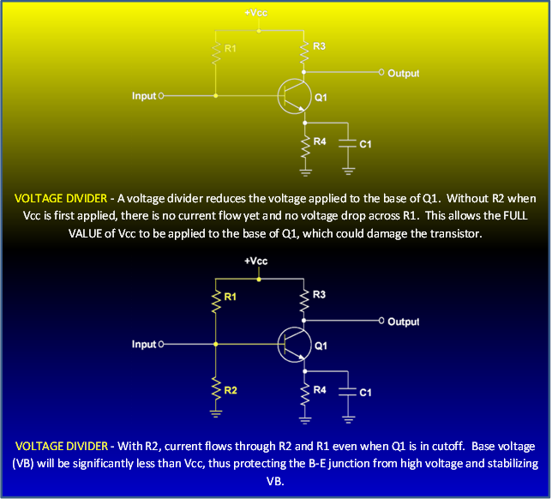

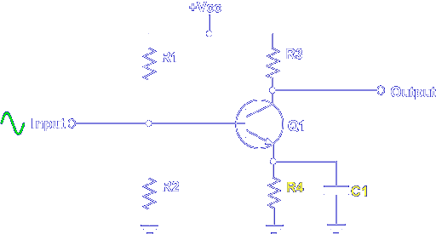

Resistor R4 and bypass capacitor C1 provide self-biasing or stability for the circuit. Normal operation of the amplifier produces heat. Heat causes an unpredictable change at the output. R4 provides temperature stability by decreasing emitter current when current increases due to heat.

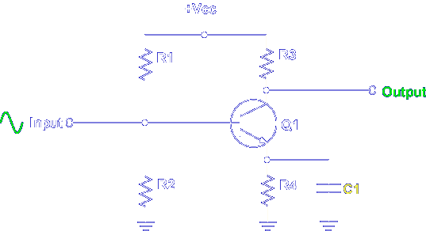

C1 provides a path for any unwanted AC that is produced. This ensures that the output signal is not affected.

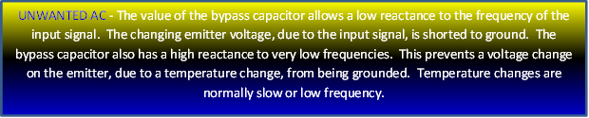

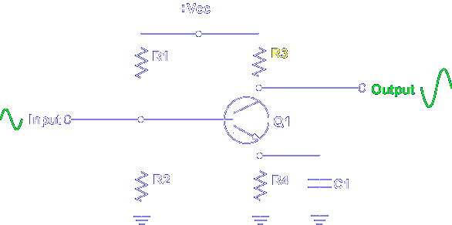

The output signal is determined by collector load resistor R3. When the emitter-to-collector current increases, more voltage drops across R3, and the output signal decreases. When current decreases, less voltage is dropped across R3, and the output signal increases. The result is a signal on the output that is a replica of the input signal, except for being amplified and inverted.

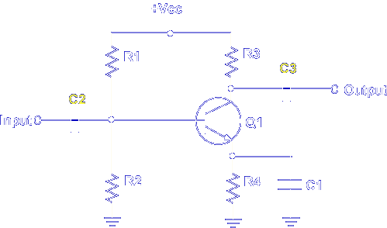

Now, let's add two important components to the amplifier circuit, C2 and C3. C2 is an input coupling capacitor that prevents any DC component of the input from reaching the base of the transistor. C3 is an output coupling capacitor that prevents the DC bias on the collector from reaching the output. The coupling capacitors do not affect the bias voltages on Q1.

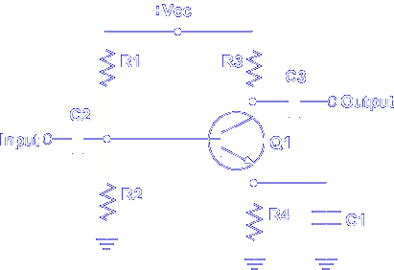

Select the component (s) that establishes the base bias.

R1 & R2

Select the component that develops the output signal and reverse biases the collector to base PN junction.

R3

Select the output coupling capacitor.

C3

This completes the information on COMMON EMITTER AMPLIFIER.

