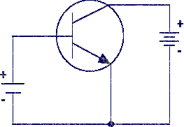
The level, and type of biasing used, affects transistor operation.
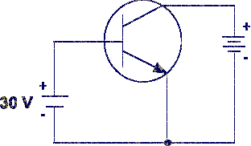
Too much positive bias on the base of an NPN transistor causes the transistor to lose its amplifying ability.
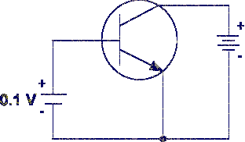
Too little positive bias on the base of an NPN transistor causes the transistor to stop conducting current.
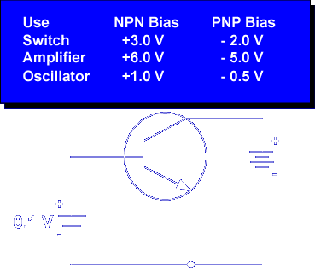

The actual bias voltage depends on the transistor and how the transistor is used in the circuit. Understanding the effects of different bias voltages on transistor operation is fundamental to the study of the various transistor circuits.

Let's begin the lesson on TRANSISTOR OPERATION.

