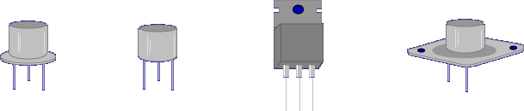

There are very few circuits that do not use transistors.

Transistors are used as:
- Amplifiers
- Oscillators
- Electronic switches

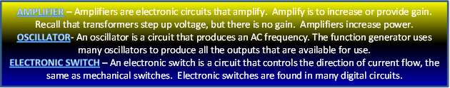

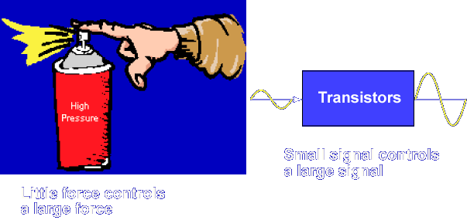

The purpose of a transistor is to control signals. Transistors control a large signal with a small signal.

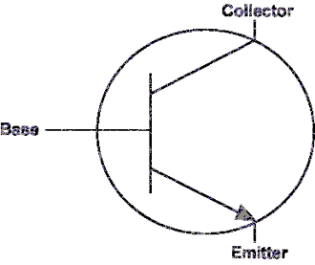

The word TRANSITOR is derived from the words. TRANSfer and resISTOR. These two words best describe transistor operation.
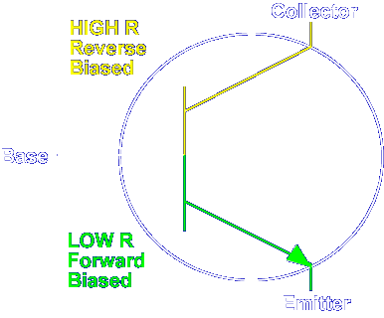

A transistor transfers its internal resistance from a low resistance (LOW R) in the emitter-base circuit to a much higher resistance (HIGH R) in the collector-base circuit.

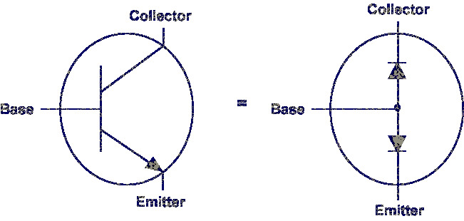

We can view the internal make-up of a transistor as two diodes placed back to back.

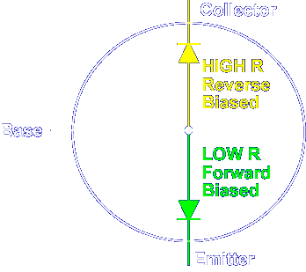

If we remember our diode theory correctly, a forward biased diode has a lower resistance than a reverse biased diode.

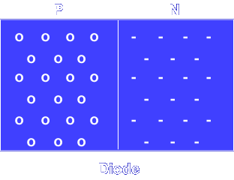

Transistors are solid state devices constructed from N type and P type materials just like diodes.

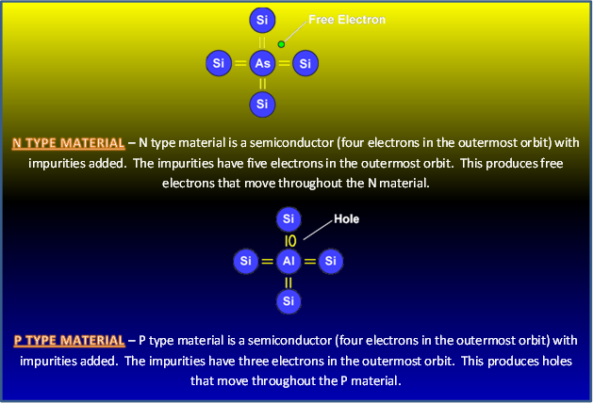

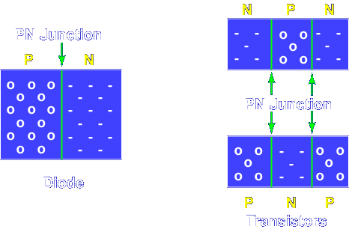

Unlike diodes, transistors have three elements with two PN junctions. The arrangements of the elements determine the type of transistor.

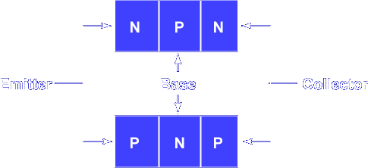

Each element is named and performs a specific function. Each element is either N or P type material.

The EMITTER is heavily doped so it produces (emits) a large number of current carriers inside the semiconductor material.

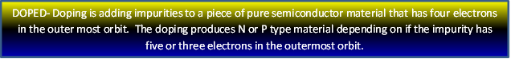

Current Carriers
Electrons in N type material
Holes in P type material

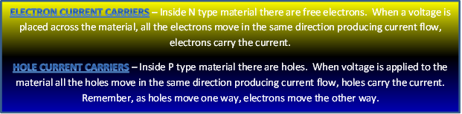

The BASE is very thin and lightly doped. Its construction allows most of the current carriers to pass from the emitter to the collector. The COLLECTOR is moderately doped. It collects the current carriers from the base. The collector is the largest of the 3 areas because it has to dissipate most of the heat generated.

What type of current carriers are P type materials?

Holes

Which element in a transistor is used to produce a large number of current carriers?

Emitter

Which element in a transistor is used to pass most of the current carriers?

Base

The schematic symbol for a transistor is the emitter and collector connected to the base, with an arrow on the emitter. The direction of the arrow on the emitter indicates a NPN or PNP transistor. If the arrow points IN, the transistor is PNP. If the arrow points OUT, the transistor is NPN. The reference designation for transistors is the letter Q.

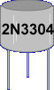

Transistors are marked with identification numbers. The 2 indicates a transistor (two PN junctions). The N indicates a solid state component. The last digits identify the type of transistor.

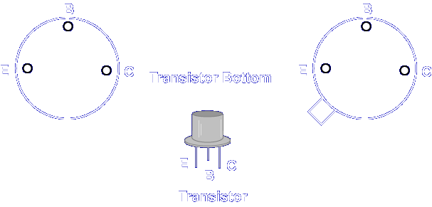

Identifying the leads on a transistor is very simple. Most transistors’ leads are arranged in a semicircle. The base lead is in the middle. The emitter is on the left or next to a tab when the semicircle is up. The collector is on the right when the semicircle is up.

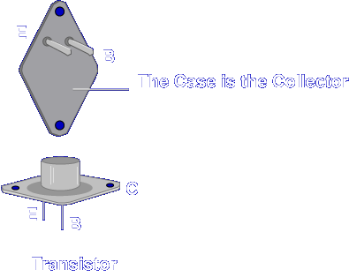

Power transistors are different. The collector is connected to the metal case of the transistor.

This completes the information on THE TRANSISTOR.

