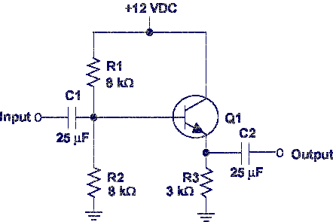
The class of operation and the voltage gain (Av) are needed to identify normal operation of a common collector.
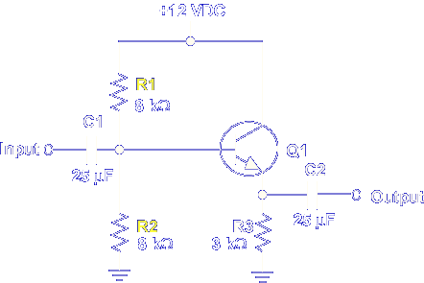
Class of operation is determined by the bias placed on the base of Q1 by R1 and R2.
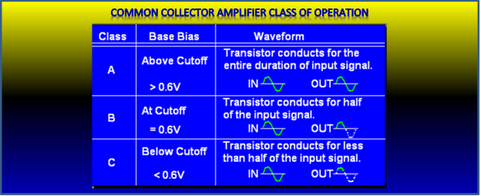

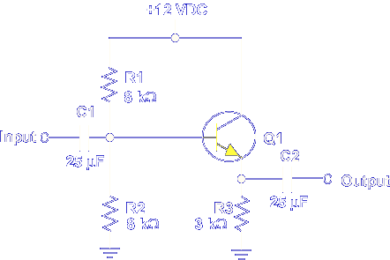
The voltage gain is determined by the base to emitter PN junction.
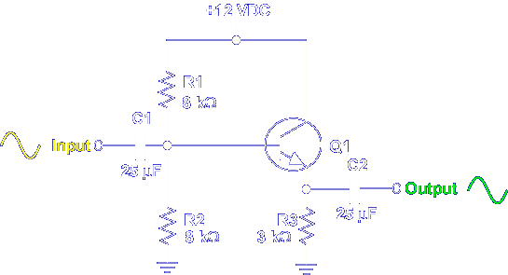

If class of operation and voltage gain are known, normal operation is determined by comparing input and output signals.

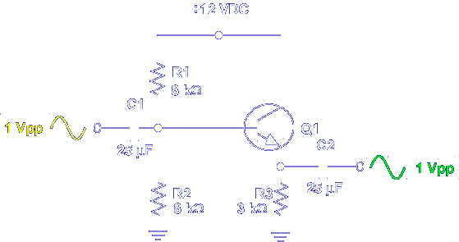

The voltage gain of a common collector amplifier is always 1. This class A common collector circuit shows normal operation.

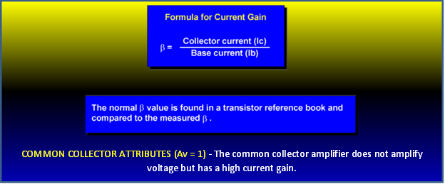

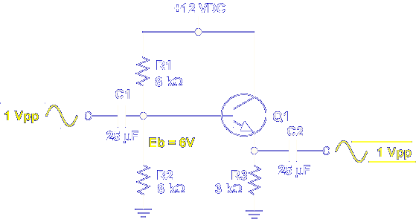

The 6 V bias at Q1 verifies class A. Dividing Eout by Ein verifies Av of 1.

$$Av=\frac{E_{out}}{E_{in}}=\frac{1}{1}=1$$

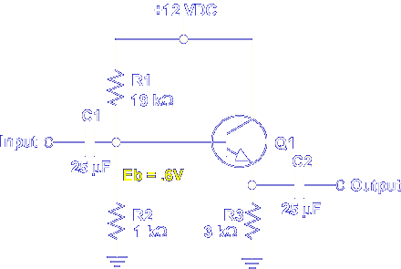

If the bias on Q1 is changed to 0.6 V, the class of operation becomes class B.

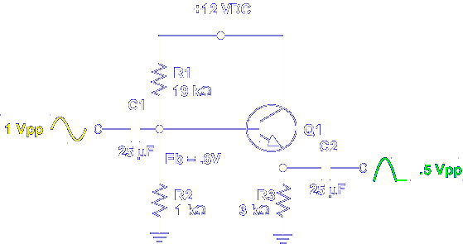

The input to output comparison shows normal operation for a class B common collector.

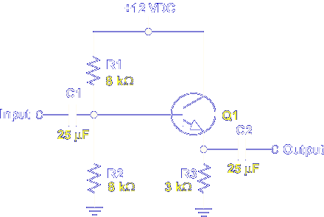

The actual component values determine the class of operation. The transistor sets the voltage gain at 1.

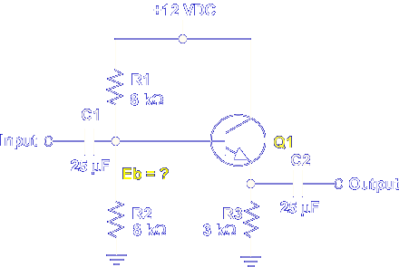

Let's calculate the base bias on Q1 to determine the class of operation.
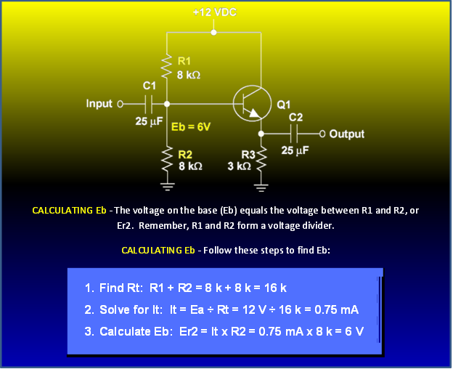

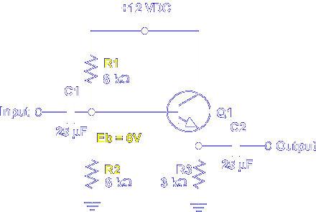

R1 and R2 form a voltage divider. The voltage felt between R1 and R2 is applied as Q1 bias voltage (Eb). Recall that 0.6 V is needed to forward bias the base to emitter PN junction. This common collector is biased to 6 V or above cutoff. This value indicates class A operation.

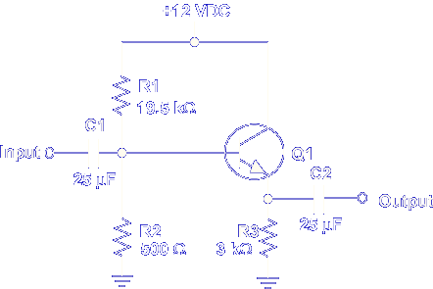

Determine the class of operation for this common collector circuit.

R_{t} = 19.5kΩ + 500Ω = 20kΩ
I_{t} = 12VDC/20kΩ = .6mA
E_{b} = E_{R2} = .6mA × 500Ω = .3V

Class C

Once the class of operation is determined, the gain (Av) is found by comparing the input and output signals. The actual gain of a common collector is determined by this formula:
$$Av= \frac{E_{out}}{E_{in}}$$

The expected gain is 1, and the formula verifies this value.

$$Av= \frac{E_{out}}{E_{in}}= \frac{1}{1}=1$$

Let's see why Av is 1 in a common collector amplifier.

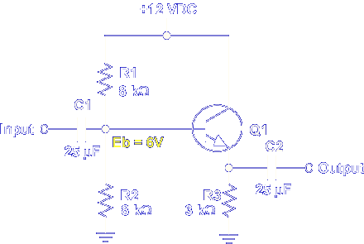

With no input, the voltage on the base is 6 V.

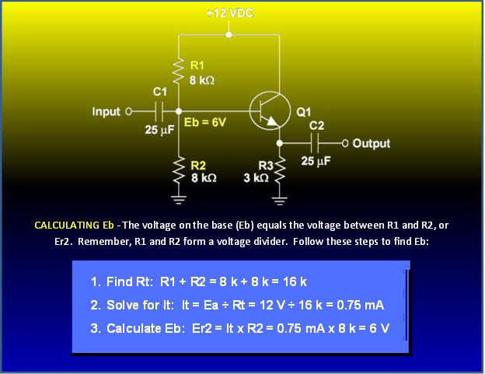

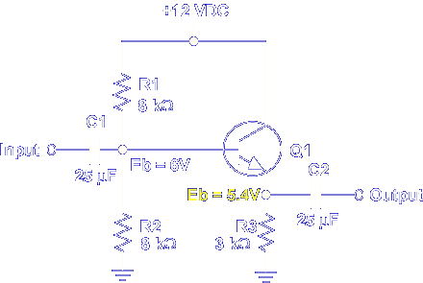

The voltage drop across the base to emitter PN junction is about 0.6 V. This places 5.4 V on the emitter.

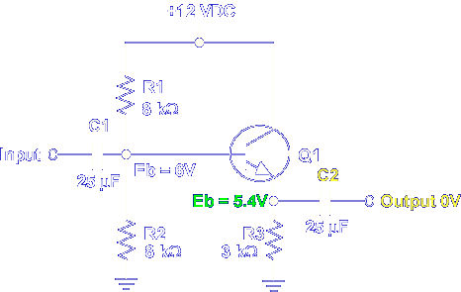

The 5.4 V on the emitter is DC which is blocked by C2. The output is 0 VDC.

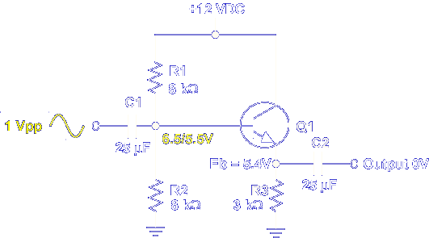

A 1 Vpp input changes the base voltage from 6 V to a range of 6.5 to 5.5 V.

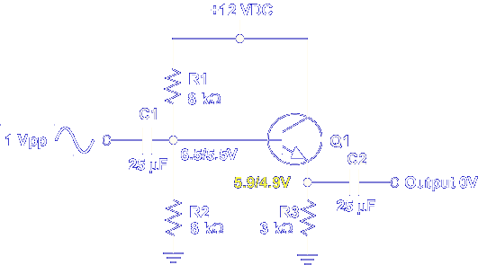

The emitter voltage changes from 5.4 V to a range of 5.9 to 4.9 V.

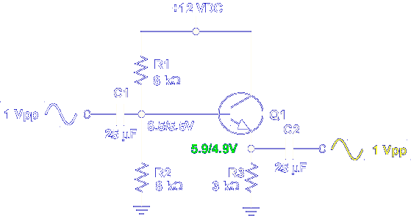

The changing emitter voltage passes through C2, producing a 1 Vpp output.

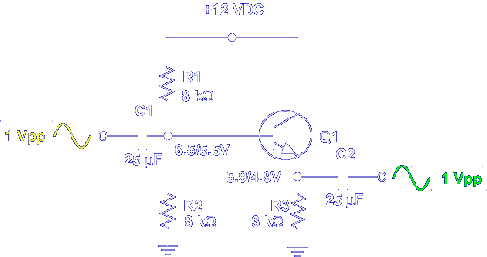

Remember, even though the voltage gain is 1, the AC current gain is large. Base current is small; emitter current is large.

This completes the information on COMMON COLLECTOR CIRCUIT VALUES.

