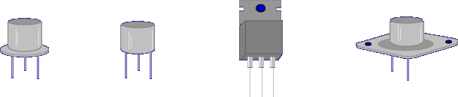
The transistor has revolutionized electronics.
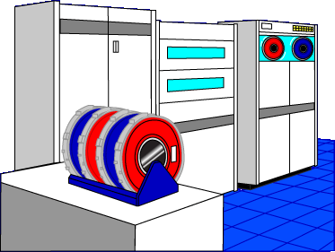
Before the transistor, the computer consisted of thousands of vacuum tubes, costing millions of dollars and filling a large room.
Due to the transistor, the very same computing capability now fits on a desk and costs much less.
Transistors are solid state devices constructed similar to diodes.
SOLID STATE DEVICE – A solid state device is an electronic component which operates by the movement of electrons within a solid piece of semiconductor material. Solid state devices replaced vacuum tubes.

Let’s begin the lesson on INTRODUCTION TO TRANSISTORS.

