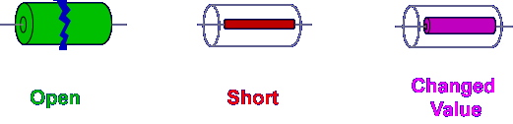
The three most common faults for junction diodes are open, short, or changed value. Let's look at each fault separately to identify its effect on circuit operation and determine how to isolate the fault.
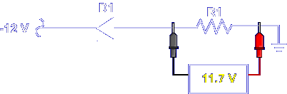

In normal operation, the forward biased diode permits current flow in the circuit as indicated by the voltage drop across R1.

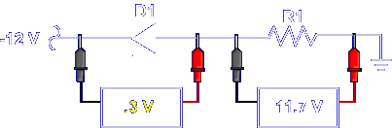

The voltage drop across the diode is very small, representing a knee voltage of 0.3 volts to 0.7 volts. Think of a forward biased diode as a closed switch producing practically no voltage drop.

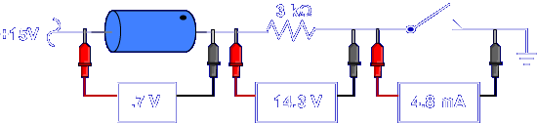

The voltmeters indicate normal voltage drops for a properly operating, forward biased diode circuit. Let’s go through the possible faults of circuits with junction diodes within them. Look at the change in circuit values.

Open Junction Diodes

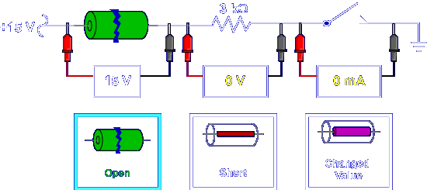

A circuit with an open diode will not operate. The open component interrupts current flow in the circuit. The open diode drops the entire applied voltage. An open diode is easily identified using voltage measurements.
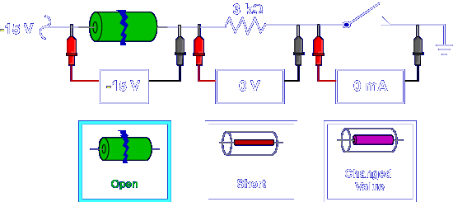
An open diode provides the same indications in a reverse biased circuit. Note, the voltage drops are negative.

Shorted Junction Diodes

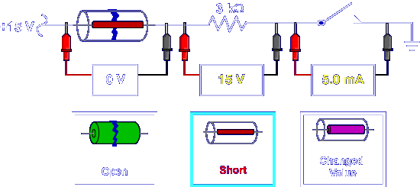

A shorted diode causes a slightly higher circuit current. Overall resistance of the circuit is decreased. No voltage is dropped across the shorted diode. A shorted diode is easily identified by voltage measurements.

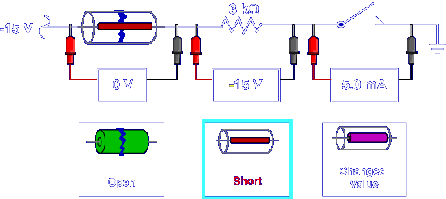

A short provides the same indications in a reverse biased circuit. Note the voltage drops are negative. Normally in a reverse biased circuit, the diode acts like an open switch.

Changed Value Junction Diodes

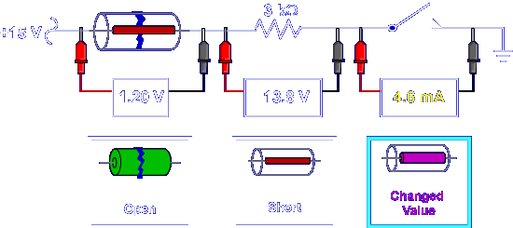

A changed value diode is the least common diode fault. Total current may change slightly. Detection of this fault probably will not occur until the component opens or shorts.

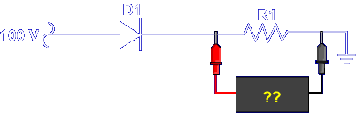

What is the voltage drop of R1 when D1 is open?

0 Volts

What is the voltage drop of R1 when D1 is shorted?

100 Volts

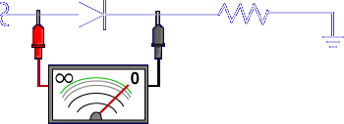

If voltage measurements indicate a faulty diode, remove power and check the diode with an analog ohmmeter set to the resistance range or use a digital multimeter with the diode test function.

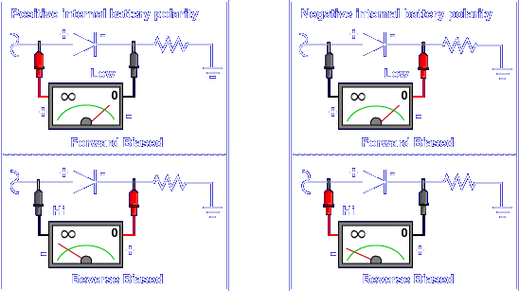

Resistance Checks Only
When making resistance measurements, check the meter's instruction manual to determine the polarity of the internal battery. The internal polarity of the meter will determine how you connect the test leads to forward or reverse bias the diode. Some multimeters may have an internal battery with a negative polarity. Throughout the rest of the lesson, we will discuss multimeters with a positive internal battery polarity. When you make resistance checks, the main objective is to measure a low resistance when forward biased and high resistance when reverse biased. Remember, this is only a concern when making resistance checks on diodes or other polarity-sensitive devices.

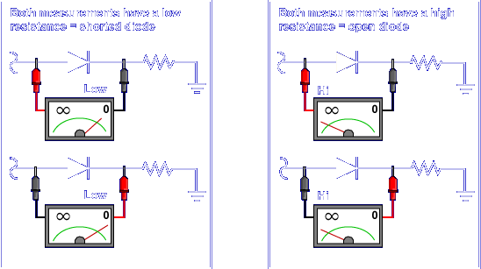

When using a meter with a negatively polarized internal battery, reverse the test leads and ensure a high and low resistance is measured for a good diode. If both readings have a high resistance, the diode is open. If both readings have a low resistance, the diode is shorted.

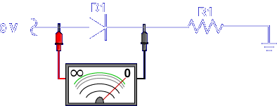

This ohmmeter indicates a normal reading for a good diode. Note the polarity of the test leads. A good diode has some resistance from the anode to the cathode, as the meter indicates. This is a normal forward resistance reading.

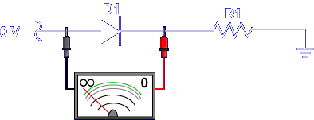

Reversing the test leads indicates high resistance between the cathode and the anode. This is a normal reverse resistance reading. Look at these faulted diodes. Observe the ohmmeter values for each fault.

Open Junction Diodes

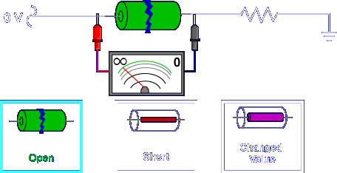

An open diode has infinite resistance. The connection between anode and cathode is broken.

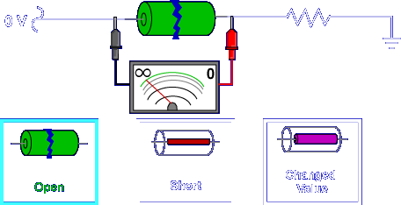

Reversing the leads will provide the same reading. An open diode is easily identified by resistance measurements.

Shorted Junction Diodes

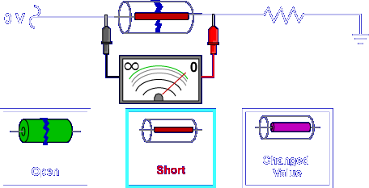

A shorted diode provides zero resistance in both directions. Checking from anode to cathode deflects the meter's needle.

Reversing the leads and checking from cathode to anode provides a similar reading.

Changed Value Junction Diodes

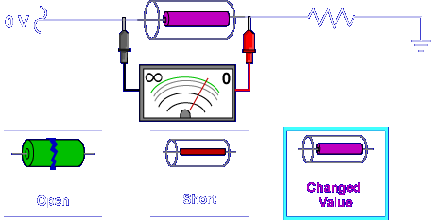

A changed value diode provides resistance readings very much like those of a good diode. Detection of this fault with an ohmmeter is not likely. Only after the component opens or shorts can the problem be detected.

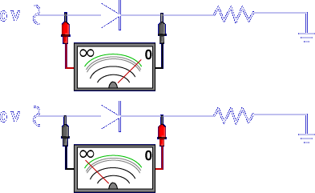

What type of fault is indicated by these two resistance readings?

No Fault

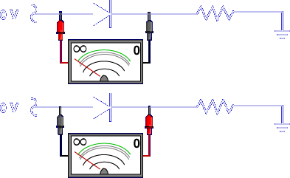

What type of fault is indicated by these two resistance readings?

Open

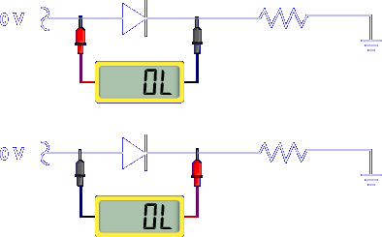

A digital multimeter set to read resistance will usually indicate an open condition even with a known good diode, as the meter does not produce enough voltage to forward bias the diode junction.

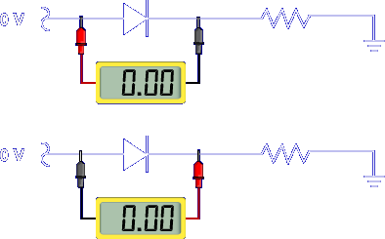

Digital multimeters will usually indicate a completely shorted diode but it's best to use the diode test function of the digital multimeter to be sure of the diode condition.
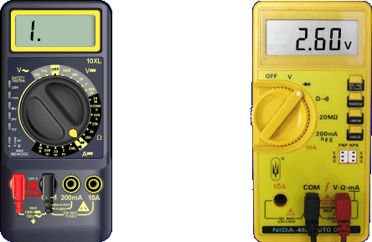

Digital multimeters include a diode test function for testing diode and transistor junctions. The multimeter increases the voltage at the leads when in the diode test mode so the diode junction can be biased. Digital multimeters differ in the way the display indicates the diode test function. Some display a resistance indication. Others display a voltage indication.

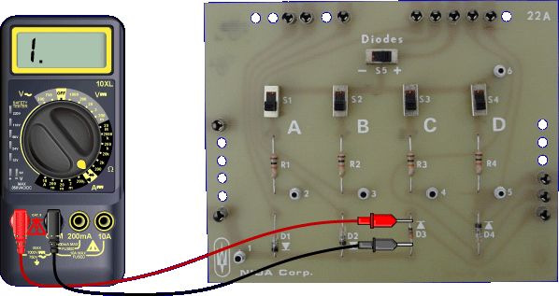

This multimeter performs the diode test using a resistance display. When reverse biased, the meter indicates infinite resistance.

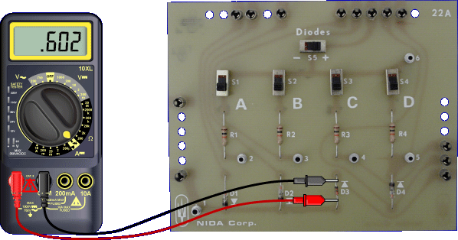

When the diode is forward biased, the meter indicates low resistance.

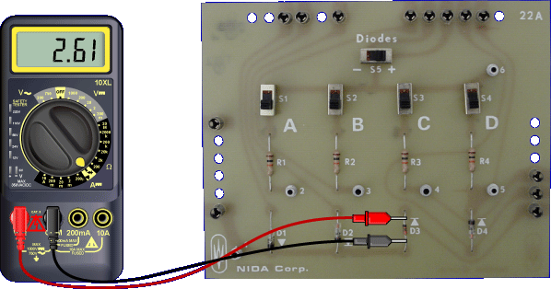

Meters displaying voltage for diode testing are actually indicating the voltage present at the meter leads.

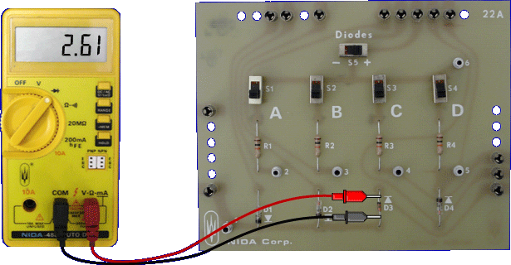

When the diode is reverse biased, the voltage displayed does not change from the static reading, as no current flows through the diode.

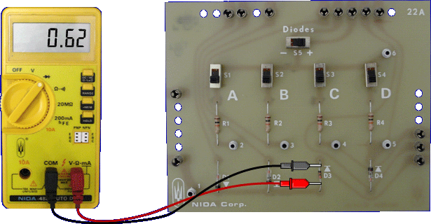

When the diode is forward biased, the voltage displayed is the actual voltage drop across the diode junction. This example shows a silicon diode. A forward biased germanium diode would have a different knee voltage.

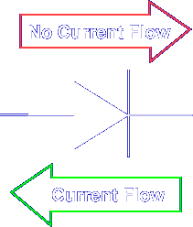

Remember, the basic operation of a diode will permit current flow in only one direction. Regardless of the type of meter used for testing, a diode should allow current flow when forward biased and no current flow when reverse biased.

This completes the information on JUNCTION DIODE FAULTS.

