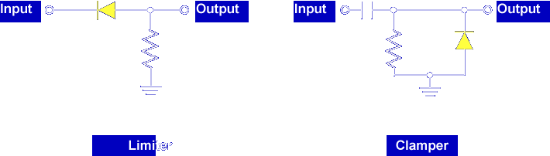

The most common fault in diode limiters and clampers is an open or shorted diode. However, the resistor in the limiter circuit and the resistor and capacitor in the clamper circuit cannot be ignored. For the circuit to operate, all components must be functioning correctly.

Let's look at the faults in a diode limiter circuit first.
Limiter Circuit

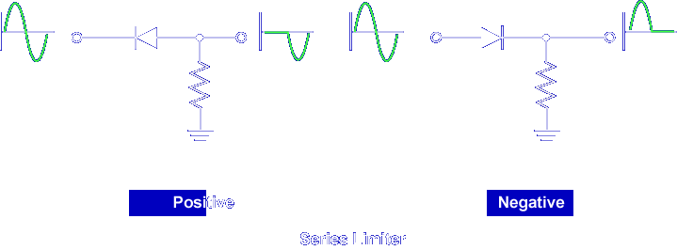

In a series diode limiter, the diode is in series with the output signal.
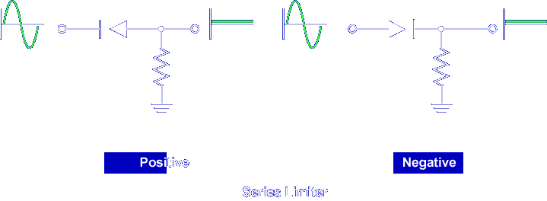
If the diode opens internally, there is no output signal.
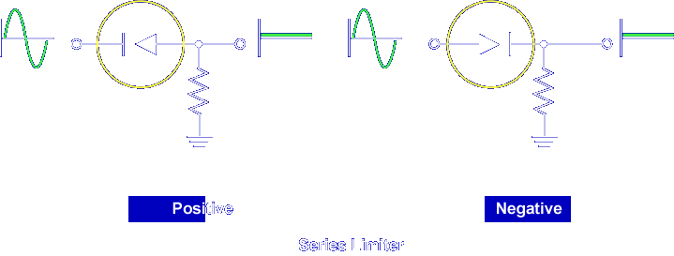

Current cannot flow through the open series diode even if it is forward biased.

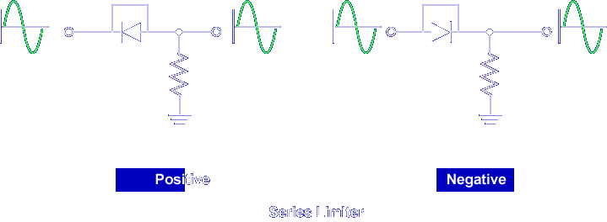

If the diode shorts internally, no limiting occurs. Current bypasses the diode. The diode is not effective in the circuit.

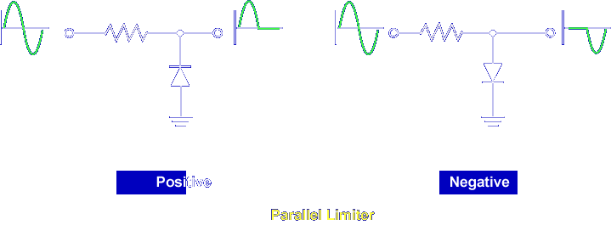

In a parallel diode limiter, the opposite happens. The diode is parallel to the output signal.

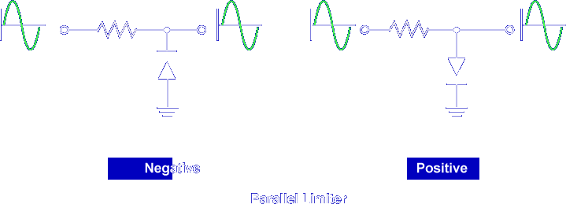

If the diode opens, no limiting occurs.

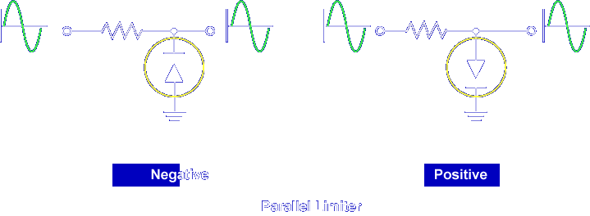

Current cannot flow through the diode to ground even if it is forward biased.

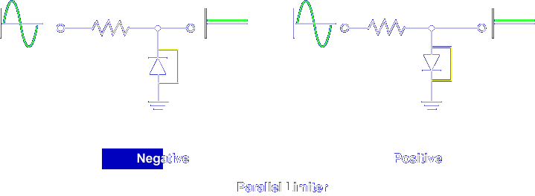

If the diode shorts, there is no output signal. The entire input signal is dropped across the resistor. The signal is grounded.

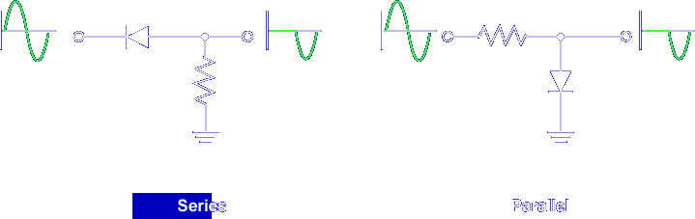

Opens and shorts in the resistor also affect the outputs of series or parallel limiters.

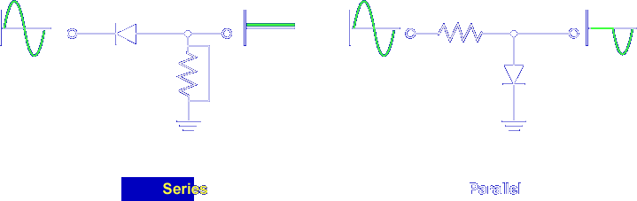

In a series limiter, a shorted resistor grounds the output signal.

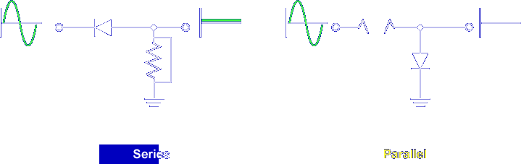

In a parallel limiter, an open resistor blocks current and there is no output.

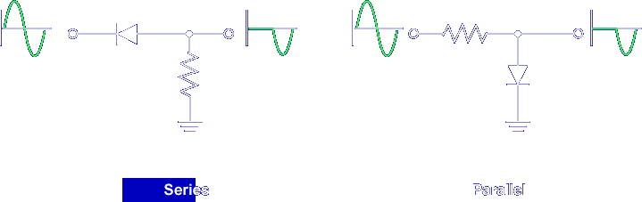

Reversing the faults, that is, opening the resistor in a series limiter and shorting the resistor in a parallel limiter, has little effect on the output.

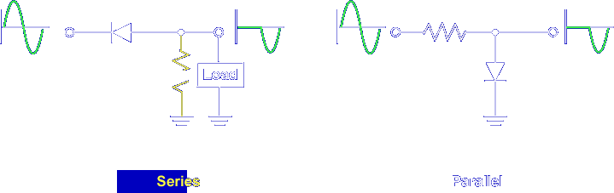

An open resistor in a series limiter still produces an output if a load is attached. If there is no load, no signal is developed. Note, placing an oscilloscope on the output supplies a load and the correct output is observed.

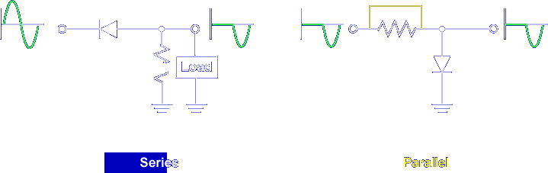

A shorted resistor in a parallel limiter also produces an output. Note, the input signal is also limited. The input and output are the same point in the circuit.

Adding positive or negative bias does not change the effect of the common faults in limiter circuits. However, the DC bias level is felt on the output.

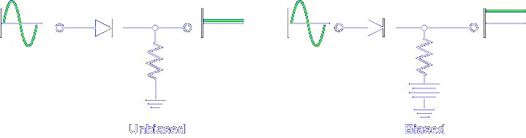

For example, the open diode in the biased limiter causes a DC level on the output.

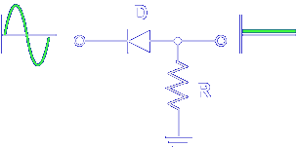

What type of fault produces no output (0 V) in a series limiter circuit?

Open D or Shorted R

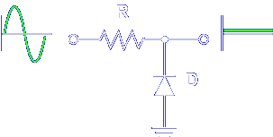

What type of fault produces no output (0 V) in a parallel limiter circuit?

Open R or Shorted D

Now, let's look at faults in diode clamper circuits.
Clamper Circuit

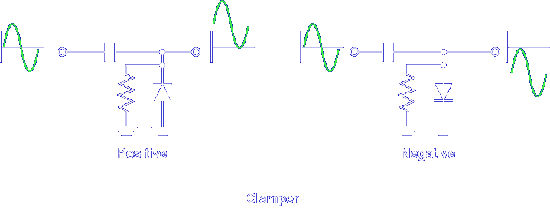

In a positive or negative clamper, the diode is in parallel with the output.

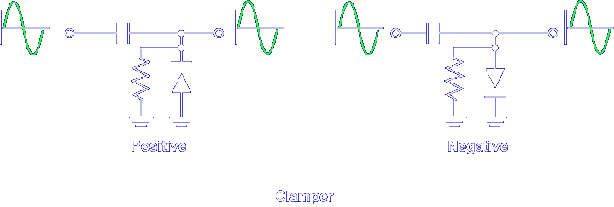

If the diode opens internally, there is no clamping.

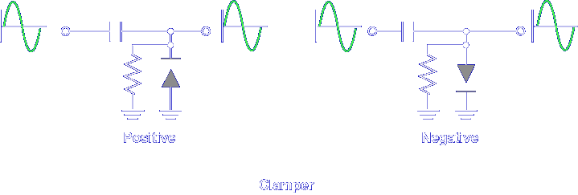

The circuit reduces to an RC voltage divider.

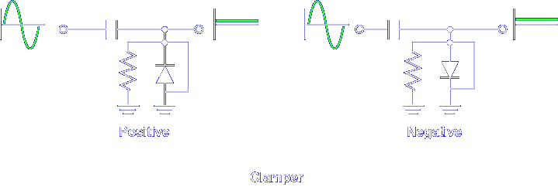

If the diode shorts internally, there is no output. The output signal is grounded.

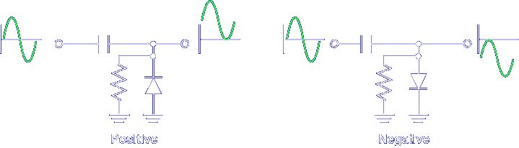

Opens and shorts in the resistor and capacitor will also affect the outputs of positive or negative clampers.

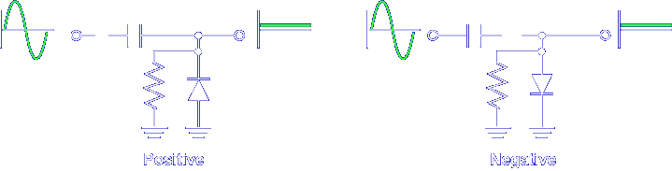

An open capacitor causes no output signal. The open prevents current flow to the output.

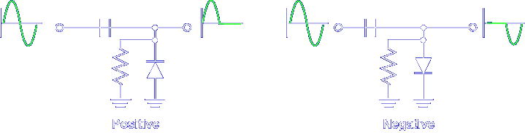

A shorted capacitor eliminates clamping.

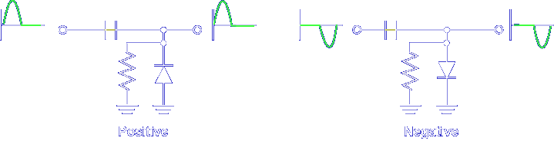

The circuit reduces to a parallel limiter. The clamping action of the capacitor is gone and no longer provides isolation between the circuits, thus affecting the input signal as well as the output signal.

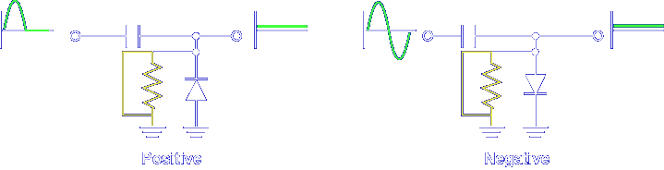

A shorted resistor causes no output signal. It's just like a shorted diode: the output signal is shorted to ground.

Adding positive or negative bias does not change the effect of the common faults in clamper circuits. However, the DC bias level may be felt on the output.

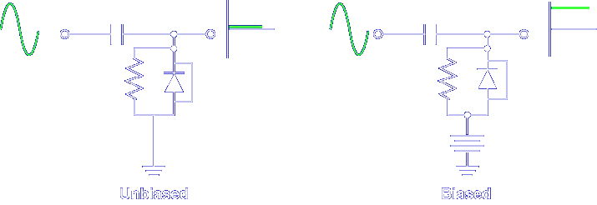

For example, the shorted diode in the biased clamper causes a DC level on the output.

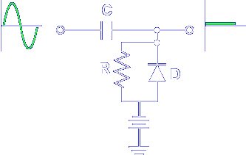

What type of fault produces no signal output in a clamper circuit?

Open C, Shorted R or D

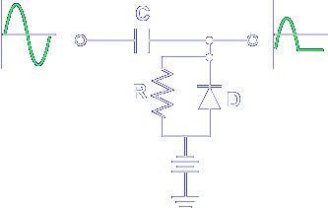

What type of fault produces a limited output signal in a clamper circuit?

Shorted C

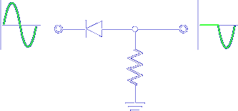

As you have seen, opens and shorts cause changes in the output waveform in limiters and clampers.

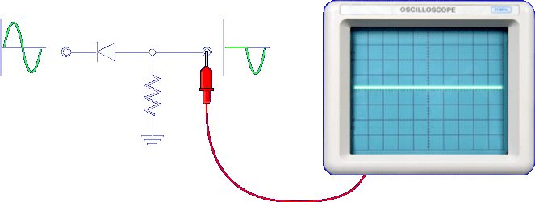

Therefore, waveform measurements made with an oscilloscope will quickly determine if a limiter or clamper circuit is operating normally.

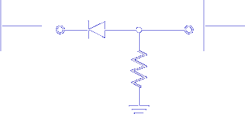

If the waveform measurements are incorrect, resistance measurements are used to determine the fault.

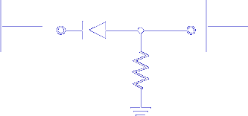

Any open is identified by an infinity reading on the multimeter.

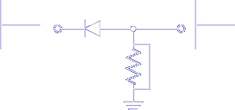

Any short is identified by a 0 Ω reading on the multimeter.

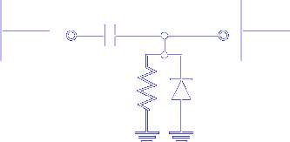

Note, an open capacitor and a good capacitor will measure infinity.

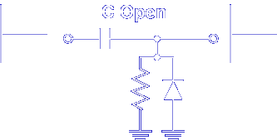

Measuring no short across the resistor or the diode proves that the capacitor is open. Remember, waveform measurements will quickly determine if a limiter or clamper circuit is operating normally. Resistance measurements are used to determine the fault.

This completes the information on LIMITER AND CLAMPER FAULTS.

