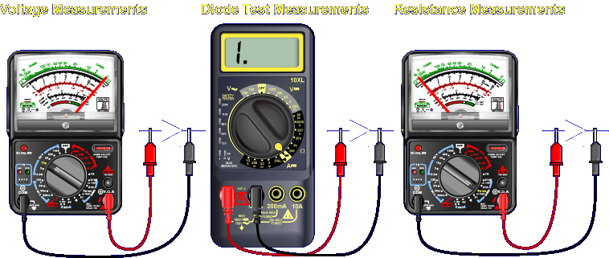

Identifying a faulted diode may require voltage, resistance, or diode test measurements. Voltage measurements can identify a faulty diode only when power is applied to the circuit. Resistance measurements and diode tests can identify a faulty diode only when power is not applied to the circuit.
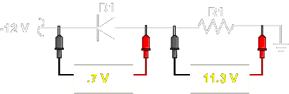
VOLTAGE MEASUREMENTS - Voltage measurements are used to check the voltage drops of components. The voltage drop across a diode is very small, representing a knee voltage of 0.3 volts to 0.7 volts.
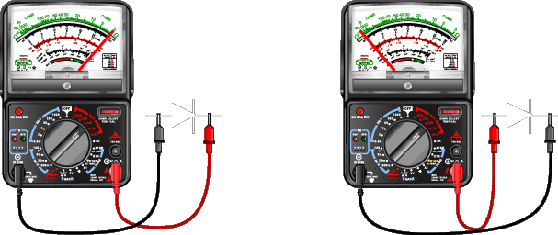
RESISTANCE MEASUREMENTS - Resistance measurements on diodes check forward and reverse resistance. Forward resistance is low with a normal range of 20 Ω to 1 kΩ. Reverse resistance is very high and normally reads near infinity.
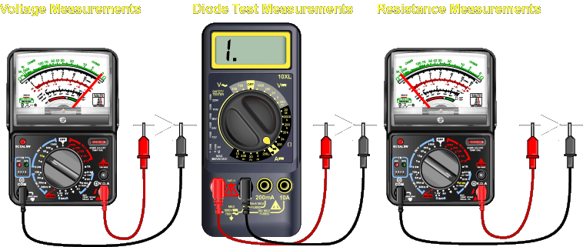
DIODE TEST - Digital multimeters do not normally have enough voltage in the resistance ranges to forward bias the junction of a diode, which is necessary for diode testing. Most digital multimeters have a special setting to handle this function.

