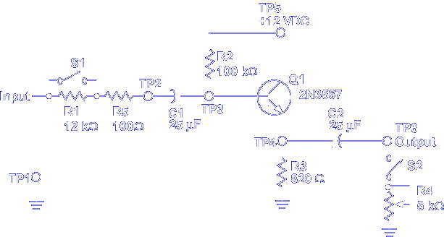

This lesson teaches the common collector amplifier circuit.

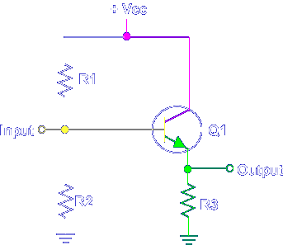

This is a Common Collector because the input is applied to the base, the output is taken from the emitter, and the collector is common.

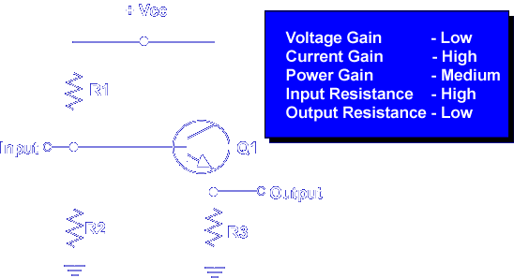

The common collector amplifier matches a high input resistance source to a low output resistance load. Also, the common collector amplifier is used as a current source due to the high current gain. Let's begin the lesson on COMMON COLLECTOR AMPLIFIER.

