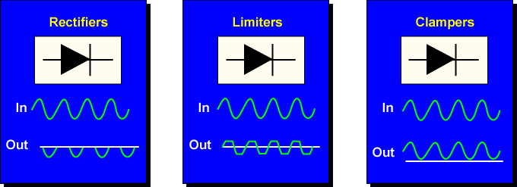
Junction diodes are used in many different circuit applications. The rectifier, limiter, and clamper are just a few. Identifying normal operation of a basic diode is the first step in circuit analysis.
This experiment demonstrates the operation of junction diodes. You will apply forward and reverse biasing to diodes and measure circuit values to verify normal operation.
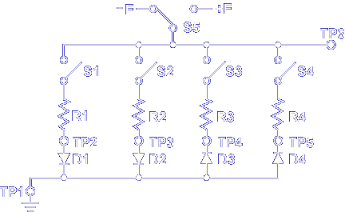

Pick up the PC130-22A card. The purpose of this card is to demonstrate the operation of junction diodes. Diodes D1, D2, and D4 are germanium diodes. Diode D3 is a silicon diode. Switches S1 through S4 place the diodes into the circuit.
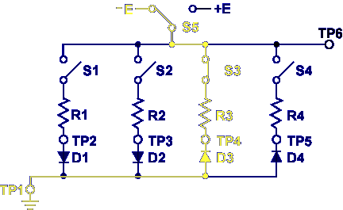

For example, closing S3 places R3 and D3 into the circuit.
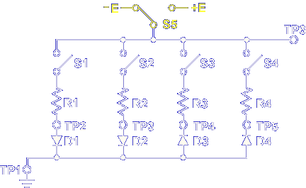

Switch S5 selects positive or negative biasing. Let's begin the experiment.
- Set the test console controls to the initial control settings.
- Press enter to set: Positive Supply Voltage -12
Negative Supply Voltage -12
- Carefully insert PC130-22A into the test console PC1 position.
- Set S1 through S4 down on PC 130-22A
- Set S5 to + (positive) on PC130-22A
- Press enter to set : PC1 DC Power Switch – ON
- Measure the voltage from TP6 to TP1.
What is the voltage measured?
12.28 Volts
The circuit is now set up correctly. Let’s verify the operation of a diode. Look at circuit C.
With S3 closed and +12 volts applied, is D3 forward or reverse biased?
Reverse
Select the forward Biased diode in this circuit.
D2
Now let’s verify D4 is reverse biased. Remember if the diode is reverse biased, no current should flow. The diode should appear as an open.
- Set S4 to UP on PC130-22A
- Measure the voltage drop across R4.
What is the voltage drop on R4?
Should have measured 0V….measured .04V
- Measure the voltage drop across D4.
What is the voltage drop across D4?
12.22V

Note, your measured values prove that a reverse biased diode permits no current to flow.

