In this lesson, you will learn about diode limiters. Limiting is one circuit application for a diode. Limiters are so named because they alter the shape of waveforms by limiting part of the input waveform. They are useful, simple circuits, consisting of a diode and a resistor.
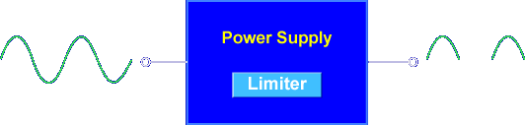

Limiters are used in power supplies to change AC to pulsing DC.

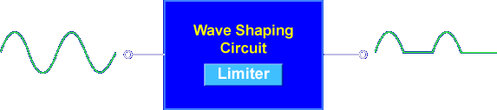

Limiters are used in wave shaping circuits to change the shape of signals.
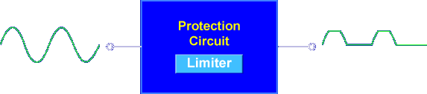

Limiters are used in protection circuits to limit the size of signals.

Let's begin the lesson on DIODE LIMITER OPERATION.

