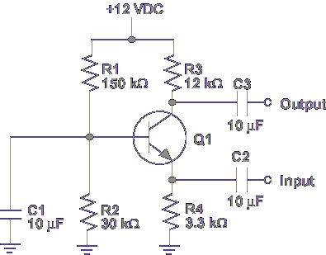
The class of operation and the voltage gain (Av) are needed to identify normal operation of a common base amplifier.
Class of operation is determined by the bias placed on the base of Q1 by R1 and R2.
The gain is determined by emitter resistor R4 and collector resistor R3.

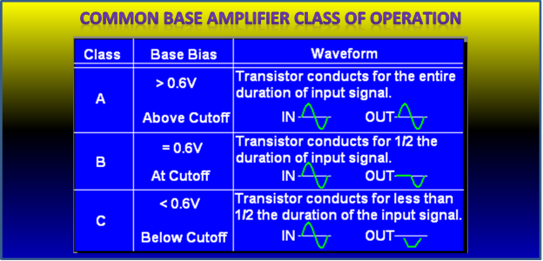

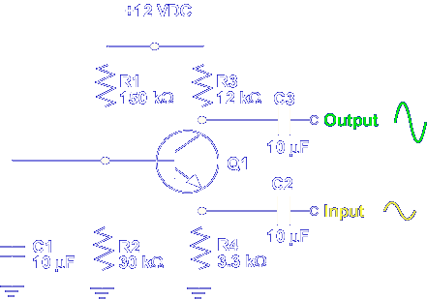

If class of operation and voltage gain are known, comparison of input to output signals determines if the amplifier is operating normally. Common base amplifiers are normally biased class A for good fidelity with low distortion.

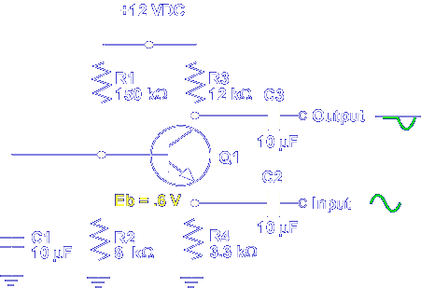

For example, a class B operation requires 0.6 V on the base. Transistor conducts for 1/2 the duration of input signal.

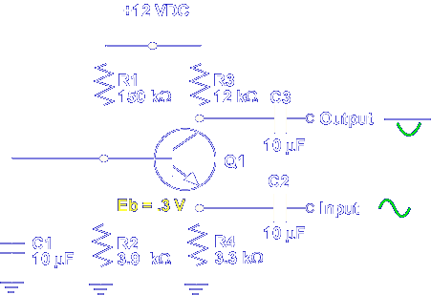

A class C operation uses 0.3 V on the base. Transistor conducts for less than 1/2 the duration of input signal.

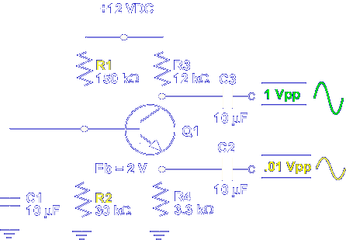

This is a class A common base with a gain of 100. The input to output comparison shows normal operation.

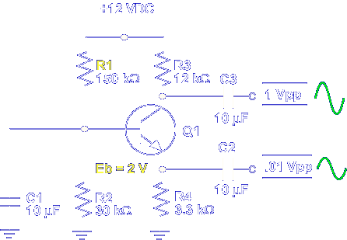

The 2 V bias at Q1 verifies class A. Dividing E_{out} by E_{in} verifies Av.

$$Av=\frac{E_{out}}{E_{in}}= \frac{1.0}{0.01}=100$$

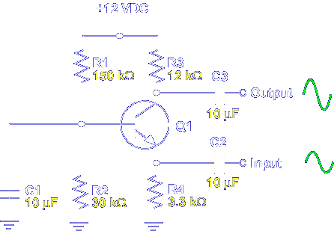

The actual component values determine the class of operation and voltage gain.

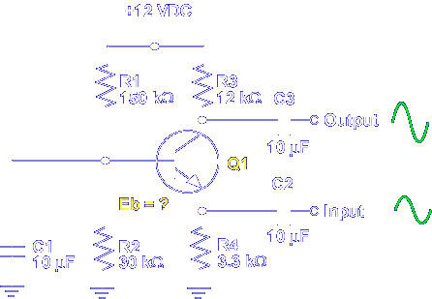

Let's calculate the base bias on Q1 to determine the class of operation.

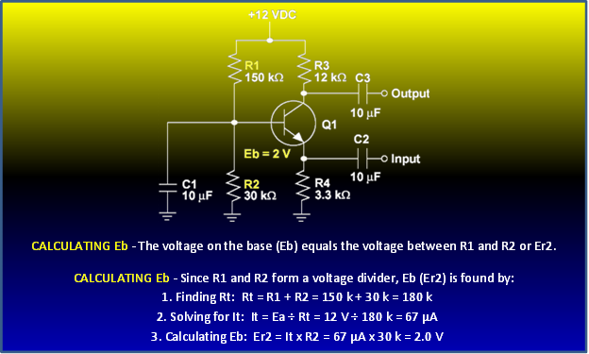

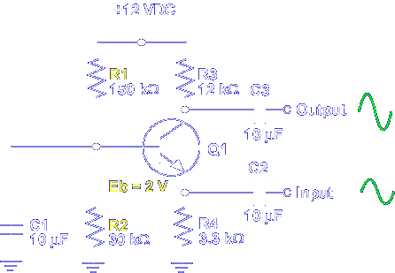

R1 and R2 form a voltage divider. The voltage felt between R1 and R2 is applied as Q1 bias voltage. Recall that 0.6 V is needed to forward bias the base to emitter PN junction. This common base is biased to 2 V or above cutoff. This value indicates class A operation.

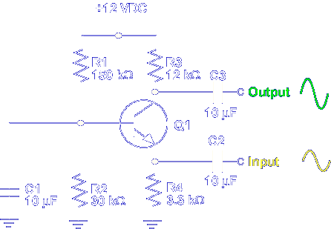

Once the class of operation is determined, the gain (Av) is found by comparing the input and output signals.

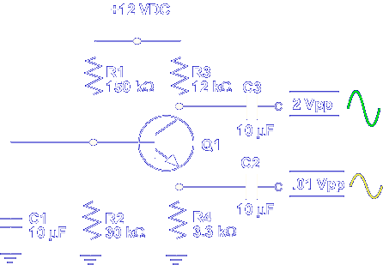

The actual gain of a common base is determined by this formula:

$$Av= \frac{E_{out}}{E_{in}}$$

The expected gain is 200, and the formula verifies this value.

$$Av= \frac{E_{out}}{E_{in}}=\frac{2.0 Vpp}{.01 Vpp}=200$$

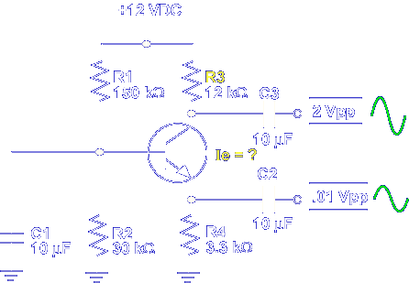

However, if the gain is unknown, you must calculate using component values.
The collector load resistor (Rc) and emitter current (Ie) values are needed. This formula does not give an exact value but checks for normal operation.

$$Av= \frac{R_{c}}{.025 ÷ I_{e}}$$

First, substitute the value for the collector resistor in the formula.

$$Av= \frac{R_{c}}{.025 ÷ I_{e}}= \frac{12 k}{.025÷I_{e}}$$

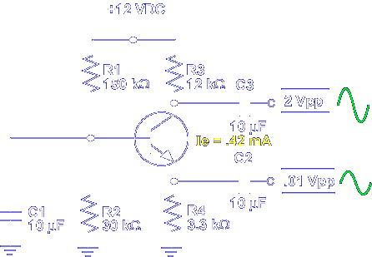

Second, solve for Ie.

$$Av= \frac{R_{c}}{.025 ÷ I_{e}}= \frac{12 k}{.025÷I_{e}}$$

Third, substitute Ie in the formula and solve for Av.

$$Av= \frac{R_{c}}{.025 ÷ I_{e}}= \frac{12 k}{.025÷0.00042}=\frac{12000}{59.52} =201.6$$

Check normal operation by multiplying Av by the input signal and comparing to the measured output signal.

10.0 mV x 201.6 = 2.01 V

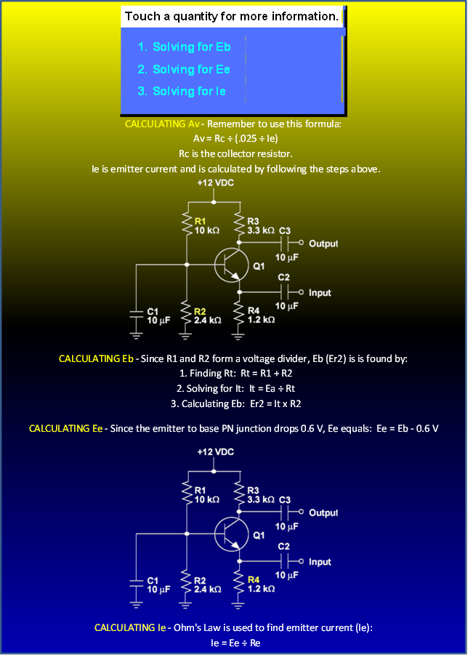
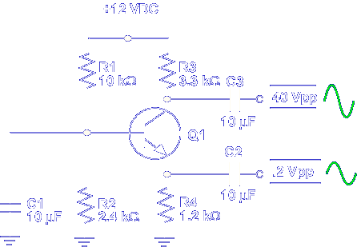

What is the measured Av of this circuit?

200

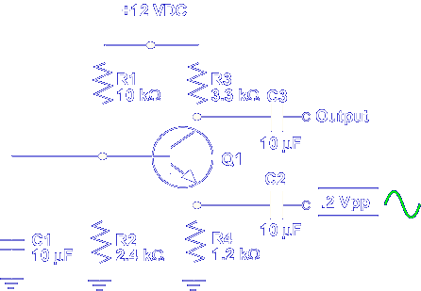

What is the calculated Av of this circuit?

$$Av = \frac{R_{c}}{.025 ÷ I_{e}}= \frac{3.3 kΩ}{.025÷1.43 mA}$$
R_{t} = 10 kΩ + 2.4 kΩ = 12.4 kΩ
I_{t} = 12 VDC ÷ 12.4 kΩ = .97 mA
E_{b} = E_{R2} = 2.4 kΩ × .97 mA = 2.32 VDC
E_{e} = 2.32 VDC – 0.6 VDC = 1.72 VDC
I_{e} = 1.72 VDC ÷ 1.2kΩ = 1.43 mA
$$Av = \frac{3.3 kΩ}{.025÷1.43 mA}=190$$

This completes the information on COMMON BASE CIRCUIT VALUES.

