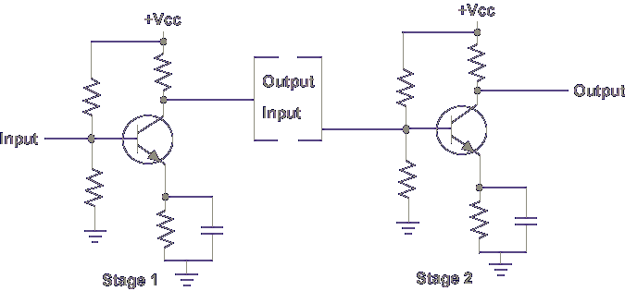
This is a typical common base amplifier circuit.
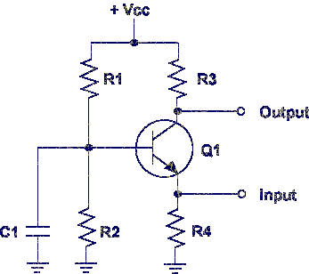
For this discussion, an NPN transistor is used. Note that Vcc is positive.
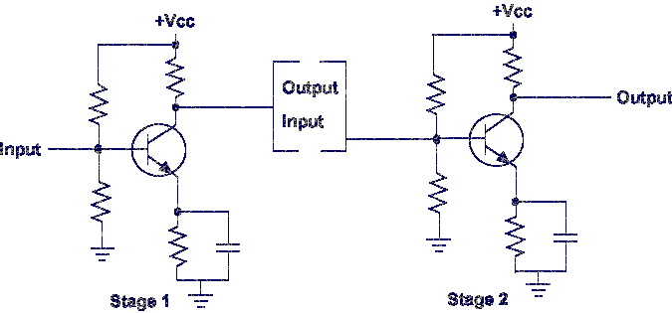

The amplifier's output is controlled by a small input signal. The output signal is a large replica of the input signal.
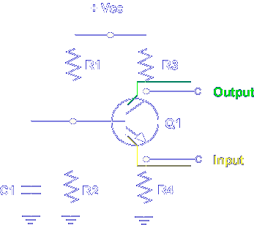
The amplifier has two basic circuits:
1. Input - Emitter to Base
2. Output - Base to Collector
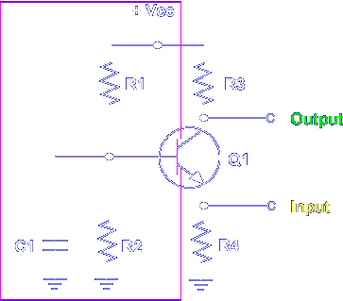
Note, the base is common to both circuits.
1. Input - Emitter to Base
2. Output - Base to Collector
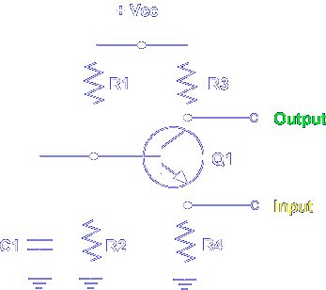
This means that a change in one circuit affects the other circuit. A changing input signal changes the bias voltage on the emitter of the transistor.
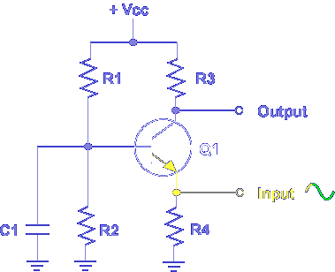
When the input signal increases, the emitter voltage increases, decreasing the forward bias on the base to emitter PN junction.
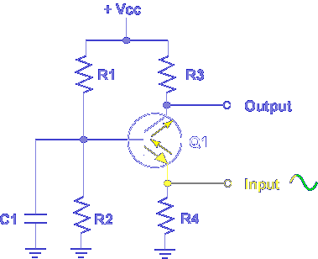
A decreased forward bias decreases collector to emitter current.
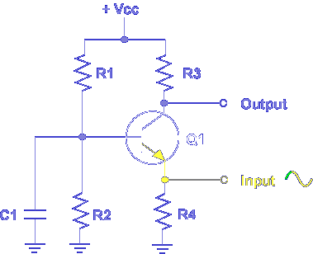
When the input signal decreases, the voltage on the emitter decreases increasing forward bias on the base to emitter PN junction.
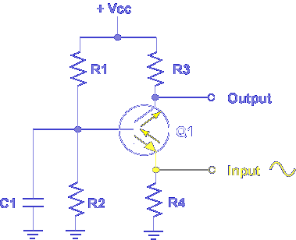

An increased forward bias increases emitter to collector current.
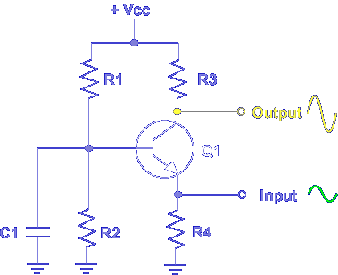
The effects of a changing input signal are seen in a changing output signal.
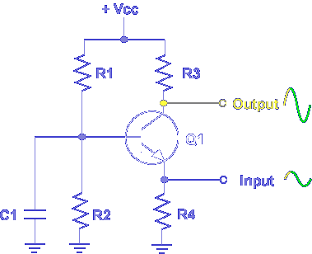
Note an increasing input signal produces an increasing output signal.
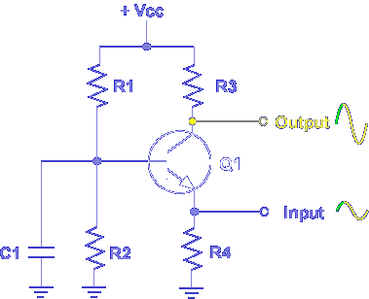

A decreasing input signal produces a decreasing output signal.

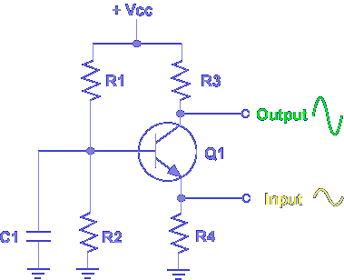

A small input signal controls a large output signal.

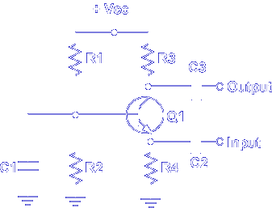

In a common base amplifier, when the emitter voltage increases, the emitter to base forward bias _______

Decreases

In a common base amplifier, when emitter voltage increases, emitter current _______

Decreases

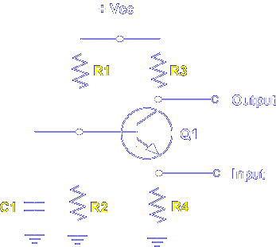

Transistor bias is determined by R1, R2, R3, R4, and C1.

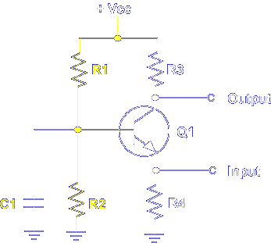

R1 and R2 develop the base bias of Q1 and establish the operating point. R1 and R2 form a voltage divider that is operated by +Vcc. A fixed bias is always present on the base of Q1. C1 grounds any AC voltage that develops on the base.
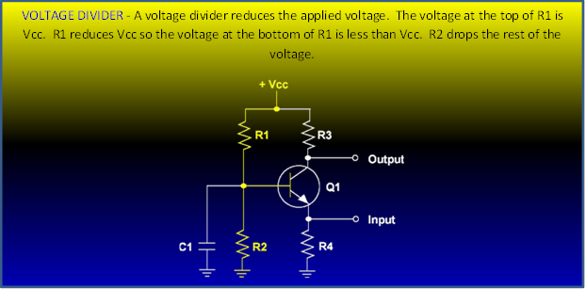

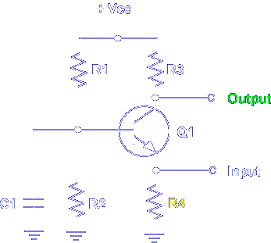

Resistor R4 establishes emitter bias. Any change in emitter voltage produces a predictable change at the output.

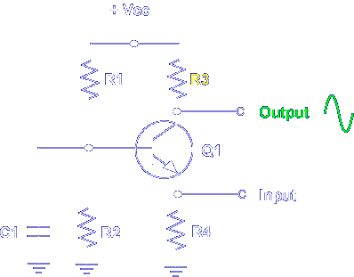

The output signal is determined by collector load resistor R3.

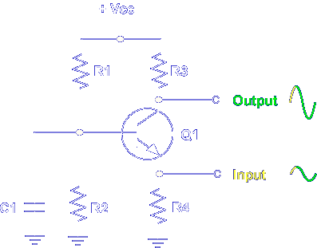

An increasing input signal decreases the emitter to collector current. Less voltage drops across R3 and the output signal increases.

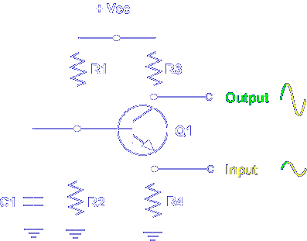

A decreasing input signal increases current. More voltage drops across R3 and the output signal decreases.

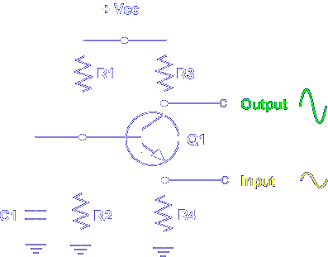

The result is an output signal that is an amplified replica of the input signal.

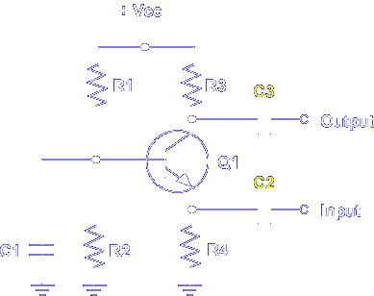

Now let's add two important components to the amplifier circuit, C2 and C3. C2 is an input coupling capacitor that prevents DC voltage from reaching the emitter of the transistor. C3 is an output coupling capacitor and prevents the DC bias on the collector from reaching the output. The coupling capacitors do not affect the DC bias voltages on Q1.

Which component(s) establish the base bias for Q1?

R1 and R2

Which component(s) develop the output signal and reverse bias the collector to base PN junction.

R3

Which is the output coupling capacitor?

C3

This completes the information on COMMON BASE AMPLIFIER.

