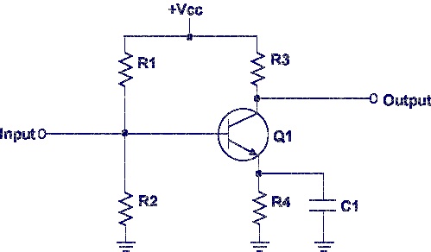
This lesson teaches the common emitter amplifier circuit. This is a Common Emitter amplifier because the input is applied to the base, the output is taken from the collector, and the emitter is common. The common emitter amplifier is normally used as a power amplifier due to its properties.
• Voltage Gain - Medium
• Current Gain - Medium
• Power Gain - High
• Input Resistance - Medium
• Output Resistance – Medium
Let's begin the lesson on COMMON EMITTER AMPLIFIER.

