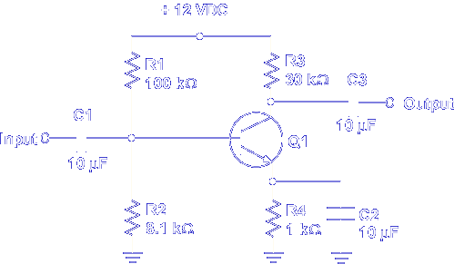
The class of operation and the voltage gain (Av) are needed to identify normal operation of a common emitter amplifier.
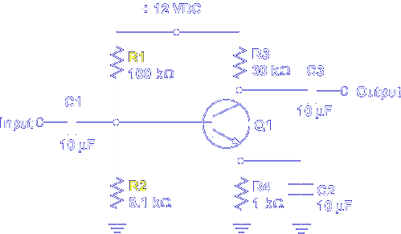
Class of operation is determined by the bias placed on the base of Q1 by R1 and R2.
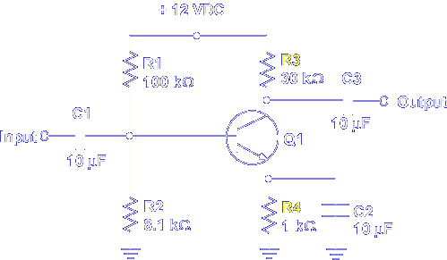
The gain is determined by emitter resistor R4 and collector resistor R3. If class of operation and voltage gain is known, normal operation is determined by comparing input and output signals.
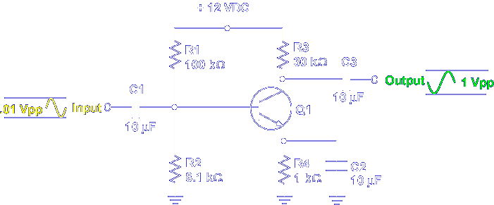

For example, this is a class A common emitter with a gain of 100. The input to output comparison shows normal operation.

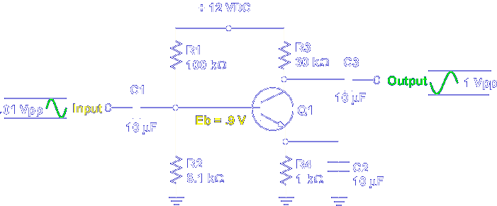

The 0.9 V bias at Q1 verifies class A. Dividing E_{out} by E_{in} verifies Av.

$$Av=\frac{E_{out}}{E_{in}} = \frac{1.0}{0.01}=100$$

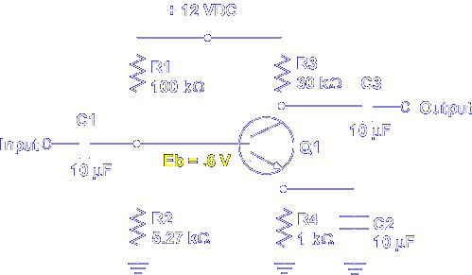

If the bias on Q1 is changed to 0.6 V, the class of operation becomes class B.
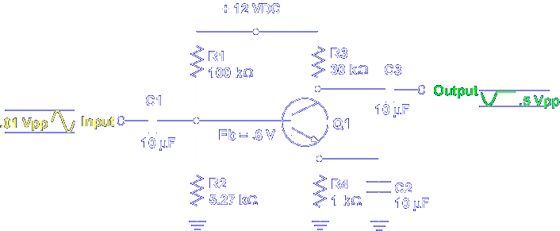

The input to output comparison shows normal operation for a class B common emitter.

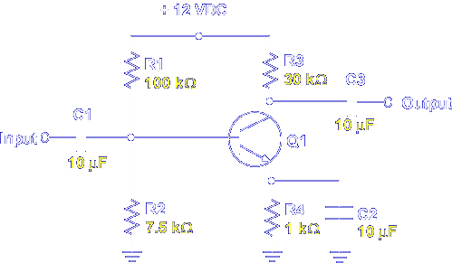

The actual component values determine the class of operation and voltage gain. Let's calculate the base bias on Q1 to determine the class of operation.

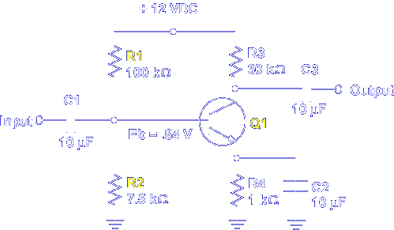

R1 and R2 form a voltage divider. The voltage between R1 and R2 is applied as Q1 bias voltage. Recall that 0.6 V is needed to forward bias the base to emitter PN junction. This common emitter is biased to 0.84 V or above cutoff. This value indicates class A operation.

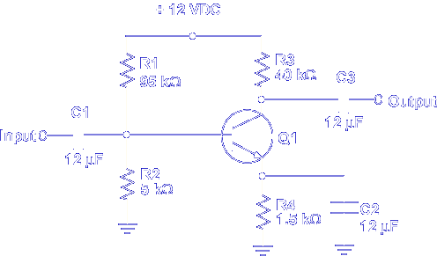

Determine the class of operation for this common emitter circuit.

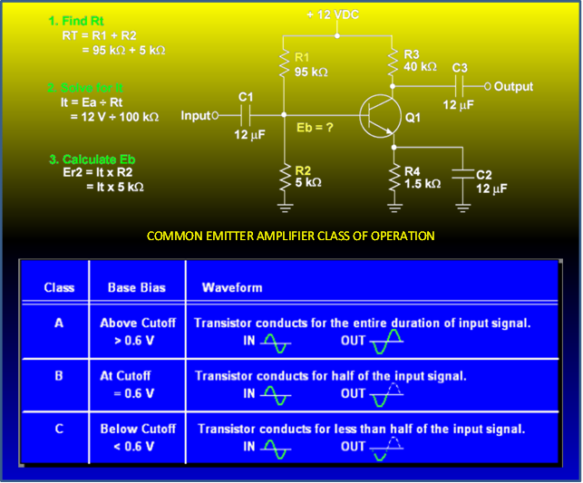

R_{t} = 100kΩ
I_{t} = .12mA
Eb = 12mA×5kΩ = .6V

Class B

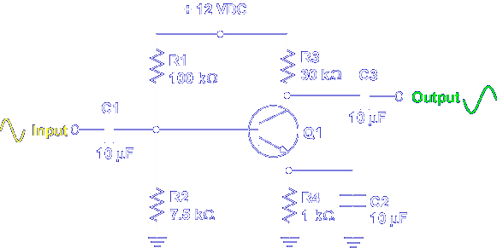

Once the class of operation is determined, the gain (Av) is found by comparing the input and output signals.

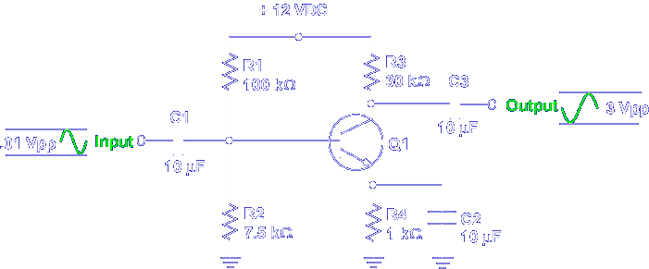

The actual gain of a common emitter is determined by this formula.

$$Av=\frac{E_{out}}{E_{in}}$$

If the expected gain is 300, using the formula verifies this value.

$Av=\frac{E_{out}}{E_{in}}=\frac{3.0}{0.01}=300$

However, if the gain is unknown, you must calculate using component values.

$$Av=\frac{Rc}{0.025 ÷ I_{e}}$$

The collector load resistor (Rc) and emitter current (I_{e}) values are needed. This formula does not give an exact value but checks for normal operation.

First, substitute the value for the collector resistor in the formula.

$$Av=\frac{Rc}{0.025 ÷ I_{e}}= \frac{30 k}{0.025÷I_{e}}$$

Second, solve for Ie.

$$Av= \frac{30 k }{0.025÷I_{e}}$$

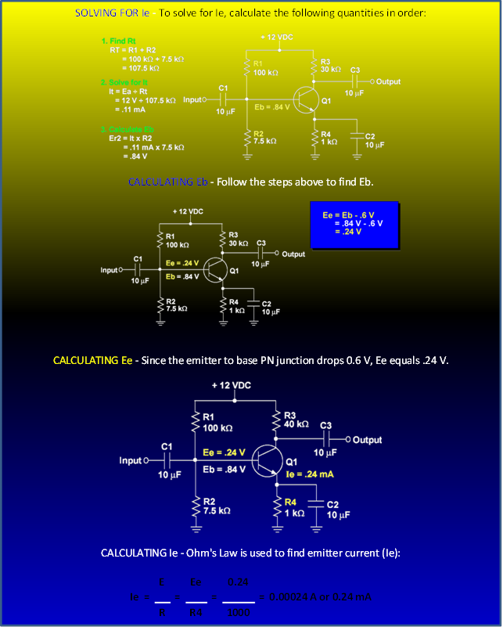

Third, substitute Ie in the formula and solve for Av.

$$Av=\frac{R_{c}}{0.025÷I_{e}}=\frac{30 k}{0.025÷0.00024}=\frac{3000}{104.17}=288$$

Check normal operation by multiplying Av by the input signal and comparing to the measured output signal.

$$0.01 V×288=2.88 V$$

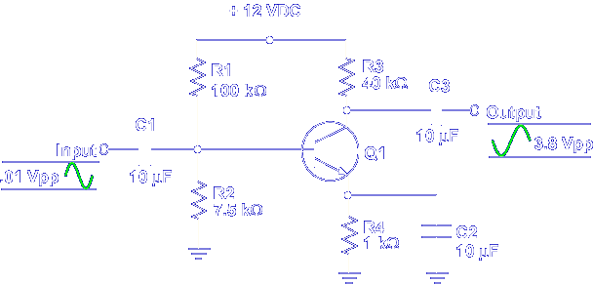

What is the calculated Av of this circuit?

3.8 V/.01 V = 380

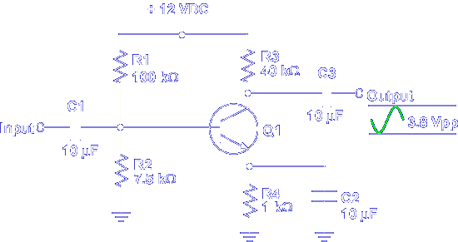

What is the calculated Av of this circuit?

Av = Rc/(.025/Ie)
Av = 40k/(.025/Ie)
Ie:
R_{t} = 100kΩ + 7.5kΩ = 107.5kΩ
I_{t} = 12V/107.5kΩ = .11mA
E_{b} = .11mA × 7.5kΩ = .83V
E_{e} = .83 V-.6 V = .23 V
I_{e} = .23 V/1kΩ .23mA
A_{v} = 40kΩ/(.025/.23mA) = 368

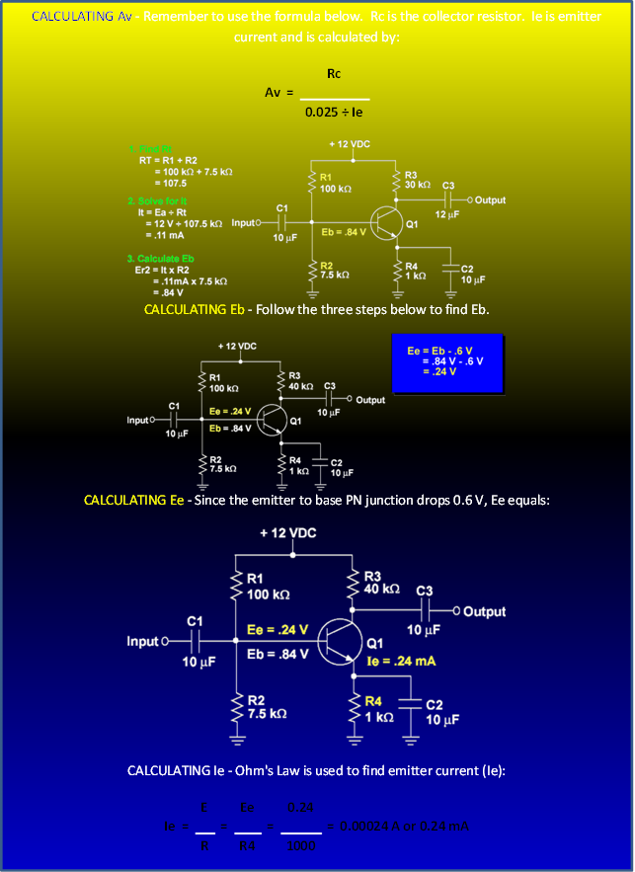
This completes the information on COMMON EMITTER CIRCUIT VALUES.

