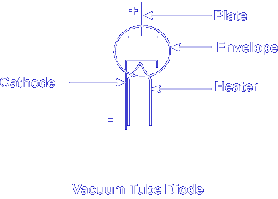
Electron Tubes are classified according to the number of electrodes they contain. A diode (di = two, ode = electrode) tube is a two-element tube. The electrodes are the cathode and plate. The heater is not counted for the purposes of classifying an electron tube.
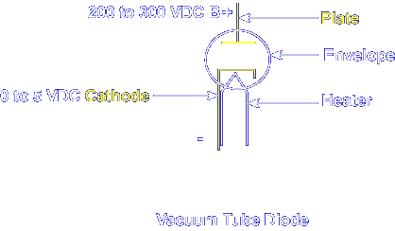
In a diode tube, the two electrodes are the plate (anode), which receives the electrons, and the cathode, which emits the electrons. Even though the cathode voltage is positive, the plate is a larger positive value, allowing electron emission. At normal room temperatures, cathode electrons are not free from the cathode itself.
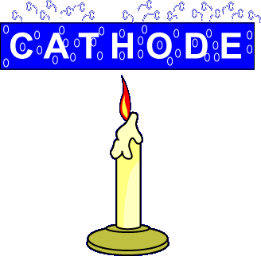
The cathode must be subjected to something which will release the free electrons into its surrounding space. The method we will discuss is called Thermal Emission. Thermal Emission: the discharge of electrons from a material when the material is subjected to high temperatures. As the applied temperature increases, the number of free electrons increases. Too much heat, though, will damage the material.
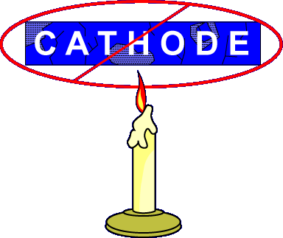
The cathode needs to be made from material that can handle the heat required to generate large quantities of free electrons. This material is normally tungsten.
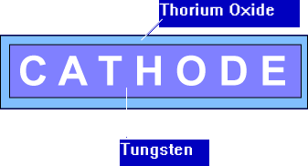

The only problem with tungsten is that it requires too much heat to emit electrons. To solve this problem, the tungsten is coated with thorium oxide. This material not only adds to the life of the cathode, but also makes it more efficient.

A heater filament is required to increase the temperature of the cathode. The two types of heater filaments are 1) directly heated cathode and 2) indirectly heated cathode. The operating voltage for a heater is typically 6.3 VAC to 12.6 VAC.

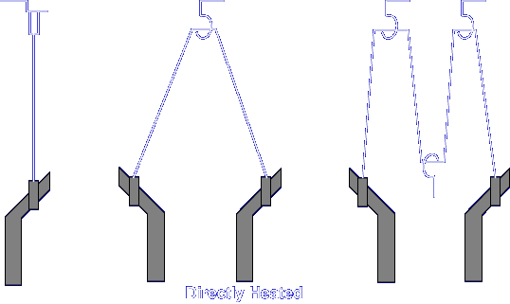

The directly heated cathode has two major disadvantages. With DC heater voltages, the potential in the wire is not consistent, making the emission of electrons inconsistent. With AC heater voltages, undesirable variations in emission current (hum) may occur.

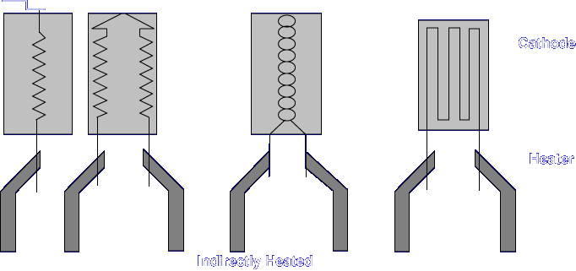

The indirectly heated cathode has a twisted or folded loop of insulated tungsten wire which is inserted into a thin-walled, hollow metal cylinder (which is normally made of nickel). The cylinder, which is normally coated with the same oxide, can now emit electrons when heated. This method eliminates hum because only the heater has current flowing through it. The cathode has the same potential throughout.

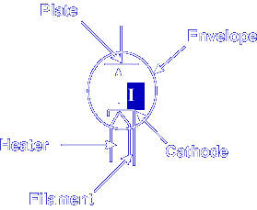

Current flows from lower potential to higher potential, or cathode to plate. For this to occur, all of the components of the electron tube must be located within an envelope.

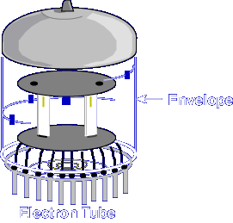

An envelope is normally made of glass or ceramic material. The envelope either has all of its air removed during construction, leaving a vacuum, or the air is replaced with another gas. If the air was left in the envelope, the electrons would collide with air molecules and become very inefficient. In a vacuum, the number of collisions is drastically reduced. Also, there are no air molecules to cause the heating element to burn up.

What are the names of the two electrodes in an electron tube diode?

Plate and Cathode

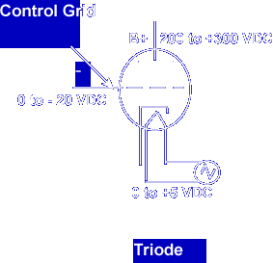

The Triode is another type of electron tube. The triode is simply a diode with the addition of a control grid. The purpose of the control grid is to regulate the amount of electron flow between the cathode and the plate. A small voltage on the control grid has a large effect on the current to the plate (anode). The control grid, in effect, controls the resistance of the tube.

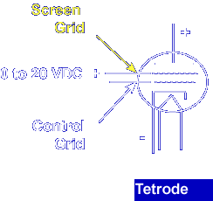

Adding another electrode to the triode produces the tetrode. The fourth electrode, the screen grid, is placed between the plate and control grid.

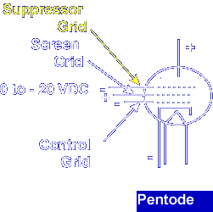

Adding yet another electrode turns the tetrode into a pentode. The pentode has a suppressor grid added between the screen grid and the plate.

How many electrodes does a tetrode have?

4

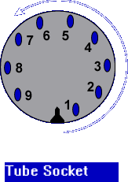

Since electron tubes do not last as long as the equipment they are used in, they are normally mounted in sockets. These sockets are usually numbered as shown below. Viewed from the top of the tube, the pins are counted counterclockwise from the guide notch.

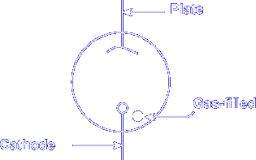

The last type of tube that we are going to discuss is gas-filled tubes. A gas-filled tube has an inert gas injected into it after the air has been removed. When voltage is first applied, the gas opposes current. The dot inside the schematic symbol indicates that the electron tube is gas-filled. As soon as enough voltage is applied, the gas will begin to ionize. Electrons are torn off the atoms of the gas by electrostatic pressure. These free electrons allow the tube to conduct current. Because the electrons are not from the cathode, the cathode doesn't need to be heated. As the current continues to increase, the resistance of the tube continues to decrease, producing a constant voltage drop. This type of tube is often referred to as a voltage regulator tube.

When voltage is first applied to a gas-filled tube, the gas will _______

Oppose current flow

This completes the information on ELECTRON TUBES.

