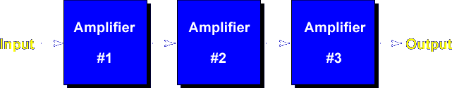
This lesson teaches the common base amplifier circuit. This is a Common Base amplifier because the input is applied to the emitter, the output is taken from the collector, and the base is common. The common base amplifier is normally used to match a low input resistance source to a high output resistance load.
Voltage Gain - High, Current Gain - Low, Power Gain - Medium, Input Resistance - Low, Output Resistance – High
Let's begin the lesson on COMMON BASE AMPLIFIER.

