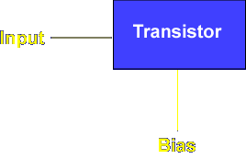
There are two types of signals applied to transistors. The input is the signal that is changed to produce an output. Input signals are either AC or DC. The bias is the signal that allows the transistor to operate. Bias signals are DC voltages.
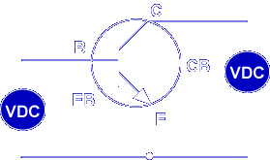
The transistor must be biased with a DC voltage before use. Transistor bias is accomplished by forward biasing the emitter to base PN junction (EB) and reversing biasing the collector to base PN junction (CB).
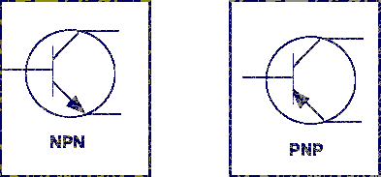
Biasing is opposite for NPN and PNP transistors. Let’s first look at NPN transistor biasing. Remember, input and output signals are not considered.
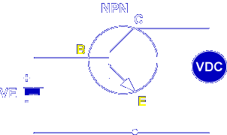
Placing a positive voltage on the base and a negative voltage on the emitter forward biases the emitter to base (EB) PN junction, low resistance junction.
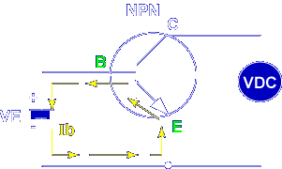
Current flows through the forward biased BE junction. This current is called l_{b}.
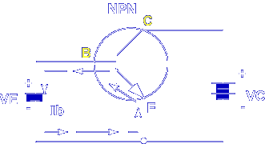
Placing a large positive voltage on the collector reverse biases the collector to base PN junction, high resistance junction.
Current does not flow from the base to the collector; the PN junction is reverse biased.
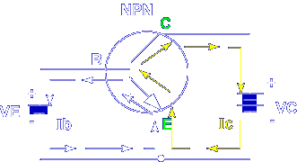
Current does flow from the emitter to the collector (I_{c}). This is what makes transistors different from two diodes connected end to end.
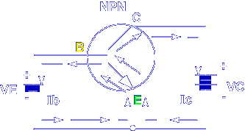
Current flows from the emitter to the collector because the base is thin and lightly doped.
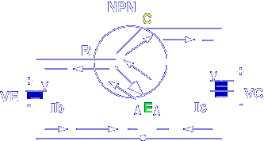
The base cannot use all the current carriers from the heavily doped emitter. The current carriers (electrons in NPN transistors) are attracted to the positive voltage on the collector.
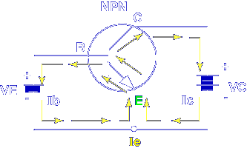
Total current flowing through the transistor circuit (Ie) is found by: I_{e} = I_{b} + I_{c}. As long as the EB junction is forward biased and the CB junction is reverse biased, the transistor is operating.

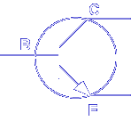

In an operating NPN transistor, which PN junction is forward biased and which PN junction is reverse biased?
Forward EB, Reverse CB
The polarity of the bias voltages is different in PNP transistors.
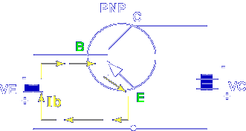
The base to emitter PN junction is forward biased by placement of a negative voltage on the base and a positive voltage on the emitter.
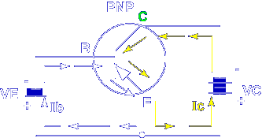
The collector to base PN junction is reverse biased by placement of a negative voltage on the collector.
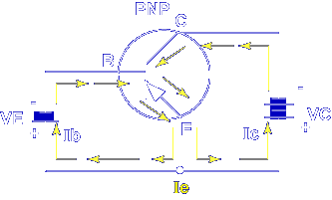
The direction of current through the transistor is opposite to the NPN transistor but the results are the same.
I_{e} = I_{b} + I_{c}
Remember, the base cannot use all the current carriers from the heavily doped emitter. The current carriers (holes in PNP transistors) are attracted to the negative voltage on the collector. As long as the EB junction is forward biased and the CB junction is reverse biased, the transistor is operating.
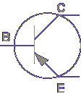
In an operating PNP transistor, which PN junction is forward biased and which PN junction is reverse biased?
Forward EB, Reverse CB
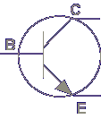
In an NPN transistor, the base DC bias voltage must be _______
Positive compared to the emitter

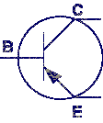
In a PNP transistor, the base DC bias voltage must be _______
Negative compared to the emitter
This completes the discussion over TRANSITOR BIAS.

