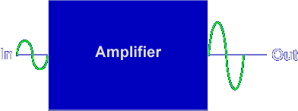
The purpose of an amplifier is to increase signal strength. Signal is a general term used to describe current, voltage, or power in a circuit.
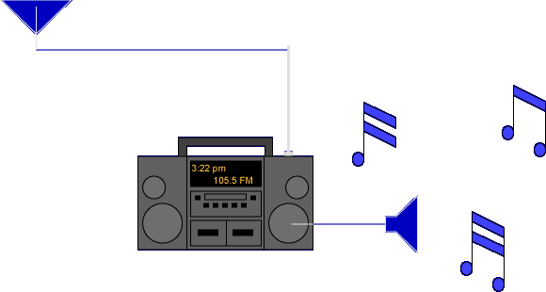
A radio receiver is an excellent example of how amplifiers are used.
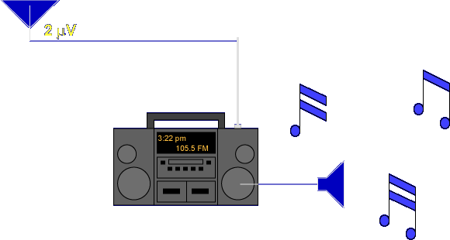
The signal received by the antenna is small (2 µV). This small voltage is not enough to drive the speaker.
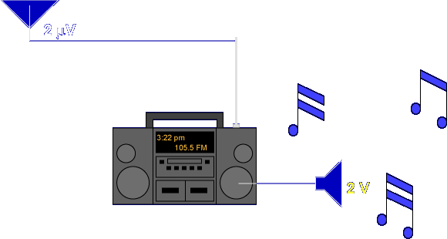
Amplifiers inside the radio receiver increase the voltage to about 2 V. The received signal is increased 1,000,000 times.
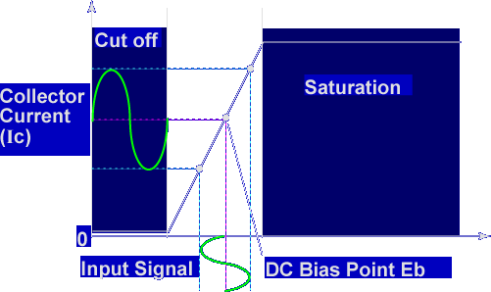
Transistor amplification of an input signal occurs because a small change in base bias causes a large change in collector current. Once a transistor is DC biased, an AC input signal is applied that adds to or subtracts from the bias levels.
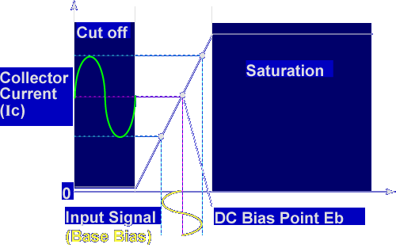
The changing base bias changes the collector current. A small change in base bias causes a large change in collector current, or amplification.
Transistor amplifiers require what type of signals to function?
DC bias and AC input signals
What changes are necessary for amplification to occur?
Small change in Eb, large change in Ic
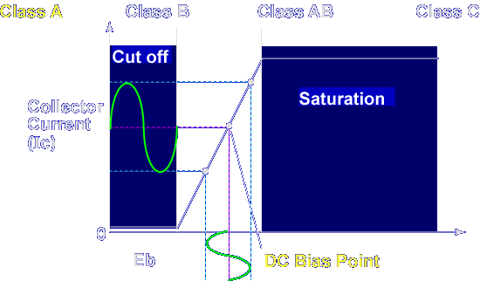
The point where a transistor is DC biased determines the class of operation. Let's discuss Class A operation first.
Class A
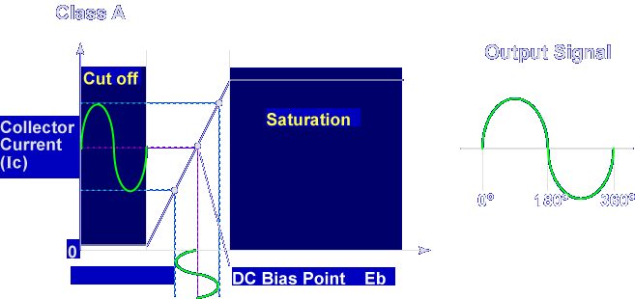
Class A amplifiers are biased so the input signal occurs within the limits of cutoff and saturation. Collector current (Ic) flows for the complete 360° cycle of the input signal. The bias point is normally mid-way between cutoff and saturation.
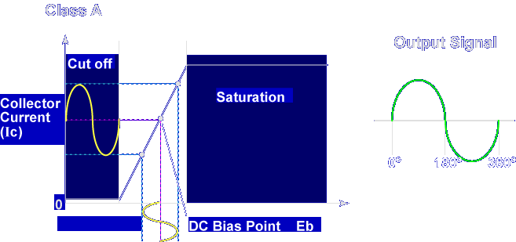
An advantage of class A operation is that the output signal is a replica of the input signal, good fidelity with low distortion.
FIDELITY / DISTORTION - Fidelity is the faithful reproduction of a signal. An amplifier has a high degree of fidelity when the output signal is just like the input signal except for amplitude. Distortion is the opposite of fidelity. The output signal does not match the input signal.

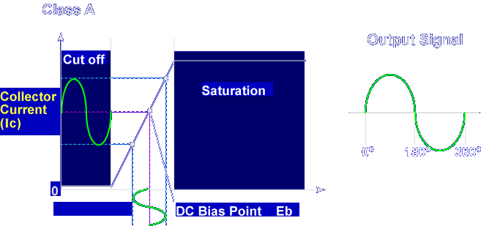
A disadvantage of class A operation is that collector current flows even when no input signal is applied, causing lower efficiency. Class A amplifiers are commonly used in audio amplifiers.
EFFICIENCY - The efficiency of an amplifier refers to the ratio of signal power compared to the total input power. Since an amplifier takes power to operate, an amplifier that operates for 360° degrees of the input is less efficient than one that operates for less than the entire input.

Class B

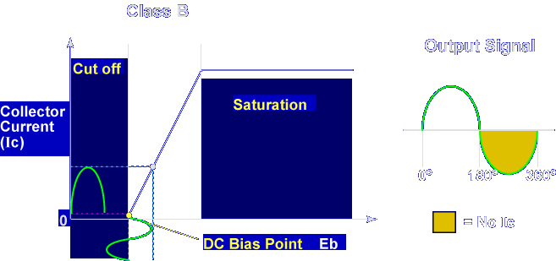

Class B amplifiers are biased so collector current is zero for half of the input signal (one alternation). The DC bias point is at cutoff. Collector current, (Ic), flows during only half, (180°), of the input signal.

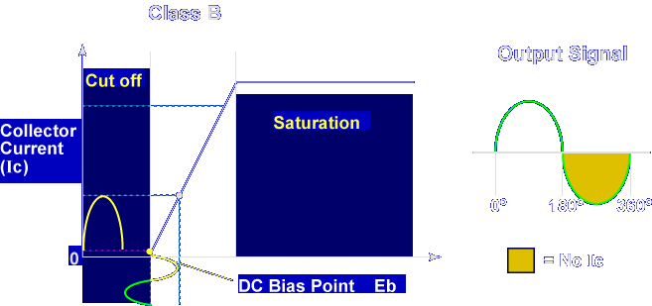

An advantage of class B operation is increased efficiency because it does not operate for the entire input cycle.
A disadvantage of class B operation is that it has poor fidelity. The output is not an exact replica of the input.
Class B amplifiers are commonly used in push-pull amplifiers. A push-pull amplifier uses two amplifiers connected together to overcome the poor fidelity while maintaining good efficiency.

PUSH-PULL AMPLIFIER - A push-pull amplifier is actually two amplifiers. One amplifies the positive alternation of the input signal and the other amplifies the negative alternation of the input signal. The output is taken across both amplifiers, producing a complete 360° cycle.

Class AB
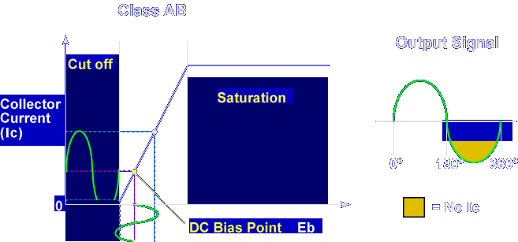
Class AB amplifiers are biased so that collector current is zero for a portion of one alternation. The bias point is above cutoff, so collector current flows for more than 180° but less than 360°.
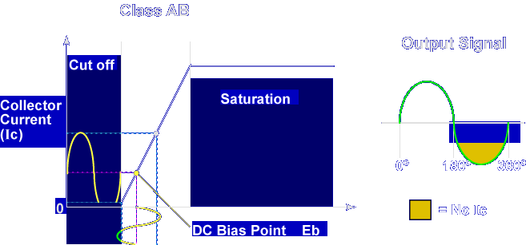
An advantage of class AB operation is that it is more efficient than class A and has higher fidelity than class B. A disadvantage of class AB operation is that it has less fidelity than class A and less efficiency than class B. Class AB amplifiers are commonly used to overcome crossover distortion found in class B push-pull amplifiers.
CROSSOVER DISTORTION - Crossover distortion occurs when class B push-pull amplifiers are used. For a short period of time, both amplifiers are cut off and no collector current flows.

CROSSOVER DISTORTION - Crossover distortion occurs when class B push-pull amplifiers are used. For a short period of time, both amplifiers are cut off and no collector current flows.

Class C
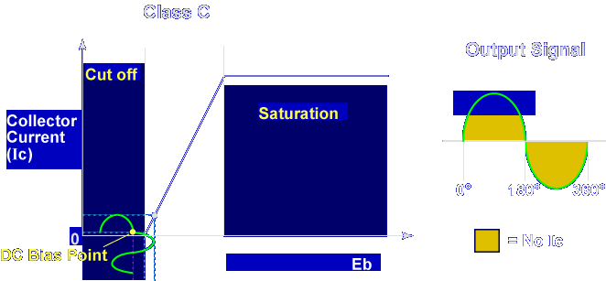
Class C amplifiers are biased so that collector current is zero for most of the input cycle. The bias point is below cutoff, so collector current flows for less than 180°.
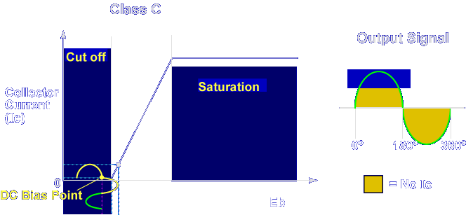
An advantage of class C operation is the high efficiency. Collector current flows during only a small portion of the input signal.
A disadvantage of class C operation is that it has very poor fidelity.
Class C amplifiers are normally used in RF tuned amplifier applications; where fidelity is not the primary issue.
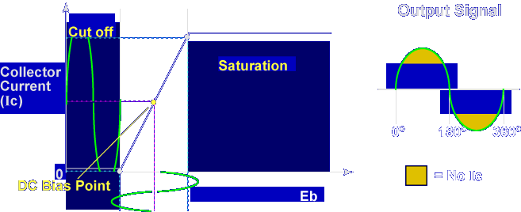

The transistor goes into saturation and cutoff if the amplitude of the input signal is high enough. This is called overdriving an amplifier. It is possible to overdrive any one of the 4 classes of amplifiers. Overdriving an amplifier distorts the output signal.

Which amplifier has the best fidelity?

Class A

Which amplifier has the best efficiency?

Class C

This completes the information on AMPLIFIERS.

