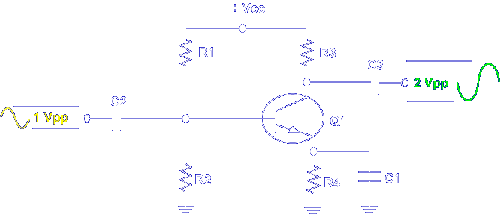

In this lesson, you will measure the normal operating voltages of a common emitter amplifier circuit. First, you measure the input and output voltages to determine the class of operation and the voltage gain. Next, you compare calculated values with measured values to determine if the circuit is operating normally. Last, you investigate circuit values in a normally operating circuit. Let's begin the lesson on COMMON EMITTER AMPLIFIER EXPERIMENT.
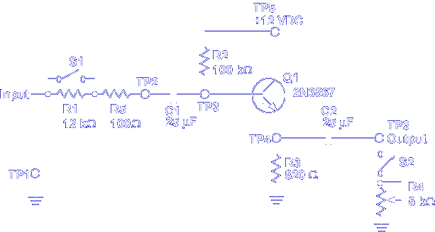

Pick up the PC130-30A card. This card demonstrates the operation of a common emitter amplifier circuit.

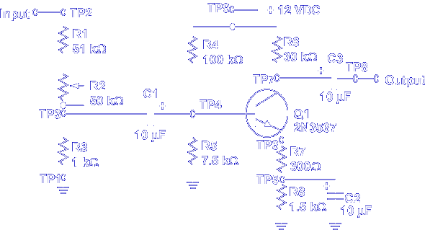

Compare the components on PC130-30A to the schematic shown. Notice that the input is applied to C1 through R1, R2, and R3. This voltage divider is used to control the amplitude of the input signal. The emitter biasing circuit is formed by R7, R8, and C2. R8 and C2 form a self-biasing network and any AC developed by R8 is bypassed to ground by C2. R7, a swamping resistor, reduces distortion caused by non-linear changes in emitter current. Note, C2 does not bypass AC developed by R7.
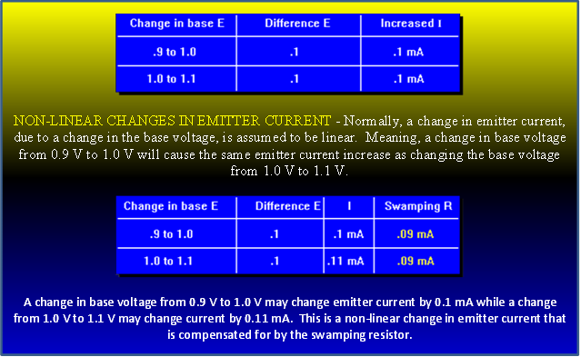
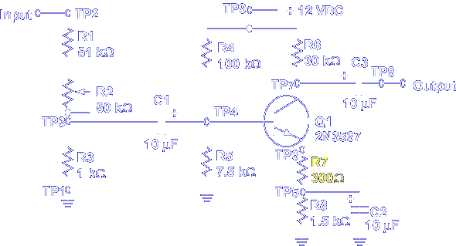

AC developed by R7 reduces voltage gain and is considered in the Av formula:
Av | = | R_{c}/  Rswamping ÷ (0.025 ÷ Ie)

