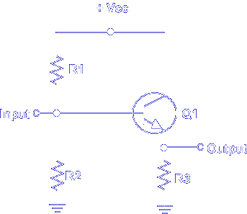

This is a typical common collector amplifier circuit, also known as an emitter-follower. For this discussion, an NPN transistor is used. Note that Vcc is positive.

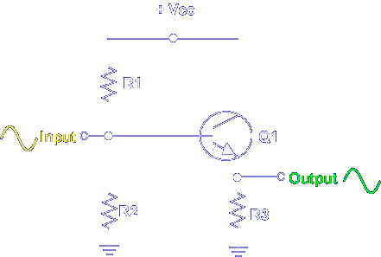

The amplifier's output is controlled by the input signal. The output signal is a replica of the input signal.
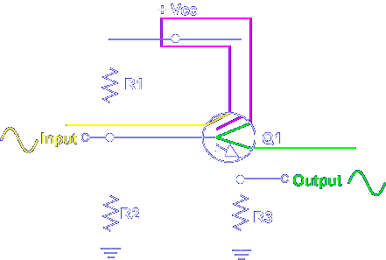

The amplifier has two basic circuits:
1. Input - Base to Collector
2. Output - Collector to Emitter
Note the collector is common to both circuits. This means that a change in one circuit affects the other circuit.

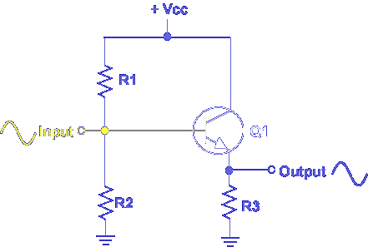

A changing input signal changes the bias voltage on the base of the transistor. When the input signal increases, the bias voltage increases.
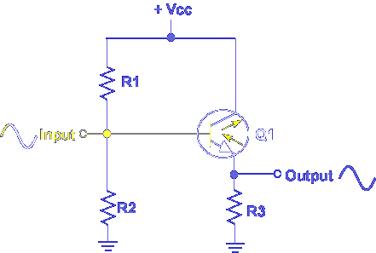

An increase in bias voltage increases current flow in the emitter collector circuit. When the input signal decreases, the bias voltage decreases.

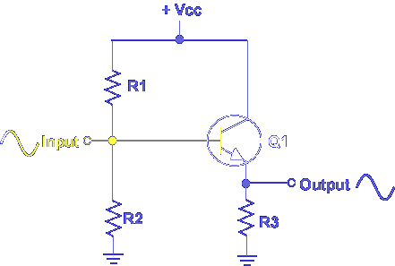

When the input signal decreases, the bias voltage decreases. A decrease in bias voltage decreases current flow in the emitter collector circuit.

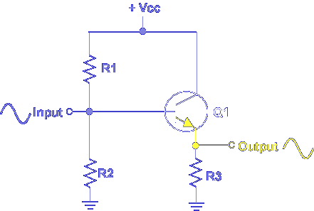

The effects of a changing input signal are seen in a changing output signal.
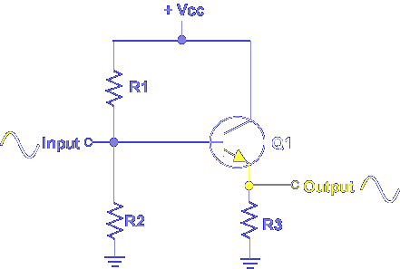
Note, an increasing input signal produces an increasing output signal. A decreasing input signal produces a decreasing output signal. The input signal controls the output signal.
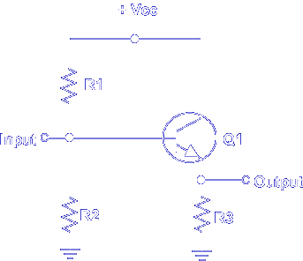

In a common collector amplifier, when the base voltage increases, the emitter current _______

Increases

In a common collector amplifier, when base voltage decreases, output voltage _______

Decreases

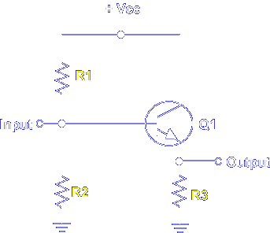

Transistor bias is determined by R1, R2, and R3.

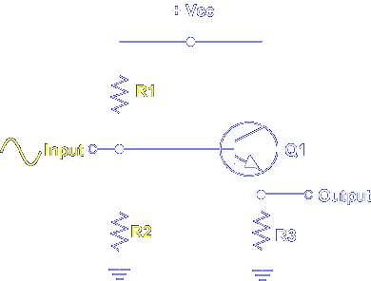

When an input signal is applied to the base of Q1, it's combined with the fixed bias voltage established by R1 and R2.

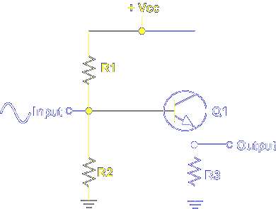

R1 and R2 form a voltage divider that is operated by +Vcc. A fixed bias is always present on the base of Q1. Any change in the fixed bias of Q1 produces a predicted change at the output. The collector is biased by +Vcc.

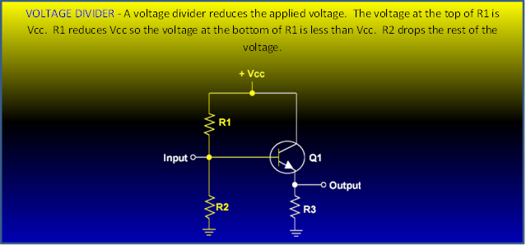

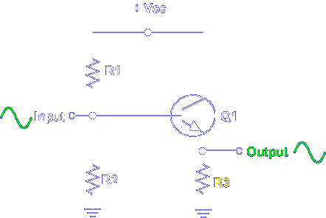

The output signal is determined by emitter load resistor R3. When the emitter to collector current increases, more voltage drops across R3 and the output signal increases. When current decreases, less voltage is developed across R3 and the output signal decreases. The result is a signal on the output that is a replica of the input signal.

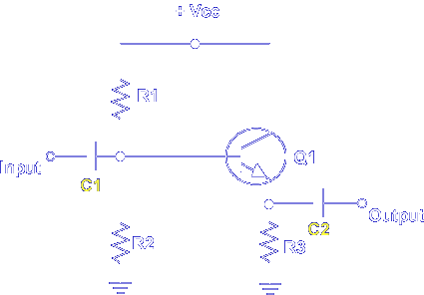

Now, let's add two important components to the amplifier circuit, C1 and C2.
C1 is an input coupling capacitor that has 2 purposes. It prevents DC voltage from reaching the base of the transistor. It also couples the AC signal from the previous stage to the base of the transistor.
C2 is an output coupling capacitor and prevents the DC bias on the emitter from reaching the output. The coupling capacitors do not affect the DC collector bias voltage from Vcc.

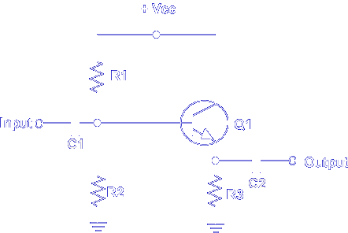

Which component(s) establish the base bias?

R1 and R2

This completes the discussion over Common Collector Amplifiers.

