Common Collector Amplifier Experiment
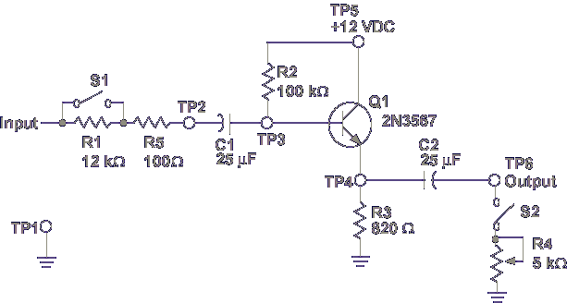
In this lesson, you will measure the normal operating voltages of a common collector amplifier circuit. First, the input and output voltages are measured to determine the class of operation and the voltage gain. Next, measured values are compared with known values to determine if the circuit is operating normally. Last, you investigate circuit values on a normally operating circuit.
Let's begin the lesson on COMMON COLLECTOR AMPLIFIER EXPERIMENT.
Pick up the PC130-31 card. This card demonstrates the operation of a common collector amplifier circuit. This circuit is often called the Emitter Follower, as the output is taken at the emitter and is in phase, or follows, the input at the base. Compare the components on PC130-31 to the schematic shown.
Notice that the input is applied through R1. When S1 is closed (in the OUT position), a short around R1 is made, taking R1 out of the circuit. R1 is used as a sampling resistor to measure AC base current.
$$I_{b}(AC)= \frac{E_{R1}}{R1}$$
The base biasing circuit is formed by R2. Note that a voltage divider is not used. R2 and R3 form an emitter feedback bias circuit that applies 5.7 V on the base of Q1. The β value of Q1 is needed to calculate this voltage. R4 is used as a variable load for the output signal. S2 disconnects the load from the circuit. Let's start the experiment.
- Set the test console controls to their initial control settings.
- Carefully plug PC130-31 into the test console PC1 position.
- Place S1 and S2 on PC 130-31 to OUT.
- Adjust R4 on PC130-31 fully CW.
- Press Enter to set: Positive Supply Voltage – 12
- Connect the function generator’s Main output to the test console’s PC1 INPUT BNC
- Adjust the function generator’s frequency for a 4 kHz sine wave output.
- Adjust the function generator’s amplitude for a 3 Vpp output measured with an oscilloscope at PC130-31 TP2.
- Measure the peak to peak input voltage at PC130-31 TP3. What is the measured voltage?
3 Vpp.
The experiment is set up. Let’s determine the class of operation and voltage gain (Av) by measuring circuit values.
- Press Enter to set: PC1 DC Power Switch – ON.

- Connect the oscilloscope CH1 probe to PC130-31 TP2, amplifier input.
- Adjust oscilloscope to display no less than 2 cycles. Move trace to the top of the screen.
- Connect the oscilloscope CH2 probe to PC130-31 TP6, amplifier output.
- Use the dual display mode and over trace to the bottom of the screen.
- Compare the input on CH1 to the output signal on CH2. What is the class of operation?
Class A (Full wave displayed)
- Using the voltage levels displayed on the oscilloscope, calculate the voltage gain of the amplifier.
What is the voltage gain?
1
Comparing the input and output waveforms with an oscilloscope determines class of operation, Av, and allows a quick check for normal operation. Now let’s compare the measured values to the known circuit values and verify normal operation.
- The base voltage for this circuit is approximately 5.7 VDC. The emitter voltage is about 5 VDC.
What is the class of operation with 5.7 V on the base and 5 V on the emitter?
Class A
Comparing the measured and known circuit values confirms class A operation.
What is the voltage gain of the common collector amplifier?
1
Comparing the measured and known values shows that the amplifier is operating normally as a Class A common collector transistor with an Av of 1. Remember, though the voltage gain is 1, a common collector amplifier amplifies current. Let’s check.
- Place S1 on Pc130-31 to IN.
- Using an oscilloscope, measure the peak to peak voltage at PIN E and TP2 on PC130-31.
- Find the voltage drop across R1 by subtracting the voltage readings.
- Calculate the input AC current
Input AC Current = $\frac{E_{R1}}{R1}$
= $\frac{0.8 Vpp}{12 kΩ}$
= 67µA
- Measure the peak to peak voltage at TP4 on PC130-31.
- Calculate the output AC current.
Output AC Current = $\frac{voltage}{R3}$
= $\frac{2.5 Vpp}{820 Ω}$
= 3.05 mA
Notice the current gain.
I_{in} = 67 µA
I_{out} = 3.05 mA

Now that you know the circuit is operating normally, let’s measure the other circuit voltages.
- Place S1 on PC130-31 to OUT.

- Set the oscilloscope coupling to AC, CH1 to measure DC, display mode to CH1 and connect the Ch1 probe to TP2.

- Ensure the function generator is producing a 4 kHz, 3Vpp sine wave at PC130-31 TP2.
This is the input signal. The coupling capacitor C1 prevents input DC from passing the base of Q1.

- Connect the CH1 probe to PC130-31 TP3.
Note
The input signal is riding on a DC level. This DC level is the base bias approximately 5.7 V.

- Set the CH1 Volts/Div control the 5 V and remove the probe from TP3. Make sure the oscilloscope trace is centered at the zero reference point and connect the CH1 probe to TP5.
Note
This signal is DC. The value is +Vcc.

- Remove the CH1 probe from TP5. Set CH1’s Volts/Div control to 2 V and center the trace in the oscilloscope display. Connect the CH1 probe to PC130-31 TP4.
Note
The AC signal is riding on a DC voltage. The DC voltage is the emitter bias approximately 5.1 V.

- Connect the CH1 probe to PC130-31 TP6.
Note
The DC level is gone. Coupling capacitor C2 blocked the DC bias on the emitter.
The signals you have measured are normal for an operating common collector amplifier. Values may vary for different circuits but knowing what type of signals to expect aids in troubleshooting.

- Set the test console’s Power to OFF.

