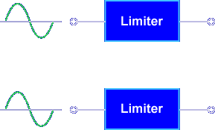
The purpose of a diode limiter is to limit the amplitude of an input signal.
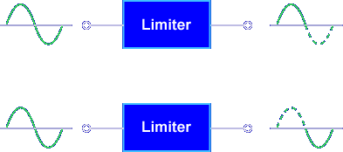
One entire alternation can be limited.
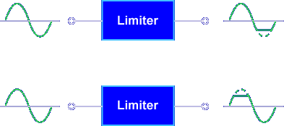

Part of one alternation can be limited.

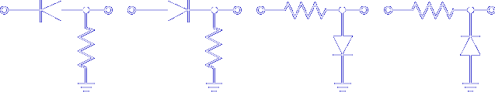

A limiter's effect on input signals depends on how the circuit components are connected. The operation of every circuit is based on the action of a junction diode.
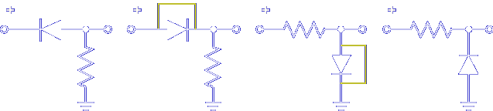

A forward biased diode conducts, acting almost like a short circuit.

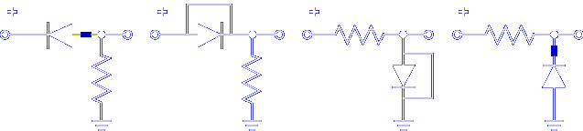

A reverse biased diode is cut off, acting like an open circuit. By placing the diode in different configurations, different output signals are produced. There are two basic configurations of diode limiters:

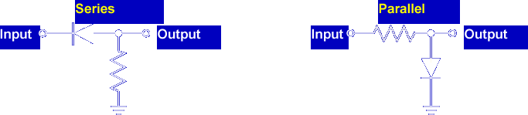

Series Limiters

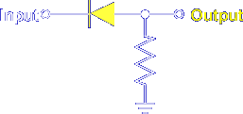

A series limiter has the diode in series with the output signal.

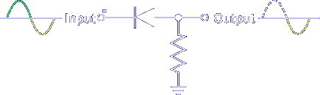

Whenever the diode is forward biased, current flows and the output signal is developed across the resistor.

Series Positive Limiter
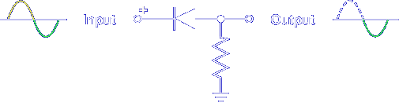

Whenever the diode is reverse biased, current flow stops. There is no output. This circuit is called a series positive limiter because the positive alternation is eliminated.

Series Negative Limiter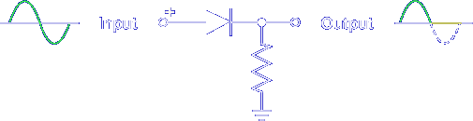

When the diode is reversed, the circuit becomes a series negative limiter.

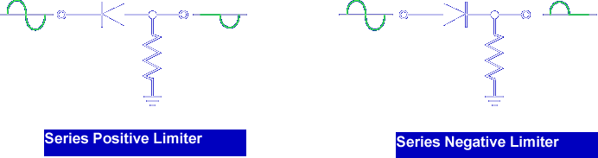

Remember, a series limiter has the diode in series with the output and limits when the diode is reverse biased.

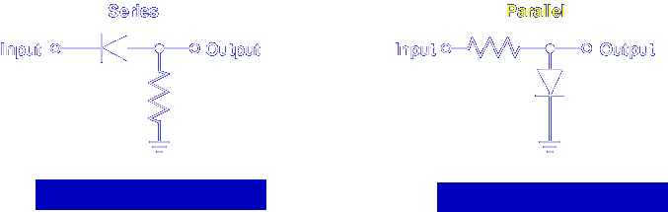

Parallel Limiters
The parallel limiter works opposite of the series limiter.

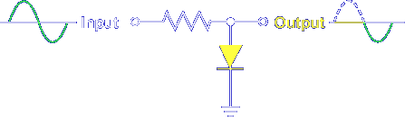

A parallel limiter has the diode in parallel with the output signal.

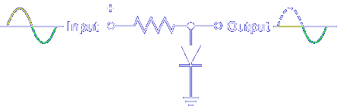

When the diode is forward biased, it has a very low resistance and the input signal is shunted or shorted to ground. Therefore, no output signal is developed across the diode.

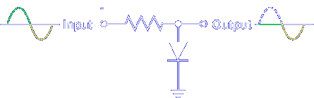

When the diode is reverse biased, the diode acts like an open circuit (or high resistance); therefore, the signal is passed to the output.
Parallel Positive Limiter
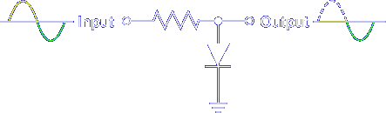

This circuit is called a parallel positive limiter because the positive alternation is eliminated.

Parallel Negative Limiter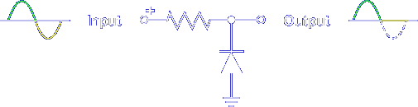

When the diode is reversed, the circuit becomes a parallel negative limiter.

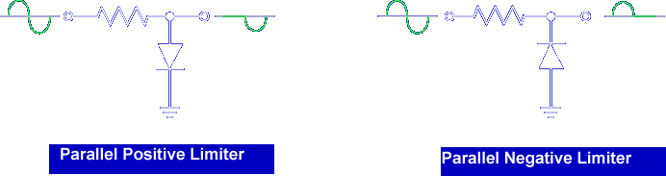

Remember, a parallel limiter has the diode in parallel with the output and limits when the diode is forward biased.

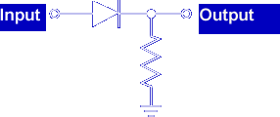

What type of limiter is this?

Series Negative

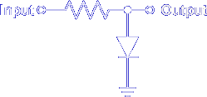

What type of limiter is this?

Parallel Positive Limiter

Circuit Bias

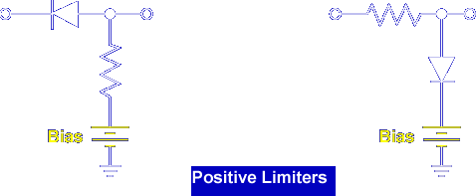

When circuit bias is added, partial alternations can be eliminated.

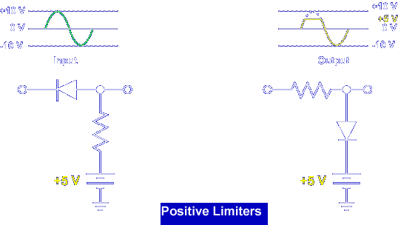

A positive series or parallel limiter with positive circuit bias raises the limit point from 0 V to the bias level. The bias voltage changes the reverse bias point for the series limiter and changes the forward bias point for the parallel limiter.

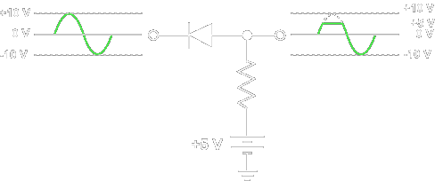
POSITIVE SERIES LIMITER BIAS POINT - Limiting action does not occur until the diode is reverse biased (input signal greater than +5 V). When the diode is reverse biased, the bias voltage is felt on the output.
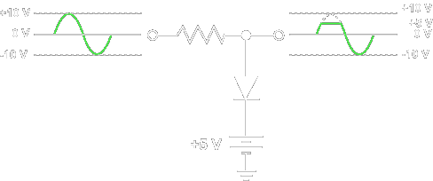

POSITIVE PARALLEL LIMITER BIAS POINT - Limiting action does not occur until the diode is forward biased (input signal greater than +5 V). When the diode is forward biased, the bias voltage is felt on the output.

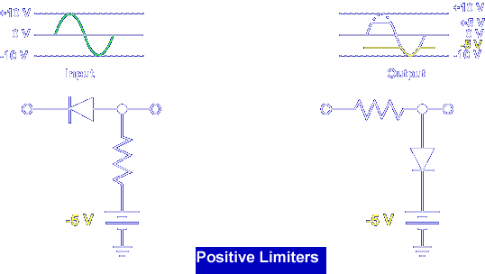

A positive series or parallel limiter with negative circuit bias lowers the limit point from 0 V to the bias level.

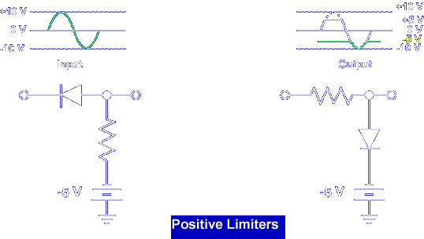

The bias voltage changes the reverse bias point for the series limiter and changes the forward bias point for the parallel limiter.
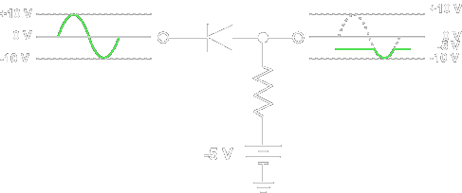

POSITIVE SERIES LIMITER BIAS POINT - Limiting action does not occur until the diode is reverse biased (input signal greater than -5 V). When the diode is reverse biased, the bias voltage is felt on the output.
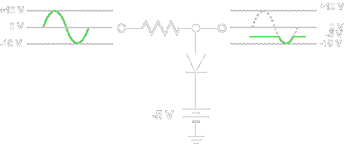
POSITIVE PARALLEL LIMITER BIAS POINT - Limiting action does not occur until the diode is forward biased (input signal greater than -5 V). When the diode is forward biased, the bias voltage is felt on the output.

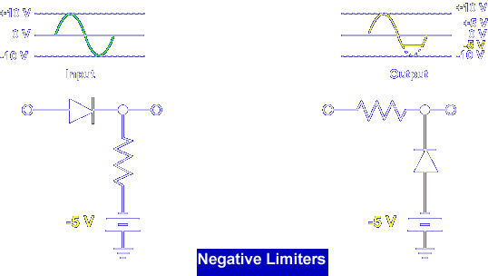

A negative series or parallel limiter with negative circuit bias lowers the limit point from 0 V to the bias level. The bias voltage changes the reverse bias point for the series limiter and changes the forward bias point for the parallel limiter.

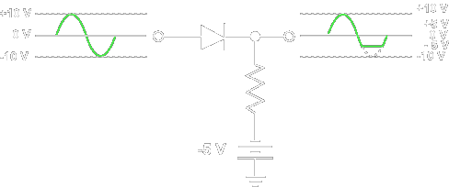
NEGATIVE SERIES LIMITER BIAS POINT - Limiting action does not occur until the diode is reverse biased (input signal less than -5 V). When the diode is reverse biased, the bias voltage is felt on the output.
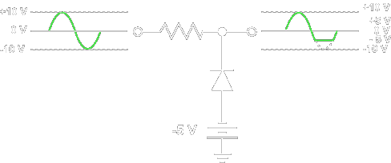
NEGATIVE PARALLEL LIMITER BIAS POINT - Limiting action does not occur until the diode is forward biased (input signal less than -5 V). When the diode is forward biased, the bias voltage is felt on the output.

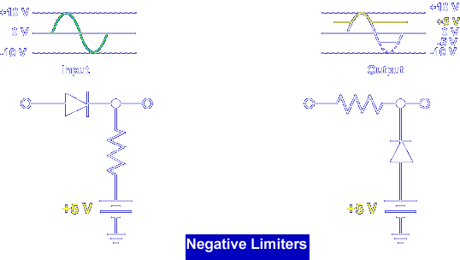

A negative series or parallel limiter with positive circuit bias raises the limit point from 0 V to the bias limit. The bias voltage changes the reverse bias point for the series limiter and changes the forward bias point for the parallel limiter.

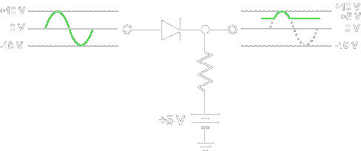

NEGATIVE SERIES LIMITER BIAS POINT - Limiting action does not occur until the diode is reverse biased (input signal less than +5 V). When the diode is reverse biased, the bias voltage is felt on the output.
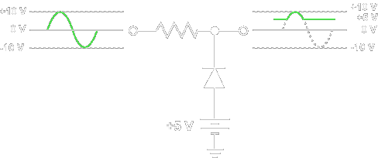
NEGATIVE PARALLEL LIMITER BIAS POINT - Limiting action does not occur until the diode is forward biased (input signal less than +5 V). When the diode is forward biased, the bias voltage is felt on the output.

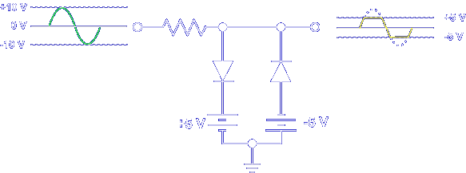

Combining a biased positive parallel limiter and a biased negative parallel limiter changes both alternations.

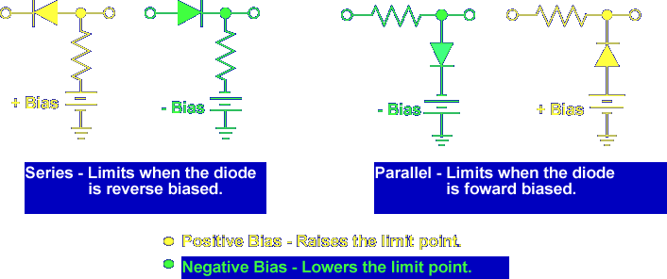

Remember, biased limiters operate just like unbiased limiters.

This completes the information on DIODE LIMITERS.

