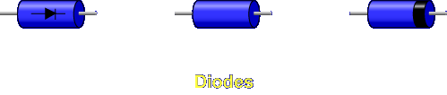

Diodes are not like any other component you have studied. They cannot be compared to resistors, capacitors, inductors, or transformers. Diodes are made from semiconductor materials that have the properties of conductors and insulators.

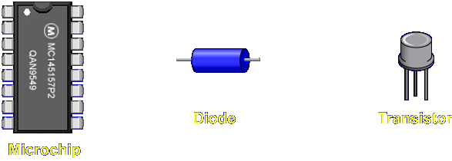

Diodes belong to a group of components called solid-state devices.

SOLID-STATE DEVICE - A solid-state device is an electronic device which operates by virtue of the movement of electrons within a solid piece of semiconductor material.

Let's begin the lesson on INTRODUCTION TO DIODES.

