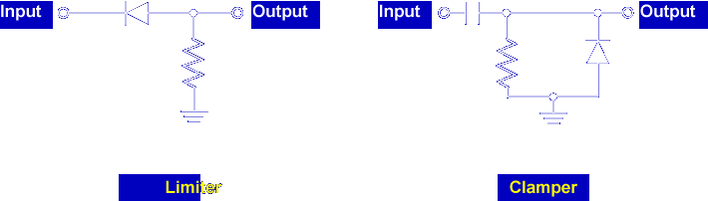

In this lesson, you will learn about troubleshooting diode limiter and clamper circuits, and you will troubleshoot a faulted limiter and clamper circuit.

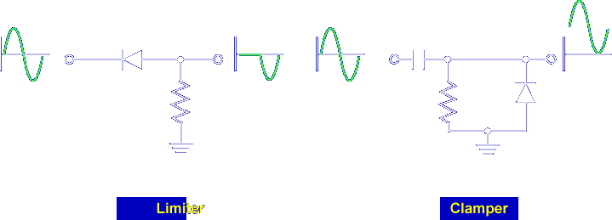

Limiters and clampers alter AC input signals. Measuring the input and output signal with an oscilloscope will determine if the circuit is operating normally.

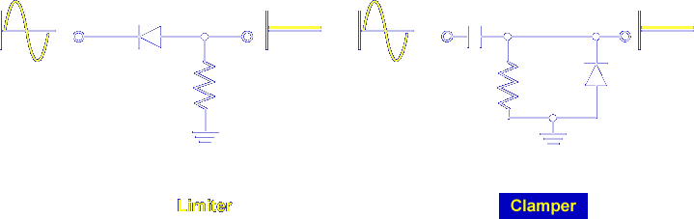

An incorrect waveform indicates that the circuit is faulted. Let's begin the lesson on LIMITER AND CLAMPER TROUBLESHOOTING EXPERIMENT.

