Student Enrollment Directions: Students will need a voucher number from the instructor in order to enroll and begin the CareerSafe® course.
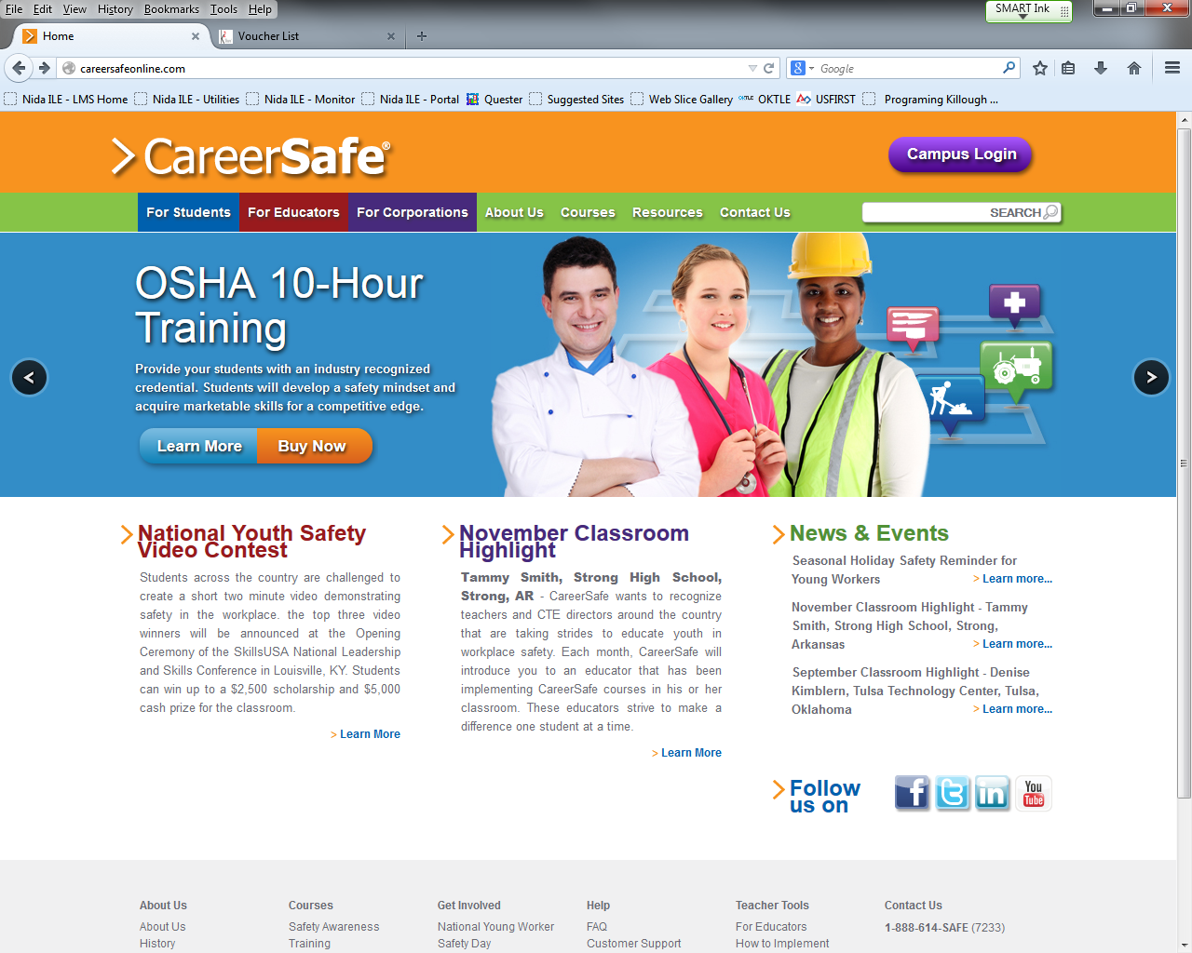
1.
www.careersafeonline.com
2.
  - Go to the CareerSafe® Campus at www.careersafeonline.com
  - Click on "Campus Login"
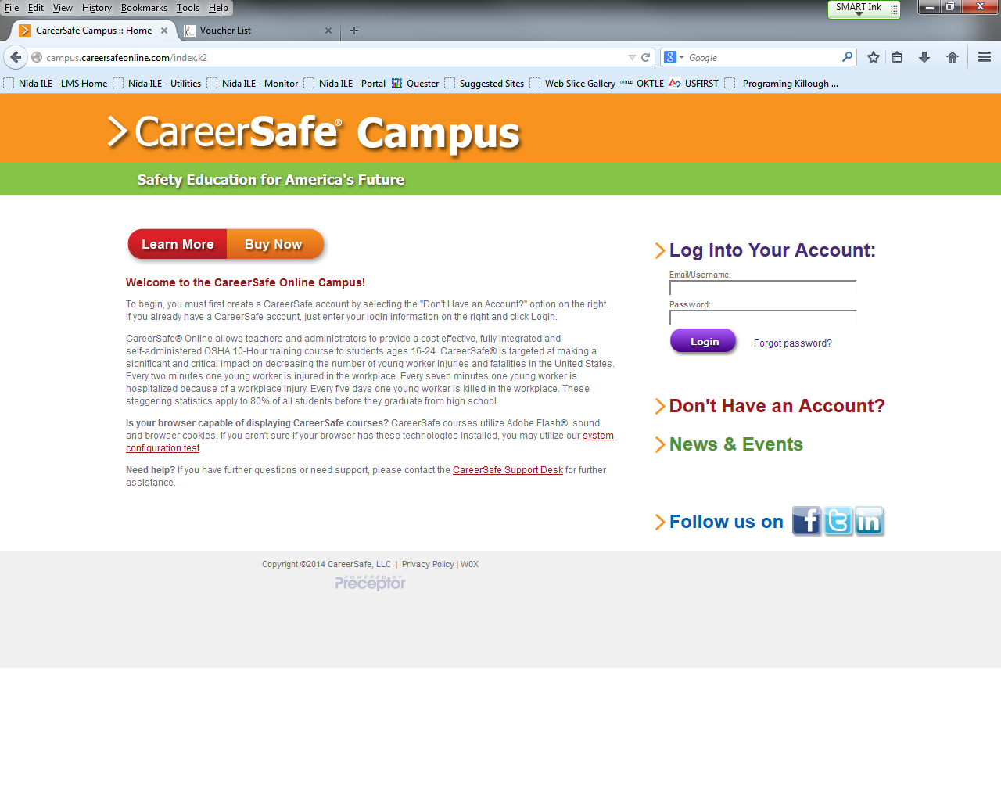
3.
  - Click on "Don’t Have an Account?"
- Students must complete the New User Registration form by giving:
  - A valid email
  - First and Last name
  - The voucher number (Given out by your instructor).
- Students are now logged in and can immediately begin taking the course

NOTE: Once a student is enrolled, they will not need to input their voucher number again

