In this lesson, you will learn about diode clampers. This is a circuit application for the diode.

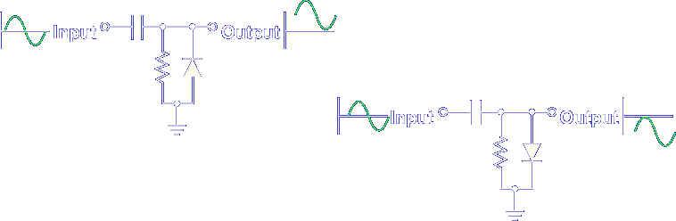

Clampers are so named because they change the voltage level of an AC signal by adding a DC voltage. They are useful, simple circuits, consisting of a diode, resistor, and capacitor.

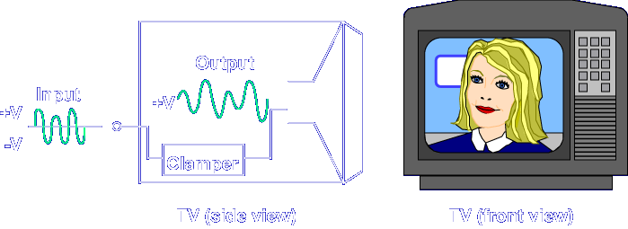

Clampers are used in televisions to add a DC voltage to the video signal for operation of the picture tube.

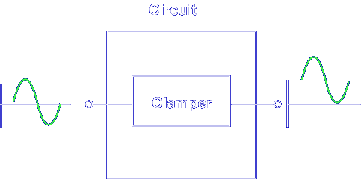

Clampers are used in any circuit where an AC signal must ride on a DC level.

Let's begin the lesson on DIODE CLAMPER OPERATION.

