Cheese Tasting
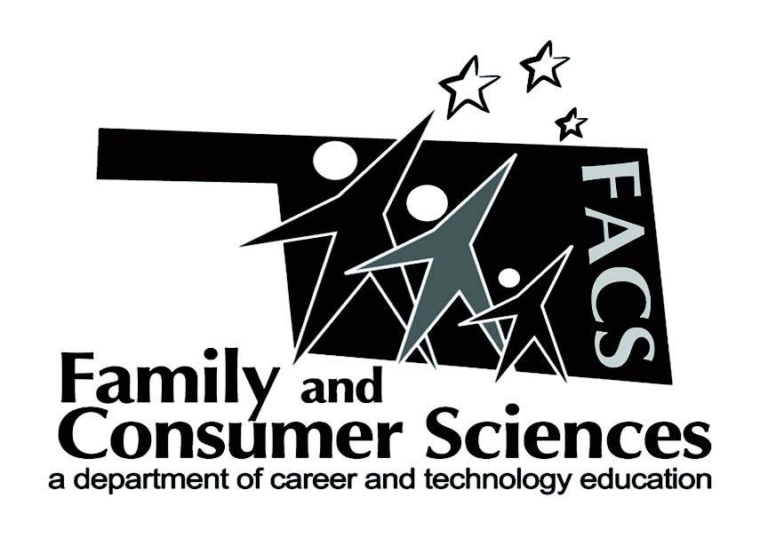

Lesson Plan Title:
FACS I Unit 14
Subject Area:
Recommended course(s):

Aligned to NASAFACS Standards:
8.5.7

Objectives:
Objective 3 Identify forms of cheese
Objective 4 Identify guidelines for cooking milk and cheese

Materials needed:  Different types of Cheese.  Hard—Parmesan and Romano  Firm---Cheddar, Gouda, and Provalone  Semi soft—Colby Jack, Mozzarella, pepper jack, and blue cheese  Soft—Cream Cheese  Processed—Velvetta  Pasturized Processed—American Slices  Rotel  Green Onions  Dried Beef  Chips  Recipe for the Red Pepper Crackers and Cheese Ball | Resources:  Unit 14 from the Oklahoma CIMC FACS I Textbook

Lesson Summary/Outline:
Day one: Go over the objectives and watch the youtube video on cheese making.
Day two: Assign the 3 labs and have one lab group cut cheese into squares
Day three: Rotel and Cheese Dip lab (Processed Cheese)
And the Red Pepper Crackers Lab
Day four: Cream Cheese Ball Lab (soft cheese)
Day five: Cheese tasting of the (hard, firm and semi soft cheese)

Motivator/Opening:

Activities:  You Tube Video:The Art of Cheesemaking by  University of Wisconsin Extension  Labs:  Rotel Cheese Dip and Chips  Red Pepper Crackers  Cream Cheese Ball | Assignments:  Unit 14 Vocab and Review Questions  Cheese Around the World wordsearch

Evaluation:
Unit 14 Test
Student evaluation of the Cheese Tasting

Notes:
Submitted by:

Shelly Crawford
Contact info:
scrawford@ridgerunners.net
Make sure Red Pepper Cracker are make a day or two before the Cheese tasting day.

