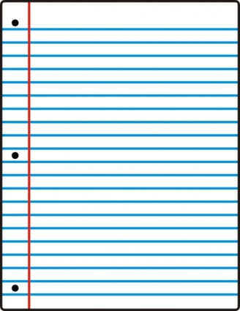

**Heading goes in the upper RIGHT corner of your paper. Failure to follow these rules will result in a 25-point deduction per occurrence.**

**CORRECT HEADING FOR YOUR PAPERS:**

FIRST & LAST NAME (Written legibly)

Date (9-27-12)

Hour (1st hour)

Assignment (Chapter Review – page number & which questions to answer)

For a grade, you must turn ALL ASSIGNMENTS IN! If you leave them on the table, they get thrown in the trash.



**CORRECT HEADING FOR YOUR PAPERS:**

FIRST & LAST NAME (Written legibly)

Date (9-27-12)

Hour (1st hour)

Assignment (Chapter Review – page number & which questions to answer)

For a grade, you must turn ALL ASSIGNMENTS IN! If you leave them on the table, they get thrown in the trash.

**Heading goes in the upper RIGHT corner of your paper. Failure to follow these rules will result in a 25-point deduction per occurrence.**