**SIMPLE PURSE FROM BANDANA SQUARE**

* Fold in half to form a triangle.
* Measure from corner approximately 1/3. Sew from folded edge to about 1 inch from top.
* Repeat from other side.
* Cut two squares of fabric (or use two bandandas).
* Cut one piece of batting, about ¾ “ smaller than fabric squares.
* Stack layers (fabric, batting, fabric)
* Stitch around edges to join all layers.
* Free-embroider design through all layers.
  + This can be done in a particular design or just random.

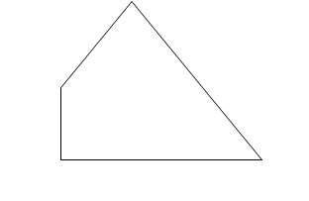

* Open out the side point and wrap back around to meet point to opposite stitched line.
* Repeat with other side
* This will create an outside pocket on each side
* Stitch the two layers of fabric together where they cross so that they pockets will hold contents.
* Attach strap to each side where the layers connect at top of pockets.
* Can attach fasteners to pockets and flaps if you choose.

