Toy Evaluation
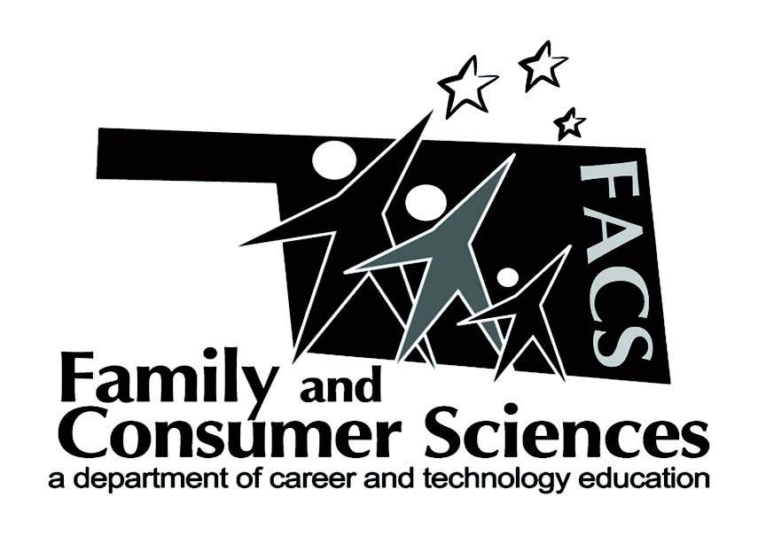

Lesson Plan Title:
Child Development
Subject Area:
Recommended course(s):
FACS 1

Aligned to NASAFACS Standards:
Area of Study 12.0
Human Development
Comprehensive Standard
Analyze factors that influence human growth & development.

Objectives:
Evaluate children’s entertainment for appropriateness.

Materials needed:  Toy Evaluation Worksheet  Children’s toy, craft, website, book, and tv show | Resources:  Pbskids.org/games

Lesson Summary/Outline:
Students will be given a handout to take with them to each station. Every station will have a different toy setup according to a child’s age and one will have computers with the kids website loaded. Students will be given a set amount of time per station to evaluate the toys and answer the questions on the worksheet, with the last 5 minutes of class we will discuss what the students thought of each station and if they felt the toy would help a child with their physical, mental and emotional growth.

Motivator/Opening:
Children learn through play, it is important as caregivers that we only give children games that are appropriate for their age and mental, physical and emotional growth. Whatever they are playing with needs to be teaching them in some way.

Activities:  Students will go to each station and evaluate the toys and web games for their appropriateness according to the different stages of developments, they will have a set amount of time depending on how many stations and time allotted. | Assignments: Answer questions on worksheet, turn in at the end of class.

Evaluation:

Notes:
Submitted by:
Kaitlen McCarty at Jenks 9th Grade Center

Contact info:

