**Sew a Pocket Pack Tissue Cover- - Slit Front Style**

By [Debbie Colgrove](http://sewing.about.com/bio/Debbie-Colgrove-4090.htm), About.com Guide

Pocket packs of tissues are great to have in your purse but all too often the plastic rips and the tissues are a mess before you were ready to use them. Make a durable fabric cover for the pack and preserve the tissues until you are ready for them.

**Materials**

[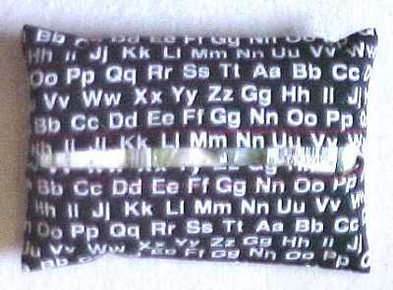](http://z.about.com/d/sewing/1/0/9/A/pockettissue3.jpg)

Materials:

* Fabric -- 5 1/2" x 8"
* Coordinating Thread (Contrasting thread was used in the photos for visibility)

Finished pocket pack tissue cover

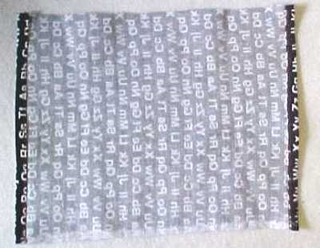

* Mark the center of the 8" edges
* On both 5 1/2" edges, turn under 1/4" with wrong sides together, turn under again to enclose raw edge. Stitch the hem in place.

**The Seams**

* Fold both hemmed edges to the center with right sides of the fabric together.
* Bring hemmed edges to middle and sew seam.
* Using a 1/4" seam allowance, stitch the raw edges. Zigzag the seam allowance.
* Turn right side out.
* Press

[The 
seams](http://z.about.com/d/sewing/1/0/7/A/pockettissue2.jpg)

*Debbie Colgrove, Licensed to About.com*

|  |  |  |  |  |  |
| --- | --- | --- | --- | --- | --- |
| |  | | --- | | Teen Sewing & Craft Projects | | |  |  | | --- | --- | | http://www.sewing.org/assets/images/autogen/clearpixel.gif | Project provided courtesy of:  [Coats & Clark](http://www.coatsandclark.com)  © | | |
| |  |  | | --- | --- | | Denim Organizerhttp://www.sewing.org/assets/images/Denim_Organizer_Pic.jpgThis fun organizer, made from the legs of cut-off jeans, is a great recycling project. The finished hem of the jeans creates the top of the organizer’s pockets, so there is no need to bind the edges.  This project can be embellished in many ways. We used machine embroidery and decorative stitches. Other options include hand embroidery, rickrack or other trim, or appliqué. It could also be personalized and the pockets labeled. Supplies  * Jeans Legs: 3 pairs of legs * Denim fabric: 1 yard (91.4cm) * Cord for hanging: 1 yard (91.4cm) * Dowel: 24 inches (61.0cm) * Coats Dual Duty Plus® Extra Strong Jeans Thread (N574) or * Coats Dual Duty Plus® All-purpose Thread (Art 200): color 5 Copenhagen or to match denim * Coats Rayon Thread-30 wt. (Art D93): color 182 Spark Gold and Coats Rayon Thread-40 wt. (Art. D63): Color 51 Chona Brown were used in this project * Stabilizer for embroidery.  Steps 1. Organizer fabric:Cut 2 pieces of fabric 22 inches x 25 inches (55.9cm x 63.5cm).  2. Pockets: Cut the pant leg sections apart at the outer seam, trimming away the seam. 1st row: Trim 3 leg pieces 5 inches (12.7cm) high by 10 inches (25.4cm) wide. 2nd row: trim 3 leg pieces 9 1/2 inches (24.1cm) high by 10 inches wide. (25.4cm).  3. Embellish pockets as desired with decorative stitching, appliqué, machine or hand embroidery, or trims.  4. To form each pocket row, sew the three same-size leg sections together.  5. Mark the pockets as shown for folding pleats (Illustration 1). At the two ends, fold solid line to dotted line. At seams, fold solid lines to seam line; do not overlap. Baste pleats in place at lower edge.   |  | | --- | | http://www.sewing.org/assets/images/Denim_Organizer_Illustration__1.jpg |   http://www.sewing.org/assets/images/Denim_Organizer_Illustration__2.jpg6. Attaching top row: Mark a line on organizer fabric 11 1/2 inches (29.2cm) from top edge. Place pocket row on fabric, right sides together, with the lower raw edge of pockets against the line (Illustration 2). Stitch, 1/2 inch (1.3cm) from edge. Press seam allowance toward pocket. Fold pocket section right-side-up; press. Baste side seams. Using Jeans thread or all-purpose thread, stitch in the ditch along seams in pocket row to form individual pockets.  7. Bottom row: Fold pleats as above and baste. Place pocket section on organizer fabric, right side facing you, aligning raw edges. Baste sides and bottom edge of pocket. Stitch in the ditch along seams in pocket row to form individual pockets.  8. Place backing fabric on top of organizer, right sides together. Stitch together, using a 1/2-inch (1.3cm) seam allowances. At the top corners, leave a 1-inch (2.5cm) opening in the side seams for inserting a dowel or curtain rod. At the lower edge, leave a 6-inch (15.2cm) opening for turning.  9. Trim corners diagonally. Grade lower edge to reduce bulk. Press the seams open before turning. Pay particular attention to places that are thick due to jeans seams. Turn to right side. Press. Hand sew opening in lower edge closed.  10. Insert dowel, and attach a cord for hanging. For better stability, use a curtain rod and brackets for hanging. | |  | | |

**Oilcloth Crafts: Lunch Bags**

The same oilcloth that covers your kitchen table can transport your children's lunches -- or your own -- in leak-free style. These reusable bags will cut back on waste since they can simply be washed with a damp sponge (oilcloth is not washing-machine safe). Use a single print for the whole bag, or cut out complementary patterns or solid colors for side panels. You can attach small Velcro tabs to hold the bags closed, or clip the tops with colorful wooden clothespins.

**Lunch Bag How-To**

Cut main piece 29 1/2 by 8 inches and two side panels, each 12 1/4 by 5 inches.

. 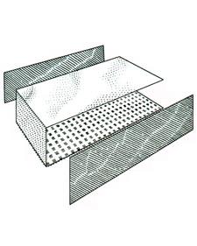

1. Fold long panel, inside out, into U shape with 5-inch bottom

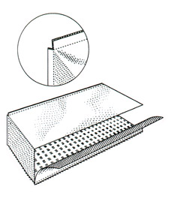

2. Make 1/4-inch cut at bottom corners of side and middle pieces so bag folds smoothly. Sew-in side panels, leaving 1/4-inch seam allowance.

. 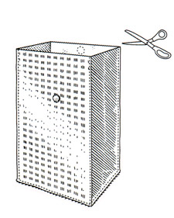

3. Turn right side out and top-stitch all around, 1/8 inch from edge

**T-shirt sling bag** (repurpose)

[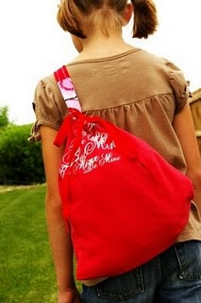](http://4.bp.blogspot.com/_5fjP-q9XAOo/SiVWUtLGIVI/AAAAAAAAD54/SSJ8eG8n5sE/s1600-h/redtbag.jpg)[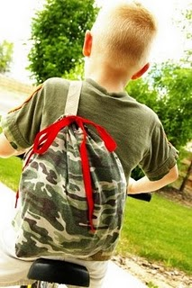](http://3.bp.blogspot.com/_5fjP-q9XAOo/SiVWUR3iv7I/AAAAAAAAD5w/LVjhLVpRvDA/s1600-h/camobag.jpg)

Supplies:

T-shirt - any size. Great to re-purpose or re-use a favorite shirt, outgrown, stained, etc.

Rotary Cutter and Mat (not necessary but nice)

Scissors

Sewing Machine

Thread

Pins

Material for a Bag Strap - can use fabric, or the by the yard materials at fabric store - 27 inches long for child sized

Shoestring/ribbon/string - something similar in width and strength for casing and closure

(and if you craft one up please share it in the [Brassy Apple Flickr Group](http://www.flickr.com/groups/brassyappleprojects/pool/)!)

STEP 1: Lay out your T-shirt (if your shirt has a direction image on it see directions below)

[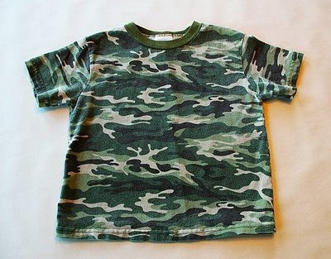](http://2.bp.blogspot.com/_5fjP-q9XAOo/SiViZiy4IcI/AAAAAAAAD8A/acc6Meevkas/s1600-h/camo+step1.jpg)

Step 2: Using your Rotary Cutter and Mat (or scissors) cut off both sleeves at an angle - leaving as much shirt as possible. Then cut off the neck hole as well.[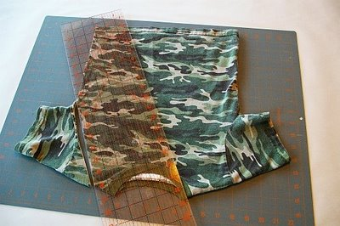](http://3.bp.blogspot.com/_5fjP-q9XAOo/SiViZZtS9_I/AAAAAAAAD74/UUC4X0MTVk4/s1600-h/camo+step2a.jpg)  
  
[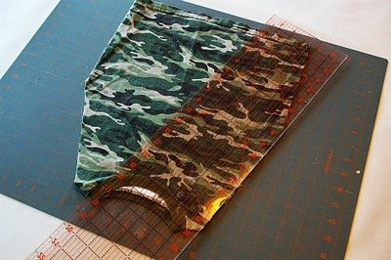](http://1.bp.blogspot.com/_5fjP-q9XAOo/SiViR8bGG2I/AAAAAAAAD7w/bwSkT2omuGw/s1600-h/camo+step2b.jpg) [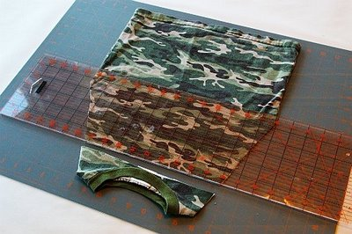](http://1.bp.blogspot.com/_5fjP-q9XAOo/SiViRe-4yoI/AAAAAAAAD7o/h3C9pnRsFEA/s1600-h/camo+step2c.jpg) [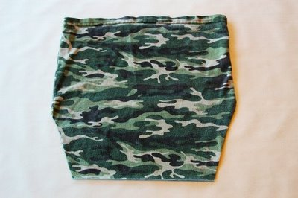](http://4.bp.blogspot.com/_5fjP-q9XAOo/SiViRB1YB6I/AAAAAAAAD7g/Bc6iLbEbgow/s1600-h/camo+step2d.jpg)

Step 3: Flip your t-shirt inside out. Now let's attach your bag strap. In one of the corners pin the end of your strap through one layer of the t-shirt. Sew in place.

[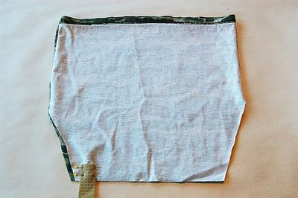](http://4.bp.blogspot.com/_5fjP-q9XAOo/SiViRLLs0_I/AAAAAAAAD7Y/1cWQLU4BK3A/s1600-h/camo+step3.jpg)

Step 4: Tuck the bag strap under and in between the t-shirt layers so it lays flat and comes out the top of the t-shirt. Pin.

[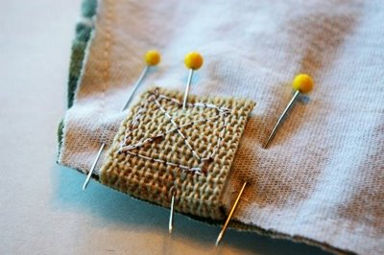](http://3.bp.blogspot.com/_5fjP-q9XAOo/SiViQ4z0lcI/AAAAAAAAD7Q/SjfJfpvDk_Q/s1600-h/camo+step4.jpg) [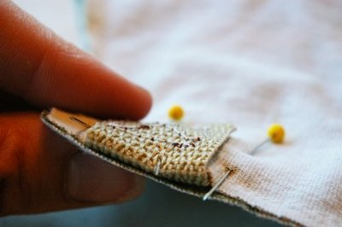](http://4.bp.blogspot.com/_5fjP-q9XAOo/SiVh_-RRmcI/AAAAAAAAD7I/tKtJWRyXKT4/s1600-h/camo+step4a.jpg)

Step 5: Pin the 3 sides you cut and sew together.

[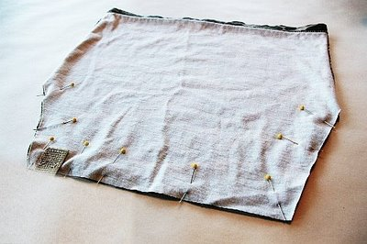](http://3.bp.blogspot.com/_5fjP-q9XAOo/SiVh_hb1NfI/AAAAAAAAD7A/wJqbKufps7A/s1600-h/camo+step5.jpg)

Step 6: Keeping your strap flat and un-twisted, place the other end of the strap in the opposite corner and pin through one layer of the t-shirt. Be sure to place, pin and sew under the finished hemline. Sew in place being careful to not sew through the finished hemline area. We need that area in the next step.  
[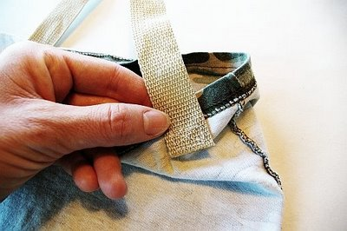](http://4.bp.blogspot.com/_5fjP-q9XAOo/SiVh_YzDQHI/AAAAAAAAD6w/glHSbP2Z7N8/s1600-h/camo+step6b.jpg)

Step 7: Flip your "bag" right side out. Using the hemline as a premade casing, find the middle of the top and slightly roll the hemline between your two fingers to seperate the two layers. Cut two small slits side by side for your string to go through.

[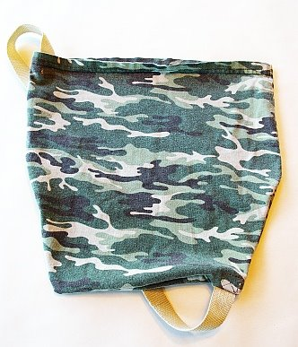](http://3.bp.blogspot.com/_5fjP-q9XAOo/SiVh_FNf6oI/AAAAAAAAD6o/jqxnKMbxXyg/s1600-h/camo+step7.jpg) [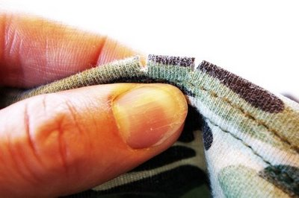](http://1.bp.blogspot.com/_5fjP-q9XAOo/SiVhvUwwwHI/AAAAAAAAD6g/ADDB87Xy5jU/s1600-h/camo+step8.jpg)  
  
Step 8: Thread through 1 shoestring, ribbon, string, or whatever you would like to pull the top of your bag together. I found this pair of shoelaces on clearance for .90! Pull the top together, tie it off and strap it on!

[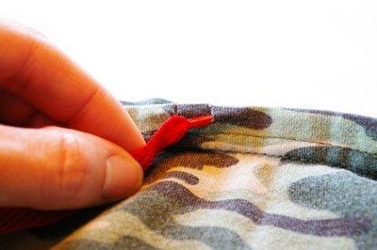](http://1.bp.blogspot.com/_5fjP-q9XAOo/SiVhvI5tfyI/AAAAAAAAD6Y/gpCSw8UKsbI/s1600-h/camo+step9a.jpg) [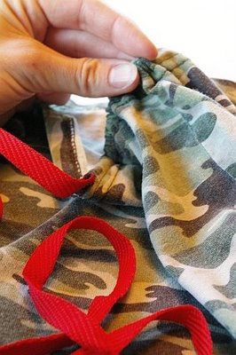](http://1.bp.blogspot.com/_5fjP-q9XAOo/SiVhvGdFxuI/AAAAAAAAD6Q/bYwodZNXKS4/s1600-h/camo+step9b.jpg) [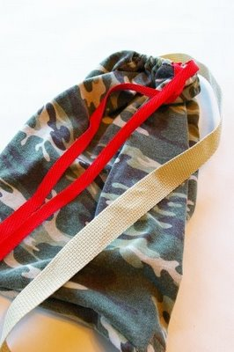](http://3.bp.blogspot.com/_5fjP-q9XAOo/SiVhuxJcXvI/AAAAAAAAD6I/HdvEj_pnagk/s1600-h/camo+bag+DONE.jpg)

These bags for great for your kids to be able to throw on their backs while bike riding or taking to the park. They can hold a water bottle or any of their "treasures" they find while out playing. Perfect for trips too to hold all of their cars/toys/crayons. Take it to the beach or the pool! And one of the great things about this bag? It's machine washable! Just throw the entire bag in the washer and the dryer when it gets dirty!

[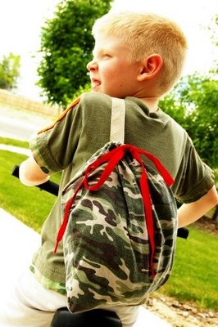](http://4.bp.blogspot.com/_5fjP-q9XAOo/SiVhuhE2pfI/AAAAAAAAD6A/zldu10kHlFg/s1600-h/camo+bag+finish.jpg)

**Second option: (directional graphic)**

If your t-shirt has a directional image on it and can't be flipped upside down, cut and sewn up like pictured above and follow these alternate directions.

[](http://1.bp.blogspot.com/_5fjP-q9XAOo/SiVzGpAD3eI/AAAAAAAAD9Q/cEkS1rO3MjU/s1600-h/red+step1.jpg)

Step 1: Cut off the sleeves and neck hole. (Same as instructions above)

[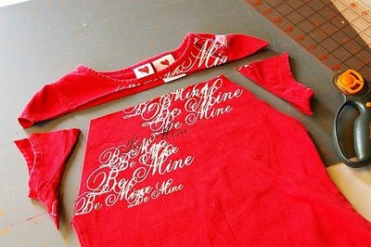](http://4.bp.blogspot.com/_5fjP-q9XAOo/SiVzGcRDx1I/AAAAAAAAD9I/oEux9eIQwSc/s1600-h/red+step2.jpg)

Step 2: Turn your shirt inside out and lay flat. Place your strap inside the shirt between the 2 layers, lining up with the bottom of the shirt. Pin in one corner. Pin the entire bottom of the shirt and sew together sewing through and attaching the strap

.[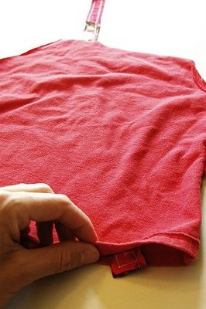](http://2.bp.blogspot.com/_5fjP-q9XAOo/SiVzGFxiT4I/AAAAAAAAD9A/i2PrBvKieds/s1600-h/red+step3a.jpg) [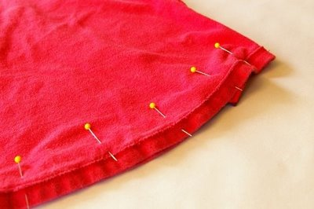](http://3.bp.blogspot.com/_5fjP-q9XAOo/SiVzGC6fGFI/AAAAAAAAD84/3BvadbGG7QU/s1600-h/red+step3b.jpg)

Step 3: Pin and sew the 2 angled sides where the sleeves where once located. Leave the top open. Be sure your bag strap is out of the way.

[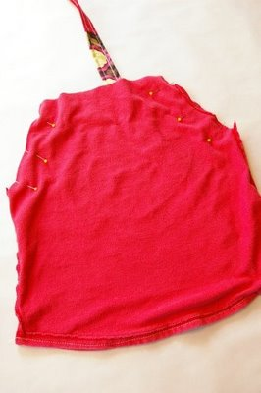](http://1.bp.blogspot.com/_5fjP-q9XAOo/SiVzF6E-GVI/AAAAAAAAD8w/-QHnn8cjaJk/s1600-h/red+step4.jpg)

Step 4: Fold back the top edge about 3/4 an inch (or however wide you would like your casing to be) and pin. Sew. Turn your bag right side out and cut to slits in the casing (follow instructions above)

[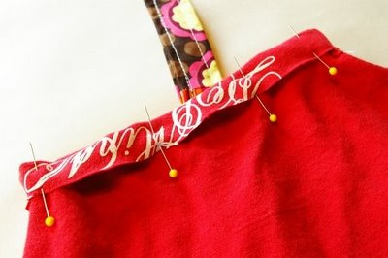](http://4.bp.blogspot.com/_5fjP-q9XAOo/SiVyvFac_fI/AAAAAAAAD8o/YY1_ZxrB8pE/s1600-h/red+step5.jpg) [](http://4.bp.blogspot.com/_5fjP-q9XAOo/SiVyvJtwbjI/AAAAAAAAD8g/2ZabWthHEXU/s1600-h/red+step6a.jpg) [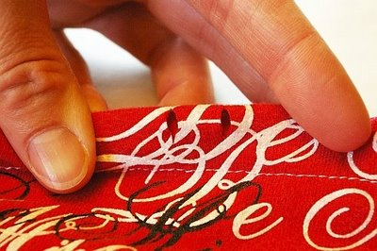](http://4.bp.blogspot.com/_5fjP-q9XAOo/SiVyu4ElDTI/AAAAAAAAD8Y/dWO-ESNGlaI/s1600-h/red+step6b.jpg)

Step 5: Keeping your strap flat and untwisted pin and sew it under your casing on the "back" side of your bag. Thread your string through the casing.

[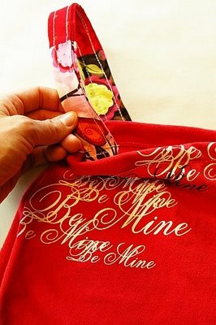](http://1.bp.blogspot.com/_5fjP-q9XAOo/SiVyupiv1wI/AAAAAAAAD8Q/-6VfjpFZF5w/s1600-h/red+step+7.jpg) And you are done! [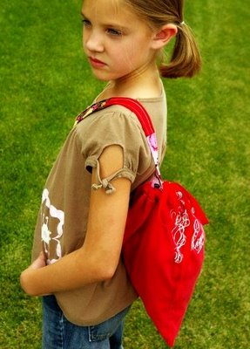](http://2.bp.blogspot.com/_5fjP-q9XAOo/SiVyutYgglI/AAAAAAAAD8I/NJlDYSDQ4as/s1600-h/red+bag+finish.jpg)

Paula Milner’s

Purse Pattern

pmilner@cyberport.net

http://users.cyberport.net/~milnerwm/index.html



Supplies: 1/2 yard lining, 1/2 yard binding fabric, blue jeans, stiff mesh, 3/4” French Snap, 1/2 yard faux

suede, 6 yards-1/2” cotton piping 2” velcro, 3 inches suede for pull tab, Fancy button for RS of flap.

1. Cut out front of purse one each: denim and lining fabrics
   1. Sew in gusset at bottom of purse in denim and lining fabrics
   2. Baste denim & lining fabrics WS together on perimeter 1/8” from edge of back of purse
   3. Bind top of purse front
2. Embellish purse front
3. Cut out organizer of stiff mesh same dimensions as purse body.
   1. Cut a 10”x 15” pocket from lining fabric for the organizer.
   2. Fold to make 5”x15” rectangle, line up raw edges at round of mesh.
   3. Layout actual items on mesh & lay folded pocket on top, pin & mark stitch line.
   4. Pockets on backside will have to same stitch lines as the front.
   5. Trim lining to match bottom and sides of mesh. Pocket is lower than the top of the mesh.
   6. Bind all edges of organizer
4. Cut out flap pocket of mesh
   1. Bind straight edge of flap pocket, sew on velcro and suede pull tab.
5. Cut out back of purse one each: denim and lining fabrics
   1. Apply pocket(s) to back RS
   2. Apply velcro to RS of lining. Use mesh flap pocket as guide for velcro placement.
   3. Baste denim unit & lining fabric WS together on perimeter 1/8” from edge of back of purse.
6. Baste front purse unit to back unit (RS lining to RS lining)
7. 7, Make a 58” tube and insert piping, attach to top sides of front purse
8. Cut bias faux suede about 2.25” wide (measure see if this works for your purse’s layers)
   1. Apply folded bias to front of purse
   2. Wrap folded edge of bias to back of purse so that 1/8” more extends beyond the front.
   3. From the front of purse stitch in the ditch catching the wrapped bias fold on the back of purse.
9. Install French Snap or closure of your choice and sew on decorative button on outside of flap.



**Sturdy Tool Wrap**

**BERNINA®**

Supplies

• ¾ yard denim or canvas

-Cut two backs, 12” x 16”

-Cut two fronts according to diagram below

• ½ yard contrasting fabric for binding

• Construction thread

• Bias Binder Attachment (BERNINA® #84 with

Foot #94

• Walking Foot (BERNINA® #50)

• 505 Spray (optional)

• Fabric marking pen

Machines

• Any BERNINA® sewing machine with a preprogrammed alphabet

• Most other sewing machines with a

preprogrammed alphabet

*This roll-up holder keeps wrenches in order, ready to use, each marked with the correct size. Makesa great gift for the handyman in your life!*



*www.berninausa.com*

•*Optional:* Using the preprogrammed alphabets of the sewing

machine, stitch a name or monogram in the upper

left corner of one of the back pieces.

*Optional: Stitch the letters using an embroidery*

*machine as in the sample shown in the photograph.*

• Place the two back pieces *wrong sides* together;

bond with temporary spray adhesive if desired.

• Using a walking foot, stitch all four sides with a

narrow zigzag stitch, about ¼” from the edges; set

aside. Repeat with the two front pieces.

• Using the bias binder attachment, bind

all edges of the holder. Start approximately

in the center of the left edge, leaving about 15” of bias cord at the beginning and ending point for ties. *Note: Another alternative is to bind the tool wrap (rectangle) and stitch the ties on separately at the*

*center of one end*

• Tie each end of the cord into a knot. Roll the holder from the right side, wrap the ties around and tie to secure.

• Cut bias strips from the contrasting fabric as

directed by binder instructions. Stitch together to

form one long strip, approximately 3 yards long.

• Using a bias binder attachment, bind the slanted

edge of the front.

• With a marking pen or chalk, draw lines to indicate

the pocket separations as shown.

• Using the preprogrammed alphabets of the sewing

machine, stitch the wrench sizes about ½” below the

bound edge of the front of the holder. *Note: On the*

*diagram below, the upper numbers are the wrench*

*sizes and the lower numbers are the distances*

*between the pockets. Adjust these as needed*

*to suit your tool set.*

• Place the front right side up on the back

and stitch the edges together

• Using a triple straight stitch, sew the

pocket separations as marked.

### [Fabric-covered CD coaster](http://mojoandco.blogspot.com/2009/10/tutorial-fabric-covered-cd-coaster.html)

**Materials (for one coaster):**

* 2 x fabric scraps at least 14 cm square.
* Enough scraps to make up 55cm of bias binding
* 1 unwanted CD
* Thread

[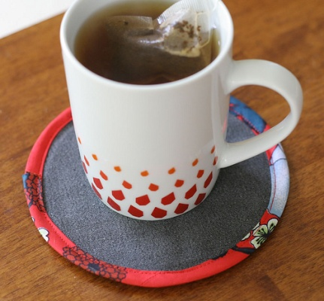](http://farm4.static.flickr.com/3492/4031166528_b7ed7d5ec1.jpg)

**Before you start:**

You will need to use a fairly sturdy fabric, as the CD will show through lighter fabrics. I've used denim from an old pair of jeans. Alternatively you could line loosely woven fabrics with plain fabric or interfacing scraps.

Also it is important that when attaching the binding it is close to the CD. Otherwise the CD will slide around and the coaster will be a bit floppy. If necessary, trim the seam allowance down to allow the binding to be up against the enclosed CD.

**Step 1:**

Lay fabric scraps together with wrong sides together. Cut out a 14 cm diameter circle. To do this I drew around my CD then added a 1 cm seam allowance.

**Bias binding:**

Cut diagonal strips of fabric 4 cm wide. Join to form at least 55 cm of bias binding. Press binding flat with seams opens. Trim off any overhanging corners. Fold strip in half along length and press, to make it 2 cm wide. Open binding out flat again. Fold one long side of strip to center crease and press. Repeat for other side. Fold two sides together along center crease again and press. The binding strip should now be 1 cm wide.

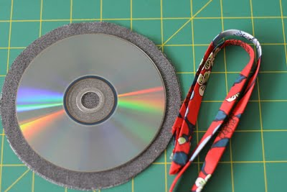

**Step 2:**

Place the CD between the two circles, right sides facing out. Pin the two fabric layers together around the CD, enclosing it in the center. Using your sewing machine's zipper foot, baste the circles together around the CD. Make sure the CD is tightly enclosed by stitching as close to the CD as possible.

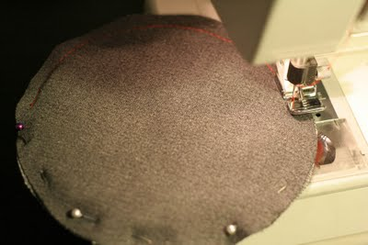

**Step 3:**

Pin and then sew binding over the raw edges of the circles. Stitch close to the edge of the binding, which should also be close to the CD. Trim off excess binding, leaving a small overlap and sewing the binding end down over the binding start. Done!

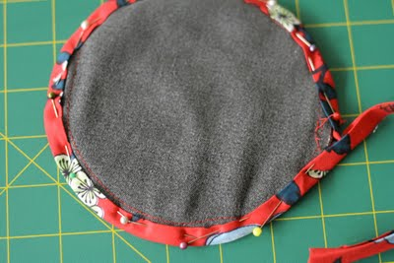

Now you can pour yourself a beverage of your choosing and admire your handiwork!

# Soda Can Coasters

Here is a fun recycled project that is quick and easy. It is guaranteed to make people smile when they realize the coasters are constructed from soda can metal. What is your favorite [flavor](http://www.favecrafts.com/Green-Crafting/Soda-Can-Coasters) of soda?  Project designed by [Lorine Mason](http://www.favecrafts.com/Craft-Designers/Lorine-Mason).

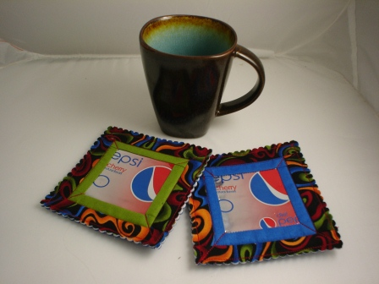

**Materials:**

* Soda cans
* Scraps of two fabrics - 1" strips
* Steam a Seam fusible web
* Felt
* Heavyweight craft interfacing
* Basic sewing supplies

**Instructions:**

1. Wash out the soda can, turn it over onto a dry cloth and let it drip dry.
2. Cut the can apart using craft scissors (no, not your sewing scissors) along the top and bottom edge of the can. Be careful not to cut your fingers as the edges can be quite sharp.
3. Press fusible web to the back of the metal. Using a rotary cutter, mat and ruler, cut 3-inch squares.
4. Remove the paper backing from the metal square and press it to the center of a 5-inch square of scrap cotton [fabric](http://www.favecrafts.com/Green-Crafting/Soda-Can-Coasters).
5. Cut 1-inch wide strips from two complementary fabrics.
6. With right sides together, stitch the solid color strips of fabric along both sides of the 3-inch square, stitching through the scrap fabric base. Trim the strips even with the top and bottom edges of the metal square. Press the fabric away from the metal center piece. Repeat, stitching additional strips to the top and bottom edges of the 3-inch square, trimming and pressing the strips away from the center.
7. Repeat, stitching the second row of fabric strips to the outside edges of the first row of sewn strips. Trim and press the second row away from the metal center piece. You have created the top layer of the coaster.
8. Layer the following together, right sides up. The top layer of the coaster is a 5-inch square of heavyweight craft double-sided fusible interfacing and a 5-inch square of felt. Press well.
9. Sew through all layers of the coaster, stitching between the two rows of fabric strips and then again 1/4 inch in from the outside edge of the coaster fabric.
10. Trim close to the outside stitching lines using pinking or scalloped scissors.

### How to make a Tote Bag

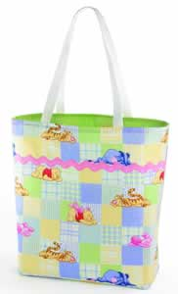

**Materials Needed:**

* 5/8 yard each of fabric and lining
* 5/8 yard of fusible fleece
* 1 1/4 yard of 1 1/8" wide decorative rick-rack
* 1 1/2 yard of 1" wide webbing (cut in half for handles)

### Instructions:

**Step 1.** From fabric and lining cut two 21" squares from each

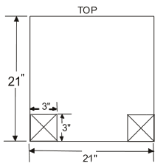

**Step 2.** Cut out a 3" square at the lower corners of each piece

**Step 3.** Bond fusible fleece to the back of each lining piece

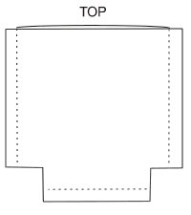

**Step 4.** Stitch 1/2" seam allowances unless otherwise noted. Stitch fabric pieces together on the sides and bottom & repeat with the lining pieces leaving an opening in the bottom for turning

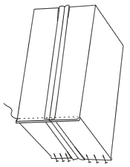

**Step 5.** Matching the side and bottom seams of the fabric, stitch across corners. Repeat with lining

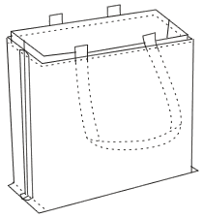

**Step 6.** Stitch fabric to lining at top edge catching the handles that are 7" apart on the front and the back

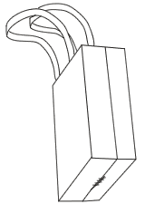

**Step 7.** Turn right side out through opening in lining. Slipstitch opening

**Step 8.** Stitch 1/4" topstitching at top edge and stitch rick rack where desired