Stretchy Book Cover
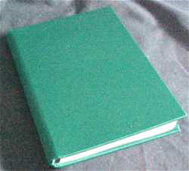
Materials needed:
- 2 way stretch fabric
- Thread
- Sewing machine with a stretch stitch or a serger.
Note: Two way stretch fabric must stretch on the lengthwise and crosswise grain. Bathing suit Lycra works well and may be found on clearance at the end of the summer just in time for the start of school. Your seams MUST be sewn with a stretch stitch.

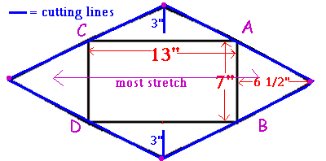

Make a pattern as shown in the diagram for most text books. Find directions for making a custom book cover here.
Cut fabric with the most stretch as shown in the pattern.

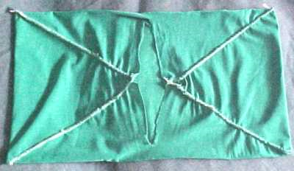
- Fold side A back on itself, matching the dots, with wrong sides together. Stitch with a 1/4 - 1/8" seam allowance.
- Fold side B back on itself, matching the dots, with wrong sides together. Stitch with a 1/4 - 1/8" seam allowance.
- Fold side C back on itself, matching the dots, with wrong sides together. Stitch with a 1/4 - 1/8" seam allowance.
- Fold side D back on itself, matching the dots, with wrong sides together. Stitch with a 1/4 - 1/8" seam allowance.
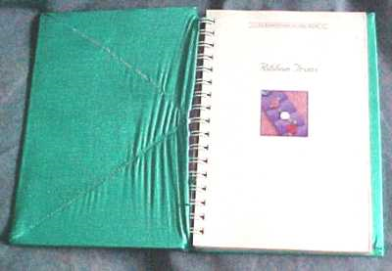
- If you have used a straight stretch stitch, zig zag the seam allowances.
- Turn right side out and cover a book.
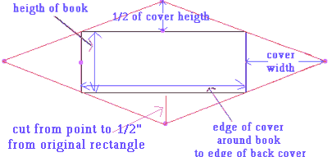

Customize your book cover to any size book by following these directions.
You will need the following measurements from the book you want to cover:
- Height of the book(for this example: 8 3/4")
- Distance around the book - edge of front cover, around book to back cover (For this example: 23 1/2")
- Width of book cover (For this example: 11")
Create the pattern
- Draw a square or rectangle to represent the measurements you have from measuring the book.
- Mark the half way point of all sides.
- At a right angle from the halfway marks, make a mark the width of the cover from the book heigth line
- Make a mark 1/2 of the cover height from the distance around book line.
- Repeat for all sides.
- Join the dots as shown in the diagram. creating your own fabric book cover pattern
- Cut from point to 1/2" from original rectangle on "1/2 of cover" triangle.

