Foundation Standard 1 ACADEMIC FOUNDATION

Body Planes, Directions, and Cavities

INSTRUCTIONAL ACTIVITIES

- Instruct the student to read Diversified Health Occupations.
- Instruct the student to define the key terms.
- Instruct the student to complete the workbook assignment for Diversified Health Occupations.
- Assign 3-D model projects of the body cavities, planes and organs.
- Assign Anatomy and Physiology Project for this unit.
- Using butcher paper, have students trace each other's outline and label parts.
- Instruct the student to take notes and participate in class discussion and activities. (See notes in the Diversified Health Occupations: Teacher’s Resource Kit.)
- Discuss related health careers.

INSTRUCTIONAL MATERIALS/RESOURCES

Thomas. Tabor’s Cyclopedic Medical Dictionary.

Simmers. Diversified Health Occupations.

Simmers. Diversified Health Occupations: Teacher’s Resource Kit.

Simmers. Diversified Health Occupations Workbook.
- Websites:
www.texashste.com
Daily Jigsaw
Jigsaw puzzle (human anatomy) as part of http://sig.biostr.washington.edu/projects/da/.
Frog Dissections:
http://curry.edschool.virginia.edu/go/frog/Frog2/home.html
http://www-itg.lbl.gov/ITG.hm.pg.docs/Whole.Frog/Whole.Frog.html
Froguts - An Amazing Online Virtual Dissection of a Frog
www.froguts.com
Human Anatomy:
http://www.madsci.org/~lynn/VH/planes.html
- PowerPoint presentations:
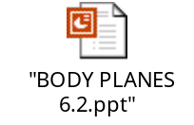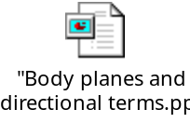

RELATED HEALTH CAREERS

Biochemist
Cytologist
Cytotechnologist
Histologist
Histopathologist
Laboratory Assistant
Medical Office Assistant
Medical Laboratory Technician
Medical Laboratory Technologist
Medical Technologist
Microbiology Technologist
Nurse
Pathologist
Phlebotomist
Physician

TRACE THE DIAGRAMS OF BODY CAVITIES, ABDOMINAL QUADRANTS, AND ABDOMINAL REGIONS. DRAW A LINE TO AND LABEL THE FOLLOWING:

abdominal cavity
cranial cavity
epigastric region
hypogastric region
left hypochondriac region
left iliac region
left lower quadrant
left lumbar region
left upper quadrant

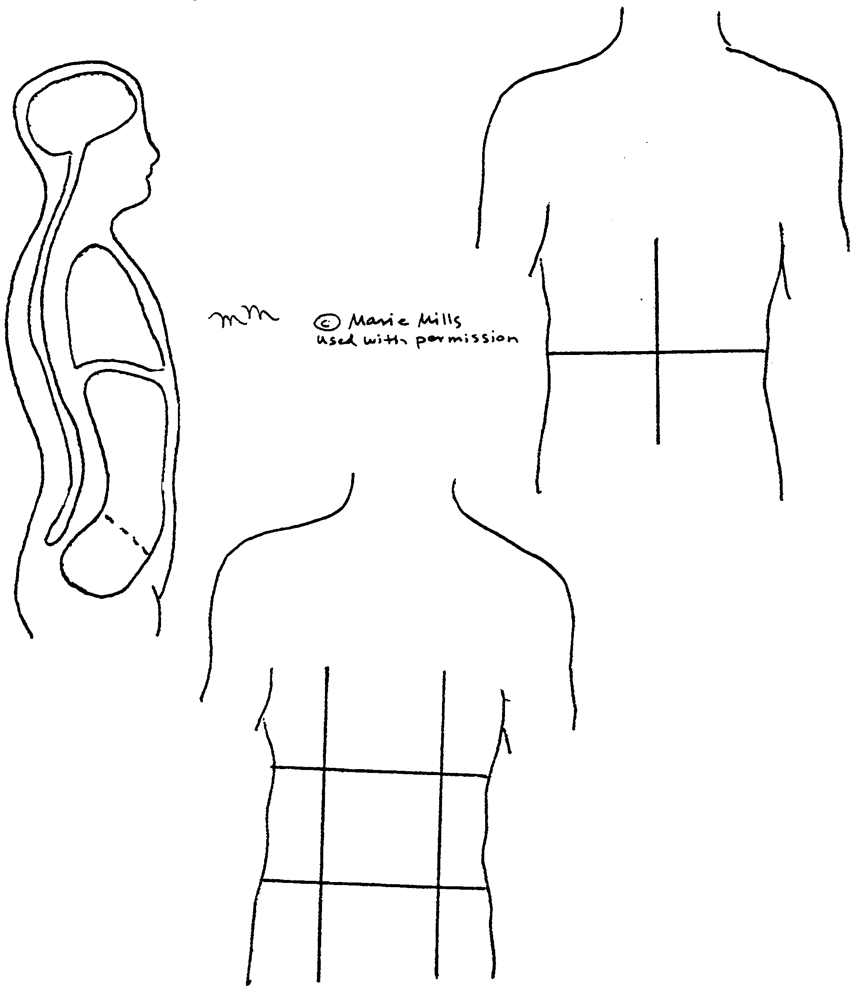
pelvic cavity
right hypochondriac region
right iliac region
right lower quadrant
right lumbar region
right upper quadrant
thoracic cavity
umbilical region
vertebral cavity

ANATOMY AND PHYSIOLOGY PROJECT

by Nanette Morris
Academy for the Arts, Science, and Technology
Myrtle Beach, South Carolina

ANATOMY AND PHYSIOLOGY PROJECT

Objectives/Competencies:

Upon completion of this unit, the student will be able to:
- Compare and contrast cells, tissues, organs and systems.
- Describe body planes, directions, and cavities.
- Describe and interpret the following systems including composition, function,
terminology, three common diseases of each, and related careers:
- Integumentary
- Skeletal
- Muscular
- Circulatory
- Lymphatic
- Nervous
- Special Senses
- Respiratory
- Digestive
- Urinary
- Endocrine
- Reproductive

Read and discuss each system chapter in Diversified Health Occupations

Each student will compose a flow chart or visual organizer of each system, which includes:
- Student’s name
- Date
- Subject
- Title (name of system)
- Key terms
- Composition
- Function
- Three common diseases
- Related careers (if unique)

The student will choose five systems (or as many as directed by instructor), use relevant textbooks or the Internet to research a disease associated with the system being studied, and use a word processing program to produce a 1 to 1½ page paper on that disease. Evaluation will be based on classroom participation (10%), visual organizer project (45%), and system disease research paper (45%). If a test is used, it will consist of the information required on the visual organizer.

Foundation Standard 1 ACADEMIC FOUNDATION

Cells, Tissues and Organs

INSTRUCTIONAL ACTIVITIES

1. Instruct the student to read Diversified Health Occupations.
2. Instruct the student to define the key terms.
3. Instruct the student to complete the workbook assignment for
Diversified Health Occupations.
4. Instruct the student to complete the Parts of the Body seek and
find puzzle.
5. Assign 3-D model projects of the cell, tissue, and organs, etc.
6. Instruct the student to complete the Cell Analogy Collage.
7. Assign Anatomy and Physiology Project for this unit.
8. View available audiovisual resources related to the body as a
whole.
9. Instruct the student to take notes and participate in class
discussion and activities. (See notes in the Diversified Health
Occupations: Teacher’s Resource Kit.)
10. Discuss related health careers.

INSTRUCTIONAL MATERIALS/RESOURCES

1. Thomas. Tabor’s Cyclopedic Medical Dictionary.
2. Simmers. Diversified Health Occupations
3. Simmers. Diversified Health Occupations: Teacher’s Resource Kit
4. Simmers. Diversified Health Occupations: Workbook
5. Software programs: “A.D.A.M.–The Inside Story” and “How Your
Body Works.”
6. Web sites:
a. http://www.templejc.edu/ems/resource.htm
Resources developed by Temple offers PowerPoint presentations
covering anatomy and physiology; all body systems
b. http://cellsalive.com
Provides images and real video downloads of bacteria, viruses,
etc.
c. http://www-micro.msb.le.ac.uk/Video/Video.html
Offers collection of microbiology teaching videos in OuickTime
Format
d. www.texashste.com
Provides lesson plans as well as some PowerPoint presentations
7. PowerPoint presentations:


NAME_________________________________DATE_____________________

PARTS OF THE BODY

The words listed below can be found in the puzzle in horizontal, vertical, diagonal, and reverse directions. Circle words as you find them and check them off the list.

NERVES
TISSUE
HEART
BLOOD
LUNGS
SPINAL CORD

MUSCLES
ORGAN
ARTERY
LYMPH
STOMACH
PITUITARY

SKIN
SYSTEM
VEIN
KIDNEY
ESOPHAGUS

TENDONS
JOINT
CAPILLARY
LIVER
BRAIN

H | U | T | A | A | R | T | E | R | Y | K | X | T | E | T | O
Z | I | T | S | H | E | K | E | N | S | O | I | X | H | E | M
E | T | E | Y | A | L | T | V | N | I | S | I | D | P | R | R
L | I | N | S | A | Y | T | D | N | D | K | R | E | N | N | U
P | S | S | T | O | M | A | C | H | I | O | S | S | E | E | T
S | A | T | E | T | P | O | U | D | C | N | N | E | S | R | Y
M | E | C | M | O | H | H | O | L | P | T | A | S | A | V | S
V | Y | J | A | L | B | N | A | N | I | E | B | E | H | E | M
L | E | O | N | P | T | N | W | G | T | V | H | L | I | S | T
A | Z | I | E | R | I | A | O | D | U | E | E | O | O | I | R
H | K | N | N | P | S | L | R | E | I | S | G | R | O | O | S
S | S | T | S | D | S | B | L | F | T | O | I | G | F | S | D
N | C | I | L | N | U | E | I | A | A | Y | H | A | G | S | A
M | U | S | C | L | E | S | F | B | R | A | I | N | N | E | Y
Y | H | I | D | C | T | O | D | O | Y | Y | U | E | D | T | O
S | L | O | P | G | Y | H | F | R | C | L | L | R | X | N | G

Answer Key

PARTS OF THE BODY

The words listed below can be found in the puzzle in horizontal, vertical, diagonal, and reverse directions. Circle words as you find them and check them off the list.

NERVES MUSCLES SKIN TENDONS
TISSUE ORGAN SYSTEM JOINT
HEART ARTERY VEIN CAPILLARY
BLOOD LYMPH KIDNEY LIVER
LUNGS STOMACH ESOPHAGUS BRAIN
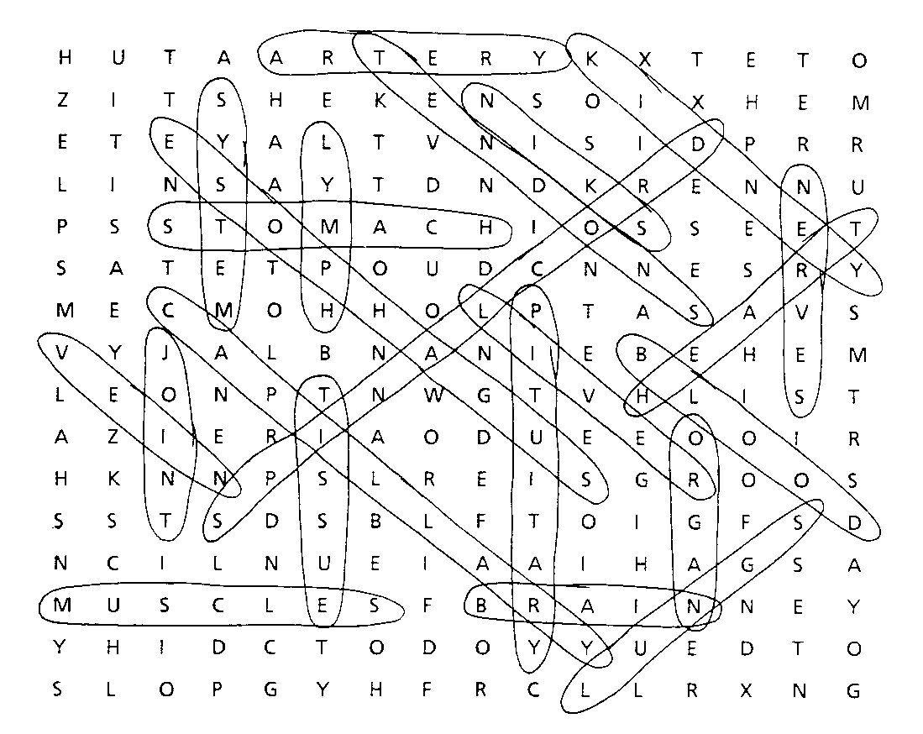SPINAL CORD PITUITARY

