Foundation Standard 9 Health Maintenance Practices

Food Pyramid

INSTRUCTIONAL ACTIVITIES

- Instruct the student to read Diversified Health Occupations.
- Instruct the student to define the key terms.
- Instruct the student to complete the workbook assignment for Diversified Health Occupations.
- Assign the student to make a poster on the Food Pyramid.
- Assign the student to write three days’ menu using the Food Pyramid as a guide.
- Invite a nutritionist/dietician to speak about the Food Pyramid and General Principles of Nutrition.
- Instruct the student to complete Activity “Find the Food Group.”
- Instruct the student to complete Activity “That Blankety-Blank.”
- Instruct the student to complete Activity “Good Nutrition Vocabulary.”
- Discuss related health careers.
- View available audiovisual resources related to the Food Guide Pyramid.
- Compare fat grams in candy/chips labels.
- Instruct the student to take notes and participate in class discussion and activities. (See notes in the Diversified Health Occupations: Teacher’s Resource Kit.)

INSTRUCTIONAL MATERIALS/RESOURCES

- Thomas. Tabor’s Cyclopedic Medical Dictionary.
- Simmers. Diversified Health Occupations.
- Simmers. Diversified Health Occupations: Teacher’s Resource Kit.
- Simmers. Diversified Health Occupations: Workbook.
5. PowerPoint presentation:

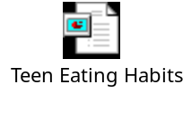

SUPPLEMENTAL TERMS

Food Pyramid
Saturated fat
Sodium

RELATED HEALTH CAREERS

Dietetic Technician
Dietetic Assistant (Food Service Workers)
Dietary Service Manager
Registered Dietitian

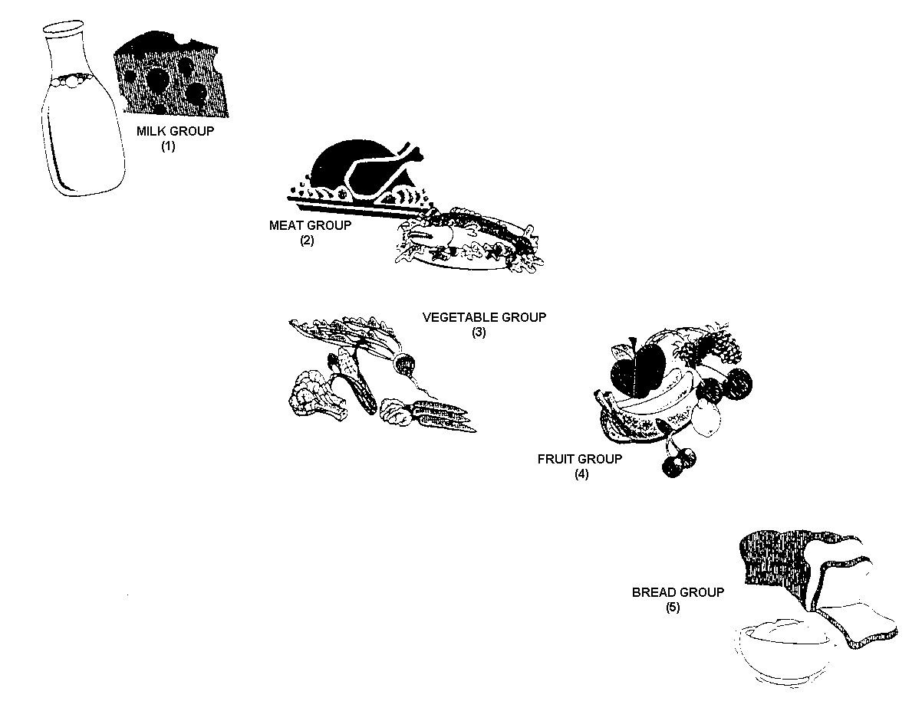
FIND THE FOOD GROUP
By Marie Mills
DIRECTIONS: Each one of these foods is in the five food groups of the food guide pyramid. Write the number 1, 2, 3, 4, or 5 in the blank to represent the food group.

roast
roll

peas

ice cream

potato

turkey

string beans

rice

bread

orange

lettuce

fish

liver

cheese

oatmeal

egg

lemon

corn flakes

strawberry

raisins

carrot

ham

apple

banana

yogurt

peach

grits

tomato

grapes

broccoli

FIND THE FOOD GROUP (key)
DIRECTIONS: Each one of these foods is in the five food groups of the food guide pyramid. Write the number 1, 2, 3, 4, or 5 in the blank to represent the food group.

2 roast

5 roll

3 peas

1 ice cream

3 potato

2 turkey

3 string beans

5 rice

5 bread

4 orange

3 lettuce

2 fish

2 liver

1 cheese

5 oatmeal

2 egg

4 lemon

5 corn flakes

4 strawberry

4 raisins

3 carrot

2 ham

4 apple

4 banana

1 yogurt

4 peach

5 grits

3 tomato

4 grapes

3 broccoli

Name ______________________________________ Date:_____________________________

“THAT BLANKETY BLANK”

Fill in each blank with the name of a food. Choose one from the following list:

meat heart cauliflower
carrot turnip cantaloupe
lettuce liver squash
dates orange beet

- If we practice, we can ______________ the other team.

- When I fail to clean my house, company will always ___________.

- This is a good way to _________ new people.

- If they don’t let us get married, we __________________.

- We may take the afternoon off if our boss will _______________.

- Move over, you are going to _____________ me.

- Before I was twenty, I had lots of ________________.

- A program assistant not only works with his/her hands but also his/her ___________.

- Do you think you could _______________ all for me?

- Can you ______________ by its scientific name?
Answer Key

“THAT BLANKETY BLANK”

Fill in each blank with the name of a food. Choose one from the following list:

meat heart cauliflower
carrot turnip cantaloupe
lettuce liver squash
dates orange beet

- If we practice, we can beet the other team.

- When I fail to clean my house, company will always turnip.

- This is a good way to meat new people.

- If they don’t let us get married we cantaloupe.

- We may take the afternoon off if our boss will lettuce.

- Move over, you are going to squash me.

- Before I was twenty, I had lots of dates.

- A program assistant not only works with her hands but also her heart.

- Do you think you could carrot all for me?

- Can you cauliflower by its scientific name?

Name ______________________________________ Date:_____________________________

GOOD NUTRITION VOCABULARY
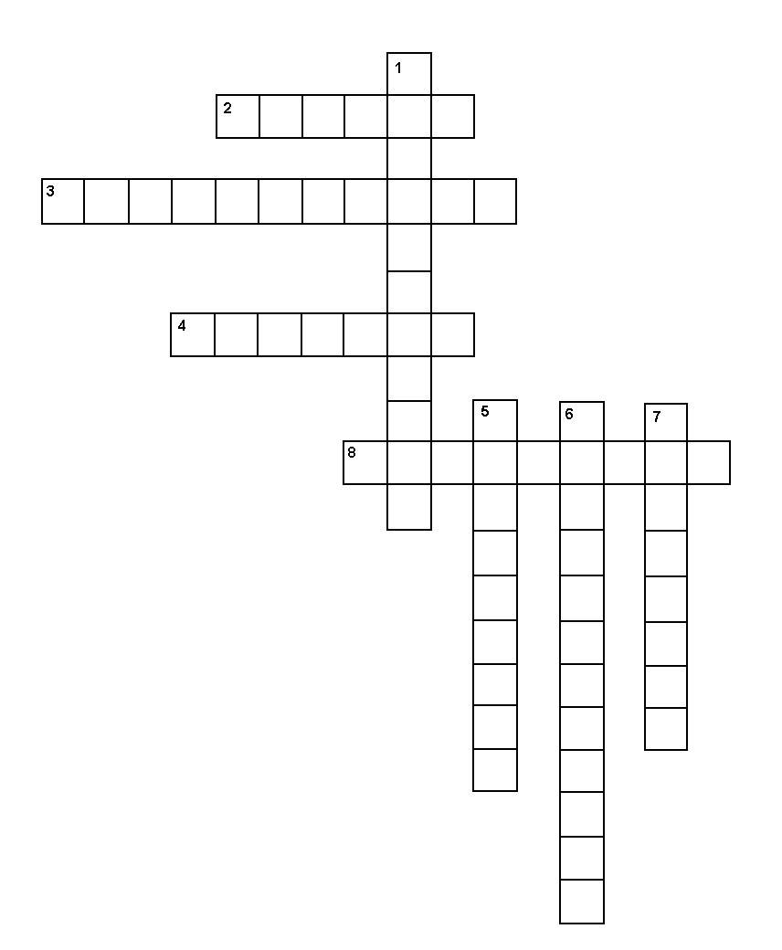

ACROSS
- combines with chlorine to form salt
- fatty substance in animal fat
- guide for making daily food choices
8. animal fat

DOWN
- _____ status: the state of one’s nutrition
- all body processes related to food
- poor nutrition
- being in good health

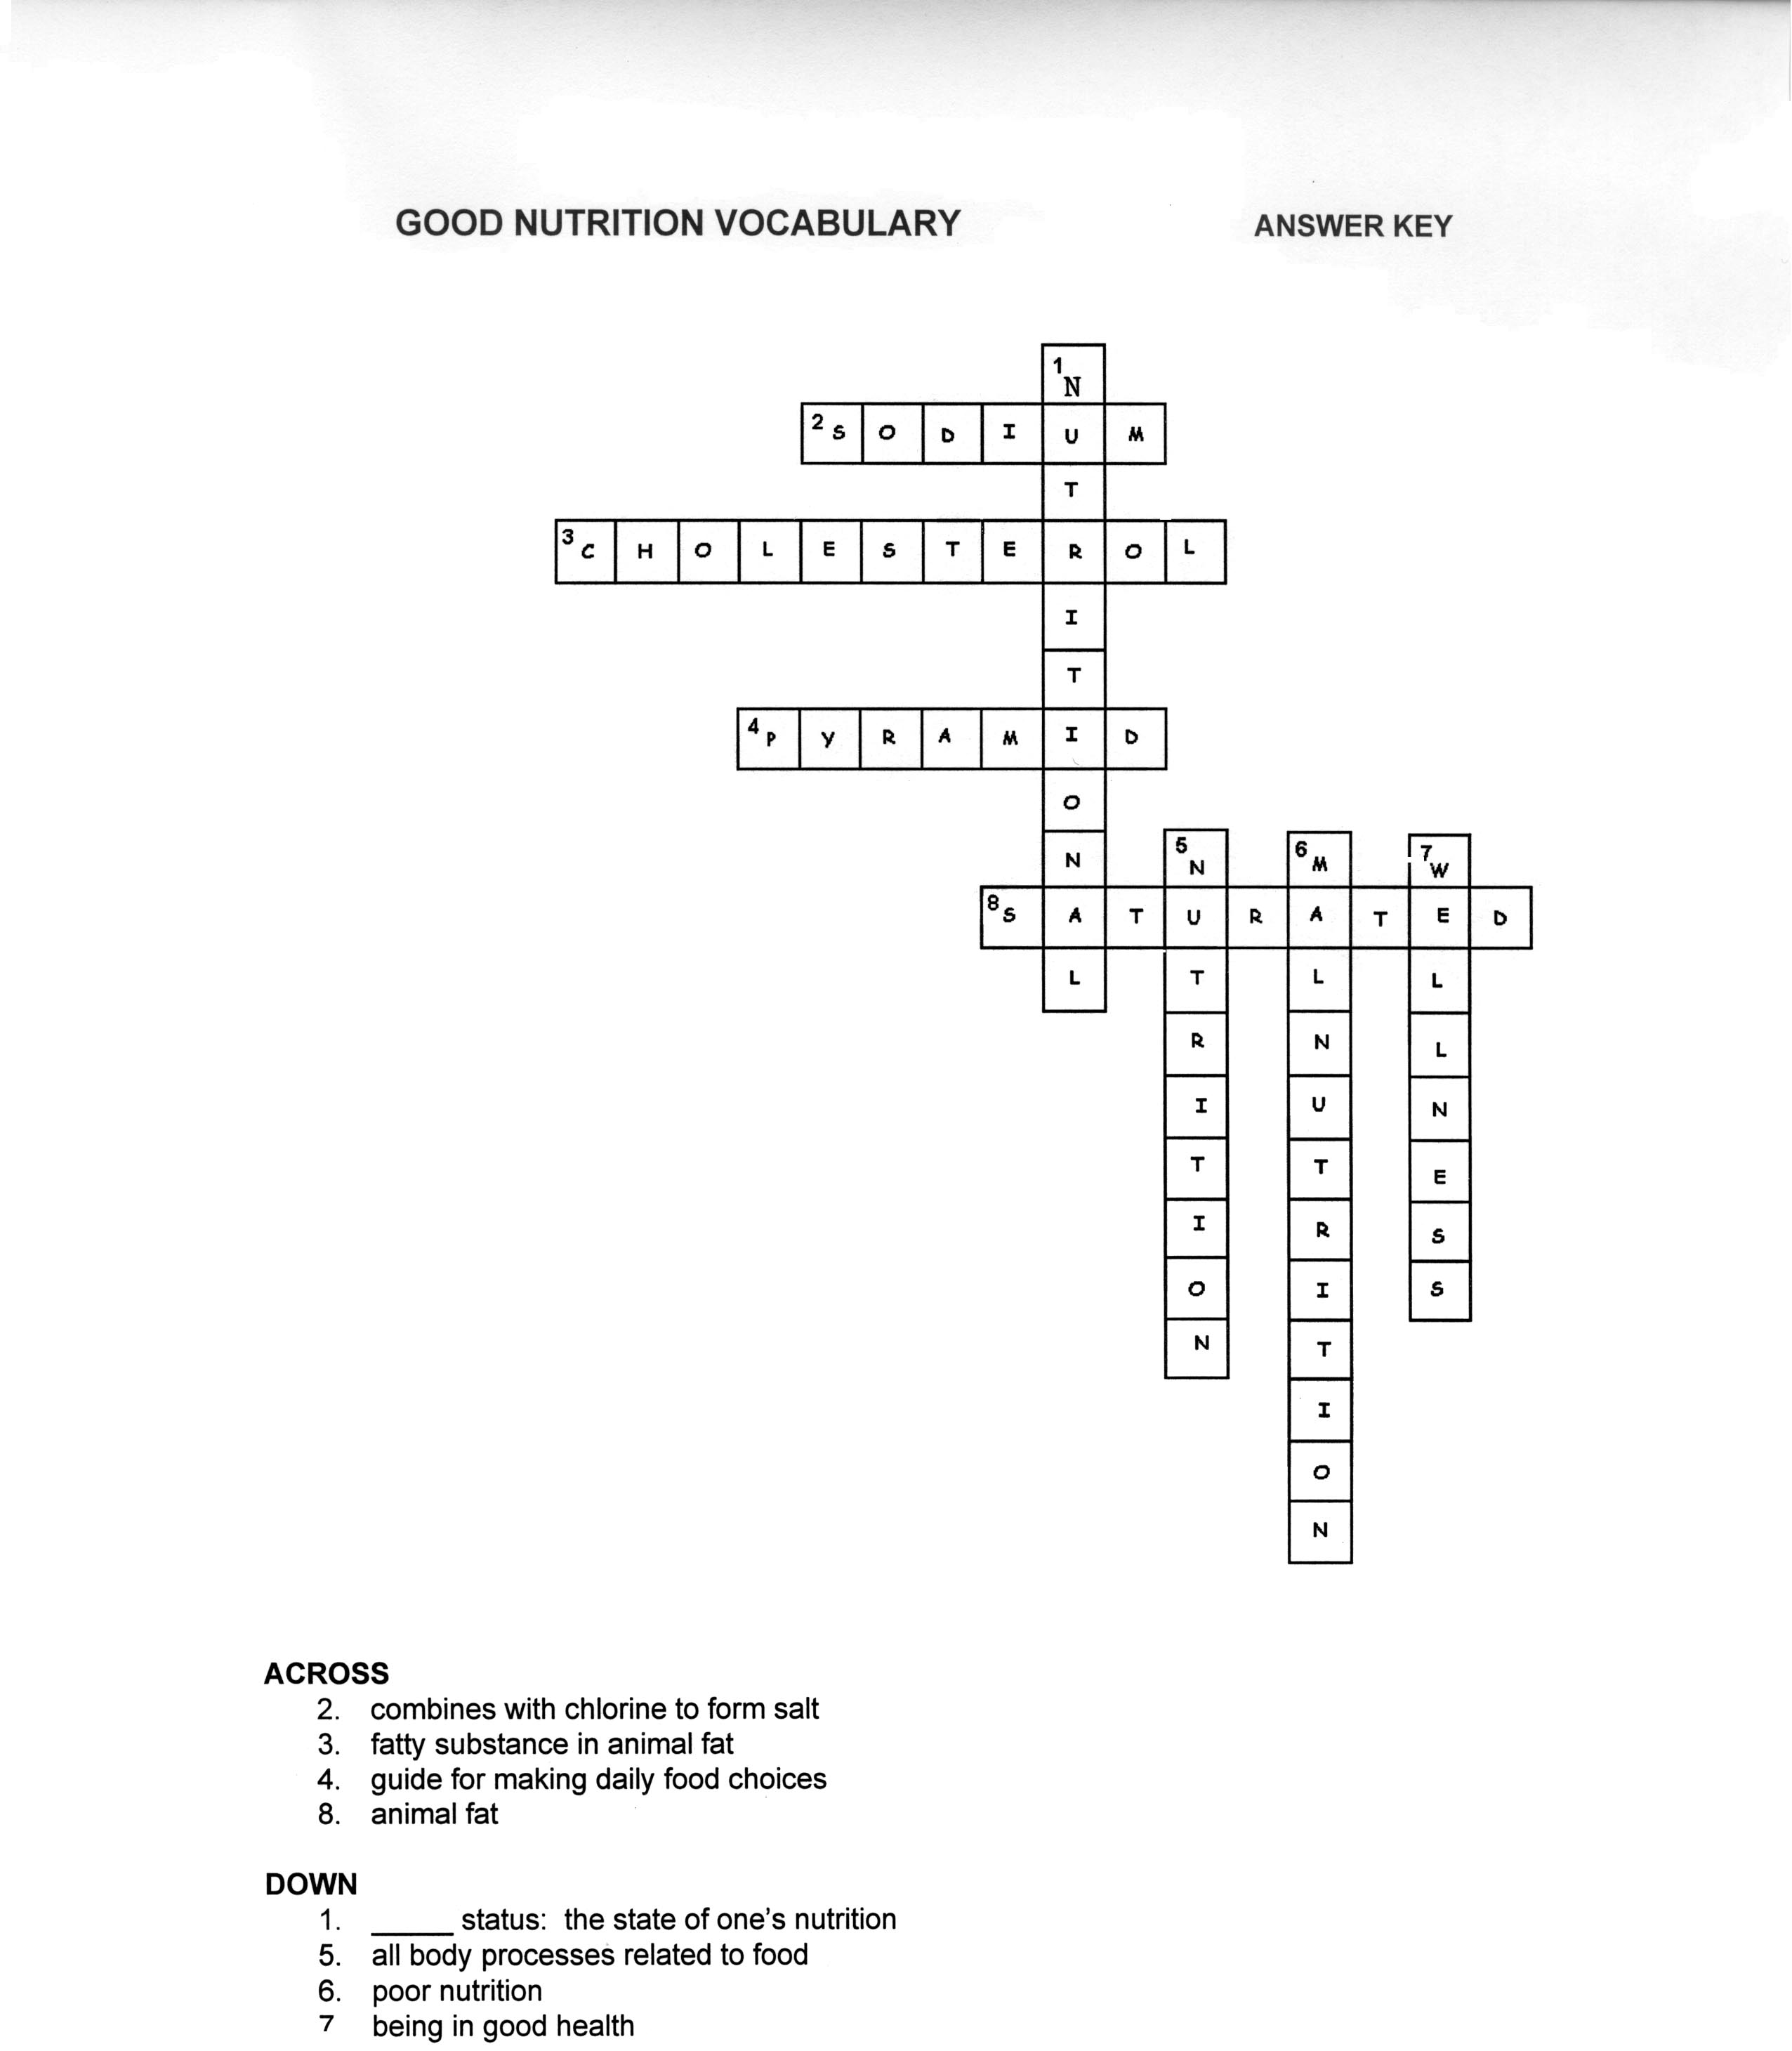
Foundation Standard 9 Health Maintenance Practices

Nutrient Groups

INSTRUCTIONAL ACTIVITIES

1. Instruct the student to read Diversified Health Occupations.
2. Instruct the student to define key terms.
3. Instruct the student to complete the workbook assignment for Diversified Health Occupations.
4. Assign the student to make a poster on the six major nutrient groups.
5. Assign the student to compute the reduction of daily calories to lose _____ pounds of his/her body fat.
6. Assign the student to compute the number of daily calories to maintain his/her present weight.
7. Instruct the student to complete Nutrition Crossword Puzzle, “The Nutrient Groups-Key Terms.”
8. Instruct the student to complete “Nutrition and the Nutrients” Word Search.
9. View available audiovisual resources related to the six major nutrient
groups.
10. Instruct the student to take notes and participate in class discussion and activities. (See notes in the Diversified Health Occupations: Teacher’s Resource Kit.)

INSTRUCTIONAL MATERIALS/RESOURCES

- Thomas. Tabor’s Cyclopedic Medical Dictionary.
- Simmers. Diversified health Occupations.
- Simmers. Diversified health Occupations: Teacher’s Resource Kit.
- Simmers. Diversified Health Occupations: Workbook.
SUPPLEMENTAL TERMS

Amino acids
Cholesterol
Complete protein
Fat-soluble vitamins
Incomplete protein
Lipids
Monounsaturated fat
Polyunsaturated fat
Saturated fat
Starches
Sugars
Water-soluble vitamins

RELATED HEALTH CAREERS

Dietetic Technician
Dietetic Assistant (Food Service Worker)
Dietary Service Manager
Registered Dietitian

Name Date
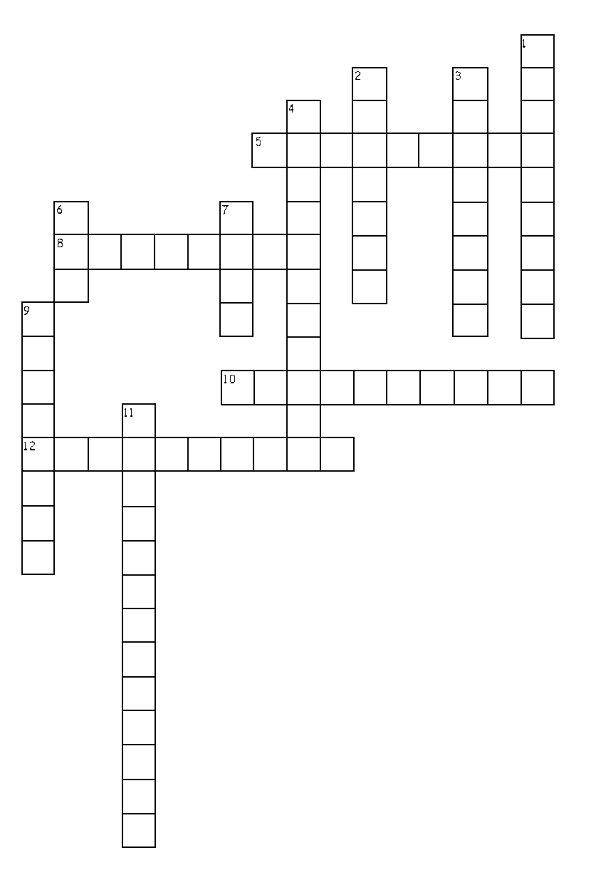

THE NUTRIENT GROUPS – KEY TERMS

ACROSS
5. indigestible part of carbohydrates
8. inorganic elements
10. passing of digested nutrients into the blood
12. body’s use of the food nutrients

DOWN
1. physical and chemical breakdown of food
2. measure of the energy content of food
3. made up of amino acids
4. rhythmic, wavelike muscle movements
6. abbreviation for the metabolic rate at rest
7. lipids
9. fat-soluble and water-soluble
11. sugars and starches

Answer Key
THE NUTRIENT GROUPS – KEY TERMS
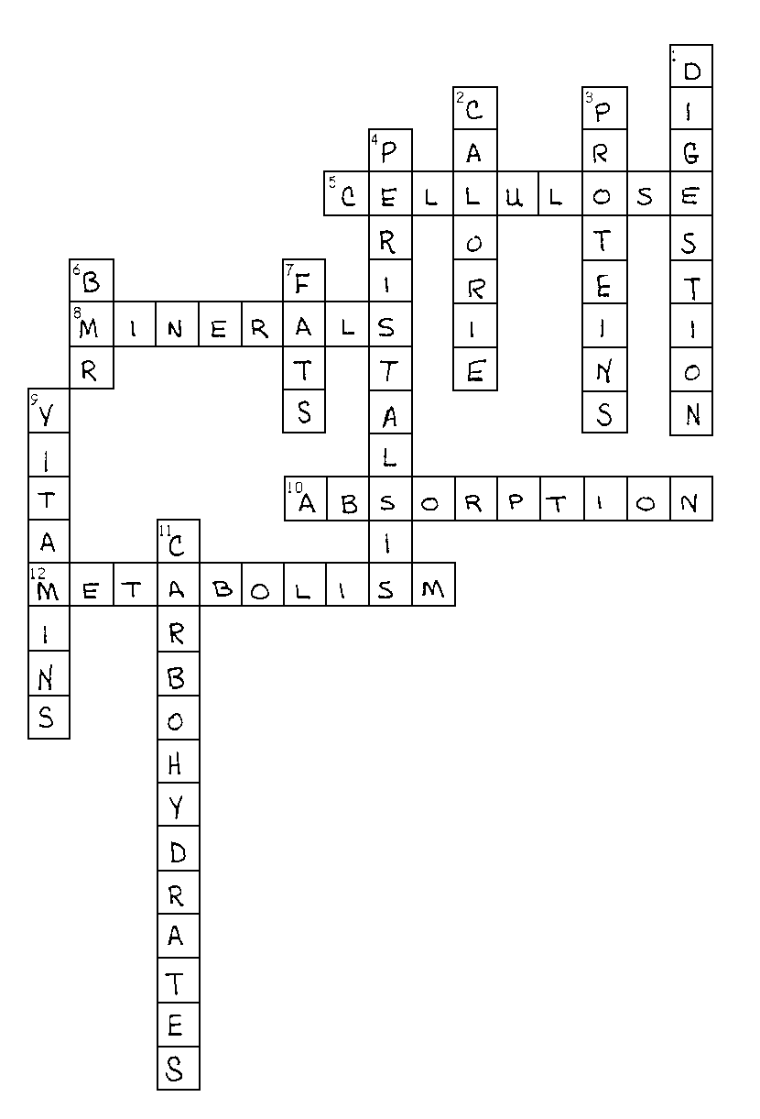

ACROSS
5. indigestible part of carbohydrates
8. inorganic elements
10. passing of digested nutrients into the blood
12. body’s use of the food nutrients

DOWN
1. physical and chemical breakdown of food
2. measure of the energy content of food
3. made up of amino acids
4. rhythmic, wavelike muscle movements
6. abbreviation for the metabolic rate at rest
7. lipids
9. fat-soluble and water-soluble
11. sugars and starches

NUTRITION AND THE NUTRIENTS

The words listed below can be found in the puzzle in horizontal, vertical, and reverse directions. Circle words as you find them and check them off the list. There is one word that is not in the puzzle; write it in the blank at the bottom of the page.

ABSORPTION LIPIDS SATURATED
AMINO ACIDS METABOLISM STARCHES
CALORIE MONOUNSATURATED SUGARS
CARBOHYDRATES PERISTALSIS VITAMINS
CELLULOSE POLYUNSATURATED
DIGESTION PROTEIN

M O N O U N S A T U R A T E D
E M W S Z W C E L L U L O S E
T Q O P B D E T A R U T A S T

A X B E N I F M L V E A B R A
B T B R W S T A R C H E S A R
O A M I N O A C I D S Q O G U
L Q H S N I M A T I V L R U T
I W C T I A N Z X X I Q P S A
S J C A R B O H Y D R A T E S
M V Z L L Z D I G E S T I O N
E O E S N O A J Z K R D O W U
I M V I S P R O T E I N N Z Y
N R P S D I P I L U G M C B L
F B H L W Y Z O E X G X V T O
U D S P D P J P C C B Y Y S P

____________________________
NUTRITION AND THE NUTRIENTS

The words listed below can be found in the puzzle in horizontal, vertical, and reverse directions. Circle words as you find them and check them off the list. There is one word that is not in the puzzle; write it in the blank at the bottom of the page.

ABSORPTION LIPIDS SATURATED
AMINO ACIDS METABOLISM STARCHES
CALORIE MONOUNSATURATED SUGARS
CARBOHYDRATES PERISTALSIS VITAMINS
CELLULOSE POLYUNSATURATED
DIGESTION PROTEIN

M O N O U N S A T U R A T E D
E C E L L U L O S E
T P D E T A R U T A S T

A E B R A
B R S T A R C H E S A R
O A M I N O A C I D S O G U
L S N I M A T I V R U T
I T P S A
S C A R B O H Y D R A T E S
M L D I G E S T I O N
S O U
I P R O T E I N N Y
S D I P I L L
O
P

Calorie
Foundation Standard 9 Health Maintenance Practices

Nutrition and Therapeutic Diets

INSTRUCTIONAL ACTIVITIES

- Instruct the student to read Diversified Health Occupations.
- Instruct the student to define the key terms.
- Instruct the student to complete the workbook assignments for Diversified Health Occupations.
- Assign the student to research one therapeutic diet and present an oral report/poster to the class.
- Invite a dietitian to speak to the class on therapeutic diets.
- View available audiovisual resources related to therapeutic diets.
- Instruct the student to complete “Therapeutic Diets” Word Search.
- Instruct the student to take notes and participate in class discussion and activities. (See notes in the Diversified Health Occupations: Teacher’s Resource Kit.)

INSTRUCTIONAL MATERIAL/RESOURCES

- Thomas. Tabor’s Cyclopedic Medical Dictionary.
- Simmers. Diversified Health Occupations.
- Simmers. Diversified Health Occupations: Teacher’s Resource Kit.
- Simmers. Diversified Health Occupations: Workbook.

SUPPLEMENTAL TERMS

Anorexia nervosa
Bulk
Clear liquid diet
Fiber
Full liquid diet
High-protein diet
Lactating
Low-protein diet

RELATED HEALTH CAREERS

Dietetic Technician
Dietetic Assistant (Food Service Workers)
Dietary Service Manager
Registered Dietitian

Name__________________________________________ Date____________________________

THERAPEUTIC DIETS

The words listed below can be found in the puzzle in horizontal, vertical, diagonal, and reverse directions. Circle words as you find them and check them off the list. All words are found in the Word Search.

ANOREXIA CLEAR LIQUID MALNUTRITION

ATHEROSCLEROSIS FIBER OSTEOPOROSIS
BLAND FULL LIQUID PROTEIN
BULK HYPERTENSION REGULAR
CALORIE LACTATION SODIUM
CHOLESTEROL LOW FAT SOFT

A O E M T V J Z N R Y S G U U
B T I I A I C R O A R M K Z Y
L J H A R L T T I L D N Z Q Y
A I X E R O N A T U C O I D P
N R H F R T L U A G B Q I F Z
D T A F W O L A T E O U X J U
Y T P Y Z B S N C R Q B L B Q
E Q P E N W A C A I I X M K L
W D I U Q I L L L U F T U F A
P Q V H Y P E R T E N S I O N
J D O M M R A T U O R B D O K
T S S Z I E I M O J E O O I N
I C H O L E S T E R O L S K V
O P L C F K K A C R P P Z I A
A N Q O S T E O P O R O S I S
Answer Key

THERAPEUTIC DIETS

The words listed below can be found in the puzzle in horizontal, vertical, diagonal, and reverse directions. Circle words as you find them and check them off the list. All words are found in the Word Search.

ANOREXIA CLEAR LIQUID MALNUTRITION

ATHEROSCLEROSIS FIBER OSTEOPOROSIS
BLAND FULL LIQUID PROTEIN
BULK HYPERTENSION REGULAR
CALORIE LACTATION SODIUM
CHOLESTEROL LOW FAT SOFT

A O E M T V J Z N R Y S G U U
B T I I A I C R O A R M K Z Y
L J H A R L T T I L D N Z Q Y
A I X E R O N A T U C O I D P
N R H F R T L U A G B Q I F Z
D T A F W O L A T E O U X J U
Y T P Y Z B S N C R Q B L B Q
E Q P E N W A C A I I X M K L
W D I U Q I L L L U F T U F A
P Q V H Y P E R T E N S I O N
J D O M M R A T U O R B D O K
T S S Z I E I M O J E O O I N
I C H O L E S T E R O L S K V
O P L C F K K A C R P P Z I A
A N Q O S T E O P O R O S I S

Foundation Standard 9 Health Maintenance Practices

Personal Qualities, Health, and Wellness

INSTRUCTIONAL ACTIVITIES

- Instruct the student to read Diversified Health Occupations.
- Instruct the student to define the key terms.
- Instruct the student to complete the workbook assignment for Diversified Health Occupations.
- View available audiovisual resources related to the personal qualities unit.
- Instruct the student to take notes and participate in class discussion and activities. (See notes in the Diversified Health Occupations: Teacher’s Resource Kit.)

INSTRUCTIONAL MATERIALS/RESOURCES

- Thomas. Tabor’s Cyclopedic Medical Dictionary.
- Simmers. Diversified Health Occupations.
- Simmers. Diversified Health Occupations: Teacher’s Resource Kit.
- Simmers. Diversified Health Occupations: Workbook.
- Colbert. Workplace Readiness for Health Occupations.
- Transparency Masters: "Goal Setting" and "Problem Solving."
- Websites: http://mentalhelp.net/psyhelp/
Online mental health text by Clayton E. Tucker-Ladd
http://www.yourcancerrisk.harvard.edu/
Your cancer risk estimates your risk of cancer and provides personalized tips for prevention.
8. PowerPoint presentations:

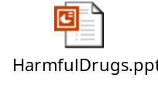

Writing Criteria for Date Rape Paper

Please write a one to one and a half page paper on the "Date Rape Phenomenon" as it relates to drugs and alcohol. Please share your thoughts and feelings about this subject and how it impacts young females/males in our society today.

Your paper will be graded on the following criteria:

- Did you follow the format? (Appropriate content as stated above) - 20%
- Are there five paragraphs (1-Introduction, 3-Body, and 1-Conclusion) - 50%
- Title Page with your name, date, and class period - 20%
- Spelling/Punctuation - 10%
- STD PowerPoint presentation (double click to begin):



NAME________________________________________ DATE_________________________

ALL ABOUT GOOD GROOMING CROSSWORD PUZZLE

 |  |  | 1
 |  | 2 |  |  |  |  |  |  | 3
 | 4
 |  |  | 5 |  |  |  |  |  |  |  |  |  |  |  |  |  | 6 | 7
 | 8 |  |  |  |  |  |  |  |  |  |  |  |  | 9 |  |  |  |  |  |  | 10
 |  |  |  |  |  |  |  |  |  |  |  |  | 11
 |  |  |  |  |  |  |  |  |  |  |  | 12
 |  |  |  |  |  | 13 |  |  | 14
 |  | 15
 |  |  |  |  |  |  |  |  |  |  |  |  |  | 16
 | 17 |  |  |  | 18
 |  |  |  |  |  |  |  |  |  |  |  |  |  | 19
20

ALL ABOUT GOOD GROOMING
CROSSWORD PUZZLE

ACROSS

- Cells that help the body get rid of waste products such as oil or perspiration.

- A creamy substance used to clean teeth; may contain a fluoride compound.

- Liquid used to rinse mouth and keep breath fresh smelling.

- It’s on your head and needs regular shampooing.

8. A process of caring for cuticles and nails.

11. A general name to describe outer facial skin.

- Substance that helps prevent underarm or other body odor.

- A slippery body liquid that helps keep skin smooth and hair shiny; comes through pores.

- A method of cleaning your whole body by getting into a tub of water. Requires soap.

- Eating a good selection of vitamins, minerals, and protein and carbohydrate-rich foods to maintain good health. (Two words)

- A method of cleaning your whole body by standing under a stream of water. Requires soap.

- A doctor who specializes in the care of teeth and gums. You should see him/her twice a year.
DOWN

- All the processes involved in keeping your body clean and healthy. (Two words)

- Substance used to dissolve body dirt and oils during cleaning.

- Do this to keep hair clean and healthy.

7. Skin disease often associated with young people.

- Used to keep teeth well scrubbed.

- Small sac at the root of any strand of hair.

- Another name for tooth decay.

14. Tiny specks of dry skin in hair. Special shampoos help eliminate it. Proper brushing is also helpful.

- Should be manicured weekly.

Answer Key

ALL ABOUT GOOD GROOMING

 |  |  | 1  G | L | A | N | D | S
 |  |  | R
 |  | 2  T | O | O | T | H | P | A | 3  S | T | E
 | 4  S |  | O |  |  |  |  |  | O
 | H |  | 5  M | O | U | T | H | W | A | S | H |  |  |  |  |  | 6  H | 7  A | I | R
 | A |  | I |  |  |  |  |  | P |  |  |  |  |  |  |  |  | C
 | 8  M | A | N | I | C | U | R | E |  |  |  |  |  | 9  T |  |  |  | N |  |  | 10  F
 | P |  | G |  |  |  |  |  |  |  |  |  | 11  C | O | M | P | L | E | X | I | O | N
 | O |  | S |  |  |  |  |  |  |  |  | 12  C |  | 0 |  |  |  |  |  |  | L
 | O |  | K |  |  | 13  D | E | O | 14  D | O | R | A | N | T |  |  |  |  |  |  | L
 |  | 15  O | I | L |  |  |  |  | A |  |  | V |  | H |  |  |  |  |  |  | I
 |  |  | L |  |  |  |  |  | N |  |  | I |  | 16  B | A | T | H |  |  |  | C
 | 17  B | A | L | A | 18  N | C | E | D | D | I | E | T |  | R |  |  |  |  |  |  | L
 |  |  | S |  | A |  |  |  | R |  |  | Y |  | U |  |  |  |  |  |  | E
 |  |  |  |  | I |  |  |  | U |  |  |  |  | 19  S | H | O | W | E | R
 |  |  |  |  | L |  |  |  | F |  |  |  |  | H
20  D | E | N | T | I | S | T |  |  | F
NAME________________________________________ DATE______________________________

GOOD HEALTH IS NO PUZZLE

Caring for yourself and your skin is a lifelong activity. The earlier you begin, the easier it will be. The puzzle below includes many health care reminders. First, fill in the blanks in the statements (the number of letters is indicated by the number of spaces). Then find the filled-in words in the jumble puzzle in the middle of the page.

P | O | H | M | Z | F | O | L | L | I | C | L | E
A | S | T | R | E | S | S | B | S | W | D | J | X
Q | K | Y | P | U | B | E | R | T | Y | E | W | E
V | I | E | C | F | T | X | I | N | P | R | O | R
I | N | L | W | H | G | R | O | E | L | M | Z | C
T | H | O | R | M | O | N | E | D | Y | I | K | I
A | A | J | W | B | P | L | V | C | R | S | N | S
M | I | B | A | E | S | Q | O | P | D | T | W | E
I | R | T | S | H | F | U | R | G | V | B | M | O
N | X | M | H | D | E | M | W | E | I | G | H | T
S | P | E | R | O | X | I | D | E | P | C | R | G
F | T | A | W | O | N | P | C | K | N | U | A | Y
O | D | L | M | L | S | C | R | U | B | C | W | L
H | P | S | E | B | U | M | X | G | I | J | A | N

When washing your face, it’s important not to __ __ __ __ __ too hard.

A(n) __ __ __ __ __ __ __ is a substance produced by the body to control growth and development.

The covering of our bodies is called
__ __ __ __.

One way to stay in shape is to get regular __ __ __ __ __ __ __ __.

Good health is maintained by eating well-balanced __ __ __ __ __.

A tiny opening in the skin from which hair grows is a(n)
__ __ __ __ __ __ __ __.

A well-balanced diet will provide your daily requirements of minerals and
__ __ __ __ __ __ __ __.

Glands in the skin produce oil or
__ __ __ __ __to lubricate the skin.

The layer of skin below the epidermis is called the __ __ __ __ __ __.
The time of life when many body changes occur related to sexual maturity is called
__ __ __ __ __ __ __.

To allow your body to get the rest it needs, you should get enough __ __ __ __ __.

__ __ __ __ your face at least two times a day.

Exercise increases the circulation of
__ __ __ __ __.

Relaxation, exercise, and planning can reduce__ __ __ __ __ __.

Acne treatment creams and lotions with benzyl__ __ __ __ __ __ __ __kill bacteria and dry up existing pimples.

Caring about and believing in yourself is part of a healthy
__ __ __ __ __ __ __ __ __ __ __ __ __ outlook.

Careful dieting and regular exercise can help most people lose __ __ __ __ __ __.

Pimples, blackheads, and whiteheads are called __ __ __ __.

Answer Key

GOOD HEALTH IS NO PUZZLE

Caring for yourself and your skin is a lifelong activity. The earlier you begin, the easier it will be. The puzzle below includes many health care reminders. First, fill in the blanks in the statements (the number of letters is indicated by the number of spaces). Then find the filled-in words in the jumble puzzle in the middle of the page.

P | O | H | M | Z | F | O | L | L | I | C | L | E
A | S | T | R | E | S | S | B | S | W | D | J | X
Q | K | Y | P | U | B | E | R | T | Y | E | W | E
V | I | E | C | F | T | X | I | N | P | R | O | R
I | N | L | W | H | G | R | O | E | L | M | Z | C
T | H | O | R | M | O | N | E | D | Y | I | K | I
A | A | J | W | B | P | L | V | C | R | S | N | S
M | I | B | A | E | S | Q | O | P | D | T | W | E
I | R | T | S | H | F | U | R | G | V | B | M | O
N | X | M | H | D | E | M | W | E | I | G | H | T
S | P | E | R | O | X | I | D | E | P | C | R | G
F | T | A | W | O | N | P | C | K | N | U | A | Y
O | D | L | M | L | S | C | R | U | B | C | W | L
H | P | S | E | B | U | M | X | G | I | J | A | N

When washing your face, it’s important
not to S C R U B too hard.

A(n) H O R M O N E is a substance
produced by the body to control growth
and development.

The covering of our bodies is called
S K I N.

One way to stay in shape is to get regular E X E R C I S E.

Good health is maintained by eating well-balanced M E A L S.

A tiny opening in the skin from which
hair grows is a(n) F O L L I C L E.

A well-balanced diet will provide your daily requirements of minerals and
V I T A M I N S.

Glands in the skin produce oil or
S E B U M to lubricate the skin.

The layer of skin below the epidermis is called the D E R M I S.

The time of life when many body changes occur related to sexual maturity is called P U B E R T Y.

To allow your body to get the rest it needs, you should get enough
S L E E P.

W A S H your face at least two times a day.

Exercise increases the circulation of B L O O D.

Relaxation, exercise, and planning can reduce
S T R E S S.

Acne treatment creams and lotions with benzyl
P E R O X I D E kill bacteria and dry up existing pimples.

Caring about and believing in yourself is part of a healthy
P S Y C H O L O G I C A L outlook.

Careful dieting and regular exercise can help
most people lose W E I G H T.

Pimples, blackheads, and whiteheads are called A C N E.

HOW IS YOUR POSTURE?

Do You Have Poor Posture?

_____ Your head is leaning forward or tilting back.
_____ Your shoulders are bent forward.
_____ Your abdomen protrudes.
_____ You have an excessive curve in lower back when standing with your
back to the wall.
_____ You keep your knees locked when standing.
_____ You shift your weight to one leg when standing.
_____ You slouch down when sitting in a chair.

Do You Have Good Posture?

_____ Your head is held up with chin parallel to the floor.
_____ Your shoulders are down, back, and relaxed.
_____ Your rib cage or chest is held high.
_____ Your abdominal muscles are held tight.
_____ The hollow of your back is flattened when standing with back to a wall.
_____ Your knees are slightly bent and unlocked when standing.
_____ Your weight is evenly distributed on both feet with one foot slightly
forward while standing.
_____ A straight line can be drawn through your ear, shoulder, hip, knees, and
ankles when looking at your silhouette.
NAME_________________________________________ DATE______________________________

THE RISKY BUSINESS OF BEING A TEEN

The following questions make up a teen health risk appraisal. Read and answer each question honestly. Your teacher will give you a score sheet and a copy of the risk graph so that you can plot your score. It may help you get an even better handle on your future!

- How often do you wear your seat belt when riding in or driving a car?
a. Always or almost always (3)
b. More than half the time (2)
c. Only occasionally (less than 50 percent of the time) (1)
d. I never wear it (0)

- Do you ever ride with a driver who is under the influence of alcohol or other drugs, or drive under the influence yourself?

a. No, never (3)
b. Yes, but rarely (2)
c. Yes, sometimes (1)
d. Yes, often (0)

3. If you drive a car, how often do you exceed the speed limit by 10 mph or more?
a. I never drive or ride with someone exceeding the limit by more than 10-mph. (3)
b. I rarely drive or ride with someone exceeding the limit by more than 10-mph. (2)
c. I sometimes drive or ride with someone exceeding the limit by 10 mph or more. (1)
d. I often drive or ride with someone exceeding the limit by 10 mph or more. (0)

- If you are a passenger on or drive a motorcycle, how often do you wear a helmet?
a. Always, or I don’t ride on or drive motorcycles (3)
b. Sometimes (2)
c. Rarely (1) d. Never (0)

- If you ride a bike, walk, or jog at night, how often do you wear light clothing or reflective clothing?
a. Always, or I don’t ride, walk, or jog at night (3)
b. Sometimes (2)
c. Rarely (1)
- Never (0)

6. Have you ever been under the influence of drugs or alcohol when you were swimming or
boating?
a. Never, or I don’t swim or boat (3)
- Sometimes (2)
c. Rarely (1)
d. Never (0)

7. Which of the following describes your experience with hitchhiking?
a. I never hitchhike or pick up hitchhikers. (3)
b. I seldom hitchhike or pick up hitchhikers. (2)
- c. I sometimes hitchhike or pick up hitchhikers. (1)
d. I frequently hitchhike or pick up hitchhikers. (0)

THE RISKY BUSINESS OF BEING A TEEN

8. How often do you choose foods from the four food groups for each meal?
a. Every day (3)
b. 5 to 6 days each week (2)
c. 2 to 4 days each week (1)
d. 0 to 1 day per week (0)

9. How many days in a typical week do you eat breakfast:
a. Every day (3)
b. 5 to 6 days each week (2)
c. 2 to 4 days each week (1)
d. 0 to 1 day per week (0)

10. How often do you snack on food high in salt?
a. Never (3)
b. Seldom (2) c. At least three times a week (1) d. 4 to 5 times a week or more (0)
11. How often do you snack on foods high in sugar?
a. Never (3)
b. Seldom (2) c. At least three times a week (1) d. 4 to 5 times a week or more (0)
12. How often do you eat fried foods such as French fries and fried chicken?
a. Never (3)
b. Seldom (2) c. At least three times a week (1) d. 4 to 5 times a week or more (0)
- Have you ever fasted or used diet pills to control your weight?
a. No (3)
b. Yes (0)

- Have you ever vomited intentionally to control your weight?
a. No (3)
b. Yes (0)

- Do you think you usually eat at least 1,800 calories each day?
a. Yes (2)
b. No (1)
c. I don't know (0)

- How often do you brush your teeth?
a. Twice a day or more (3)
b. Once a day (2)
c. Every other day (1)
d. Less than every other day (0)

THE RISKY BUSINESS OF BEING A TEEN

- How often do you floss your teeth (which helps prevent gum disease)?
a. Once a day or more (3)
b. Once every other day (2)
c. Once a week (1)
d. I don’t floss my teeth. (0)

- Have you seen a dentist in the last 12 months?
a. yes (3)
b. no (0)

- How often do you engage in aerobic activity for at least 20 minutes nonstop?
(Aerobic activities include fast dancing, jogging, running, swimming, jumping
rope, aerobic walking, or biking.)
a. Every day (4)
b. Three times a week (3)
c. One to two times a week (2)
d. Once every other week (1)
e. Never (0)

20. Do you get enough sleep and feel rested in the morning?
a. Yes, usually (2)
b. Yes, sometimes (1)
c. No (0)

- Do you have your blood pressure checked yearly?
a. Yes (3)
b. No (0)

- Do you do either breast or testicular self-exam?
a. Yes, monthly (4)
b. Every other month (3)
c. Every few months (2)
d. I would if I knew how to do it. (1)
e. I would not do it. (0)

- Which statement best describes your smoking history and habits?
a. I have never smoked (other than once or twice to experiment.) (4)
b. I used to smoke but I’ve quit. (3)
c. I smoke one-half to one pack per day. (2)
d. I smoke one pack per week or less. (1)
e. I smoke more than one pack per day. (0)

- What statement best describes your chewing tobacco history?
a. I have never used it or tried it once. (3)
b. I use it about once a week. (2)
c. I use it more than once a week but not daily. (1)
d. I use it daily. (0)

THE RISKY BUSINESS OF BEING A TEEN

- Which statement best describes your alcohol consumption?
a. I do not drink or have quit. (4)
b. I drink once or twice a month. (3)
c. I drink one day a week. (2)
d. I drink two or three days a week. (1)
e. I drink more than three days a week. (0)

26. If you drink, how much do you consume on each occasion when you drink?
(A drink is one beer, one glass of wine, or one mixed drink containing one 1-
ounce shot and 5 ounces of mix.)
a. One to two drinks per occasion or I don’t drink. (3)
b. Three to four drinks per occasion. (2)
c. Five to six drinks per occasion. (1)
d. Seven drinks or more per occasion. (0)

27. Which of the following describes your use of marijuana?
a. I don’t use it or have quit. (3)
b. I use it once or twice a month. (2)
c. I use it one to two times a week. (1)
d. I use it three times a week or more. (0)

28. Which describes your use of other drugs such as cocaine, LSD, narcotics, depressants, or stimulants?
a. I don’t use any of these drugs. (3)
b. I use drugs one to two times per month. (2)
c. I use drugs one to two times per week. (1)
d. I use drugs three to four times per week or more. (0)

29. Do you ever use other drugs and alcohol together?
a. No (3)
b. Seldom (2)
c. Sometimes (1)
d. Often or always (0)

30. How often do you feel tense or anxious?
a. Never (4)
b. Occasionally (3)
c. Sometimes (2)
d. Frequently (1)
e. All the time (0)

31. In general, how satisfied are you with your life right now?
a. Very satisfied (4)
b. Mostly satisfied (3)
c. Somewhat satisfied (2)
d. Not satisfied at all (1)
e. Discouraged (0)

THE RISKY BUSINESS OF BEING A TEEN

32. In the past six months, have you had feelings that life isn’t worth living?
a. No (4)
b. Yes, but rarely (3)
c. Yes, occasionally (2)
d. Yes, often (1)
e. Yes, daily (0)

33. Have you suffered a serious personal loss or misfortune in the past year?
a. No (3)
b. Yes, one (2)
c. Yes, two (1)
d. Yes, more than two (0)

34. How much control do you feel you have over your future?
a. A great deal (4)
b. Quite a bit (3)
c. Some control (2)
d. A little control (1)
e. No control (0)

35. When you feel under stress or discouraged, is there someone you feel you can talk to?
a. Yes, and I talk to him/her. (4)
b. Yes, and I usually talk to him/her. (3)
c. Yes, I talk with him/her about 50 percent of the time. (2)
d. No, there isn’t anyone, so I keep it inside. (0)

36. What is your family history of cardiovascular disease (DVD), including heart attacks and strokes?
a. No relatives have had CVD. (8)
b. One relative had CVD over age 60. (6)
c. Two relatives had CVD over age 60. (4)
d. One relative had CVD under age 60. (2)
e. Two or more relatives had CVD under age 60. (0)

37. What is your family history of breast cancer (girls only)?
a. No immediate family history of breast cancer. (6)
b. Sister has had breast cancer. (4)
c. Mother has had breast cancer. (2)
d. Both mother and sister have had breast cancer. (0)

38. What is your health history of diabetes?
a. No relatives have had diabetes. (8)
b. One relative has had diabetes. (6)
c. Two relatives have had diabetes. (4)
d. Three relatives have had diabetes. (2)
e. Four or more relatives have had diabetes. (0)
NAME____________________________________ DATE______________________

SCORE SHEET FOR
TEEN HEALTH RISK APPRAISAL

DIRECTIONS: Circle the one answer that best represents your behavior.

1. A B C D
3 2 1 0

2. A B C D
3 2 1 0

3. A B C D
3 2 1 0

4. A B C D
3 2 1 0

5. A B C D
3 2 1 0

6. A B C D
3 2 1 0

7. A B C D
3 2 1 0

8. A B C D
3 2 1 0

9. A B C D
3 2 1 0

10. A B C D
3 2 1 0

11. A B C D
3 2 1 0

12. A B C D
3 2 1 0

13. A B
- 0
14. A B
- 0

15. A B C
2 1 0

16. A B C D
3 2 1 0

17. A B C D
3 2 1 0

18. A B
- 0

19. A B C D E
4 3 2 1 0

20. A B C
2 1 0

21. A B
- 0

22. A B C D E
4 3 2 1 0

23. A B C D E
4 3 2 1 0

24. A B C D
3 2 1 0

25. A B C D E
4 3 2 1 0

26. A B C D
3 2 1 0
27. A B C D
3 2 1 0

28. A B C D
3 2 1 0

29. A B C D
3 2 1 0

30. A B C D E
4 3 2 1 0

31. A B C D E
4 3 2 1 0

32. A B C D E
4 3 2 1 0

33. A B C D
3 2 1 0

34. A B C D E
4 3 2 1 0

35. A B C D E
4 3 2 1 0

36. A B C D E
8 6 4 2 0

37. A B C D
6 4 2 0

38. A B C D E
8 6 4 2 0

NAME__________________________________ DATE______________________

INDIVIDUAL RISK GRAPH

Add up your score on each section of the
Teen Health Risk Appraisal and then plot them on this graph.

Safety Diet Healthy Drugs Mental Health

History Habits Health History

23
22 E X C E L L E N T
21
20
19
18 OK
17
16
15
14 R I S K Y
13
12
11
10
9 D A N G E R O U S
8
7
6
5
4
3
2
1
0

YOUR OVERALL RISK APPRAISAL

Add your totals from all sections of the Teen Health Risk Appraisal to arrive at one score that puts your health risks in the overall picture.

136-138
133-135
130-132 Excellent
127-129
124-126
121-123
118-120
115-117
112-114
109-111 OK
106-108
103-105
100-102
97-99
94-96
91-93
88-90 Risky
85-84
79-81
76-78
73-75 Dangerous

NAME____________________________________ DATE______________________

HOW TO STUDY
SELF-CHECK

SECTION I

TERMINOLOGY

DIRECTIONS: Match the terms in Column A with their definitions in Column B.

COLUMN A COLUMN B

____ 1. Motivation A. Process of relating experiences to present action.
____ 2. Mental age B. An accumulation of facts that become knowledge.
____ 3. Chronological age C. Application of mind to a subject in order to acquire knowledge.
____ 4. Learning D. Ability to recall past impressions.
____ 5. Study E. Becoming acquainted with the environment.
____ 6. Concept F. Capacity for learning at a given time.
____ 7. Orientation G. Desire to achieve a goal.
____ 8. Association H. Actual work environment.
____ 9. Clinical I. Key idea.
____ 10. Memory J. Order of events. K. Age in years.

SECTION II

LEARNING AND STUDYING SKILLS

- List three factors that affect learning.

- List four techniques of classroom learning.

- Place a “D” next to desirable study habits.

- Wait until class time to study.
- Review class notes.
- List unfamiliar words and look up definitions.
- Study 6 hours the night before a test.
- Omit recreation in order to study.
- Take notes when reading or when listening in class.
- Discuss with classmates what you have read.

- List two purposes of examinations.

- List three types of examinations.

- List five suggestions for taking examinations.
Answer Key

HOW TO STUDY
SELF-CHECK

SECTION I TERMINOLOGY

- G
- F
- J
- B
- C
- I
- E
- A
- H
- D

SECTION II LEARNING AND STUDYING SKILLS

- Answers may vary.
- Maturity
- Experience
- Need, motivational goal, emotional state, concentration, participation.

- Answers may vary.
- Listen attentively.
- Take notes.
- Ask questions.
- Participate in all class activities.
- Build a new vocabulary.

- A.
- D
- D
D.
E.
- D
- D
- Answers may vary.
- To measure performance.
- To reinforce learning.
- To assess knowledge.
- To evaluate teaching methods.

- Answers may vary.
- Essay
- Completion
- Multiple choice
- Matching
- True or false

- Answers may vary.
- Read directions carefully.
- Budget time.
- Answer easier questions first.
- Read the entire question before you write.
- Proofread your answers.
- On your answer sheet, check number of questions and answers.

FUN ACTIVITY – PERSONALITY

TEACHER: Draw shapes on the board. Ask each student to pick quickly which form he or she likes best. When all have chosen, read the results.

BOX RECTANGLE TRIANGLE

CIRCLE

SQUIGGLY LINE

1. Box Hard workers. Well-defined with equal lines. The most organized and structured. They complain about the amount of work to be done. Very well disciplined. Data collectors. The box is not the best decision-maker, preventing advancement.

2. Rectangle Confused. Hard worker. Growing, searching, learning. In state
of transition or change. Difficult to work with or for.

3. Triangle Loves recognition. Leaders. Organizational shape, denotes
hierarchy. Very opinionated. Has difficulty with his or her own shape. Cannot be sidetracked.

4. Circle The lover. Good with people, genuinely likes people. Smooths
and flows. Caretaker and nurturer. Symbolic of harmony. Data
collector on people. Strong in communication skills. Good manager and decision-maker. Difficulty making an unpopular decision. Cannot deal with conflict.

5. Squiggly Most unusual. Open-ended. Right brained. Has to have a lot of excitement. Idea person. Has a problem dealing in large organizations. Loves compliments.

GOAL SETTING

- Determine what you want.
- What are you willing to give up temporarily to achieve it?
- What do I have to do?
- Set a date to achieve it.
- Decide on a reward!


PROBLEM SOLVING

- Define the problem.
- Collect the facts.
- Decide on a solution.
- Carry it out.
- Evaluate your decision.


PERSONALITY CHARACTERISTICS



Promptness

Honesty

Dependability

Goal-oriented

Relationships with people

Time management
Dependability
Competence

Goal-oriented

Focused

Integrity

Promptness

Honesty

Spirituality

Competence

Positive
attitude

Focused

Integrity

Spirituality

STUDENT ACTIVITY SHEET

Personal Inventory

Name___________________________________________ Age _______________

Complete the following questions; be as accurate as possible. This information will help you focus on your career objective.

- What jobs have I held? (Include any part-time or summer jobs.)
________________________________________________________________________________________________________________________________________________________________________

- What did I like about each job?
________________________________________________________________________________________________________________________________________________________________________

- What did I dislike about each job?
________________________________________________________________________________________________________________________________________________________________________

- What skills did each job require?
________________________________________________________________________________________________________________________________________________________________________

- What have I done that I am proud of (include hobbies, church, and school activities)?
________________________________________________________________________________________________________________________________________________________________________

- What is my greatest achievement?
________________________________________________________________________________________________________________________________________________________________________

- What do I like to do in my free time?
________________________________________________________________________________________________________________________________________________________________________

- What are my career choices?

First: _______________________________________________________________________________

Second: ____________________________________________________________________________

Third: _______________________________________________________________________________

STUDENT ACTIVITY SHEET continued

9. What skills are needed in each career choice?
First:
Second:
Third:

10. What do I need to do to prepare for my career choices?
________________________________________________________________________________________________________________________________________________________________________
________________________________________________________________________________________________________________________________________________________________________

11. What level of education do I want to attain? (Circle the desired level.) High school, on-the-job training, occupational training, technical school, two years of college, four years of college, or more?

12. Are my grades high enough to get into a technical or collegiate school?
________________________________________________________________________________________________________________________________________________________________________

13. Can I do better?
________________________________________________________________________________________________________________________________________________________________________

14. How will I pay for additional education?
________________________________________________________________________________________________________________________________________________________________________

15. Am I working toward a scholarship? ___________________________________________________

16. What scholarships can I apply for?
________________________________________________________________________________________________________________________________________________________________________

17. What do I see myself doing five years from now?
________________________________________________________________________________________________________________________________________________________________________

18. Ten years from now?
________________________________________________________________________________________________________________________________________________________________________

