Foundation Standard 1 ACADEMIC FOUNDATION

Reproductive System

INSTRUCTIONAL ACTIVITIES

- Instruct the student to read Diversified Health Occupations.
- Instruct the student to define the key terms.
- Instruct the student to complete the workbook assignment for Diversified Health Occupations.
- Instruct the student to write an essay on a current issue dealing with some aspect of the male or female reproductive system, such as birth control methods, in vitro fertilization, abortion, artificial insemination, surrogate mothers, teenage pregnancy, or sexually transmitted diseases.
- Instruct the student to complete “Pregnancy and Childbirth” seek-and-find.
- Label the Male and Female Reproductive System diagrams.
- Discuss the importance of related issues: growth and development, prenatal care, menstruation, menopause, and hormone therapy.
- Assign anatomy and physiology project for this unit.
- Discuss related health careers.
- View available audiovisual resources related to the reproductive system.
- Instruct the student to take notes and participate in class discussion and activities. (See notes in the Diversified Health Occupations: Teacher’s Resource Kit.)

INSTRUCTIONAL MATERIALS/RESOURCES

- Thomas. Tabor’s Cyclopedic Medical Dictionary.
- Simmers. Diversified Health Occupations.
- Simmers. Diversified Health Occupations: Teacher’s Resource Kit.
- Simmers. Diversified Health Occupations: Workbook.
- www.texashste.com
6. PowerPoint presentations:
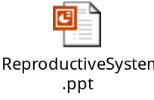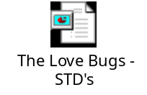

SUPPLEMENTAL KEY TERMS

Amenorrhea
Breast tumors
Cervix
Circumcision
Colpitis
Conception
Copulation (Intercourse, Coitus)
Ductus deferens
Dysmenorrhea
Ejaculation
Endometriosis
Epididymitis
Fimbria
Glans penis
Gynecology
Human Immunodeficiency Virus (HIV)
Kaposi’s sarcoma
Mammary gland
Menopause
Menstruation
Obstetrics
Orchitis
Ovulation
Ovum

Pelvic inflammatory disease
Pneumocystis carinii
Premenstrual syndrome
Prepuce (foreskin)
Prostatic hypertrophy
Puberty
Reproduction
Semen
Sexually transmitted diseases (STDs)
Acquired Immune Deficiency Syndrome (AIDS)
AIDS-related Complex
Chlamydia
Hepatitis
Herpes
Pubic lice
Syphilis
Trichomonas vaginalis
Spermatozoan (sperm)
Sterile
Testosterone
Transurethral resection (TUR)
Urethra
Vaginitis

RELATED HEALTH CAREERS
Doula
Endocrinologist
Fertility Specialist
Geneticist
Gynecologist
Laboratory Assistant
Lactation Specialist
Medical Laboratory Technician
Medical Technologist
Midwife
Neonatologist
Nurse
Obstetrician
Pathologist
Ultrasonographer
Ultrasound Technician
Urologist

NAME_________________________________________DATE_____________________

GENETICS

On the line beside each phrase in Column I, print the letter of the correct answer from Column II. Some answers may be used more than once or not at all.

COLUMN I

1. The study of heredity is called .

2. Hemophilia, a hereditary disease, is due to the fact the blood will not _______.

3. There is more color blindness among _________.

4. Characteristics such as height, eye color, hair
color, weight, and facial appearance are called
.

5. The gene that is “blocked out” by the dominant
one is called .

6. In eye color, brown is the color.

7. Females have only sex chromosomes.

8. DNA stands for .

9. The DNA molecule is shaped like a twisted .

10. A chromosome is made up of thousands of
molecules of .

11. Babies with three genes in the twenty-first pair
develop .

12. There is a connection between having the sickle
cell gene and the disease .

13. A fertilized egg with an XY gene combination will
produce .

14. Each mature body cell contains
chromosomes.

15. The major building blocks of your body are formed by “instructions” carried in .

16. If each parent has Bb genes, the children have a
in four chance of having blue eyes.

17. The sickle cell gene is usually found in people
whose skin is .
COLUMN II

- Down’s syndrome
- clot
- males
- ladder
- dominant
- DNA
- recessive
- forty-six
- hereditary
- parents
- x
- genetics
- one
- twenty-three
- three
- female
- pole
- cytology
- malaria
- diabetes
- a boy
- black
- deoxyribonucleic acid
- a girl
- white
- rickets

Answer Key

GENETICS

On the line beside each phrase in Column I, print the letter of the correct answer from Column II. Some answers may be used more than once or not at all.

COLUMN I

L 1. The study of heredity is called .

B 2. Hemophilia, a hereditary disease, is due to the fact the blood will not _______.

C 3. There is more color blindness among _________.

I 4. Characteristics such as height, eye color, hair
color, weight, and facial appearance are called
.

G 5. The gene that is “blocked out” by the dominant
one is called .

E 6. In eye color, brown is the color.

K 7. Females have only sex chromosomes.

W 8. DNA stands for .

D 9. The DNA molecule is shaped like a twisted .

F/W 10. A chromosome is made up of thousands of
molecules of .

A 11. Babies with three genes in the twenty-first pair
develop .

S 12. There is a connection between having the sickle
cell gene and the disease .

U/C 13. A fertilized egg with an XY gene combination will
produce .

H 14. Each mature body cell contains
chromosomes.

F/W 15. The major building blocks of your body are formed by “instructions” carried in .

M 16. If each parent has Bb genes, the children have a
in four chance of having blue eyes.

V 17. The sickle cell gene is usually found in people
whose skin is .
COLUMN II

- Down’s syndrome
- clot
- males
- ladder
- dominant
- DNA
- recessive
- forty-six
- hereditary
- parents
- x
- genetics
- one
- twenty-three
- three
- female
- pole
- cytology
- malaria
- diabetes
- a boy
- black
- deoxyribonucleic acid
- a girl
- white
- rickets

Name__________________________________________Date_________________

MALE REPRODUCTIVE SYSTEM

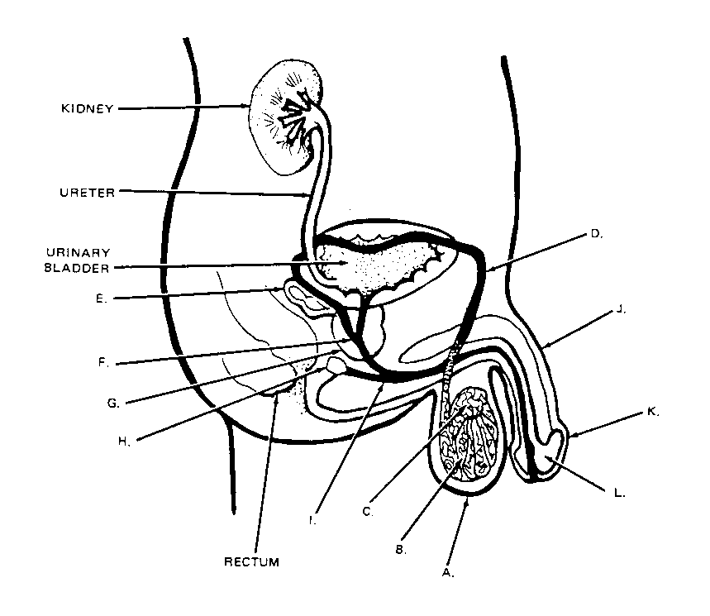Label the parts of the male reproductive system using the terms below terms below.

Scrotum
Glans penis
Penis
Seminal vesicle
Cowper’s gland
Prostate gland
Ejaculatory duct
Urethra
Epididymis
Testis
Vas deferens
Prepuce

A. ________________________ G. _________________________
B. ________________________ H. _________________________
C. ________________________ I. _________________________
D. ________________________ J. _________________________
E. ________________________ K. _________________________
F. ________________________ L. _________________________

Answer Key

MALE REPRODUCTIVE SYSTEM

Label the parts of the male reproductive system using the terms below terms below.

Scrotum
Glans penis
Penis
Seminal vesicle
Cowper’s gland
Prostate gland
Ejaculatory duct
Urethra
Epididymis
Testis
Vas deferens
Prepuce

A. SCROTUM_____________________ G. PROSTATE GLAND______________
B. TESTIS________________________ H. COWPER’S GLAND______________
C. EPIDIDYMIS____________________ I. URETHRA______________________
D. VAS DEFERENS________________ J. PENIS_________________________
E. SEMINAL VESICLE______________ K. PREPUCE______________________
F. EJACULATORY DUCT___________ L. GLANS PENIS__________________
Name__________________________________________Date_________________

FEMALE REPRODUCTIVE SYSTEM

Label the parts of the female reproductive system using the terms below.
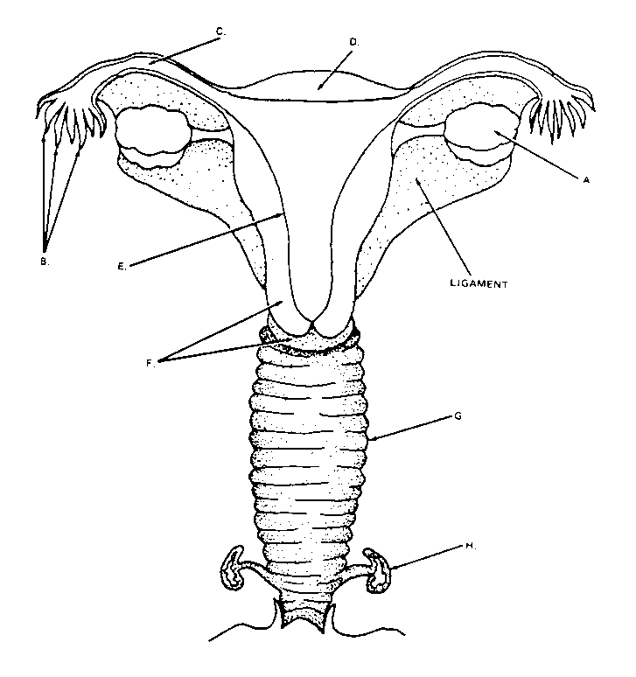
Fundus of uterus
Ovary
Fallopian tube
Body uterus
Vagina
Bartholin’s gland
Cervix of urterus
Fimbriae

A. ______________________________ E. _______________________________
B. ______________________________ F. _______________________________
C. ______________________________ G. _______________________________
D. ______________________________ H. _______________________________

Answer Key

FEMALE REPRODUCTIVE SYSTEM
Label the parts of the female reproductive system using the terms below.

Fundus of uterus
Ovary
Fallopian tube
Body uterus
Vagina
Bartholin’s gland
Cervix of uterus
Fimbriae

A. OVARY_______________________ E. BODY UTERUS________________
B. FIMBRIAE_____________________ F. CERVIX OF UTERUS____________
C. FALLOPIAN TUBE______________ G. VAGINA______________________
D. FUNDUS OF UTERUS____________ H. BARTHOLIN’S GLAND__________
Name__________________________________________Date_________________

PREGNANCY AND CHILDBIRTH

The words listed below can be found in the puzzle in horizontal, vertical, diagonal, and reverse directions. Circle words as you find them and check them off the list.

SPERM
VAGINA
ESTROGEN
UTERUS
NATURAL
LABOR
BREECH
SEMEN
FOLLICLE
PLACENTA
CESAREAN
DELIVERY
OVUM
PENIS
OVARY
LAMAZE
CERVIX
FALLOPIAN TUBE
CORPUS LUTEUM**
MENSTRUATION
PRENATAL CARE
PROGESTERONE
DILATION
AFTERBIRTH*
AMNIOTIC SAC**

M E N S T R U A T I O N R E O E
C P R E N A T A L C A R E S V A
S B R E E C H P A N A T U R A L
I R O O I T E T B N I F C S R E
O C E O G R N O O A N A T E Y S
R N P S P E R M R O A L B E M T
F C D N C A S T I N U L S R R R
P O E A E A N T I L A O E E B O
P R L I R P A G E C F P M N I G
E P I L V L A O I R S I E S R E
N U V E I V L T L M O A N P T N
I S E D X C O A P R E N C G H O
S N R U A I L N M A U T E R U S
S E Y R N T O E T A L U T E U M
O V U M T I R E N A Z B L A R T
M C A N A E R A S E C E R E E S

*Indicates a term that changes direction in the puzzle.
**Indicates a term that consists of two words that are in separate sections of the puzzle.

Answer Key

PREGNANCY AND CHILDBIRTH

The words listed below can be found in the puzzle in horizontal, vertical, diagonal, and reverse directions. Circle words as you find them and check them off the list.

SPERM
VAGINA
ESTROGEN
UTERUS
NATURAL
LABOR
BREECH
SEMEN
FOLLICLE
PLACENTA
CESAREAN
DELIVERY
OVUM
PENIS
OVARY
LAMAZE
CERVIX
FALLOPIAN TUBE
CORPUS LUTEUM**
MENSTRUATION
PRENATAL CARE
PROGESTERONE
DILATION
AFTERBIRTH*
AMNIOTIC SAC**



