HEALTH SCIENCE TECHNOLOGY EDUCATION

Instructional and Work-based Learning Arrangements

The Health Science Technology Education curriculum may be delivered by different instructional arrangements.

Introduction to Health Science, Health Science Technology 1, Sports Medicine 1, and Emergency Medical Services 1–3 are considered comprehensive courses because the student experiences provide both a broad exposure to health careers and the foundational skills of a multi-skilled healthcare worker. Career shadowing, field trips, and guest speakers should be integral components of this classroom instructional arrangement. Students should master the essential knowledge and skills of these foundation courses before enrolling in any work-based instructional class.

The Goals of Career Shadowing are to:
- Provide for realistic exploration of specific health careers; and

- Assist the student in assessing personal interests, aptitudes, abilities and comparing those with personal career choices;

- Allow the student to re-evaluate and re-direct career choices; and

- Provide students in comprehensive courses with opportunities to experience the world of healthcare in a controlled learning situation.

Field trips can be one of the most valuable experiences for students, but advance planning is critical to the success of this educational tool. Successful field trips require pre-planning with the site, arranging for transportation and a meal, recruiting chaperones, and ensuring adequate student preparation.



Health Science Technology 2, Sports Medicine 2, and Gerontology may be taught by several instructional arrangements, such as laboratory, clinical rotation, mentorship, internship, and cooperative education. Each instructional arrangement is composed of classroom instruction using the health science cluster curriculum standards as a framework and a paid or unpaid, work-based learning component.

Laboratory is a method of instruction designed to provide knowledge and skills training in a specific career pathway. The instruction is provided in a school-based laboratory setting utilizing tools, equipment, supplies, technology, and processes relevant to the career pathway.



- Clinical rotations, mentorships, and internships provide students with the opportunity to explore a variety of health careers, develop knowledge and skills related to healthcare, and transition from the role of student to that of professional. Students rotate among various departments of local healthcare facilities to develop an awareness of the many related career opportunities. Unpaid work-based instructional opportunities must be planned and supervised cooperatively by the local education agency and the training sponsor. In the classroom or training site, students are expected to master the essential knowledge and skills for Health Science Technology 1 and 2, Sports Medicine 1 and 2, Emergency Medical Services 1, 2, and 3, and Gerontology.

For any of these arrangements, the following should be anticipated:

- An affiliation agreement between the school and each healthcare facility is required;

- A training agreement between the student, parent, facility, and school must be on file before a student can begin the work-based learning experience,

- Students must have direct, professional supervision during clinical experiences, and

- After the initial work-based instruction that provides a broad overview of many healthcare professions, a student may chose to do a clinical rotation, mentorship, or internship that allows a career specialty emphasis.

Guidelines for Clinical Rotations, Mentorships, and Internships

- The number and length of rotations will vary depending on the program goals, student interest, and industry partnerships. There should be an appropriate balance of classroom and work-based instruction hours to support the program goals. The work-based training component should provide the student with a variety of learning experiences that will give the student the broadest possible understanding of the healthcare industry.

- Students should have a clear understanding of what they are and are not permitted to do, regardless of the clinical setting. They must know their scope of practice.

- Written training agreements must be on file for all students participating in unpaid work-based learning opportunities.

- Student clinical experiences should be monitored with the assignments for each rotation.

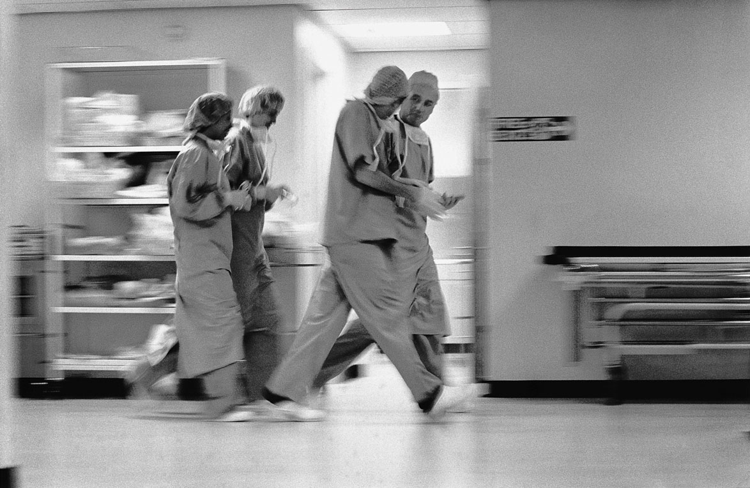

- The selection of training sites shall be dependent on the following:

  - number of healthcare facilities/agencies willing to accept students;
  - number of willing professionals available for direct supervision;
  - type of service provided by the training site;
  - patient/client/resident rights;
  - interest and aptitude of students; and
  - distance from school to facility and transportation arrangements.

- Students usually spend 3-6 weeks in class at the beginning of the year for clinical orientation. During that time, students should master the following essential knowledge and skills prior to clinical experiences:

- communication skills;
- safety and body mechanics;
- professional ethics and confidentiality;
- patient/client/resident rights;
- legal responsibilities;
- CPR, first aid, and vital signs;
- infection control and standard precautions; and
- technical skills.
- After the initial orientation period, students usually spend the remainder of the course in a balance of classroom and work-based learning time. Classroom training and education should correlate with clinical experiences.



Work-based Credit Experiences

Work-based credit refers to education experiences that primarily occur outside the classroom in cooperation with high school athletic departments, and healthcare business partners.

Health Science and Sports Medicine work-based credit experiences provide opportunities for students to enter the workplace for a specified period of time to gain skills and knowledge in health science and sports medicine. Typically, students in secondary level programs participate in internships where they apply formal classroom learning to actual work situations. Students’ workplace activities may include working on special projects, sampling tasks from different jobs, and learning tasks related to a single occupation. Internships or clinical rotations also provide opportunities for students to interact with proper role models and learn about appropriate
behavior and ethics in the workplace. Work-based credit experiences should include at least 60 contact hours for ½ credit or 120 contact hours for 1 unit. Students may earn up to 3 units through work-based credit experiences. Internships may be paid or unpaid experiences depending upon the arrangement agreed upon by the employer, school, student and parent/guardian.

Coordination of Work-based Learning Experiences
The clinical rotation instructor assumes a number of responsibilities in addition to the preparation and delivery of classroom instruction. The affiliation with clinical facilities requires that the instructor establish and maintain working relationships with healthcare partners and appropriate communications among facilities.

Cooperative Education is designed to provide paid work-based education and training and is subject to the Fair Labor Standards Act and the Federal Child Labor Laws. The student is provided the opportunity to receive school-based instruction and career specialty work-based training under the supervision of an employer. This method requires a written cooperative training agreement with a business and industry training sponsor, the student, a parent or guardian, and the school. The student’s career specialty learning experiences must be planned and supervised by the school and the training sponsor so that each contributes to the student’s education and employability skills.

Cooperative Education provides students with the opportunity to gain career specific knowledge and skills through a paid work-based learning experience. Students receive instruction by participating in career specialty classroom instruction and work-based learning experiences.

Coordination of paid work-based learning experiences
The cooperative education coordinator must assume a number of responsibilities in addition to the preparation and facilitation of classroom instruction. The partnership with healthcare facilities and agencies requires that the coordinator establish and maintain working relationships and appropriate communications among all cooperative education partners.

