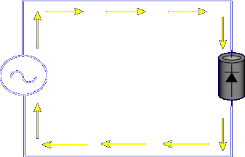

The purpose of a diode is to allow current in one direction and stop current in the other direction.
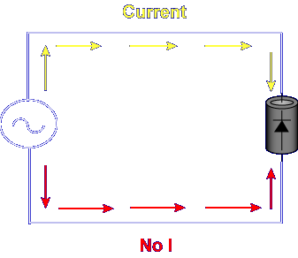
Diodes are unidirectional devices. Current flows in only one direction.
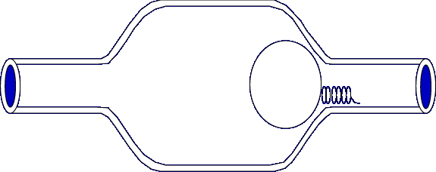
An example of a unidirectional device is a check valve.
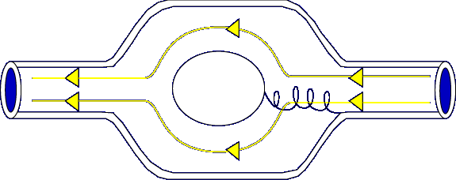
Fluid can flow from right to left as pressure pushes the ball away from the opening.
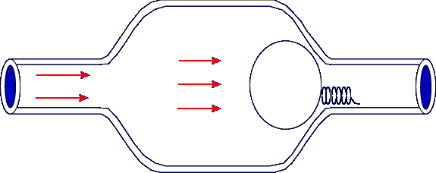

Fluid cannot flow from left to right. The pressure of the fluid forces the ball against the opening.
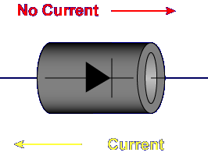

Diodes are the electrical equivalent of a check valve. Current flows in only one direction.
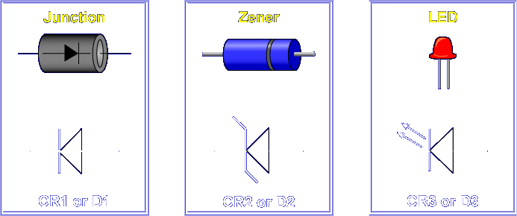
The reference designator for a diode is CR or D. There are several types of diodes. The most common are: Junction, Zener, and LED. The junction diode schematic symbol is an arrow (triangle) and bar.
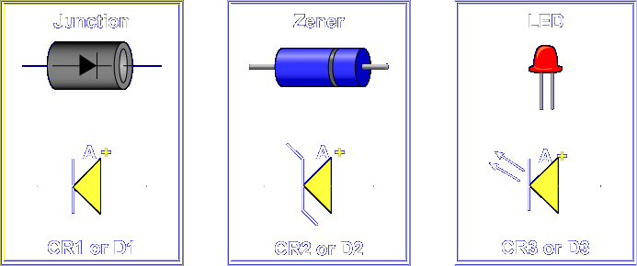
The arrow represents the positive side of the diode, called the anode.

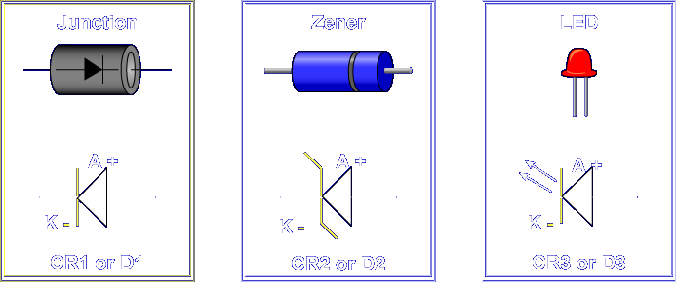

The bar represents the negative side of the diode, called the cathode.

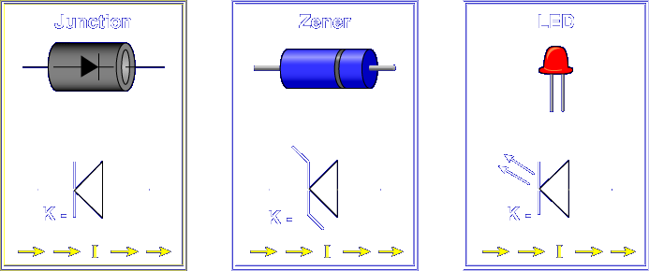

Current flows from the cathode to the anode, but not from the anode to the cathode.

The arrow and bar are generally marked on the diode. If not, a dot or band at one end will indicate the cathode side.

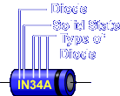

Diodes are also marked with identification numbers. The 1 indicates a diode. The N indicates the component is solid state. The last digits identify the type of diode.

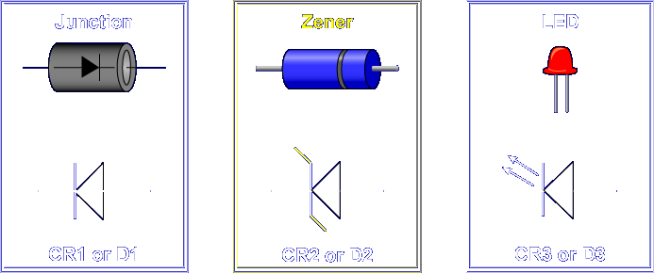

The Zener diode looks and operates like the junction diode. The symbol for the Zener looks like the junction diode with two flags. Zener diodes are special purpose diodes designed to regulate voltage.

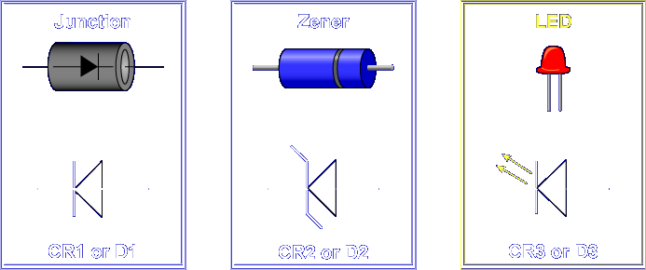

Light Emitting Diodes (LEDs) use the junction diode symbol with the addition of two small arrows. LEDs are designed to give off light when current flows through the device. Red, green, yellow, blue, orange, and infrared (invisible) LEDs are available.

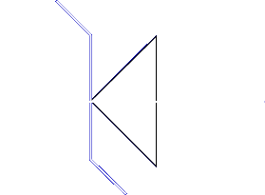

What type of diode is represented by this schematic symbol?

Zener.

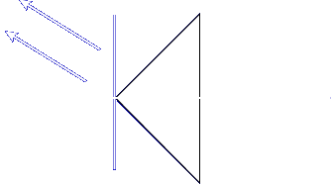

What type of diode is represented by this schematic symbol?

LED

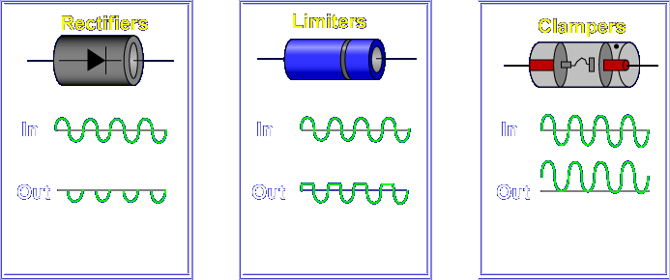

Diodes are used as: Rectifiers, Limiters, and Clampers.
Let's look at diode rectifiers first.

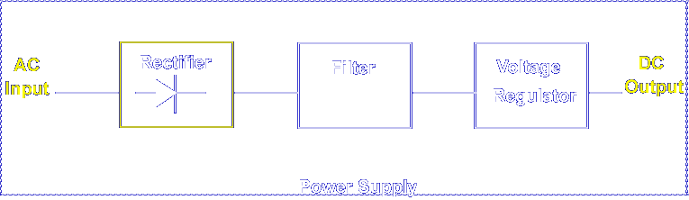

Rectifiers are used in power supplies to convert AC voltages to pulsating DC voltages.

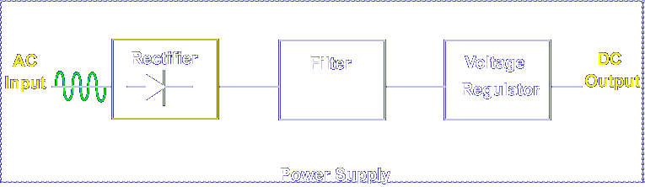

For example, a 115 VAC input is applied to the diode rectifier.

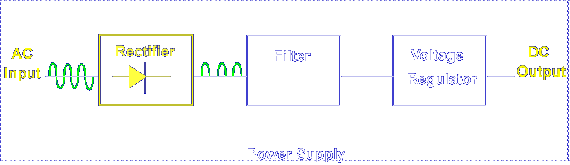

The diode allows current flow in one direction, which produces a pulsating DC voltage.

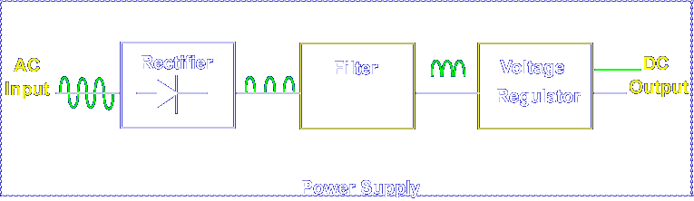

The filter and voltage regulator are added to the circuit to produce a pure DC output.

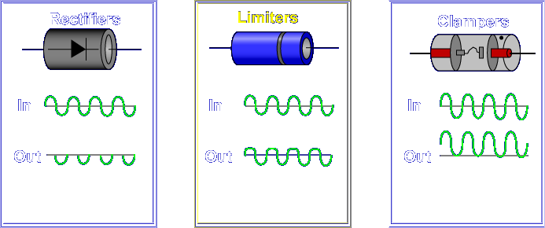

Limiters are like rectifiers, except they are useful in signal shaping and typically used at frequencies much greater than 60 Hz.
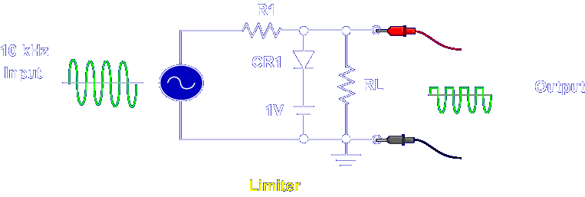

Limiters remove signal voltages above or below a specific level. For example, this is a positive limiter, sometimes called a clipper.

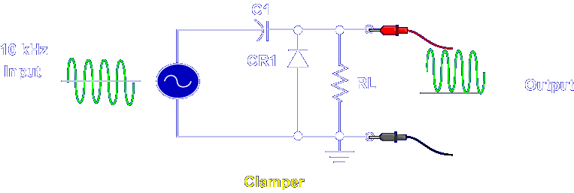

The diode clamper is a variation of the diode limiter. Clampers add a DC voltage to the input signal. For example, this is a positive DC clamper.

What type of diode removes signal voltages above or below a specified level?

Limiter

What type of diode adds a DC level to the AC input?

Clamper

This completes the information on DIODES.

