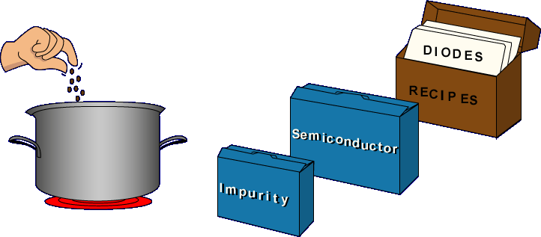
Diodes are constructed from semiconductor materials which have impurities added. To see the effect that impurities have on semiconductors, let's first look at pure semiconductors.
IMPURITIES - Impurities are materials different from the semiconductor material. For example, a glass of pure water contains only hydrogen and oxygen atoms. Adding salt to the water makes it impure and the taste of the water changes. Adding impurities to a semiconductor changes the electrical characteristics.

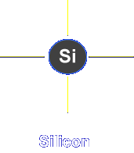
Pure semiconductor atoms have four electrons in their outermost orbit.
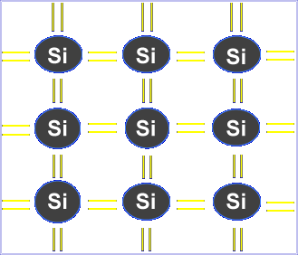
Because atoms like eight electrons in an orbit, individual atoms share electrons to form crystals. The electrons are tightly held by this bonding. Placing a voltage across the material produces only a small current.
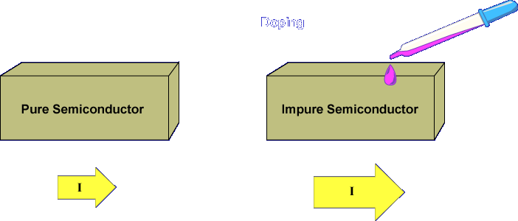
Adding impurities, called doping, increases the conduction of semiconductors. Adding different impurities to each half of a piece of semiconductor material produces a diode.
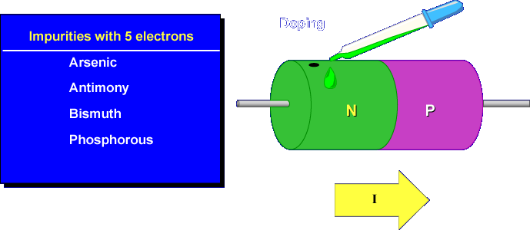
Half of the semiconductor is doped with atoms that have five electrons in the outermost orbit.
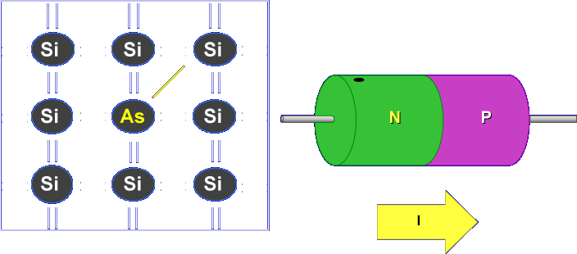
The fifth electron is free to move in any direction. It is a FREE electron that can conduct current.
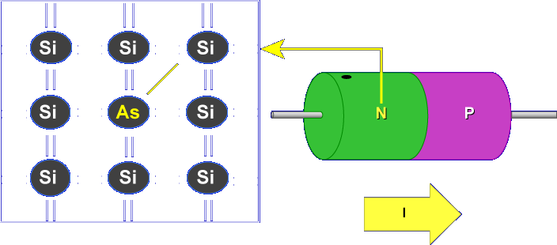
This end of the semiconductor is N-type material, or the cathode.
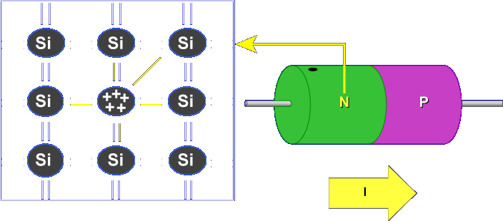
The semiconductor is still electrically neutral because the number of protons and electrons are equal.
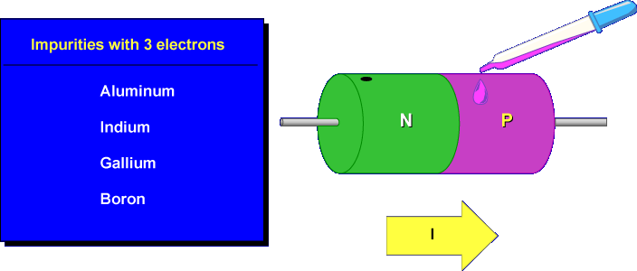
The other half of the semiconductor is doped with atoms that have three electrons in the outermost orbit.
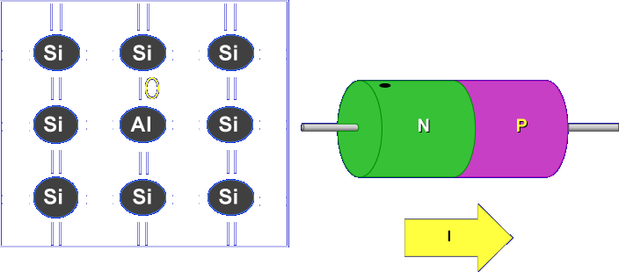
The missing electron forms a HOLE that can accept an electron. The movement of electrons from hole to hole produces current flow. The missing electron forms a HOLE that can accept an electron. The movement of electrons from hole to hole produces current flow.
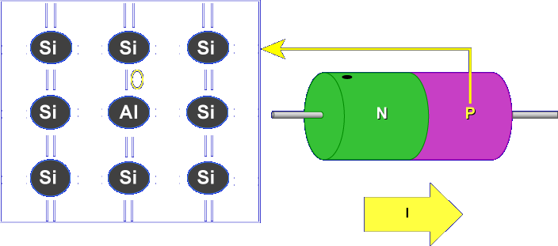
This end of the semiconductor is P-type material, or the anode. The semiconductor is still electrically neutral because the number of protons and electrons are equal.
What type of material has holes?
P-Type
N-type material has _______
Free electrons
In which direction do holes appear to move?
Opposite of electrons
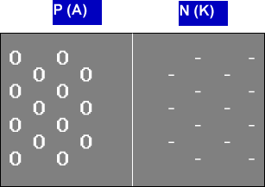
Remember, the free electrons move and the holes appear to move. The atoms do not move; they are held in place by the crystalline structure.
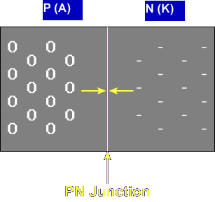
The free electrons and holes combine in the center of the doped semiconductor. This process is called "recombination". The center of the semiconductor is called the PN junction.
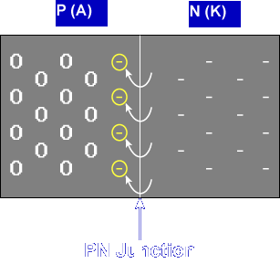
Free electrons move to the holes in the P-type material, creating negative ions near the PN junction in the P-type material.

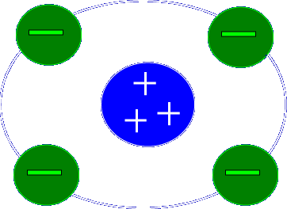
NEGATIVE IONS - A negative ion is an atom that has more electrons (-) than protons (+).

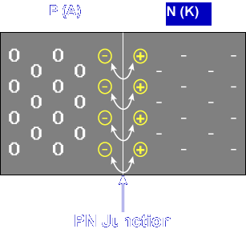
The loss of electrons from the N-type material creates positive ions near the PN junction in the N-type material.

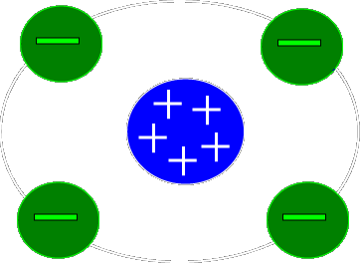
POSITIVE IONS - A positive ion is an atom that has more protons (+) than electrons (-).

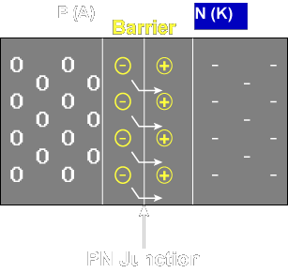
This action forms a barrier around the PN junction. The barrier is called the Barrier Voltage or Depletion Region. The free electrons are repelled by the negative ions.
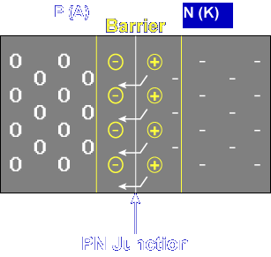
The holes are repelled by the positive ions. The barrier prevents current flow. The free electrons stay in the N-type material and the holes stay in the P-type material.
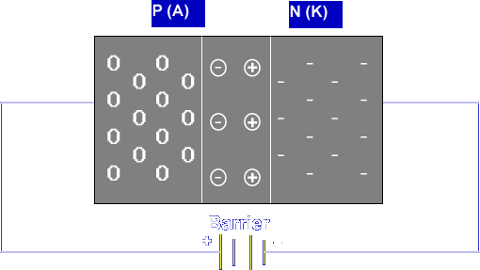
An external voltage applied to the diode, called bias, affects the barrier. The diode is forward biased with a negative applied to the N-type material and a positive applied to the P-type material.
BIAS - Bias is a steady force, voltage, magnetic field, etc., applied to a device to establish a reference level or determine the range of operation.

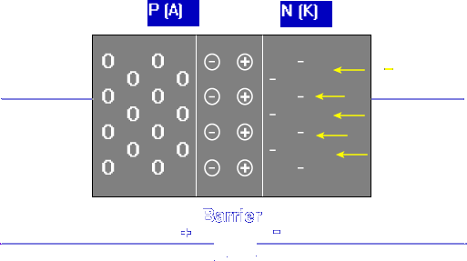

The free electrons are supplied by the battery causing the N-type material to become highly negative.
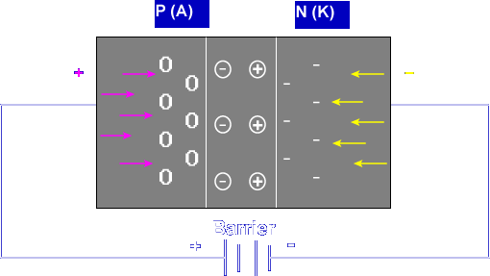
The electrons move from the P-type material to the positive terminal of the battery, leaving extra holes in the P-type material. The force pushes the electrons through the barrier to the holes. The electrons are now attracted to the positive side of the battery.
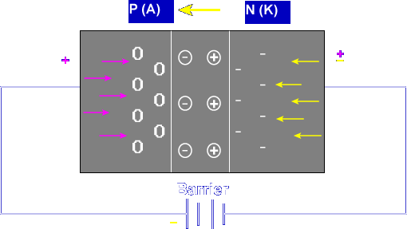

Current flows from the negative side of the battery to the positive side. Current flows from cathode to anode.
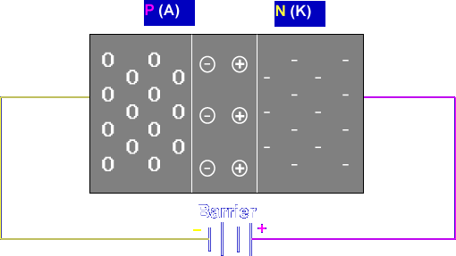
Connecting the battery the opposite way reverse biases the diode. The positive side of the battery attracts electrons, increasing the number of positive ions.
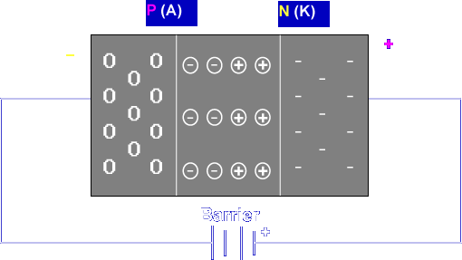
The negative side of the battery adds electrons to the holes, increasing the number of negative ions. The barrier widens, preventing electrons from flowing through the barrier.
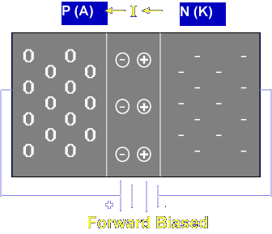
Remember, forward biasing forces the free electrons through the barrier. Current flows from cathode to anode.
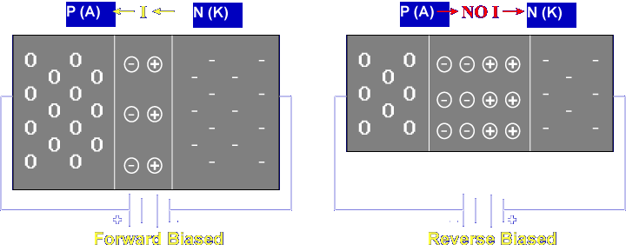

Reverse biasing increases the size of the barrier. Current cannot flow from anode to cathode.

This completes the information on DIODE CONSTRUCTION.

