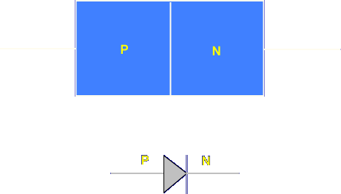

The junction diode is represented pictorially by a rectangle containing an N and P side. The schematic symbol for the junction diode is an arrow and bar. The arrow represents P and the bar N.

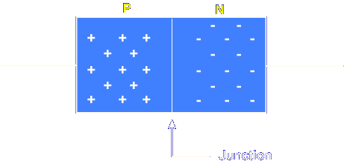

The junction diode is constructed from two materials called N-type and P-type. The N material has electrons free to move while the P material has holes free to move. They are attracted toward each other.

Let's begin the lesson on JUNCTION DIODES.

