-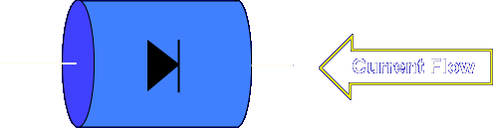

The purpose of a junction diode is to allow current flow in one direction only.

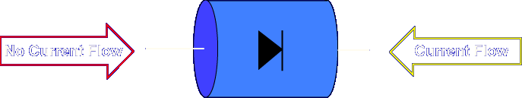

The material used to construct a junction diode stops current flow in the other direction. This characteristic of the diode is described as changing AC current flow to DC current flow.

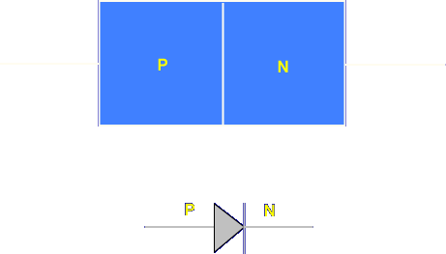

The junction diode is represented pictorially by a rectangle containing an N and P side. The schematic symbol for the junction diode is an arrow and bar. The arrow represents P and the bar N.

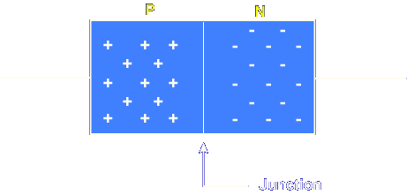

The junction diode is constructed from two materials called N-type and P-type. The N material is mostly negative in charge while the P material is mostly positive in charge. A depletion area is formed at the junction of the two materials that acts like a barrier to current flow. With no external voltage applied, the diode is neutral. A balance between the N and P materials exists.
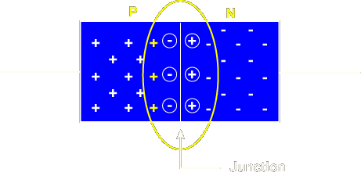
DEPLETION AREA - The depletion area is formed by positive and negative ions. These ions build up at the junction to form a barrier to any other free electron movement or current flow.

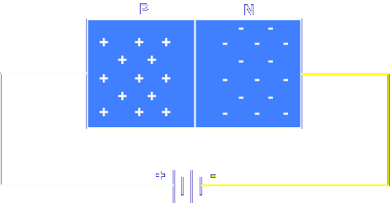

When the diode is placed in a circuit and forward biased, the negative terminal repels electrons toward the junction. The force of the battery helps electrons cross the junction or barrier region, producing current flow. If the voltage is increased, the current flow through the diode increases.
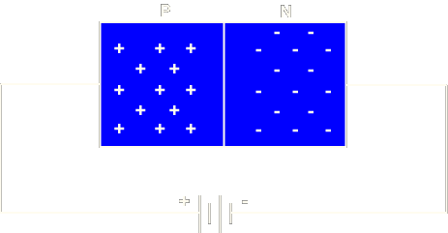
FORWARD BIASED - A diode is forward biased when the negative terminal of the voltage source is connected to the N-type material and the positive terminal of the voltage source is connected to the P-type material.

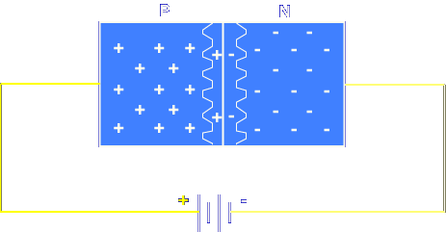

If voltage is increased beyond the limits of the diode, the excessive current flow produced will damage the component.

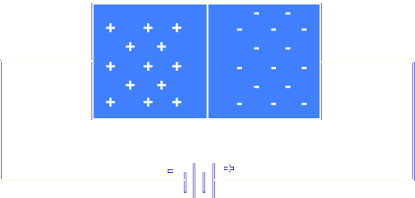

When the diode is placed in a circuit and reverse biased, the depletion area becomes larger.
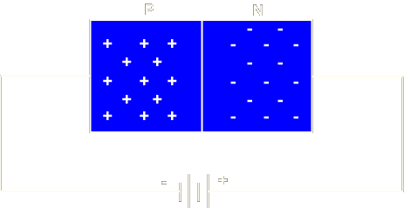
REVERSE BIASED - A diode is reverse biased when the negative terminal of the voltage source is connected to the P-type material and the positive terminal of the voltage source is connected to the N-type material.

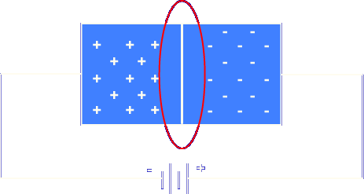

Electrons are unable to cross the barrier region and current flow is effectively stopped.

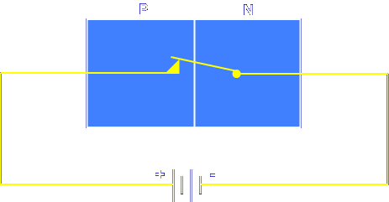

A diode acts like a switch. When forward biased, the diode (switch) is closed. Current will flow.

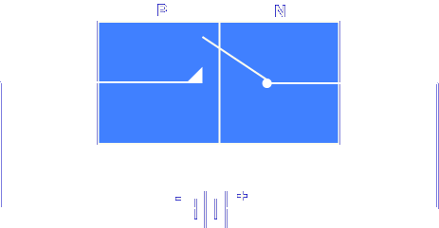

When reverse biased, the diode (switch) is open. Current flow is stopped.

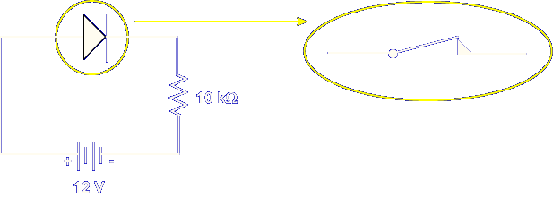

The diode in this circuit is forward biased. The diode's effect on the circuit is the same as a closed switch.

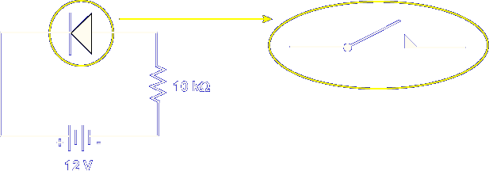

If the diode is reverse biased, its effect on the circuit is the same as an open switch.

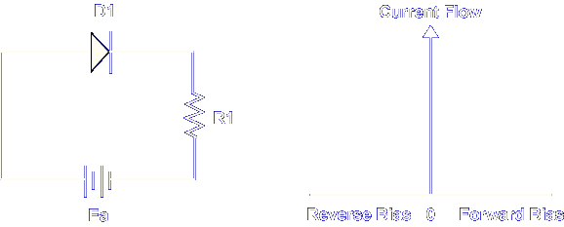

The horizontal line of the graph represents the bias voltage. The vertical line represents current flow.

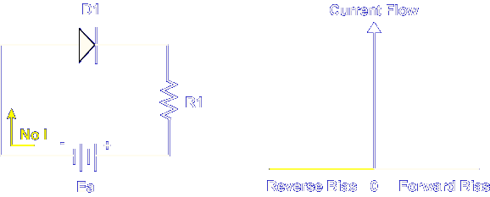

With a negative voltage applied to the anode of the diode, no current flows.

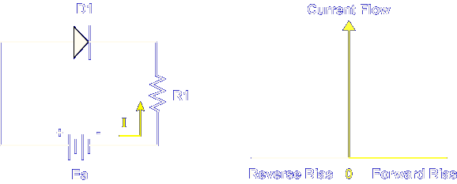

A positive voltage applied to the anode allows current flow. Current flow is determined by circuit values.

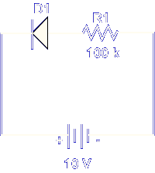

What is the total current flow of this circuit?

.1mA

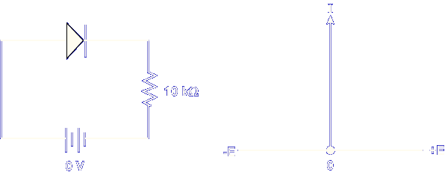

In actual circuit operation, the diode requires a bias voltage to cause the diode to conduct. The bias voltage is also known as knee voltage and offset voltage.

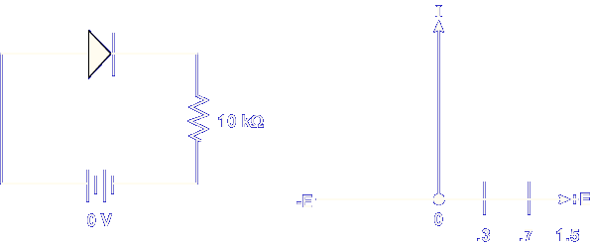

The offset or knee voltage ranges from 0.3 volts to 0.7 volts, depending on the material used to construct the diode.
DIODE KNEE VOLTAGE - Two materials used in the construction of diodes are silicon and germanium. A germanium diode requires a knee voltage of 0.3 volts to cause conduction. A silicon diode requires a knee voltage of 0.7 volts to cause conduction.

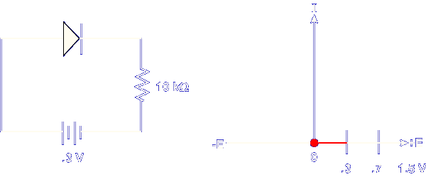

The graph shows that at 0.3 volts, the silicon diode is not conducting. There is no current flow produced.

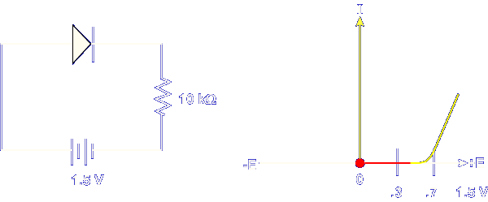

When the applied voltage exceeds 0.7 volts, the diode will conduct.

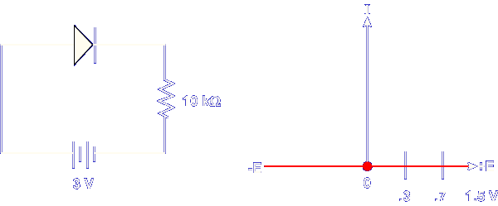

Said differently, any voltage less than 0.7 volts will keep the diode from conducting.

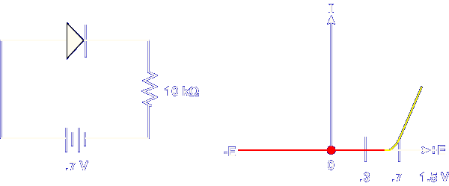

Positive voltage above 0.7 volts will cause the diode to conduct.

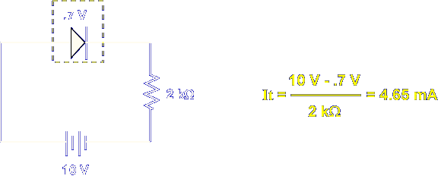

The voltage needed for the diode to conduct is subtracted from the applied voltage. In this example, It is determined by subtracting the knee voltage of 0.7 volts from the applied voltage of 10 volts and dividing by the resistance.

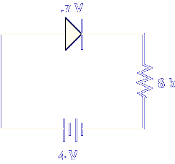

What is the current in this circuit?

.41mA

This completes the information on JUNCTION DIODE.

