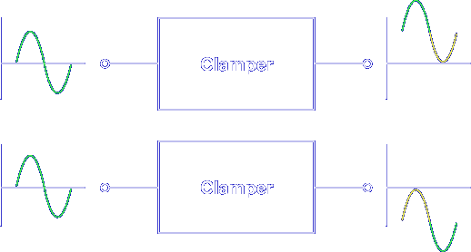
The purpose of a diode clamper is to clamp an AC input signal at a DC output level. The AC signal can be changed so either the positive or negative peak is at 0 V.
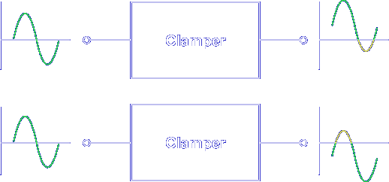
The peaks can also be placed above or below 0 V.
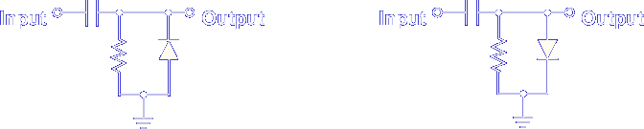
A clamper's effect on an input signal depends on how circuit components are connected. The operation of each circuit is based on the action of a junction diode.
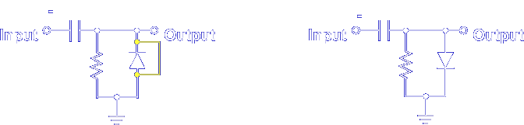

A forward biased diode conducts, acting almost like a short circuit.

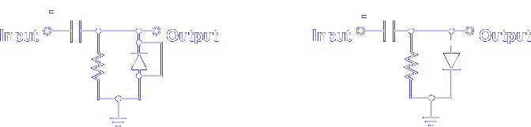

A reverse biased diode is cut off, acting like an open circuit.

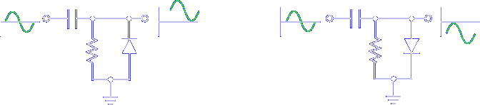

When the diode is placed in different configurations, different output signals are produced. The two basic configurations of diode clampers are:

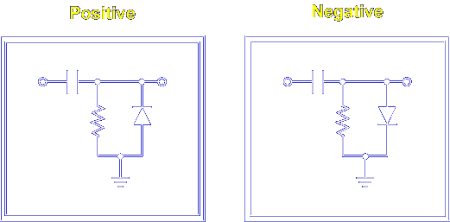

Let's start with positive clampers.

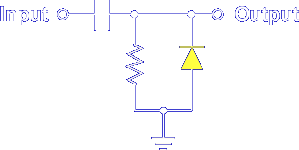

A positive clamper has the diode pointing up or towards the output signal. Positive clampers add a positive DC voltage.

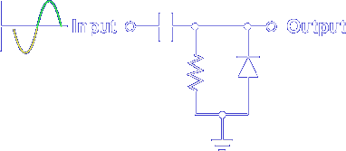

An input signal's negative alternation forward biases the diode. When the diode is forward biased, the path for AC current is through the low resistance of the diode to ground.

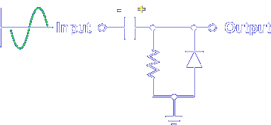

The capacitor quickly charges to the peak value with the positive polarity on the output.

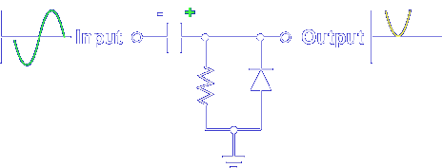

Adding the +Vp on the capacitor to the -Vp of the input signal produces a half cycle output with 0 V at the negative peak. The positive charge on the capacitor raised the voltage level of the output signal.

An input signal's positive alternation reverse biases the diode. When the diode is reverse biased, the path for AC current is through the high resistance of the resistor.

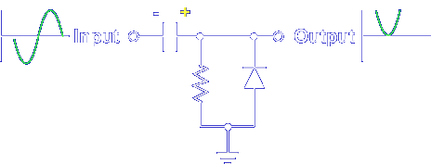

The capacitor does not have time to discharge through the resistor. The positive voltage on the capacitor remains.

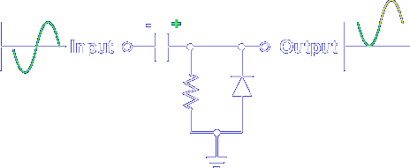

Adding the +Vp on the capacitor to the +Vp of the input signal produces twice the output. The positive charge on the capacitor raised the voltage level of the output signal.

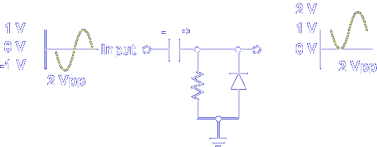

The peak-to-peak value of the output signal does not change. Only the DC level is different. Remember, the diode action allows the capacitor to charge quickly through low resistance and discharge slowly through high resistance. The capacitor charges but does not discharge quickly. Remember, the positive voltage on the capacitor is added to the input signal.

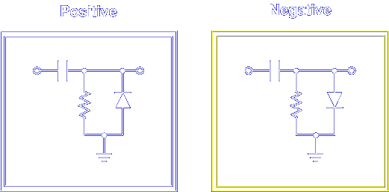

The negative clamper operates the same except that a negative DC voltage is added.

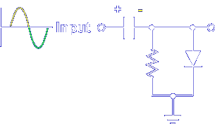

A negative clamper has the diode pointing down or towards ground. A negative clamper adds a negative voltage to the output. During the positive alternation, the diode is forward biased. The capacitor quickly charges to the peak value, with the negative polarity on the output.

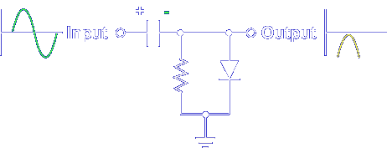

Adding the -Vp on the capacitor to the +Vp of the input signal produces a half cycle output with 0 V at the positive peak. During the negative alternation, the diode is reverse biased. The capacitor does not have time to discharge through the resistor.

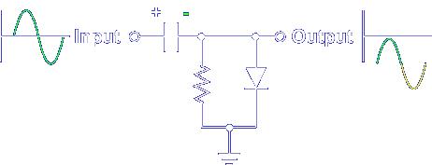

Adding the -Vp on the capacitor to the -Vp of the input signal produces twice the output.

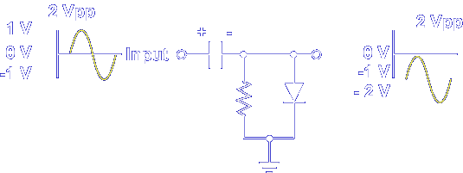

Only the DC level changes; the peak-to-peak value of the output signal remains the same. Remember, the capacitor is allowed to charge but not discharge, and the negative voltage on the capacitor is added to the input signal.

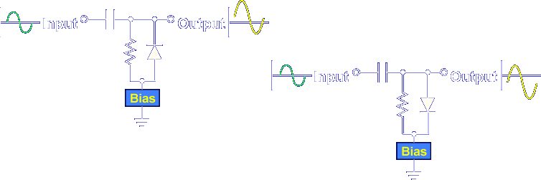

Adding circuit bias changes the voltage level of the peaks from 0 V.

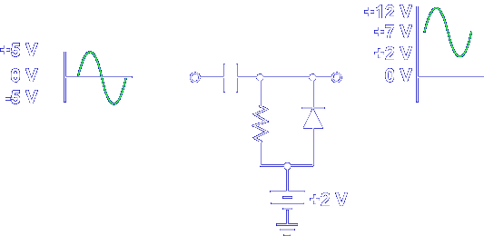

A positive bias on a positive clamper raises the output voltage DC level. The peak-to-peak input and output voltage is still 10 V, but the negative peak was raised to the level of the bias voltage.

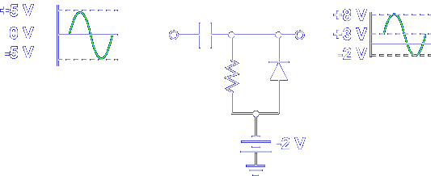

A negative bias on a positive clamper lowers the output voltage DC level.

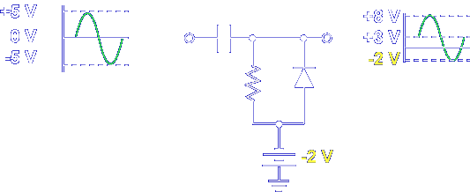

The peak-to-peak input and output voltage is still 10 V, but the negative peak was lowered to the level of the bias voltage.

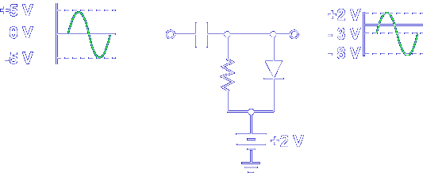

A positive bias on a negative clamper raises the output voltage DC level.

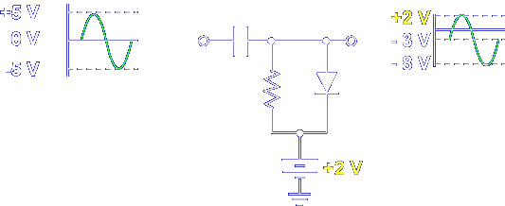

The peak-to-peak input and output voltage is still 10 V, but the positive peak was raised to the level of the bias voltage.

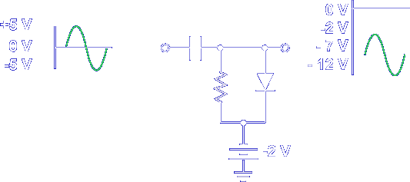

A negative bias on a negative clamper lowers the output voltage DC level.

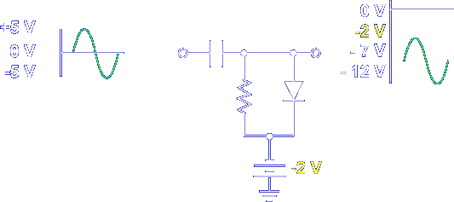

The peak-to-peak input and output voltage is still 10 V, but the positive peak was lowered to the level of the bias voltage.

Remember, a biased clamper works just like an unbiased clamper. The bias either raises (positive bias) or lowers (negative bias) the DC level.

