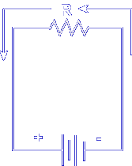
In electronics, you have learned the basic laws of current and voltage. You know that current flows in the conductor of a completed circuit.
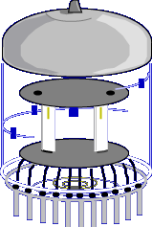
Vacuum Tubes seem to violate the basic laws of electronics because electrons flow across a gap, a break in the circuit in which there appears to be no conductor. A large part of electronics and the entire field of electron tubes is concerned with the flow and control of these electrons "across the gap".
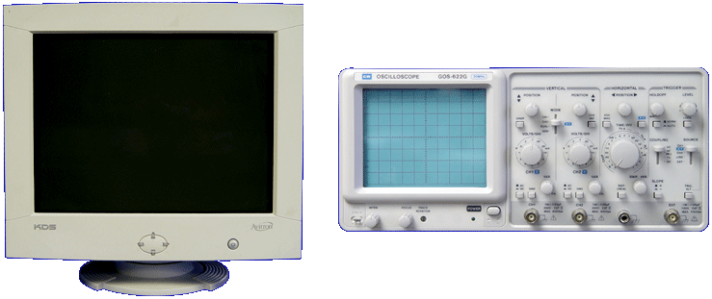

Although vacuum tube use is decreasing in today's electronics world, you will still encounter tubes in audio amplifiers, televisions, video games, computer monitors, radar screens, and test equipment.

Let's begin the lesson on ELECTRON TUBE PRINCIPLES.

