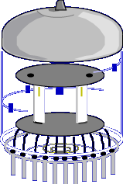
The operation of electron tubes is quite similar to that of some solid state components like the diode, transistor, and JFET. Let's talk about the operation of each of the following electron tubes, and the advantages and disadvantages of their use.
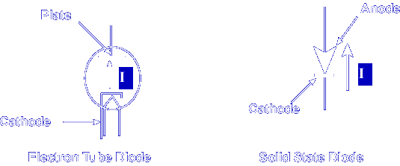
As with solid state diodes, in electron tube diodes, current flows in one direction, cathode to plate (anode) or negative to positive. In fact, this type of diode was the first rectifier. With this basic understanding of the diode, we can move on to the other types of electron tubes. As you will see, each of the other types work according to the principles of the diode with enhanced operation.
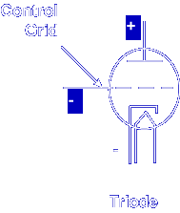
Triode
As you learned, the triode is a diode with another electrode, the control grid, added in between the cathode and the plate. The purpose of the control grid is to control the amount of electron flow between the cathode and the plate.
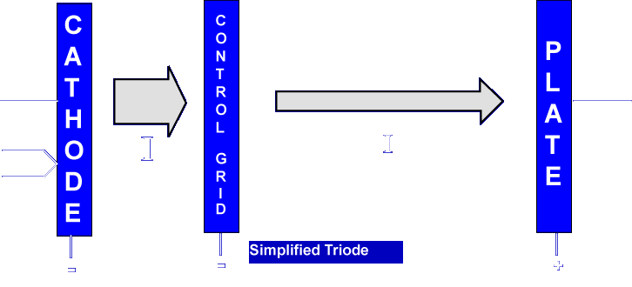
Physically, the grid is much closer to the cathode than it is to the plate. Because of this, a small voltage on the control grid has a large effect on current to the plate. The control grid actually regulates the resistance of the tube. As the grid becomes more negative, resistance to current is increased and current will decrease. Just the opposite happens if the grid is made more positive. In a normal amplifier arrangement, the grid is negative with respect to the cathode. This is similar to the way a JFET is biased. The negative grid will repel electrons and keep them from getting to the plate.
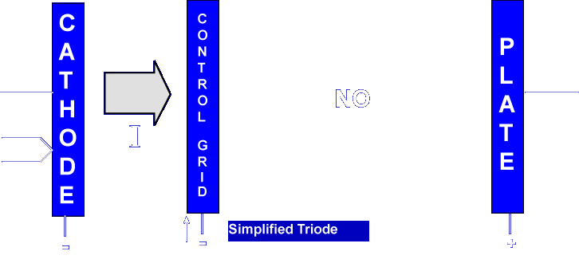
At some point of grid voltage, the electron beam will be shut off. Varying the voltage level of the control grid can control, and even shut off, the output of the plate.
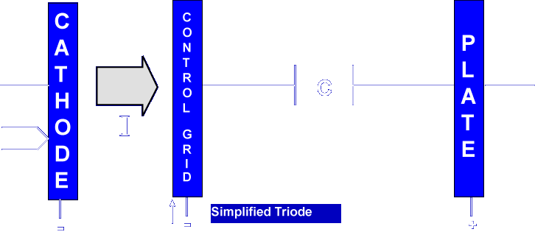
The major disadvantage of the triode is inter-electrode capacitance due to the wide surface areas of the plate and control grid. This is the major cause of loss of gain at high frequencies in amplifier operations.
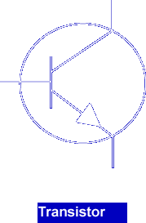

During the solid state revolution, the triode as an amplifier was replaced by the transistor.

A negative potential with respect to the cathode on the control grid will _______
Repel electrons
What component replaced the triode as an amplifier during the solid state revolution?
Transistor
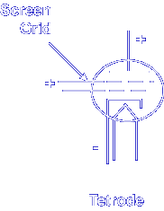
Tetrode
This electron tube is similar to the triode with the addition of a fourth electrode, called the screen grid.
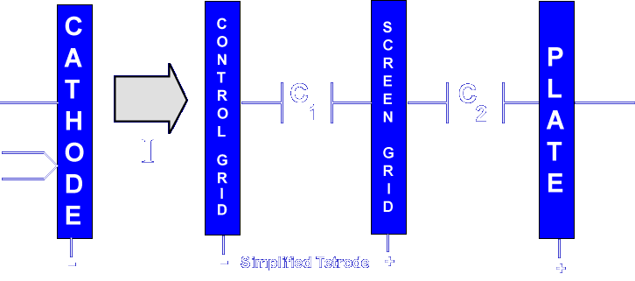
The screen grid is located between the control grid and the plate. This electrode reduces the amount of inter-electrode capacitance. Applying a more positive voltage potential to the screen grid forms two capacitors in series, one between the screen grid and the control grid, and the other between the screen grid and the plate.
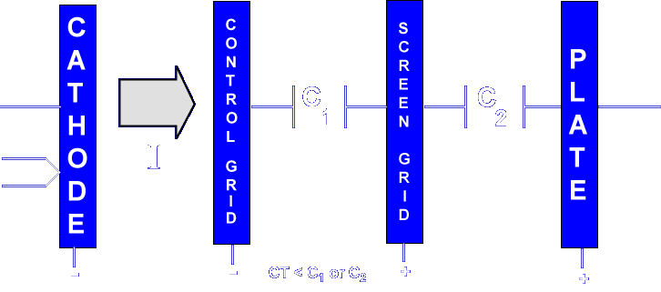
As you know, total capacitance of two series capacitors is always lower than the capacitance of either of the two capacitors. Understand that the screen grid is not used to control current emission. Its purpose is just to reduce undesirable effects of inter-electrode capacitance in electron tubes. The major disadvantage of the tetrode is removed by the addition of the fifth electrode in the pentode. We will discuss this disadvantage when we look at the pentode electron tube.
The screen grid is located between which two electrodes?
Plate and control grid
The purpose of the screen grid is to _______
Reduce the effects of inter-electrode capacitance
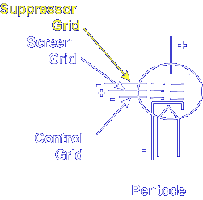
Pentode
This electron tube is similar to the tetrode with the addition of a fifth electrode called the suppressor grid.
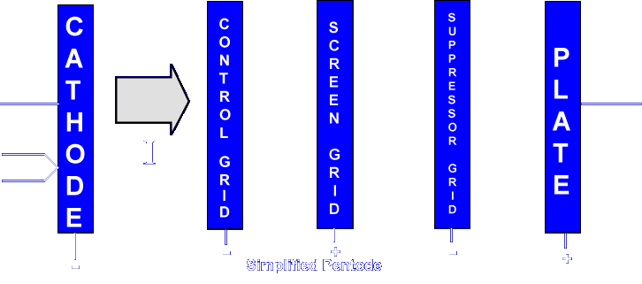
The suppressor grid is located between the screen grid and the plate. This electrode reduces the disadvantage of the tetrode. Let's look at this disadvantage.
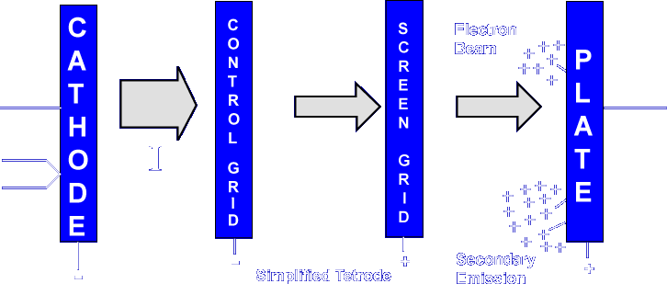
It was found that the velocity of the electrons in electron tubes as they hit the plate was knocking off other electrons. This is known as secondary emission.
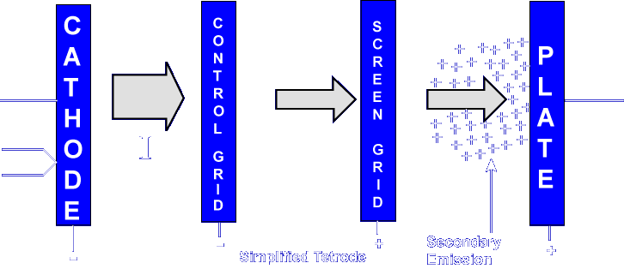
With the screen grid being positive, this cloud of slow-moving electrons would move towards the screen grid. These slow-moving electrons would interfere with the electron beam, causing the electron tube to operate inefficiently.
The suppressor grid, which should be negative with respect to the screen grid and the plate, will provide two advantages to the electron tube's operation.
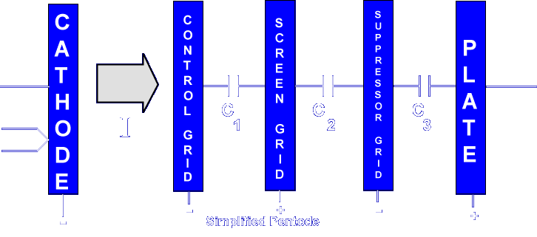
First, as with the screen grid, it will help to reduce the inter-electrode capacitance by causing three capacitors to be in series.
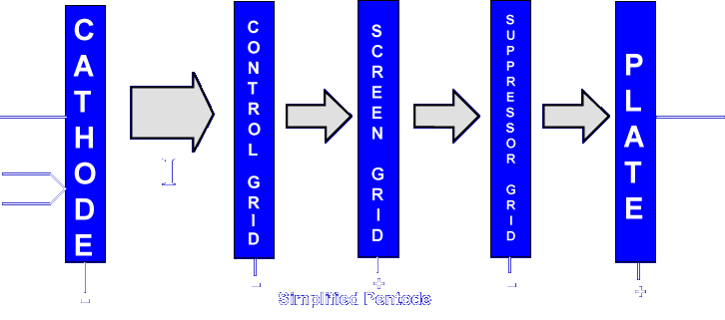
Second, it causes the electrode closest to the plate to have a negative potential, which will repel the secondary emission electrons back to the plate. Just as with the screen grid, the suppressor grid is not used to control current flow through the electron tube. Its purpose is to remove undesired effects of its operation.
The suppressor grid reduces the effects of ________
Secondary emissions
How many electrodes does the Pentode have?
5
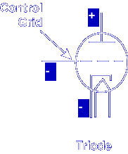
Electron Tube Applications
Let's take a look at the most common triode electron tube application, amplifier operation.
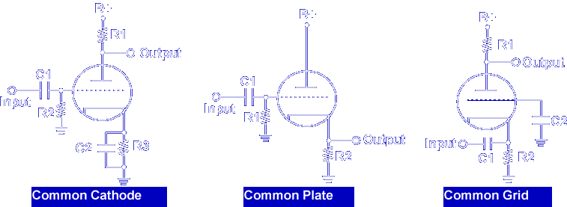
There are three different electron tube amplifier configurations: the common cathode, the common plate, and the common grid. Each configuration has different operating characteristics that make it useful for certain operations.
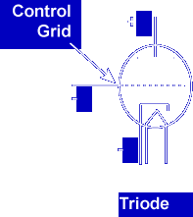

The amplifier configuration can be identified by determining the electrode to which the input signal is applied and the electrode from which the output is taken. The electrode that has neither input nor output is the common lead. The input will never be applied to the plate, nor will an output ever be taken from the control grid.

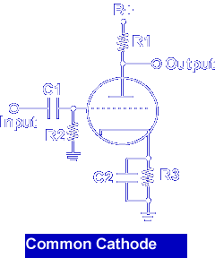

The circuit above is a common cathode amplifier. The input is applied to the control grid with respect to ground. The output is taken from the plate with respect to ground.

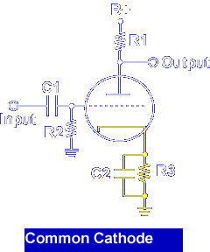

The cathode is connected to ground. The cathode is common to both the input and output and is the common electrode.

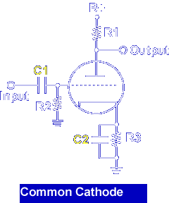

C1 couples the AC input signal to the grid and blocks any DC voltage from the input. C2 maintains a constant DC voltage on the cathode by filtering out the AC cathode signals, which reduces negative feedback.

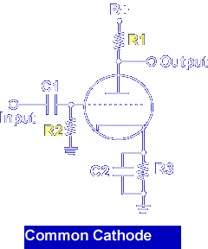

R1 develops the output voltage of the triode. R2 provides a DC path to ground for the small number of electrons intercepted by the control grid. R2 develops the input signal.

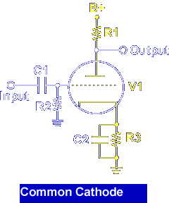

R3 develops cathode self-bias. The current flow through the circuit is from ground, through R3, V1, and R1 to B+. The current that flows in the cathode lead is referred to as cathode current (Ik). The current that flows in the plate is referred to as plate current (Ip). Recall the control grid is normally at a negative and does not draw current. In this example, plate current is equal to cathode current. When no input signal is applied, the current through the tube is called STATIC CURRENT. As the input signal on the grid goes positive, the bias decreases. When bias decreases, the resistance of V1 decreases. This means plate current increases and the voltage across R1 must increase. If VR1 increases, the voltage across the tube decreases. Likewise, as the input goes in the negative direction, bias increases. This causes the resistance of V1 to increase, the current through the plate load resistor to decrease, and the voltage across V1 to increase.

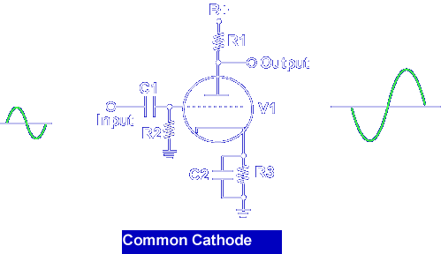

Some of the characteristics of the common cathode configuration are: high input impedance and high inter-electrode capacitance, highest gain of the configurations, and an output that is 180° out of phase with the input signal.

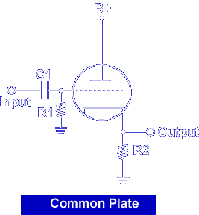

Shown above is the schematic symbol for a common plate configuration, normally referred to as a cathode follower amplifier. This type of configuration is normally used for impedance matching. The input is applied to the grid and the output is taken from the cathode. Since the plate is neither the input nor the output, it is common.

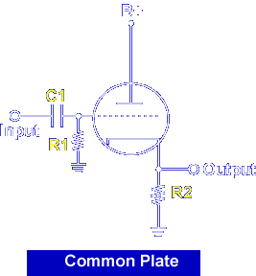

The capacitor C1 is the coupling capacitor, R1 is the grid resistor, and R2 is the cathode resistor. Notice that the input is applied to the grid and the output is off the cathode. This means that R2 is not only the bias resistor but also the load resistor.

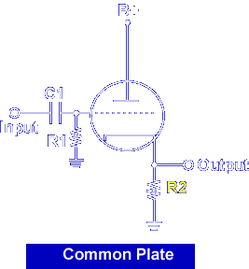

Comparing this circuit to the common cathode amplifier, we find the load resistor is not in the plate circuit but in the cathode circuit. The output is taken across the resistor, and there is no phase shift across the amplifier. The positive alternation of the input signal causes bias to decrease. The resistance of V1 decreases, current increases. As current increases, the voltage drop across R2 (load/bias resistor) increases. During the negative alternation of the input, the opposite action occurs. We see that the output voltage is in phase with the input, or "follows" the input. Since the cathode resistor is not bypassed and the voltage across it follows the input, degeneration occurs. The signal developed on the cathode is in opposition to and subtracts from the input signal.

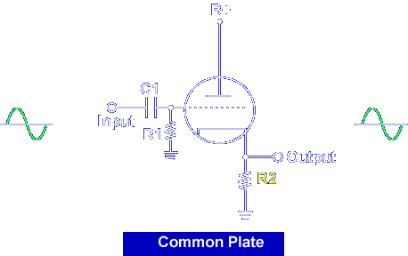

Because of this degeneration, the output will ALWAYS be less than the input (voltage gain is less than one). Remember, the cathode follower is commonly used for impedance matching. It has a high input impedance and a low output impedance as compared to the common cathode.

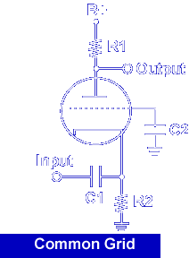

Shown above is the schematic symbol for a common grid configuration. This configuration is normally referred to as a grounded grid amplifier. The input is applied to the cathode and the output is taken from the plate. This means the grid is the common element.

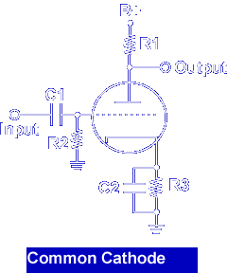

When very high frequency signals are to be amplified, the grid to plate inter-electrode capacitance drastically reduces the gain of the common cathode amplifier.

The grounded grid amplifier (common grid) was developed to overcome this difficulty. The input signal cannot use the same path from grid to plate as it did with the common cathode circuit. The grid structure acts as a shield between the cathode and the plate. The input is applied to the cathode in series with the applied grid bias. The output is taken between the plate and ground.

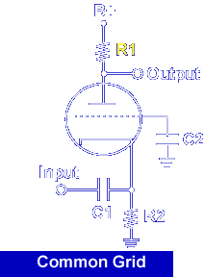

The positive alternation of the input will cause bias to increase. The resistance of the tube increases and current through the tube decreases. The voltage across R1 will decrease and the output will increase.

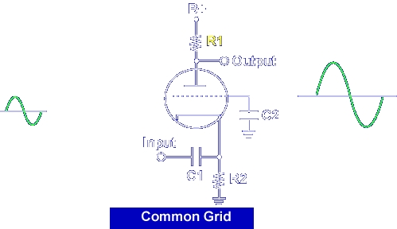

The negative alternation of the input will cause the opposite action to occur. This also means that the input and output signals are in phase. This amplifier configuration is capable of a high gain, although not as high as the common cathode. The main disadvantage of the grounded grid configuration is that the input source must furnish an appreciable amount of power to the amplifier.

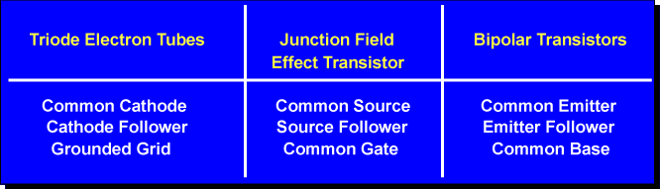

Today, these amplifier configurations have been replaced with transistor-based configurations. Even though their circuit characteristics are different, the basic function is still the same.

Which of the following electron-tube amplifier configurations provides a 180° phase-shift from the input to the output?

Common Cathode

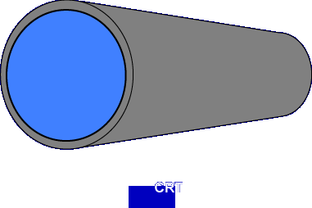

In the next section, we will look at the operation and uses of the cathode-ray tube. The CRT is the most popular electron tube still in use today.
This completes the information on ELECTRON TUBE OPERATION.

