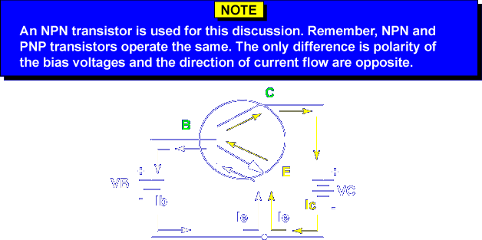
Transistors are unique in that collector current flows across the reverse biased collector base PN junction. The amount of collector current is dependent on the base bias voltage or base current within certain limits. Let's see why.
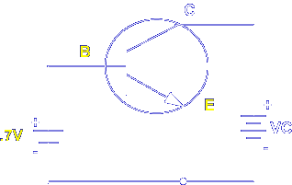
The emitter to base PN junction is similar to a diode. Approximately 0.7 volts is needed to forward bias the junction (0.3 volts for a germanium transistor).
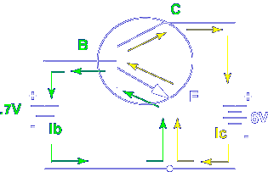
Once the EB junction is forward biased and the CB junction is reverse biased, current flows.
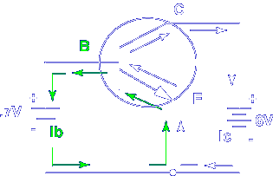

Remember, the base is thin and lightly doped. Most of the current carriers pass on to the collector. Base current is small.

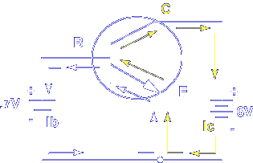

However, the collector current is large.

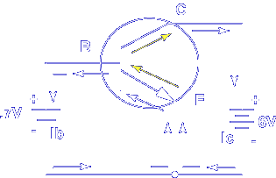

Remember, the collector is large and moderately doped. Most of the current carriers from the emitter are attracted to the collector.
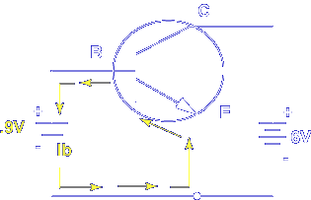
Because there are a limited number of current carriers in the base, increasing base bias only slightly increases base current.
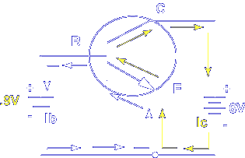
The emitter is heavily doped and an increase in base voltage causes more current carriers to enter the base. This causes collector current to increase significantly.
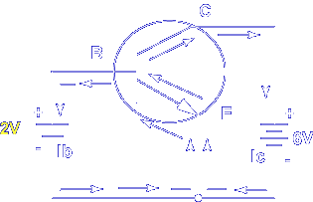
Increasing the base bias too much causes the collector current to remain constant. All the available current carriers in the emitter are used up. The point when I_{c} no longer increases although base bias voltage increases is called saturation. The transistor acts as a short between the collector and emitter.
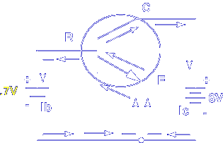
Decreasing the base bias has the opposite effect.
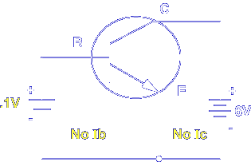
Decreasing the base bias below the forward bias level of the emitter base junction stops current flow altogether. Since the base is more negative than the emitter, I_{b} stops. I_{c} stops because the current carriers cannot enter the base. The point where I_{b} and I_{c} stop is called cutoff. The transistor acts as an open between the collector and emitter.
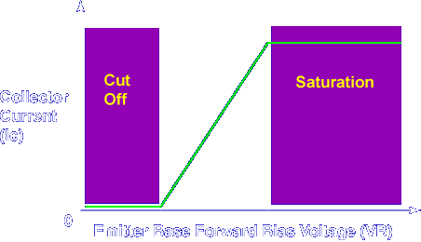
Graphing the base bias voltage and the collector current shows the cutoff and saturation points.
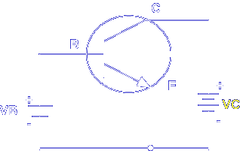
(Notice that the collector bias voltage was not discussed. This is because increasing Vc has very little effect on I_{c}.)
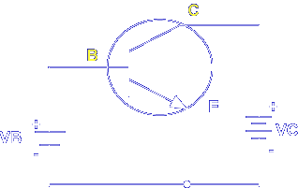
As long as the collector to base PN junction is reverse biased, all the available current carriers in the base are attracted to the collector.
What happens in a transistor when the saturation point is reached?
I_{c} stops increasing
What happens in a transistor when the base voltage reverse biases the emitter to base PN junction?
Cutoff occurs
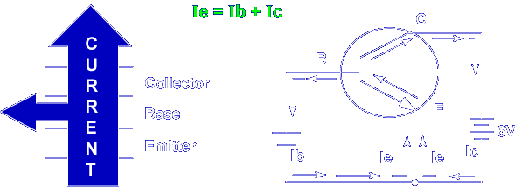
Kirchhoff's Current Law shows the relationship of the three currents in a transistor. Remember, the small base current controls the larger collector current. Although the actual values of the three currents are variable, values depend on bias voltage levels and circuit operation. The ratios of the currents are constant for each type of transistor. These ratios, called α (Alpha) and β (Beta), describe transistor operation under any condition and bias level.
α (alpha) and β (beta) values for each transistor manufactured are given in transistor reference books. α (alpha) and β (beta) values for each transistor manufactured are given in transistor reference books. α (alpha) is the ratio of collector current (Ic) to emitter current (Ie). α = I_{c}/I_{e}. α (alpha) never exceeds 1. Normal values range between 0.97 and 0.99. β (beta) is the ratio of collector current (I_{c}) to base current (I_{b}). β = I_{c}/I_{b}. Beta values are larger than 1, and I_{b} is always smaller than I_{c}. Normal values range between 20 and 400.
Alpha is the ratio of _______.
Ic/Ie
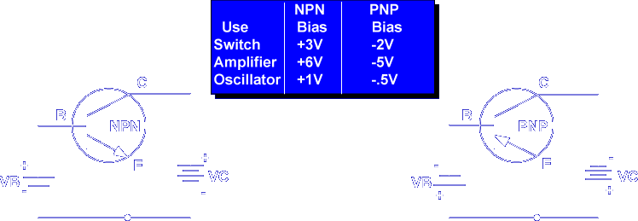
Batteries can be used to bias a transistor as shown. This is not very practical due to the different values of bias required for transistor operation. To solve this problem, one power supply is used to generate Vcc. Resistors are used to reduce Vcc to the correct bias levels.
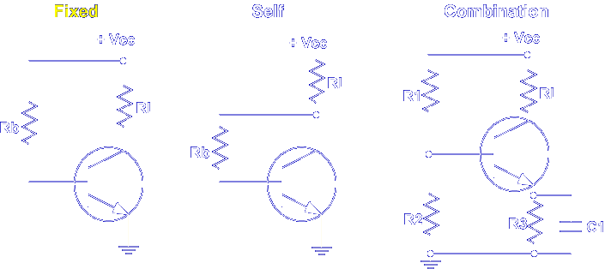
There are three types of basic bias circuits. Let's start with fixed.
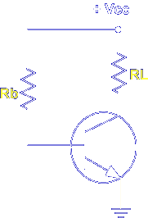
In this fixed biased transistor, RL is a load resistor and Rb is the base bias resistor. Note that Rb connects directly to Vcc. The values of the resistors are chosen so that there is a higher positive voltage on the collector than the base. Thus, the voltage drops from +Vcc forward bias EB and reverse bias CB. The disadvantage of fixed biasing is that small changes in base current, due to temperature changes, affect the voltage on the collector. The changes are small, but small voltage changes on the base cause large changes in collector current.
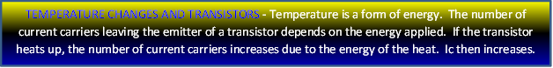
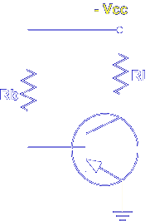
For a PNP transistor +Vcc is changed to -Vcc.
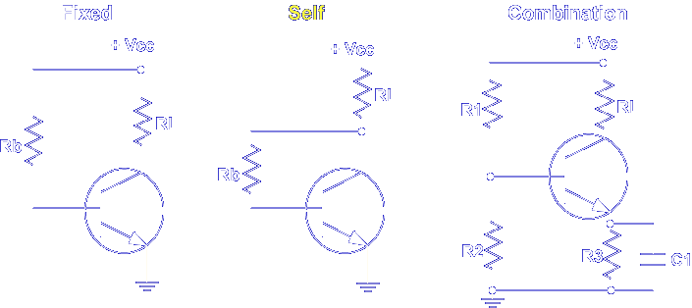
The temperature disadvantage is overcome by using self-bias.
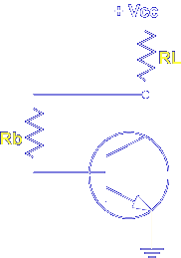
In this self-biased transistor, RL is a load resistor and Rb is the base bias resistor. Note that Rb is connected DIRECTLY to the collector. If collector current increases due to temperature, the voltage drop across RL increases, decreasing the voltage across Rb. This reduces base bias, which returns I_{c} to normal. The disadvantage of self-bias is that control of the base bias over the collector current, β (beta) is reduced.
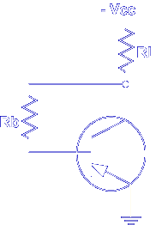
For a PNP transistor +Vcc is changed to -Vcc.
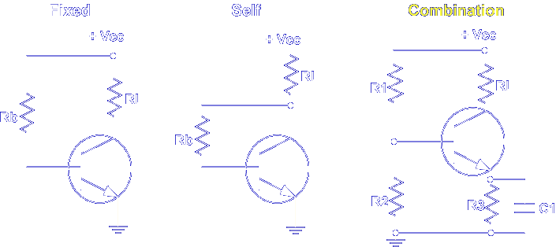

The disadvantage of fixed and self-bias is overcome by a combination of fixed and self-bias.

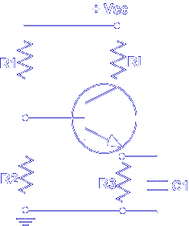

There are many types of combination bias. The voltage divider is the most widely used. R1 and R2 form a voltage divider that provides a fixed bias to the base. Note, the base resistor connects directly to +Vcc. R3 self-biases the emitter. The emitter voltage is determined by how much current is flowing through R3, which is controlled by the base voltage. C1 is used to keep any AC input signal off the emitter. This stabilizes the DC bias voltages.

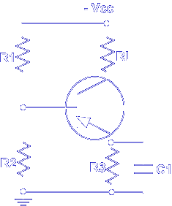

For a PNP transistor +Vcc is changed to -Vcc.

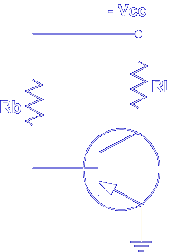

What type of DC biasing is used with this transistor circuit?

Fixed

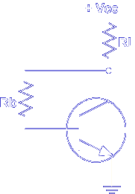

What type of DC biasing is used with this transistor circuit?

Self

This completes the information on TRANSISTOR OPERATION BIAS.

