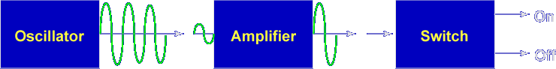
There are many uses for a properly biased transistor. The most common use is the amplifier.
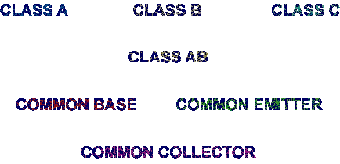

Transistor amplifiers have different classes of operation and configurations.

Let's begin the lesson on INTRODUCTION TO TRANSISTOR AMPLIFIERS.

