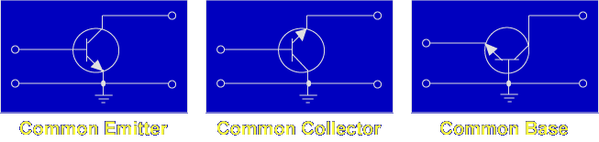

The three basic circuit configurations for transistor amplifiers are: Common Emitter, Common Collector, and Common Base. The term "common" is used to denote the element that is common to both the input and the output. Each configuration has particular characteristics that make it suitable for specific applications.

Common Emitter

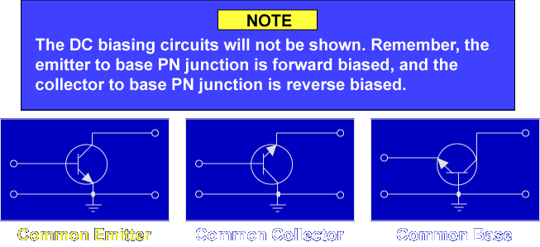

Let's begin the discussion with the common emitter configuration.

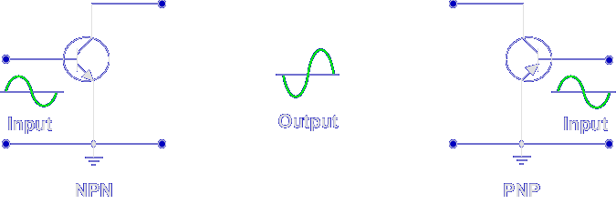

The common emitter configuration (CE) is the most frequently used amplifier. It provides good voltage, current, and power amplification. The input signal is applied to the base, the output is taken from the collector, and the emitter is common. Notice that the output signal is 180° out of phase with the input signal. The common emitter is the only configuration which provides a phase reversal.

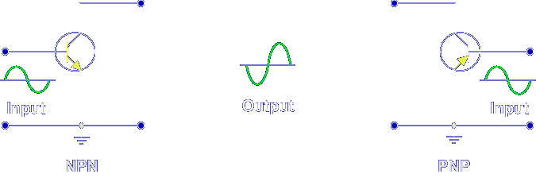

The input resistance is medium (500 Ω to 1500 Ω) because the input is applied to the forward biased PN junction.

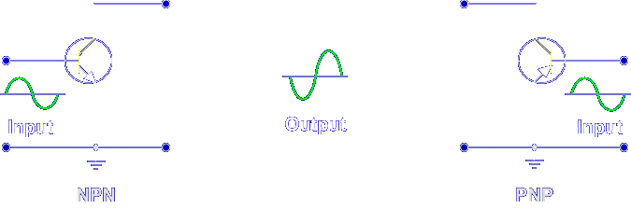

The output resistance is medium (30 kΩ to 50 kΩ) because the output is taken from the reverse biased PN junction.

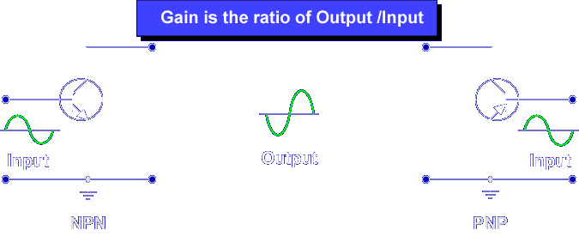

The common emitter configuration has:
Input / output phase - 180°
Power gain - high
Voltage gain - medium
Input resistance - medium
Current gain - medium
Output resistance – medium

Common Collector

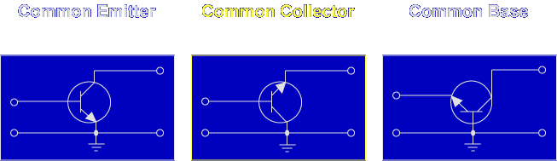

Next, let's discuss the common collector.

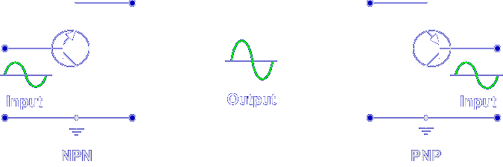

The common collector configuration (CC) is primarily used for impedance matching. High impedance inputs are matched to low impedance loads. CC amplifiers have a high current gain and are sometimes used as a current driver. The input signal is applied to the base, the output is taken from the emitter, and the collector is common. Notice that the output signal is in phase.

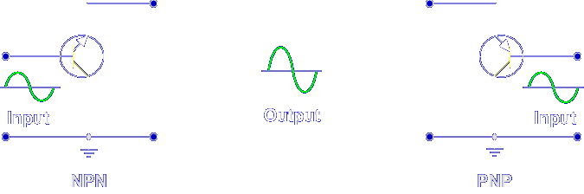

The input resistance is high (2 kΩ to 500 kΩ) because the input is applied to the reverse biased PN junction.

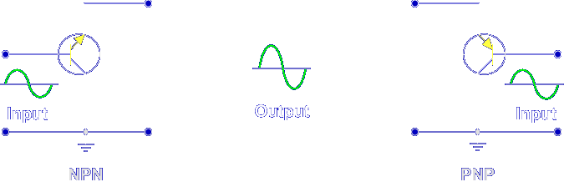

The output resistance is low (50 Ω to 1500 Ω) because the output is taken from the forward biased PN junction.

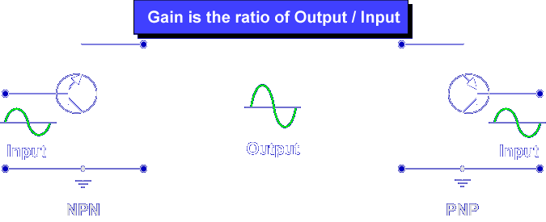

The common collector configuration has:
Input / output phase - 0°
Power gain - medium
Voltage gain - low
Input resistance - high
Current gain - high
Output resistance – low

Common Base

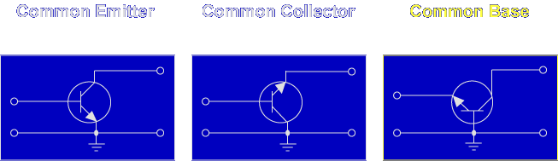

Next, let's discuss the common base.

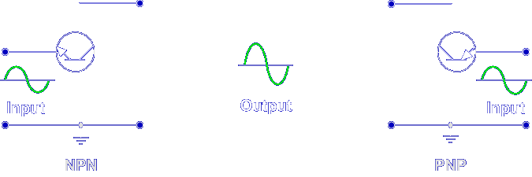

The common base configuration (CB) is primarily used for impedance matching. It matches low impedance input to high impedance loads. CB amplifiers have a large voltage gain. The input signal is applied to the emitter, the output is taken from the collector, and the base is common. Notice that the output signal is in phase with the input.

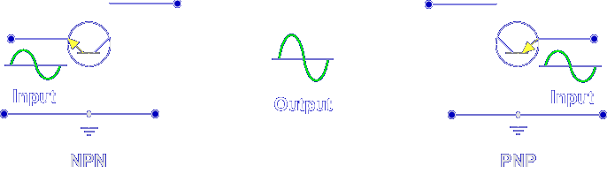

The input resistance is low (30 Ω to 160 Ω) because the input is applied to the forward biased PN junction.

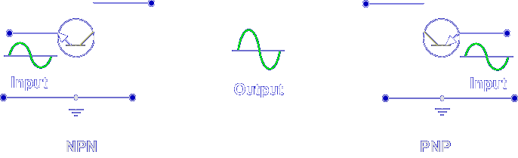

The output resistance is high (250 kΩ to 550 kΩ) because the output is taken from the reverse biased PN junction.

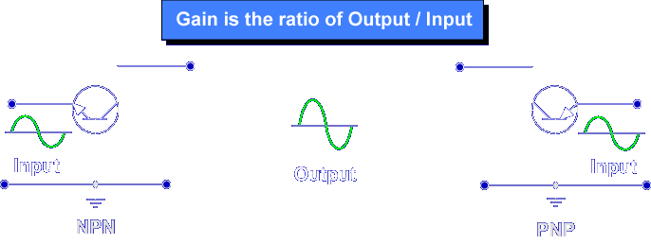

The common base configuration has:
Input / output phase - 0°
Power gain - low
Voltage gain - high
Input resistance - low
Current gain - low
Output resistance – high

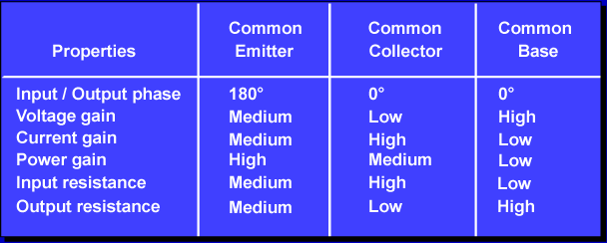

This chart summarizes the properties of transistor amplifier configurations. The common emitter is the best amplifier configuration because of its high properties. The CC and CB configurations are best suited for matching loads due to their input and output resistances.

When an input is applied across the emitter to base PN junction, what is the relative resistance?

Low

When an input is applied across the collector to base PN junction, what is the relative resistance?

High

This completes the information on AMPLIFIER CONFIGURATION.

