|  |
| --- |
| **Touch a quantity for more information.** |
| |  |  |  | | --- | --- | --- | | **1.** | **Solving for Eb** |  | | **2.** | **Solving for Ee** |  | | **3.** | **Solving for Ie** |  | |

CALCULATING Av - Remember to use this formula:  
  Av = Rc ÷ (.025 ÷ Ie)  
  Rc is the collector resistor.  
  Ie is emitter current and is calculated by following the steps above.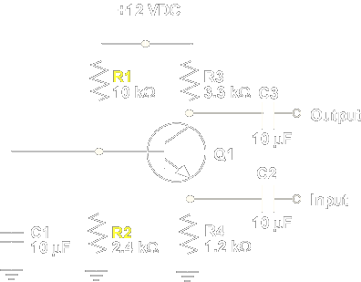

CALCULATING Eb - Since R1 and R2 form a voltage divider, Eb (Er2) is is found by:  
  1. Finding Rt:  Rt = R1 + R2  
  2. Solving for It:  It = Ea ÷ Rt   
  3. Calculating Eb:  Er2 = It x R2

CALCULATING Ee - Since the emitter to base PN junction drops 0.6 V, Ee equals:  Ee = Eb - 0.6 V

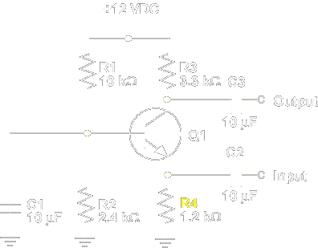

CALCULATING Ie - Ohm's Law is used to find emitter current (Ie):  
  Ie = Ee ÷ Re